Question 8.1

Describe a situation or problem from your job, everyday life, current events, etc., for which a linear regression model would be appropriate. List some (up to 5) predictors that you might use.

An example of a situation when I would use linear regression model is exam scores. The five predictors could be homework scores, attendance, number of hours spent in the class per week, hours of sleep, and number of office hours attended. We would be able to perform linear regression on this because the exam scores are continuous, it has a linear relationship with the predictors, and there is a possibility that the error distribution is normal.

Question 8.2

Using crime data from http://www.statsci.org/data/general/uscrime.txt (file uscrime.txt, description at http://www.statsci.org/data/general/uscrime.html ), use regression (a useful R function is lm or glm) to predict the observed crime rate in a city with the following data:

M = 14.0
So = 0

Ed = 10.0
Po1 = 12.0

Po2 = 15.5
LF = 0.640

M.F = 94.0
Pop = 150

NW = 1.1
U1 = 0.120

U2 = 3.6
Wealth = 3200

Ineq = 20.1
Prob = 0.04

Time = 39.0

Show your model (factors used and their coefficients), the software output, and the quality of fit.

Note that because there are only 47 data points and 15 predictors, you’ll probably notice some overfitting. We’ll see ways of dealing with this sort of problem later in the course.

Methodology

First, I removed the outliers from the dataset. The two outliers are removed were from Homework 3, 1993 and 1969.

I created a linear model using lm() and looked at the summary() and confi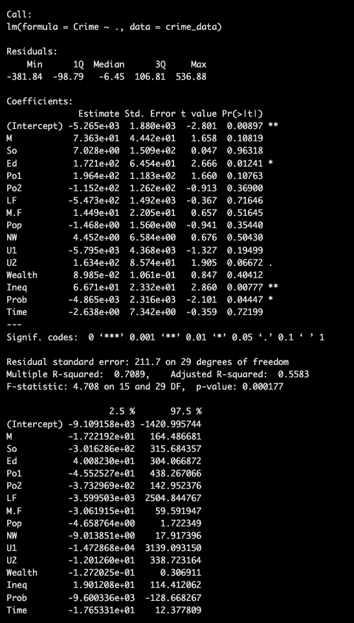

Looking at the summary of the linear model of all the predictors, the coefficients that are significant (for alpha = 0.05) are Ed, Ineq, and Prob. The adjusted R-squared is 51.14%, and the model's p-value is 0.001618. Looking at the confidence intervals of the predictors (95% confidence), the significant predictors are Ed, Ineq, and Prob, which are the same compared to the summary. If the confidence interval did not include 0, then that would mean that the predictor is not significant. Therefore, I was able to identify which predictors were significant based on this rule. The linear model's BIC is 654.5932. The linear model's Corrected AIC is 596.725. Based on the VIF, I ended up removing Po2, Wealth. After performing VIF on the new model, all the variables VIF's are close to 5 and lower, which is a good sign. That shows that there is no correlation between the predictor variables, so there is also no interruption with the individual effects to the response variable, Crime.

Then I looked at the AIC and BIC of the model. For the AIC, I calculated the corrected AIC using the formula: AIC + (2 * k * (k + 1)) / (n – k – 1)

I looked at the vif() of the model and removed the variables that I believed were causing multi-collinearity.

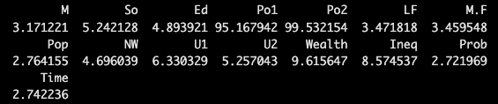

I created a new model (excluding the variables that I removed, which were Wealth and Po2), and then ran the summary() and calculated the AICc and BIC again. I repeated this process until I got the ideal model I wanted.

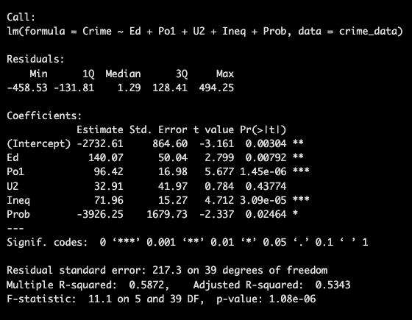

Based on the p-value tests of each predictor, the significant predictors are Ed, Po1, U2, Ineq, and Prob. Therefore, I created a model with those new variables. The variables that I ended up using were Ed, Po1, Ineq, and Prob.

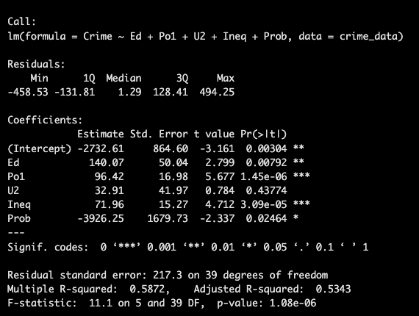

Then, I created a data frame with all the testing values and used the predict() function to predict the future Crime rate.

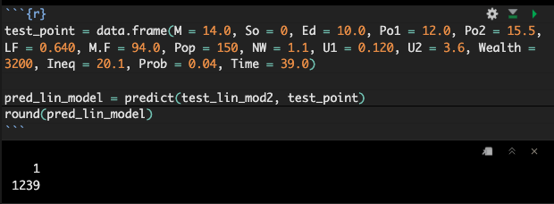

After that, I imported the library, DAAG, set the seed, and used cv.lm() to check the prediction performance.

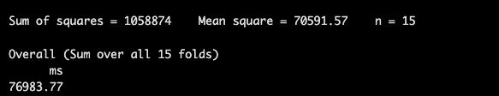

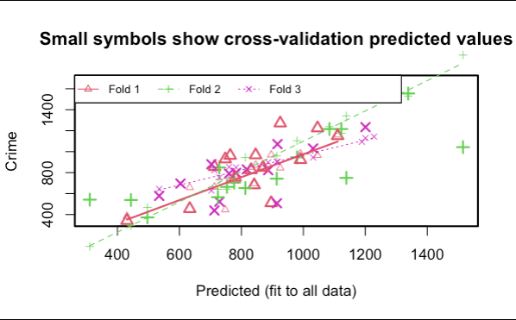

I also tested out a new model using glm() where the family was ‘poisson’. I repeated all of the steps that I did for the linear regression model. The only difference was that I had to use the library(pscl) to get the R-squared, and I had to use a new formula of AICc: AIC + (2 * k * (k + 1)) / (n – k – 1). I ended up creating two different Poisson models and comparing them.

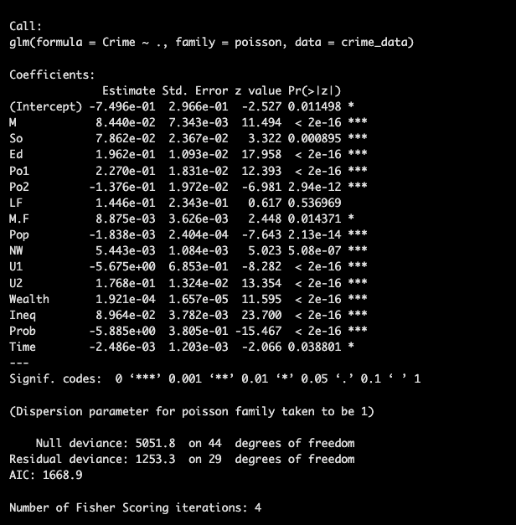

Results

Linear Model:

The predicted observed crime rate from the model that consists of Ed, Po1, Ineq, and Prob, is 1239. This means that there were 1239 number of offenses per 100,000 population in 1960.

The MSE is 70591.57, which is close to the lowest MSE out of all the linear models that I have created.

Poisson Model:

The prediction observed crime rate from the poisson model is 293. This looks highly unreasonable because the poisson model is performed on a different scale. Therefore, the multiple linear regression model is a better model to use.

The MSE is 77158.60, which is lower than the second poisson model that I have created.

Discussion of Results

Here is all the information about this new model. The P-value is 3.554e-07, which is the lowest that I have received out of all the linear models I have created. The Adjusted R-squared is 53.88%, which means that 53.88% of the variation is explained by the model with the variables: Ed, Po1, Ineq, and Prob. This current model's Adjusted R-Squared is only slightly less than the other models (maximum 2-3%). The VIF of the predictors are all below 5, which is very good because that means that multicollinearity is not present. All the predictors are significant because all of their p-values are lower than 0.05. Finally, the Corrected AIC is lower than that of the previous model (619.8326 < 621.8009). The BIC is lower than that of the previous model, but only by ~3 (629.1341 < 632.237). Therefore, this current BIC is 'somewhat likely' to do better than the previous model's. Based on all this information, I believe that this is the best performing model for lm().

Poisson Model:

Comparing the two poisson models that I have created, the original poisson model has better traits. The first model has a lower BIC, lower corrected AIC, a slightly larger R-Squared (from the McFadden), and a lower MSE. The only thing is the first model includes all the predictors, and some predictors are insignificant while the other model's predictors are all significant. If we're looking for predictive accuracy, we would use the first model. Therefore, I will predict the values according to the first model.

The original Poisson Model had an R-squared of 69.88409%, which is higher than the other (66.49702%). It also had a corrected AIC of 1688.352 and a BIC of 1697.83, which is lower than the other (AICc = 1854.775, BIC = 1866.705). This means that the BIC is ‘highly likely’ to do better than the previous model’s.

In conclusion, I decided that the linear regression model is better because it gave a predicted value that has more reasonable results.

