Question 9.1

Using the same crime data set uscrime.txt as in Question 8.2, apply Principal Component Analysis and then create a regression model using the first few principal components. Specify your new model in terms of the original variables (not the principal components), and compare its quality to that of your solution to Question 8.2. You can use the R function prcomp for PCA. (Note that to first scale the data, you can include scale. = TRUE to scale as part of the PCA function. Don’t forget that, to make a prediction for the new city, you’ll need to unscale the coefficients (i.e., do the scaling calculation in reverse)!)

Methodology

First, I removed the outliers from the original dataset where the crime rate was valued at 1993 and 1969. The reason is that Principal Component Analysis can be sensitive to outliers.

Next, I will plot a histogram of the data without the outliers.
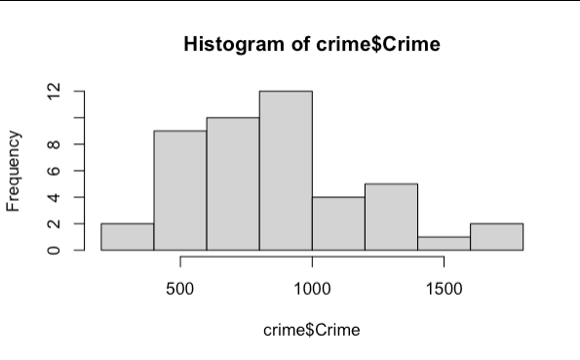

From this histogram, we see that for lower crime rates, there is less variance, while for higher crime rates, there is higher variance. Therefore, we know that heteroscedasticity exists in the data. I will perform Box Cox transformation to equalize the variance.

To prove that heteroscedasticity exists using another plot, I created a residual plot of the linear regression model of all the variables.
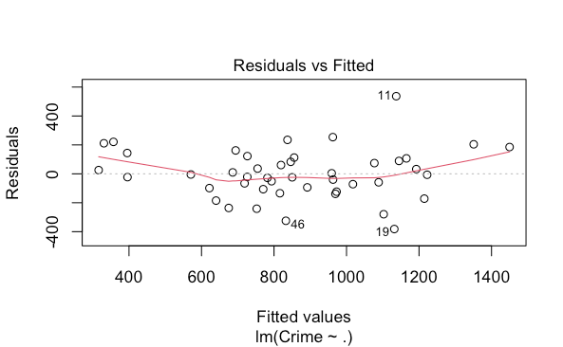

On the residual plot, the residuals fan out, forming a "U" shape, or a funnel shape. This means that heteroscedasticity (unequal variance) is present in this model. The lower and higher fitted values have a higher variance (wider) while the values in between have a lower variance (narrower). We will equal the variance through PCA.

To decide how many principal components to use, I used an elbow plot.

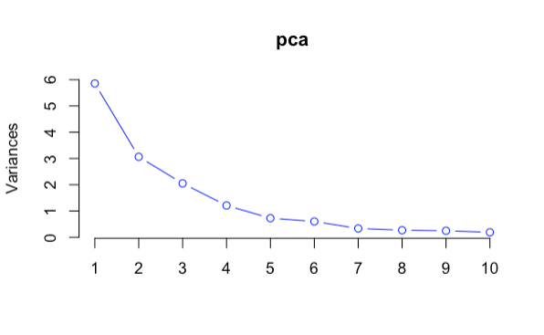

Based on this elbow plot, I have decided to use the first four principal components since the line levels off at 4.

I created a linear regression model with the first four principal components. Here is the summary:
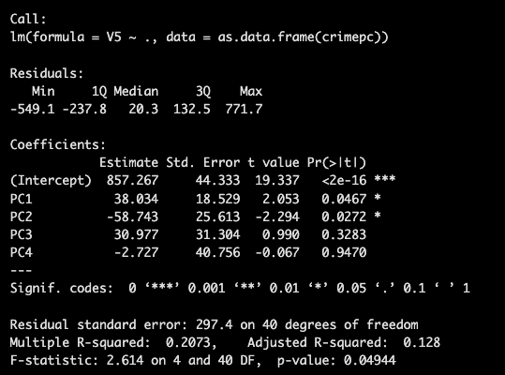

I performed the VIF function of the PCA linear regression model.

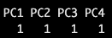

We need to transform them back into the original coefficients. In this code, the first matrix is the rotation matrix of the first four principal components. The rotation matrix is a matrix with the eigenvalues. This will tell us how each original variable contributes to each principal component. The second matrix is the model with the regression coefficients of the first four principal components, excluding the intercept. In other words, this is the linear combination of the original variables that correspond to my PCA regression model. I multiplied both matrices to get the model coefficients in the scaled variable space.
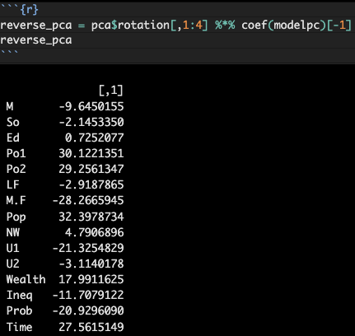

I calculated the means and standard deviation by extracting it from pca$center and pca$scale. pca$center are the means of each original variable. pca$scale are the standard deviations of each original variable. I stored into the variables "x_means" and "x_std".

The next block of code is where I performed the transformation back to the original coefficients. I calculated the original coefficients by dividing the standard deviations from the model coefficients in the scaled variable space. This is the action of "unscaling". I calculated the original intercept by getting the coefficients of the PCA model's intercept and subtracting that by the sum of the mean of each scaled variable (x_means / x_std) and then multiplying that value by the regression coefficient vector in the scaled variable space.
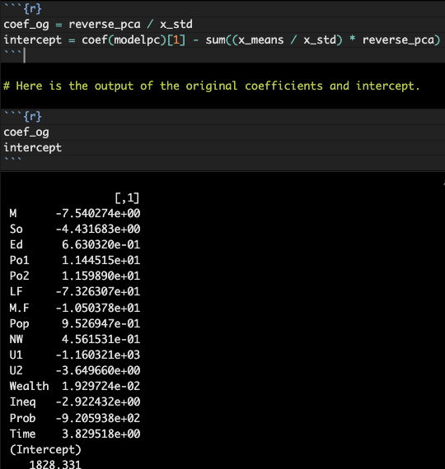

Finally, I used the testing points from the previous homework. In order to predict the crime rate, I used this formula: Intercept from original variable space + sum of (the coefficients from original variable space * the testing points).
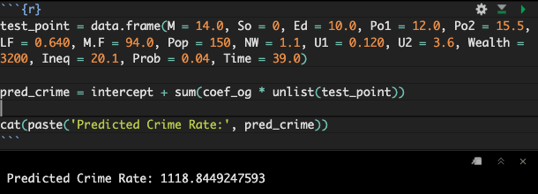

The predicted crime rate is 1118.

I repeated the whole process for five principal components and six principal components. Here are the summaries:
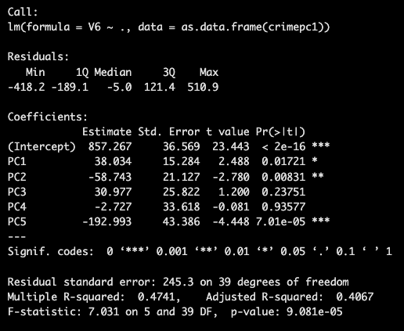

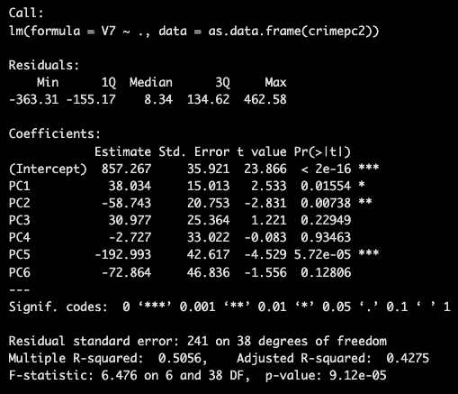

As you can see, as we add more principal components to our model, the adjusted R-squared increases. This makes sense because as we add more components, it explains more of the variance since we add more variables.

Here are the predicted crime rates for the first five and six component PCA Models:

First five principal components:

First six principal components: 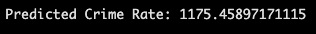

Finally, I put my code of my model solution from the previous homework. Here is the output:
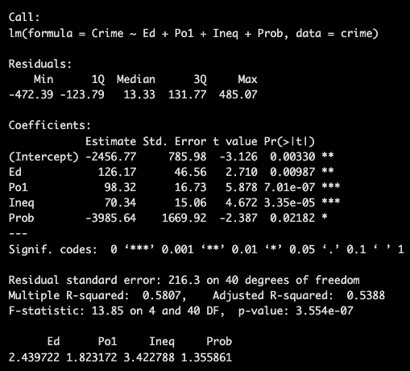

Here is the output on the variance proportions of each principal component models:

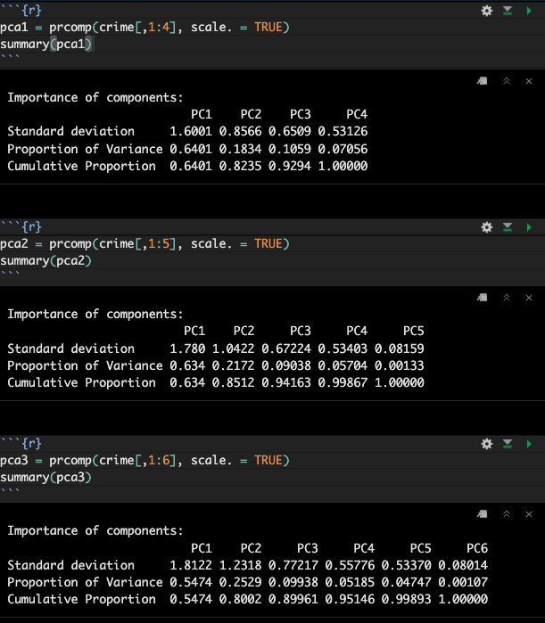

Results

I decided that for our main objective (predicting crime rate), and the focus of PCA, which is finding a small number of orthogonal linear combinations of the original variables to capture as much variance as possible, the PCA model with the first five principal components was the best model.

The predicted crime rate from the PCA model with the first five principal components is 1351. This means that there were 1351 number of offenses per 100,000 population with those testing points.

Discussion of Results

Let's compare the PCA model quality to our linear regression model from the previous homework. The linear regression model included the variables: Ed, Po1, Ineq, and Prob. Here is the summary of the model:

The PCA model with the first five principal components is better than the other PCA models because if we compare the proportion of variances of all those models, the PCA model with the first five principal components captures the most variance with the fewest principal components as possible. At four principal components, it hits 99.87%, but the model with four principal components hits 100% because it only has four components. If we look at the first three principal components of the models, it has a higher cumulative proportion (94.163% > 92.94%).

The regular model has a higher adjusted R-squared, lower RSE, and lower p-value, which are better model qualities. However, the variance is still unequal (heteroscedasticity). Let's compare it to the other VIF values from the PCA model. The VIF values of the first five principal components are all 1. This is very good, and it proves that PCA removes multicollinearity. Therefore, all the variances are equal, and heteroscedasticity does not exist anymore. Even though the PCA regression had a lower R-squared, it removed multicollinearity, used fewer effective parameters, and reduced test error. Since our goal is to predict the crime rate, reducing test error means getting a more accurate prediction of the crime rate, which is what we should prioritize.

Resources:

https://www.rdocumentation.org/packages/stats/versions/3.6.2/topics/prcomp

https://www.datacamp.com/tutorial/pca-analysis-r

https://www.geeksforgeeks.org/r-language/principal-component-analysis-with-r-programming/

