I combined the methodology, results, and discussion of results.

Question 11.1

Using the crime data set uscrime.txt from Questions 8.2, 9.1, and 10.1, build a regression model using:

Stepwise regression
- Lasso
- Elastic net
For Parts 2 and 3, remember to scale the data first – otherwise, the regression coefficients will be on different scales and the constraint won’t have the desired effect.

For Parts 2 and 3, use the glmnet function in R.

Notes on R:
- For the elastic net model, what we called λ in the videos, glmnet calls “alpha”; you can get a range of results by varying alpha from 1 (lasso) to 0 (ridge regression) [and, of course, other values of alpha in between].
- In a function call like glmnet(x,y,family=”mgaussian”,alpha=1) the predictors x need to be in R’s matrix format, rather than data frame format. You can convert a data frame to a matrix using as.matrix – for example, x <- as.matrix(data[,1:n-1])
- Rather than specifying a value of T, glmnet returns models for a variety of values of T.

Stepwise Regression

- First, I performed backward elimination. Here is the output of my final model:
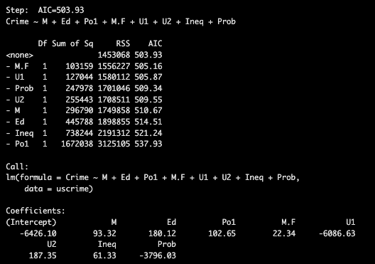

Backward starts with the full model with all the variables and removes the variable one at a time to reduce the AIC. As a result, our final model consists of the variables: M, Ed, Po1, M.F, U1, U2, Ineq, and Prob. The AIC is 503.93, which is the lowest out of all of them.

- Next, I performed forward elimination. Here is the output of my final model:
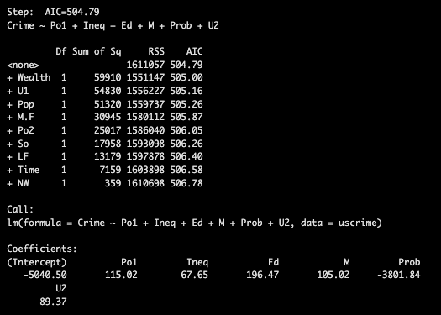

For forward selection, we start with the model with just the intercept and adds variables one at a time to reduce the AIC the most. The final model consists of the variables: Po1, Ineq, Ed, M, Prob, U2. The final model's AIC is 504.79.

- Finally, I performed stepwise regression (both directions). Here is the output of my final model:
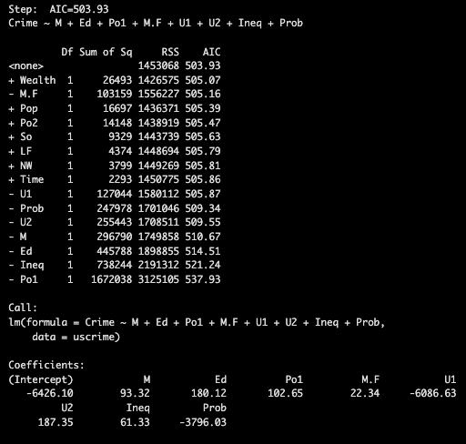

Stepwise elimination starts with the full model and looks at both additions and removals to the model at each step. The final model consists of the variables: M, Ed, Po1, M.F, U1, U2, Ineq, and Prob. The final model's AIC is 503.93.

As you can see, the AIC of the backward elimination and stepwise regression is the same (503.93). I concluded that stepwise regression is the better model because it considers both directions. However, it doesn’t matter which one to choose since they have the same result.

Lasso

First, I scaled the data.

Next, I used cv.glmnet() to create my LASSO model. These are the parameters I chose to use:
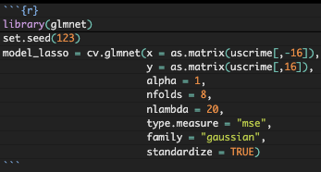

Next, I plotted the LASSO model and obtained the minimum lambda values and coefficients of the model.
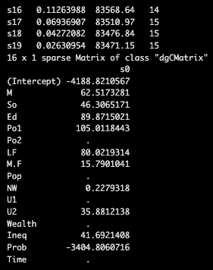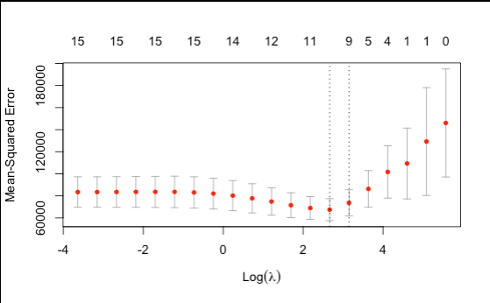

As you can see in the plot above, the minimum MSE occurs at log(lambda) when it is approximately equal to 2.2. At this lambda, the model keeps 10 variables.

The right dashed line's lambda is slightly larger. It also has a slightly larger MSE, and it uses 9 variables.

The output with the coefficients shows the non-zero variables (coefficients) of the lambda.min. The coefficients are M, So, Ed, Po1, LF, M.F, NW, U2, Ineq, Prob. I will be focusing on prediction performance, so I will focus on using lambda.min. These are the 10 variables.

Finally, I created a function to calculate the MSE. Here is the output:
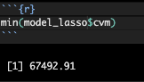

The MSE of the lambda minimum is 67492.91.

I will try using a different lasso model. For this model, I will change nlambda to 100. The nlambda parameter controls the number of lambda values when fitting the model. In other words, we try 100 different values of lambda, ranging from a large value, which focuses strong regularization, to a small value, which focuses on weak regularization.
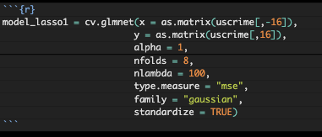

Here are the plot and coefficients.
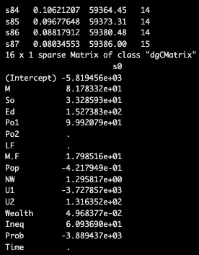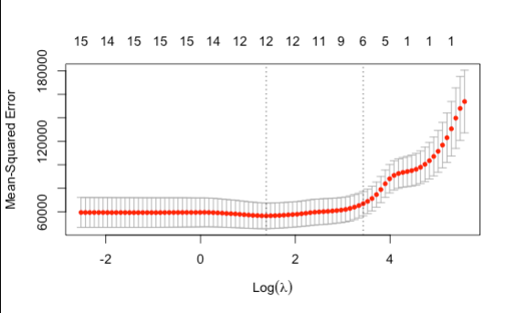

The lambda minimum uses 12 variables. The coefficients that are used are M, So, Ed, Po1, M.F, Pop, NW, U1, U2, Wealth, Ineq, and Prob.

Here is the MSE.
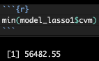

The MSE is 56482.55.

I created one last model where nlambda = 200. Let’s see what changes.

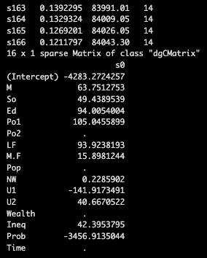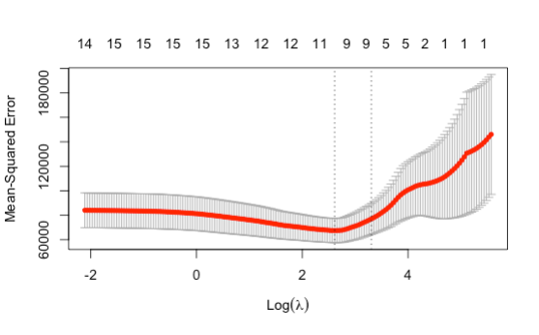

The lambda minimum uses 11 variables. The coefficients that are used are M, So, Ed, Po1, LF, M.F, NW, U1, U2, Ineq, and Prob.

Here is the MSE:

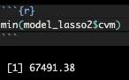

The MSE is 67491.38.

Comparing all the models, the best model is the second model. The reason for this is that the MSE is the lowest for that model. Since I am valuing predictive performance, a lower MSE is ideal. Lower MSE means that the model has the smallest average prediction error. Additionally, the model uses only one more variable than the other two models.

Elastic Net

First, I created my Elastic Net model. To do this, I had to set alpha to 0.5. Here is the code I used:
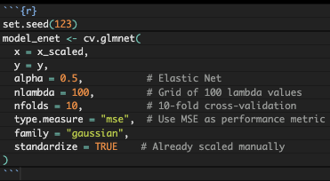

- Next, I found the coefficients and plot for the model.

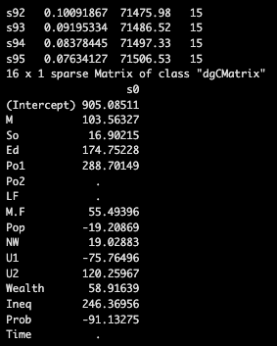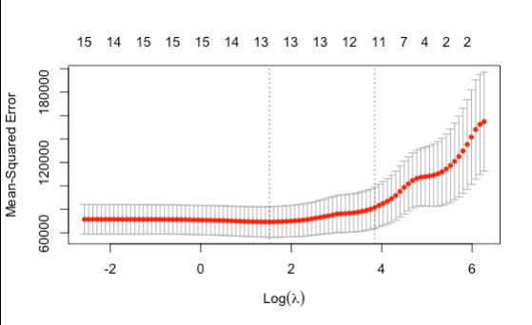

As you can see in the output, the minimum lambda uses 12 variables. The variables are M, So, Ed, Po1, M.F, Pop, NW, U1, U2, Wealth, Ineq, Prob.

I found the MSE of the model using $cvm.
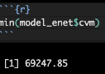

The MSE is 69247.85.

- I created a new elastic net model where I changed nlambda to 200 and nfolds to 15.

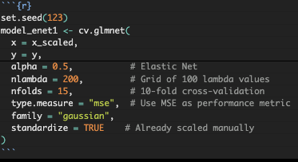

Here are the plot and coefficients.
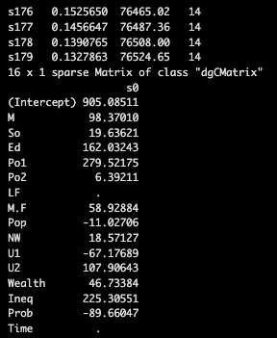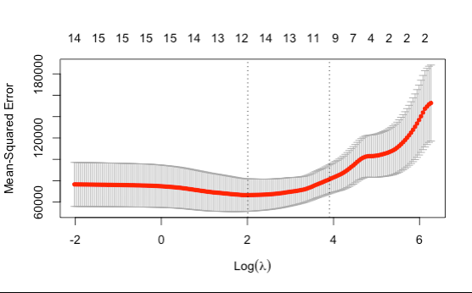

The new model’s lambda minimum uses 13 variables: M, So, Ed, Po1, Po2, M.F, Pop, NW, U1, U2, Wealth, Ineq, Prob.

Finally, I calculated the MSE.
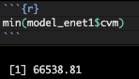

The MSE is 66538.81.

The MSE of the new model is lower than the MSE of the first model. However, it uses one extra variable. In this case, we want to consider whether overfitting is an issue here. I think it is fine to include one extra variable and settle with the new model. Therefore, I think the new model is a better model to use since it has a couple thousands difference in the MSE.

References:

AI

https://www.rdocumentation.org/packages/stats/versions/3.6.2/topics/step

https://www.rdocumentation.org/packages/glmnet/versions/4.1-10/topics/cv.glmnet

https://mediaspace.gatech.edu/media/ISYE+6501+OMSA+Office+Hour/1_ui0s5fe1

