Question 12.1

Describe a situation or problem from your job, everyday life, current events, etc., for which a design of experiments approach would be appropriate.

One example I can think of is when testing products at a Boba shop. The factors of creating a recipe for the drink could depend on: tea type, amount of hours to freeze or dry tapioca pearls, brew time for the tea, or steep time for the tea.

Question 12.2

To determine the value of 10 different yes/no features to the market value of a house (large yard, solar roof, etc.), a real estate agent plans to survey 50 potential buyers, showing a fictitious house with different combinations of features. To reduce the survey size, the agent wants to show just 16 fictitious houses. Use R’s FrF2 function (in the FrF2 package) to find a fractional factorial design for this experiment: what set of features should each of the 16 fictitious houses have? Note: the output of FrF2 is “1” (include) or “-1” (don’t include) for each feature.

According to the question, we are given that there are 10 different yes/no features (so 10 factors) and 50 potential buyers. We want to show just 16 fictitious houses (so 16 runs). We want to find the fractional factorial design: set of features for each of the houses. The output of FrF2 is ‘1’ (include) or ‘-1’ (don’t include) for each feature.

I must choose whether I will be using resolution 3 or resolution 4. A design with resolution III (resolution=3) confounds main effects with 2-factor interactions, a design with resolution IV confounds main effects with three-factor interactions or 2-factor interactions with each other, and designs with resolution V or higher are usually regarded as very strong, because all 2-factor interactions are unconfounded with each other and with main effects.

First, I imported the package ‘FrF2’.

Then, I named my features for the 10 factors: Large Yard, Solar Roof, Garage, Swimming Pool, Fireplace, Hardwood Floors, Open Layout, Basement, Smart Home, and Park Nearby.

I decided to set resolution = 3, nfactors = 10, factor.names = features, and randomize = TRUE. Here is the output:

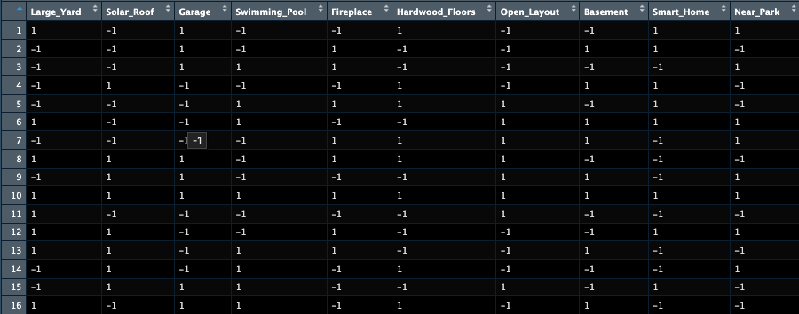

This output shows the set of features that each house includes. For example, the first fictitious house has a large yard, garage, hardwood floors, smart home, and a nearby park, but it doesn’t have all the features.

Then, I used aliasprint(res3) to show the confounding main effect relationships. Resolution 3 is aliased with 2-factor interactions.

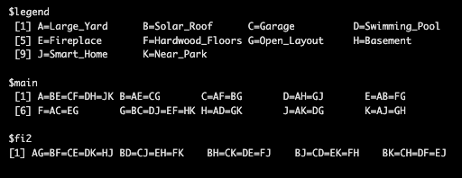

This output shows the confounded multiple 2-factor interactions. For example, for A = BE = CF = DH = JK, this means that we cannot distinguish the effect of A (large yard) from B x E, C x F, D x H, and J x K.

Question 13.1

For each of the following distributions, give an example of data that you would expect to follow this distribution (besides the examples already discussed in class).

Binomial

Geometric

Poisson

Exponential

Weibull

Binomial: Rolling an even number on a die.

Geometric: Rolling until I get a sum of 2 on two dice (1, 1).

Poisson: Number of typos per page in a book.

Exponential: Time until a volcano erupts.

Weibull: Time until shoe is completely worn out and cannot be used.

Question 13.2

In this problem you, can simulate a simplified airport security system at a busy airport. Passengers arrive according to a Poisson distribution with λ₁ = 5 per minute (i.e., mean interarrival rate μ₁ = 0.2 minutes) to the ID/boarding-pass check queue, where there are several servers who each have exponential service time with mean rate μ₂ = 0.75 minutes. [Hint: model them as one block that has more than one resource.] After that, the passengers are assigned to the shortest of the several personal-check queues, where they go through the personal scanner (time is uniformly distributed between 0.5 minutes and 1 minute).

Use the Arena software (PC users) or Python with SimPy (PC or Mac users) to build a simulation of the system, and then vary the number of ID/boarding-pass checkers and personal-check queues to determine how many are needed to keep average wait times below 15 minutes. [If you’re using SimPy, or if you have access to a non-student version of Arena, you can use λ₁ = 50 to simulate a busier airport.]

Methodology

First, I assigned the variables for: the random seed, the simulation time, the lambda arrival value, the mean time for ID check, the minimum time for scanners, and the maximum time for scanners.

I created a function called passenger. The function parameters are current simulation time, the passenger’s name, the id checkers, the scanners, and the passenger wait times. I used env.now to get the current simulation time and assigned it to the variable ‘arrival time’.

To check the ID’s, I used ‘with’ to find available ID checkers. Then, I used ‘yield’ to wait until an ID checker was available. ‘yield env.timeout’ simulated the time it took to get the ID checked, and ‘random.expovariate’ simulated the exponential service time. The rate is 1 / the mean time for ID check.

For the personal scanners, I used min() to choose the scanner with the shortest line. ‘random.uniform’ simulated the scanning time from the minimum to maximum time for scanners.

For the arrival process, I created a new function with the same parameters. I simulated the passengers arriving randomly, which is also considered the Poisson distribution. ‘yield env.timeout()’ with the lambda arrival value represents the waits between arrivals based on lambda. ‘env.process()’ schedules a new passenger in the simulation.

To run one simulation, I created a function with the parameters for number of ID checkers and number of scanners. I set both to 5. I used simpy.Environment() to create the Simpy simulation environment. ‘wait_times’ is an empty list. This resets the data collection for the simulation.

Then, I defined my resources using simpy.Resource.

To start the simulation, I used env.process() on my arrival process function to start the arrival generator. I used env.run() with the simulation time to run the full simulation. Using mean(), I got the average wait time for all the passengers in this run.

Finally, I created a for loop where the range goes from 20 to 29 for both ID servers and scanners. Inside the for loop, I used the simulation run function for each iteration of the for loop. Then, for any of them that had an average wait time less than 15, I appended it into the list.

The reason that I chose the range to be from 20 to 29 is that I wanted to avoid underperforming setups while setting a reasonable upper limit. I also set the lambda value of arrival to 50 to simulate a busy airport. The minimum scan time was set to 0.5, and the maximum scan time was set to 1.0. The simulation time was 100 minutes, and the mean ID time was 0.75. Here is the final output: 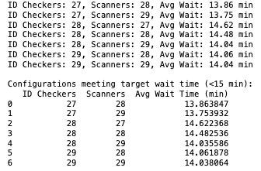

As you can see, there are seven different simulations that have an average wait time lower than 15. Based on the results, we hit the target waiting time when there are at least 27 ID checkers and 27 scanners.

I repeated this whole process but change two things: I changed the lambda to 30 to change it into a more moderately busy airport, and I also changed the range of the ID servers and scanner to 5-20. Here is the output:
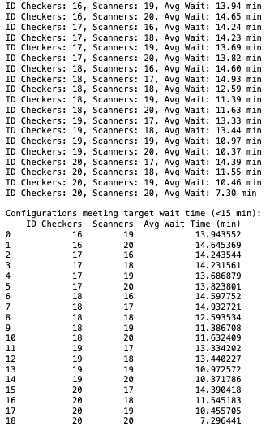

Based on these results, there are 19 different simulations that have an average waiting time lower than 15. This occurs when the ID checkers is 16+ and the Scanners is 16+.

