Audit Report Template
Project: "SwiftPay" Design Audit – Send Money screens
Auditor: Josephus Mupanda
Standard: WCAG 2.1 AA, Nielsen's usability heuristics, UI consistency principles
Please fill out the table below. You must identify a minimum of three issues.
Issue # | Issue Description (What is the problem?) | Issue Type (Accessibility, UI, or UX) | Justification (Why is this a problem? Reference a module concept.)
1 | The "Total Balance" amount is almost invisible. On Send Money 2–6, the balance "₦20,000,00.00" is bright blue #0061DD (Bold 28 px) on the blue card #235697. Measured contrast: 1.32:1 (1.51:1 on the darker part of the card). | Accessibility | This fails WCAG 2.1 Success Criterion 1.4.3 Contrast (Minimum). Even as large text the balance needs 3:1, and it reaches less than half of that. Blue on blue has almost no difference in brightness, so users with low vision, colour-vision deficiency, or a phone in bright sunlight cannot read the most important number on the screen: how much money they have before sending. It breaks the "Perceivable" principle of POUR. Fix: white #FFFFFF on the card (7.37:1).
2 | The primary "Continue" button changes colour within the same flow. On Send Money 3 the enabled "Continue" uses the brand blue (#235697 → #114280). On Send Money 6, the same button for the same action is green #0D8536. Green is also used for "Share" and the success check mark on Send Money 10. | UI | This breaks UI consistency and the colour-palette rule that one colour should always mean one thing. Users learn that "blue = primary action". When the same button turns green, the change carries no meaning, so it looks like a mistake or a different action. Green is also this app's success colour, so a green "Continue" can suggest the payment is already done when the user still has to enter a passcode. It also goes against Nielsen's "Consistency and standards" heuristic. Fix: one primary-button style (brand blue) for every "Continue"; keep green for success feedback only.
3 | There is no feedback while the transfer is processing. After the 4-digit passcode is entered (Send Money 8), Send Money 9 covers the screen with a 50% dark overlay (layer "Loading Overlay"). The overlay has no spinner, no progress indicator and no message. The user only sees a greyed-out keypad. | UX | This violates Nielsen's heuristic #1, "Visibility of system status": the system should always tell users what is going on. In a money transfer, a frozen-looking screen leaves users unsure whether the payment went through. They may tap again, close the app or retry, which risks duplicate transfers (also an "Error prevention" problem). It is inconsistent with Send Money 4, where the button does show a spinner. Fix: a spinner plus a message such as "Sending ₦5,000.00 to Victor Jimoh…", announced to screen readers.
4 | The form field labels are faded almost to white. On Send Money 2–6, "Account Number", "Bank", "Beneficiary's name", "Amount" and "Remarks (optional)" use #7D7C93 with the layer opacity set to 25%. On white this renders as #DEDEE4: 1.34:1. On empty fields the label is the only hint of what to type. | Accessibility | This fails WCAG 1.4.3 Contrast (Minimum) (4.5:1 needed for 12–14 px text). It also undermines WCAG 3.3.2 Labels or Instructions: a label that cannot be read is effectively no label. Users with low vision, or anyone outdoors, cannot tell which field is the account number and which is the beneficiary name, which leads to input errors in a payment form. Fix: remove the 25% opacity and use a darker grey such as #6B6A80 (5.25:1).
5 | The back button looks disabled and is hard to see. On Send Money 1–9 and 11, the top-left back arrow (#3C3F49) is set to 15% opacity, rendering as #E2E2E4 on white: 1.29:1. Its touch target is only 20 × 20 px. | Accessibility | Icons that carry meaning must reach 3:1 under WCAG 1.4.11 Non-text Contrast; this one reaches 1.29:1. At 15% opacity it looks like a disabled control, so users may believe they cannot go back and fix a mistake (Nielsen: "User control and freedom"). The 20 × 20 px target is also below the 24 × 24 px minimum of WCAG 2.5.8 Target Size and the 44 × 44 pt touch-target guidance from Apple's Human Interface Guidelines, which makes it hard to tap for users with motor impairments. Fix: full-opacity icon (10.5:1) with a 44 × 44 px tap area.
6 | The selected beneficiary card is grey, low-contrast and has a tiny "Change" link. On Send Money 5–6, the card showing "VICTOR JIMOH / 2122444522" has a mid-grey #A4A4A4 background. The account number and "Change" are #7D7C93 on it (1.63:1), and the name #3B3D4B reaches only 4.31:1 at 12 px. The "Change" tap area is 61 × 17 px. | Accessibility | The account number and "Change" fail WCAG 1.4.3 badly (4.5:1 needed), and even the name falls short. The account number is exactly what users must check to avoid paying the wrong person, so it should be the easiest thing to read. A flat mid-grey surface is the usual visual cue for a disabled component, so the card does not look interactive (poor affordance) even though "Change" can be tapped. The 17 px-high target fails WCAG 2.5.8 Target Size (Minimum) (24 px). Fix: a light card (#F1F5F9) with dark text (#3B3D4B, 9.8:1) and a full-height "Change" button.
7 | The payment-method list on Send Money 1 has uneven spacing, misaligned content and a misplaced "OR" divider. The title-to-subtitle gap is 2 px for "Swift Pay User" and "eNaira" but 23 px for "Bank Account". Text starts at x = 72, 73 and 76 and icons at x = 20, 21 and 24. An "OR" divider appears only between the 2nd and 3rd option, in #D5D5D5 (1.47:1). | UI | Consistent spacing and alignment on a shared grid is a core UI principle. By the Gestalt principle of proximity, items placed close together read as one group. The 23 px gap visually separates "Send to a bank account" from its own title, so the row reads as two separate items. The 1–4 px left-edge drift makes the list look unfinished and harder to scan. The single "OR" implies eNaira is the alternative to the first two options, when all three are equal choices, and its text is unreadable (fails WCAG 1.4.3). Fix: one list-item component with fixed spacing, a shared left edge, and either an "OR" between every option or none.
8 | The success screen does not say who received the money, and plain text is styled like links. Send Money 10 shows the amount, "Bank Name: United Bank Of Africa" and "2122444522", but not the beneficiary name ("VICTOR JIMOH"). These lines use the brand-blue colour of the interactive "Download receipt" button but are not tappable. The text is left-aligned under a centred icon. | UX | A confirmation screen should support Nielsen's "Recognition rather than recall". Users recognise a payee by name, not by a 10-digit account number, so they cannot quickly confirm the money went to the right person. Non-interactive text that looks interactive is a false affordance: users tap it and nothing happens. The left-aligned text under a centred icon also breaks the screen's visual hierarchy and alignment. Fix: "You sent ₦5,000.00 to Victor Jimoh (UBA • 2122444522)", centred, in body-text colour.
9 | The receipt and balance-card text is too small to read. On Send Money 11, every line of the receipt (labels, values, reference, "Generated from…") is 8 px, and the labels are #7D7C93 on white (4.06:1). On the balance card, "Last updated 2 mins ago." is 9 px. | Accessibility | Module typography guidance calls for a readable minimum size: Apple's Human Interface Guidelines set 11 pt as the smallest legible text, and 16 px is the usual mobile body size. At 8 px, the transaction reference and amount, which a user may need for a dispute, are unreadable for most people without zooming. At that size the labels also fail WCAG 1.4.3 (4.06:1 < 4.5:1). If the receipt is generated as an image, users cannot enlarge it with system font settings, which works against WCAG 1.4.4 Resize Text. Fix: at least 12–14 px, labels #6B6A80 (5.25:1), and a text-based receipt.
10 | Icon-only buttons and images have no accessible names, and one icon's meaning is unclear. The back, close and share controls are bare icons, and a speech-bubble icon ("ChatDots") on Send Money 1 has no label. Bank logos are layers with auto-generated names ("31a86295-f41b-…") and the eNaira logo is an image named "e-naira-logo 2". The file contains no accessibility annotations (alt text or button labels). | Accessibility | WCAG 1.1.1 Non-text Content requires a text alternative for meaningful images, and WCAG 4.1.2 Name, Role, Value requires every control to have an accessible name. Under "Shift Left", developers build what the design specifies. Without annotations, a screen reader announces "button, unlabelled" or a file name such as "e-naira-logo 2", so blind users cannot tell back from close or share. The chat icon is ambiguous even for sighted users (chat? support? messages?), which goes against "Recognition rather than recall". Fix: annotate accessible names ("Back", "Close", "Share receipt", "Contact support", "United Bank for Africa logo") and give the chat icon a visible label.
11 | The balance is formatted incorrectly: "₦20,000,00.00". On Send Money 2–6 and the eNaira screens, the digits are grouped 2-3-2. Standard thousands grouping gives either ₦20,000,000.00 or ₦2,000,000.00, so the real amount is ambiguous. | UX | Nielsen's "Match between the system and the real world" says the interface should follow real-world conventions, and in finance the convention is strict 3-digit grouping. A balance that cannot be read with confidence breaks user trust, which matters more in a payment app than anywhere else. The user also cannot tell whether they can afford the transfer, which weakens error prevention. Fix: format currency with a locale-aware formatter (en-NG, separator every 3 digits).
12 | The eNaira flow shows conflicting payee and transaction details. The beneficiary's wallet alias is "@adetor.1g" on the confirmation and success screens (eNaira 2, 4 and 10) but "@adetoro.1g" on the receipt (eNaira 11). The receipt labels this wallet transfer "INTER-BANK", and the success screen says "Bank Name: eNaira", although eNaira is a digital-currency wallet, not a bank. | UX | Nielsen's "Consistency and standards", and user trust, require the same information to appear the same way at every step. If the alias changes between confirmation and receipt, the user cannot tell which account received the money, and any dispute becomes harder (an "Error prevention" concern). Reusing bank-transfer wording for an eNaira transfer breaks "Match between the system and the real world": the labels describe the wrong kind of transaction. Fix: show all payee details from one data source and use eNaira-specific labels ("Wallet: eNaira", type "eNaira transfer").
Measurement note: colours, font sizes, opacities and positions were read from the Figma layers. Contrast ratios use the WCAG 2.1 relative-luminance formula; for layers with reduced opacity, the colour was first blended onto its background. Disabled buttons were not flagged because WCAG 1.4.3 exempts inactive components.

Appendix – Annotated evidence
Red boxes mark the problem on each screen. Screens are exported from the SwiftPay Figma file.

Issue 1 – The "Total Balance" amount is almost invisible.
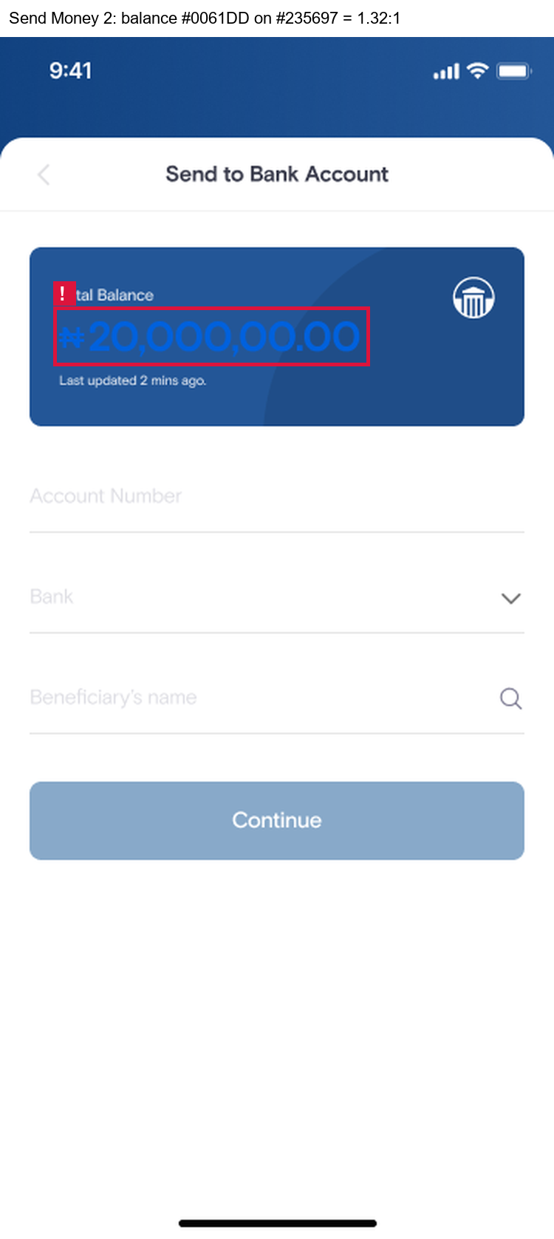

Issue 2 – The primary "Continue" button changes colour within the same flow.
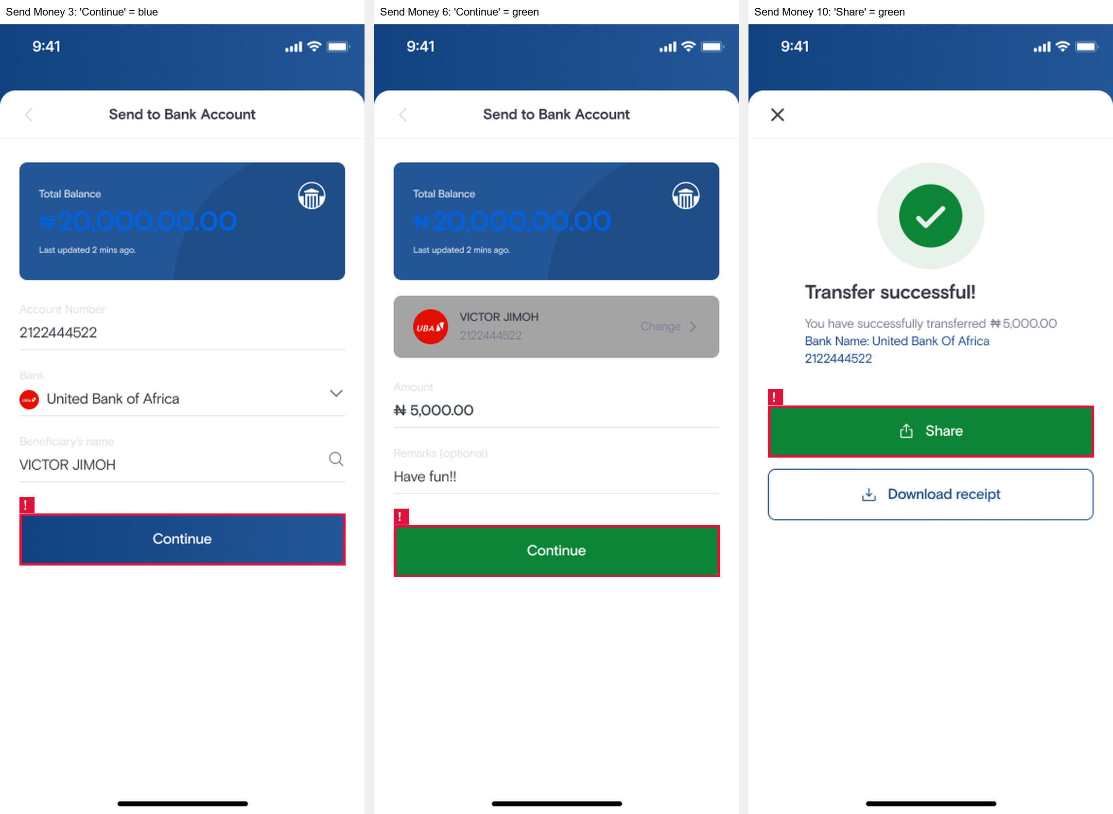

Issue 3 – There is no feedback while the transfer is processing.
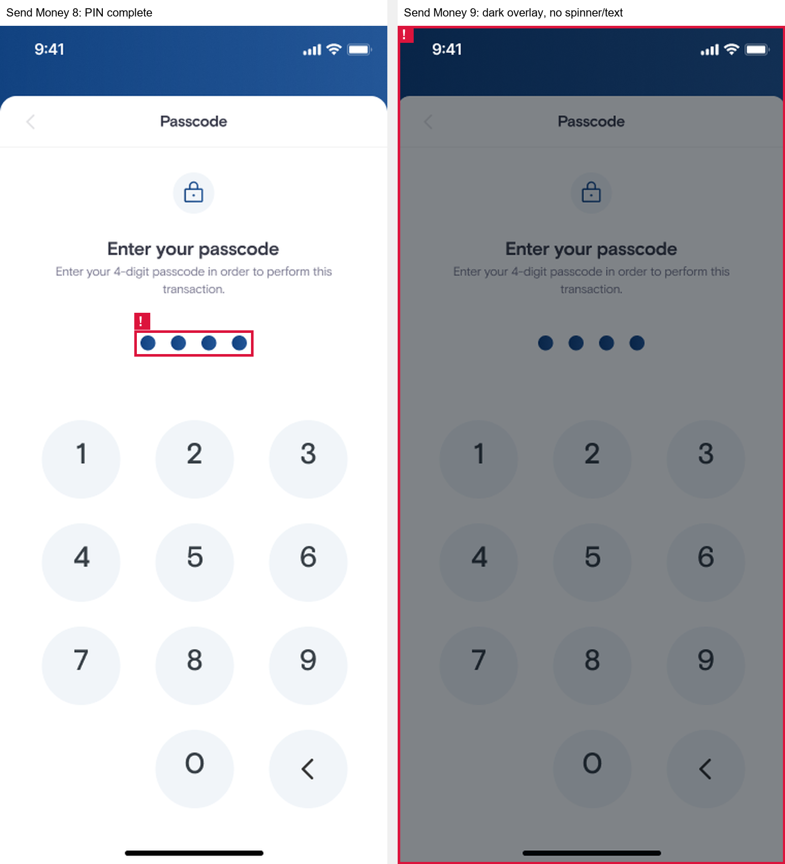

Issue 4 – The form field labels are faded almost to white.
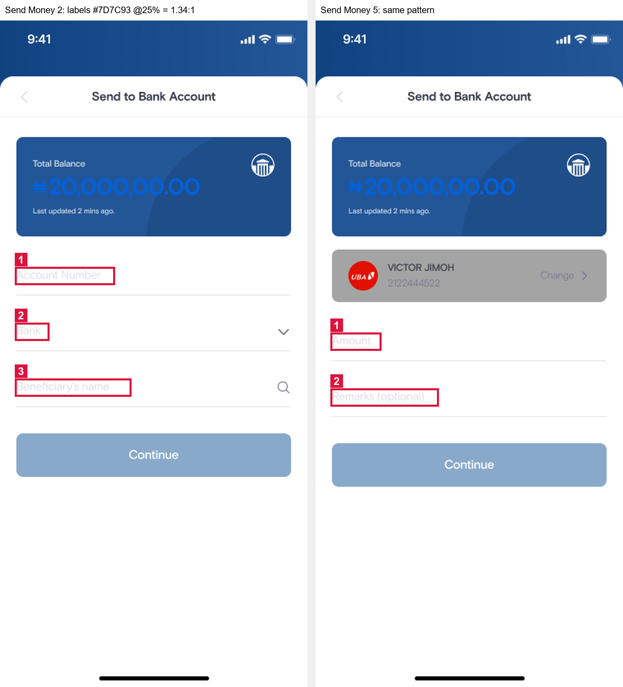

Issue 5 – The back button looks disabled and is hard to see.
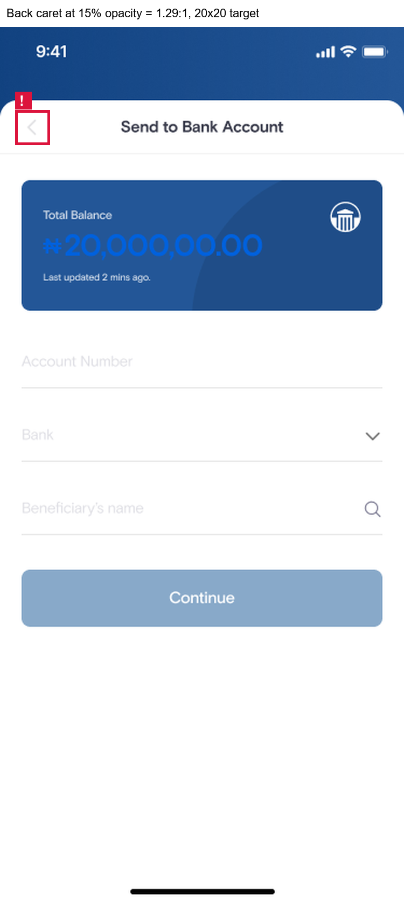

Issue 6 – The selected beneficiary card is grey, low-contrast and has a tiny "Change" link.
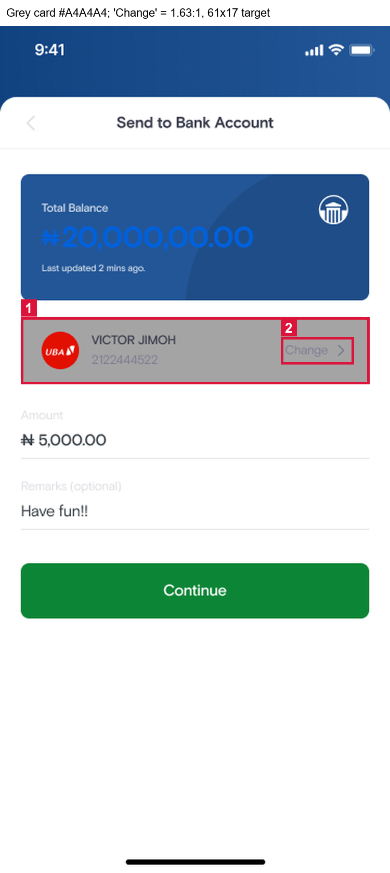

Issue 7 – The payment-method list on Send Money 1 has uneven spacing, misaligned content and a misplaced "OR" divider.
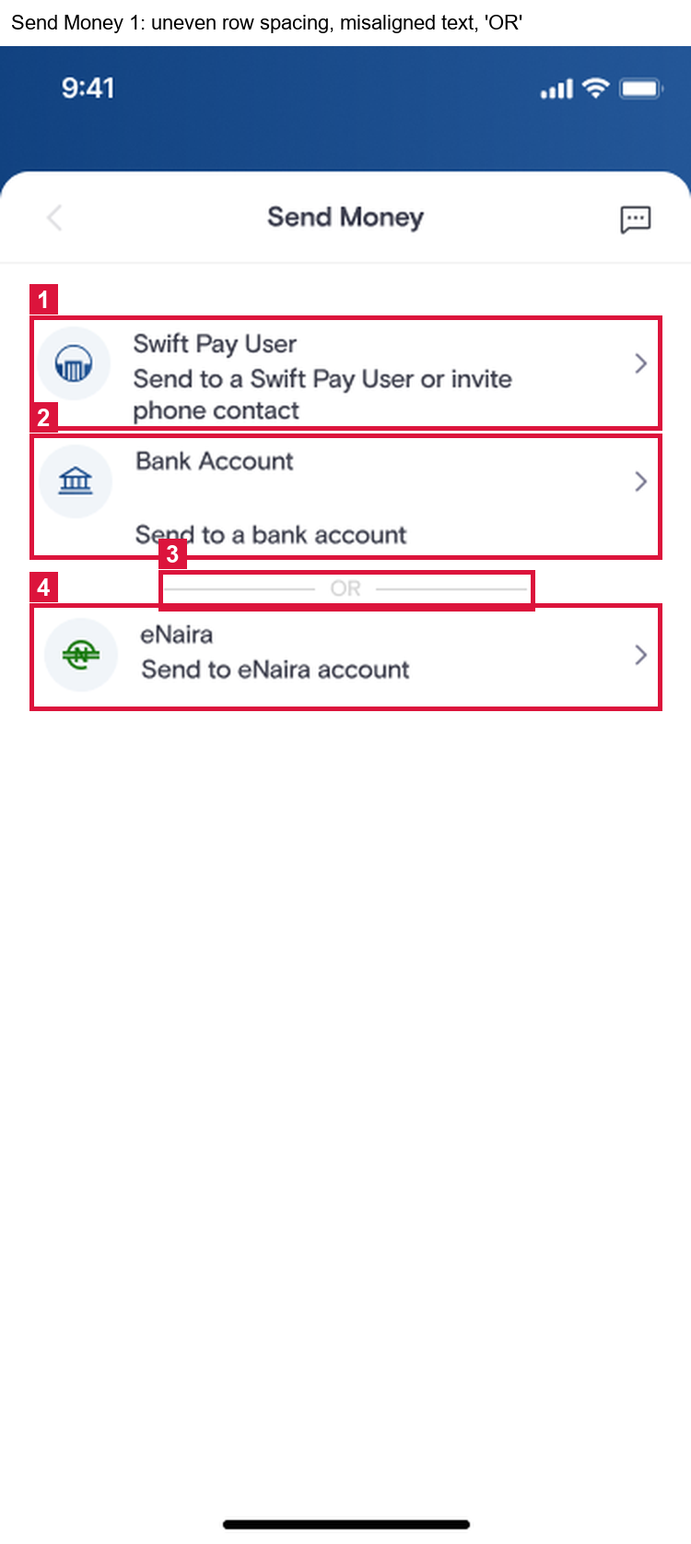

Issue 8 – The success screen does not say who received the money, and plain text is styled like links.
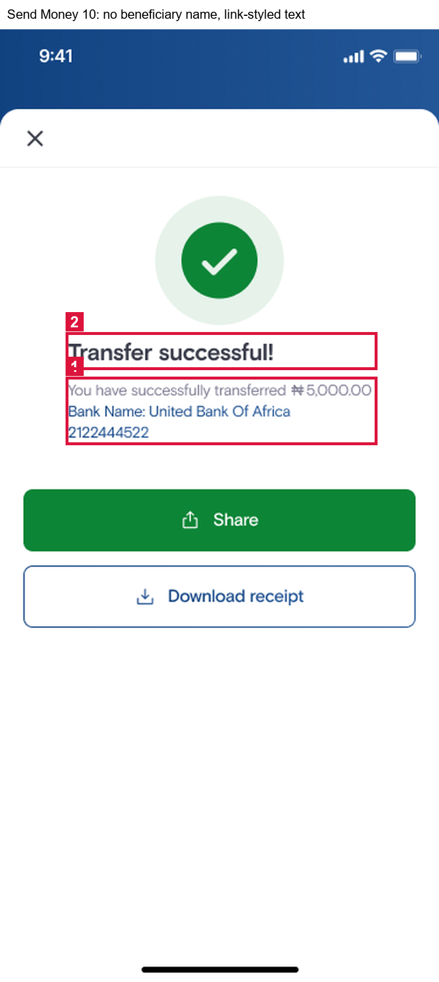

Issue 9 – The receipt and balance-card text is too small to read.
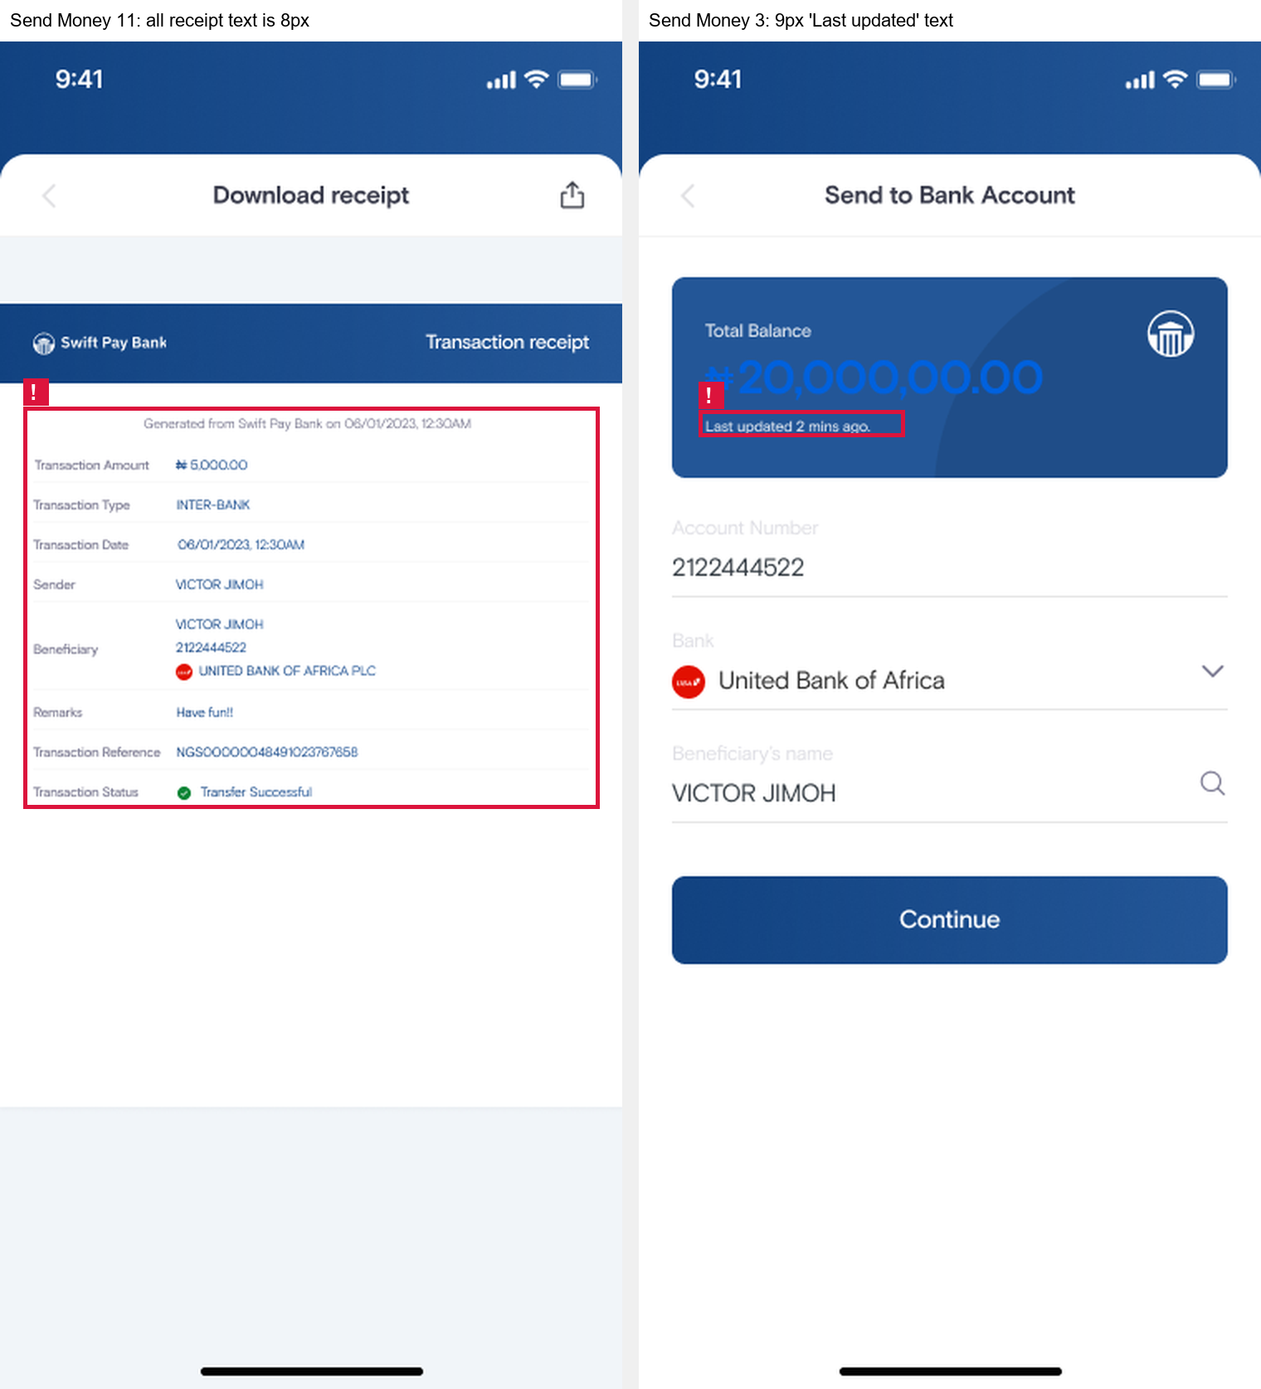

Issue 10 – Icon-only buttons and images have no accessible names, and one icon's meaning is unclear.
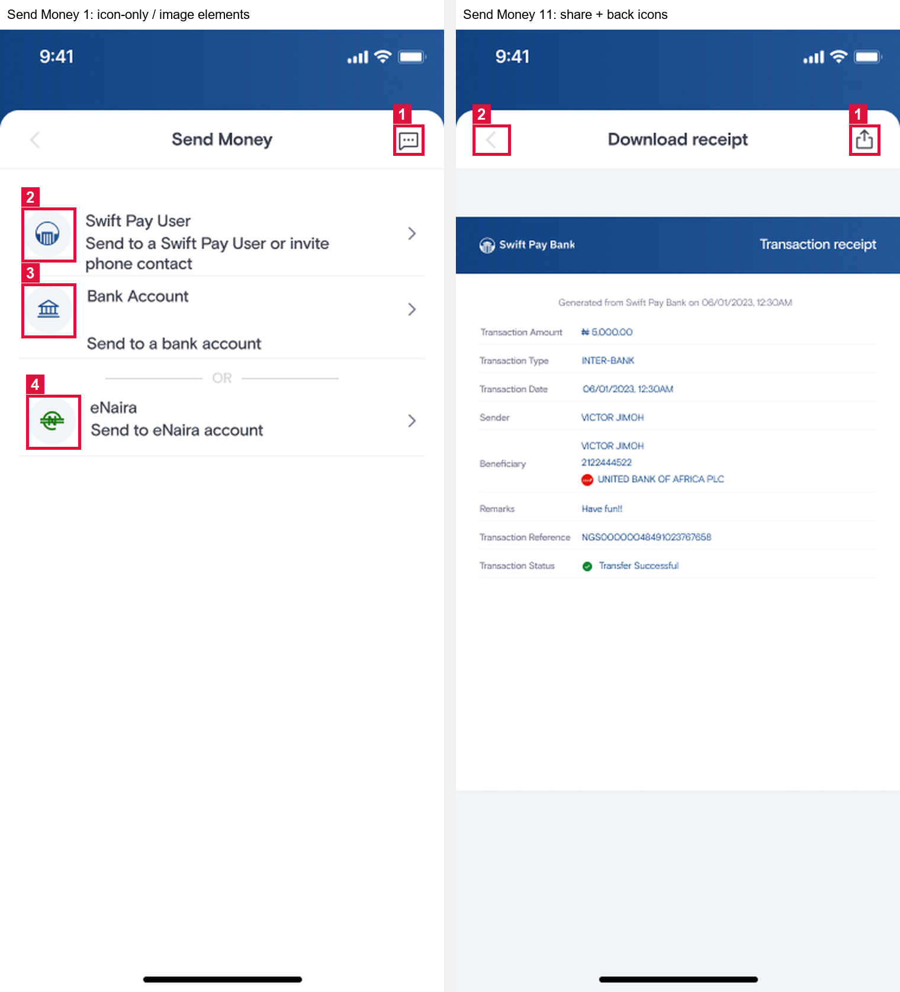

Issue 11 – The balance is formatted incorrectly: "₦20,000,00.00".
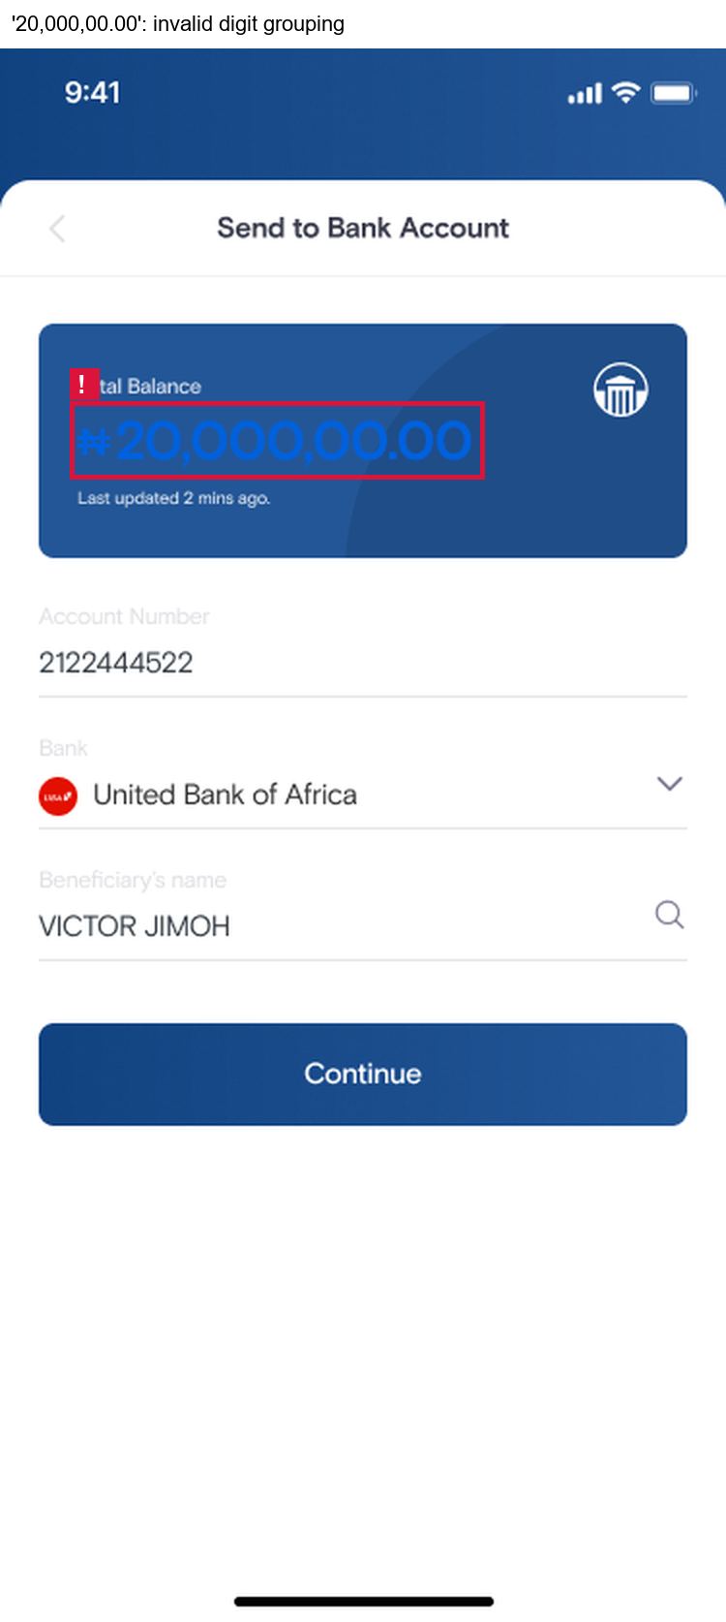

Issue 12 – The eNaira flow shows conflicting payee and transaction details.


