- Open Windows PowerShell > Run as Administrator and run below command
Install-Module -Name MicrosoftPowerBIMgmt
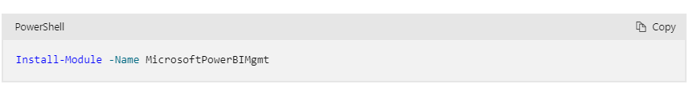
- On first prompt > ans as Y and on second prompt ans as A
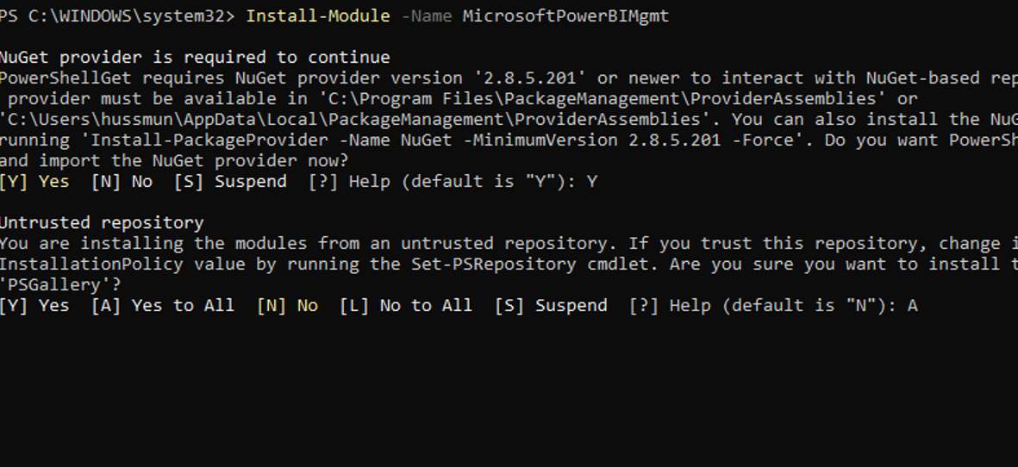

- Check the Execution Policy by running below cmd in Powershell
Note:- Before running below command, please make sure to change the directory by giving the folder path where the ps scripts are located
Get-ExecutionPolicy -List
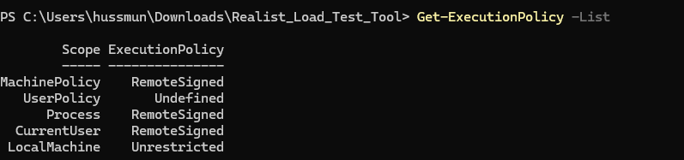

4.Run the below command to change the directory
cd C:\Users\subrnan\Downloads\Realist_Load_Test_Tool\Realist_Load_Test_Tool

Note: Replace user id ‘subrnan’ with your user id in above command before run

5.Try executing the sample file as per example below
Note: Replace user id ‘subrnan’ with your user id in above command before run

C:\Users\subrnan\Downloads\Realist_Load_Test_Tool\Realist_Load_Test_Tool\Setup_Load_Test.ps1
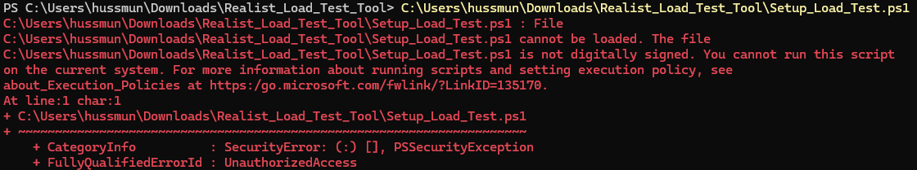

If you get above error, follow below steps

6. Open PowerShell as an admin and run the command:
1  2  3  4  5  6  7  8  9  10  11  12  13  14 | #Parameters  $CertificateName = "PowerShell Code Signing"  #Create a Self-Signed SSL certificate  $Certificate = New-SelfSignedCertificate -CertStoreLocation Cert:\CurrentUser\My -Subject "CN=$CertificateName" -KeySpec Signature -Type CodeSigningCert  #Export the Certificate to "Documents" Folder in your computer  $CertificatePath = [Environment]::GetFolderPath("MyDocuments")+"\$CertificateName.cer"  Export-Certificate -Cert $Certificate -FilePath $CertificatePath  #Add Certificate to the "Trusted Root Store"  Get-Item $CertificatePath | Import-Certificate -CertStoreLocation "Cert:\LocalMachine\Root"  Write-host "Certificate Thumbprint:" $Certificate.Thumbprint

You will get a certificate. Make a note of the certificate Thumbprint
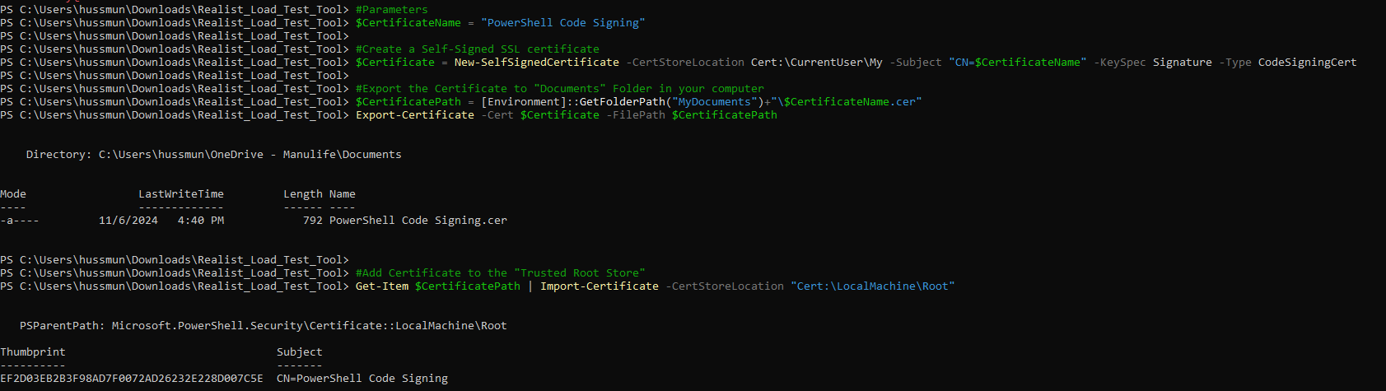
7. Update the CertificateThumbprint & ScriptPath and run below command.
1  2  3  4  5  6  7  8  9 | #Set Parameters  $CertificateThumbprint = "D00AC4CE2C766783510D67B5DAD3971891AC9239"  $ScriptPath = "C:\Temp\Backup.ps1"  #Get the Certificate from Cert Store  $CodeSignCert = Get-ChildItem -Path Cert:\CurrentUser\My | Where-Object {$_.Thumbprint -eq $CertificateThumbprint}  #Sign the PS1 file  Set-AuthenticodeSignature -FilePath $ScriptPath -Certificate $CodeSignCert

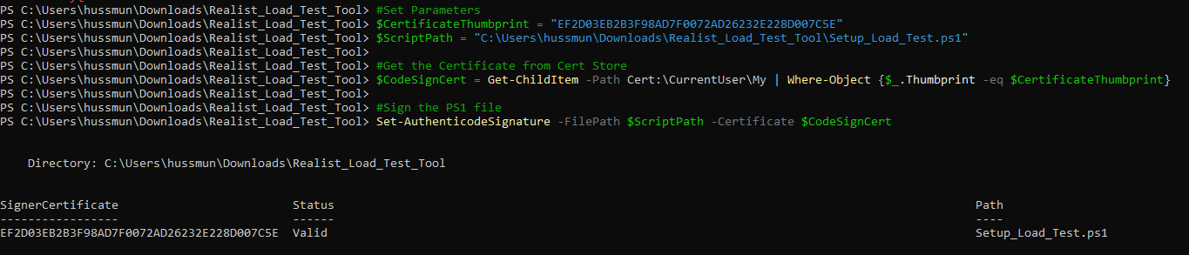

8. Once your certificate status shows valid, run the script by running below command and select appropriate report and page which needs to be tested
C:\Users\hussmun\Downloads\Realist_Load_Test_Tool\Setup_Load_Test.ps1

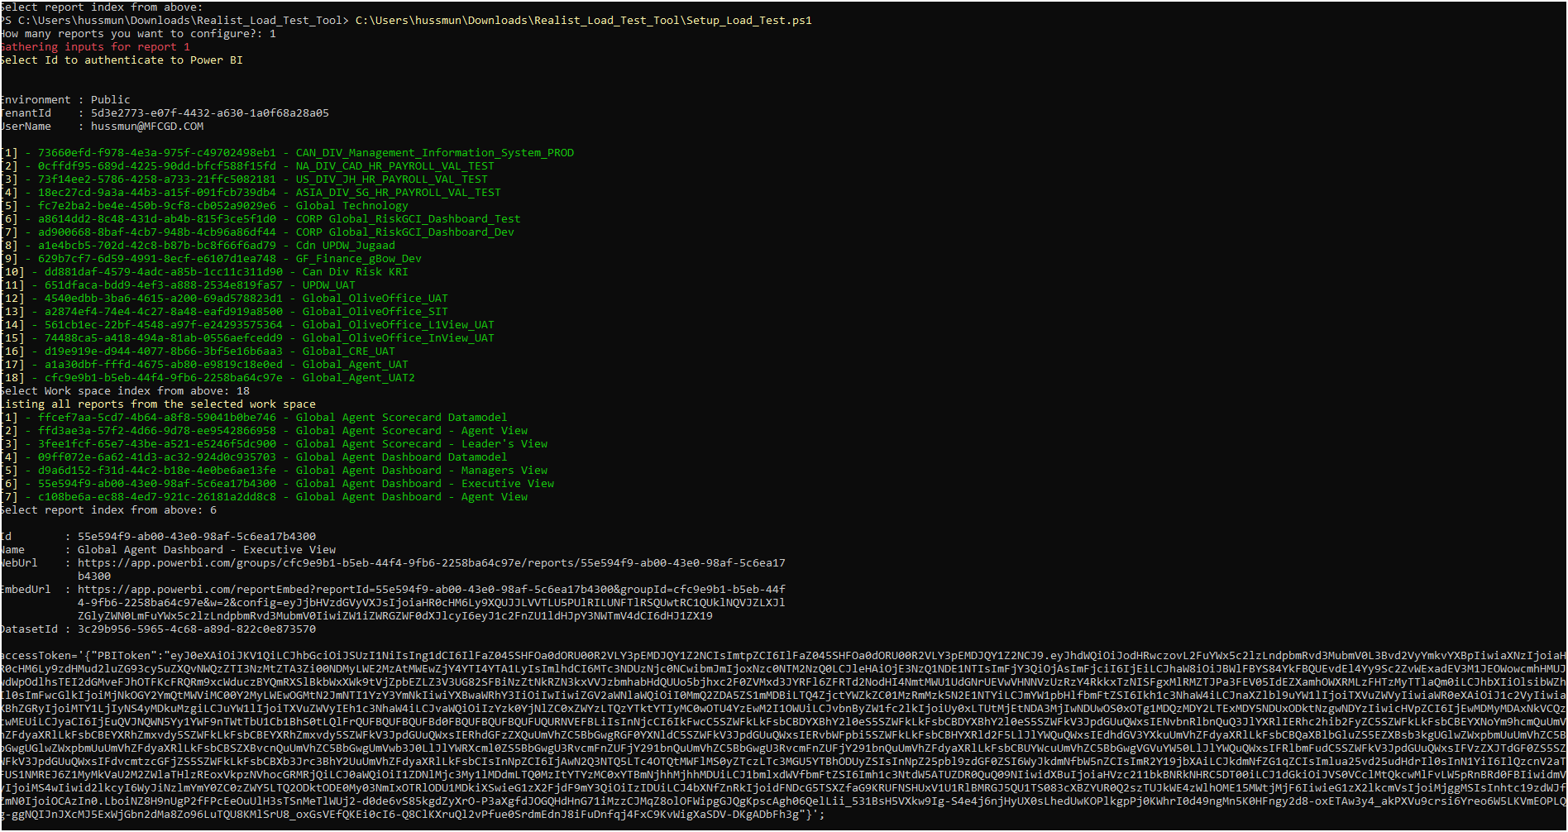

Folder will be created in your local drive for today’s date and time
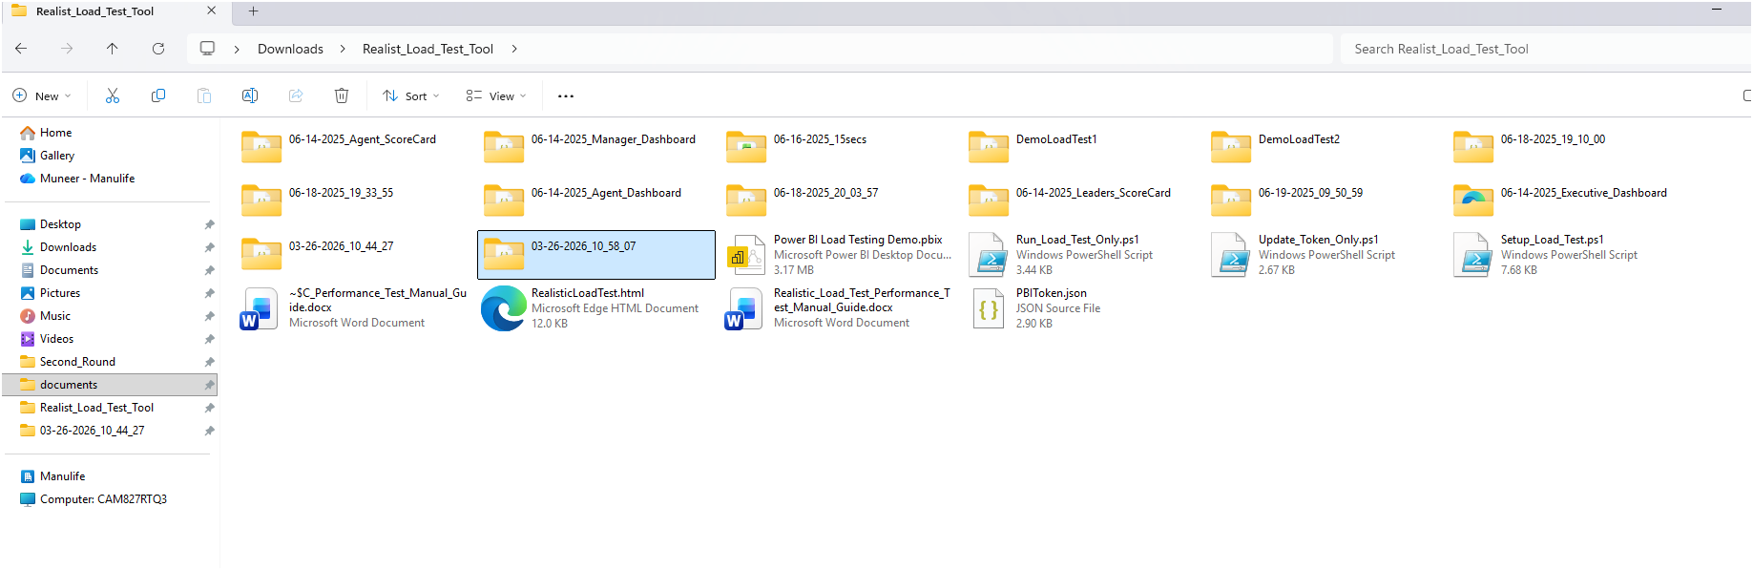
Open the folder and place the html & json script which you need to run
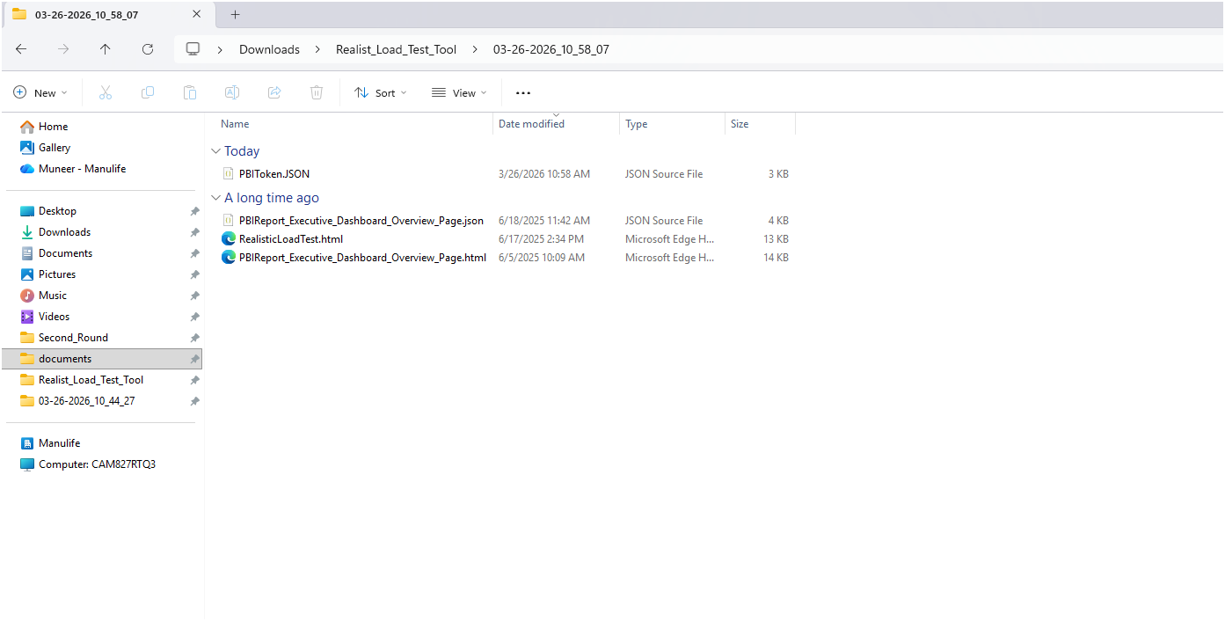

Once all required files are placed in the folder, double click on the html file. Post that, perf script will start
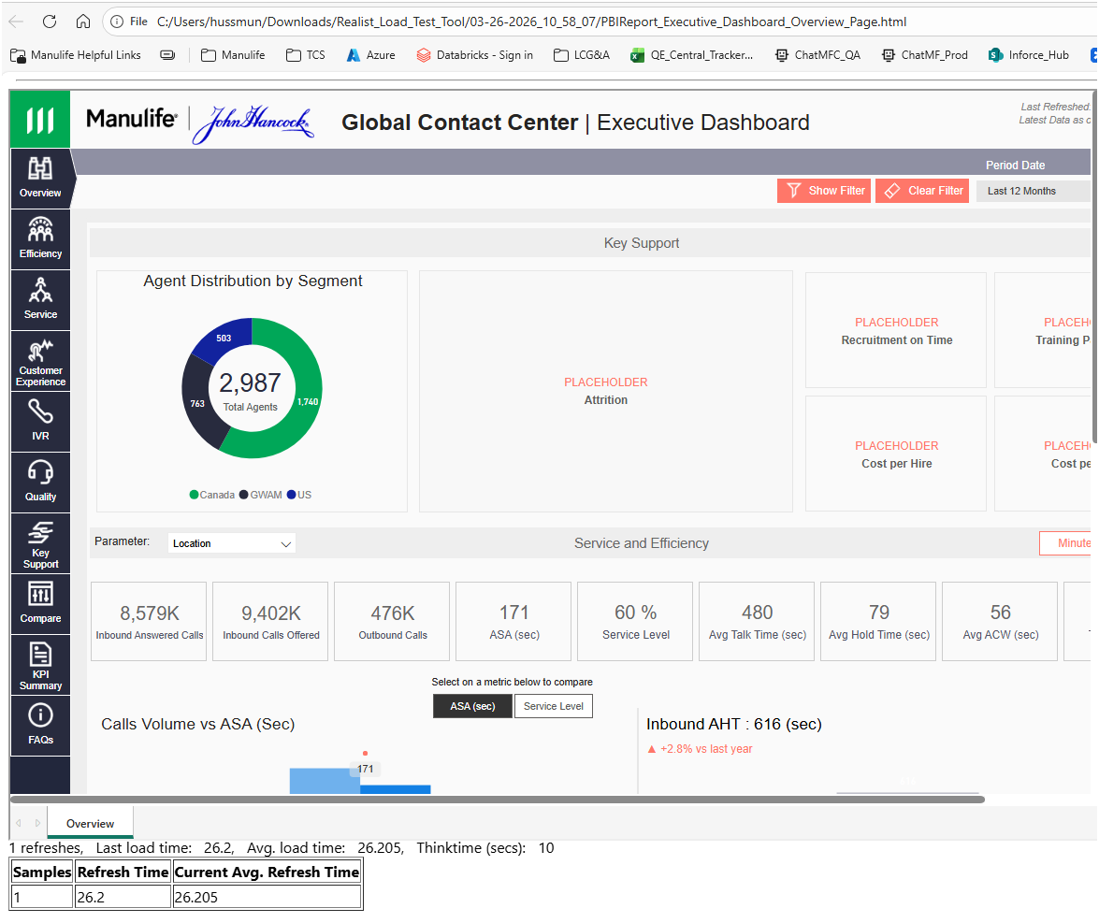

Note:- If your token expires, kindly run “Update_Token_Only.ps1” OR start from step 8

