Study Buddy
An AI study assistant backend built with Node.js, MongoDB and Google Gemini
Project documentation | Developed by Joseph

Description
Study Buddy is a backend project I built to help students study with the help of AI. A student creates an account, logs in, saves their study notes in the app, and asks the AI to turn those notes into a short summary. The AI part uses the Google Gemini API, so every summary is written from the notes the student uploaded, not from a fixed template.
The server is written in Node.js with Express. Data is stored in MongoDB through Mongoose. Login works with JWT (JSON Web Tokens), passwords are hashed with crypt before they are saved, and there are two roles, student and admin, so some routes can be kept for admins only. I tested every API with Thunder Client inside VS Code.

Scenario Based Case Study

Background
Priya is a second-year engineering student. Before every exam her material is spread all over the place: class notes, PDFs, a few web articles and some photos of the whiteboard. She has only a few days left, a lot to read, and no clear idea of which parts matter most.

Problem
- There is too much to read in the time she has.
- Writing summaries by hand takes hours that she could spend revising.
- Her notes are in many different places, with no single spot to keep them.
- Study notes are personal, so the app needs a login. Otherwise anyone could open them.

Solution
Study Buddy gives Priya one place to keep her notes and get AI summaries from them. She logs in, saves a study material, and the backend sends the text to Gemini and returns a short summary. Behind the scenes the backend:
- checks the JWT token on every protected request,
- saves users and study materials in MongoDB,
- sends the material text to Gemini through a small helper file (gemini.js),
- and sends the generated summary back to the client as JSON.

Usage
Student: registers, logs in, saves study materials and asks for a summary of any of them.
Admin: has extra access through the admin routes, which are protected by a role check. Normal students cannot use them.

Outcome
With Study Buddy, Priya spends less time making notes and more time actually learning them. The code is split into routes, controllers, models and helpers, so it is easy to add new AI features later without touching the parts that already work.

System Requirements

Software
Software | Details
Operating System | Windows 10/11 (I used Windows 11). macOS and Linux also work.
Node.js and npm | Node.js v24.21.0 and npm 11.19.0 were used for this project.
MongoDB Atlas | Free tier cluster, used as the cloud database.
Visual Studio Code | Code editor, with the Thunder Client extension for API testing.
Gemini API key | Created from Google AI Studio and stored in the .env file.

Hardware
Component | Minimum
Processor | Intel Core i5 (8th gen) / AMD Ryzen 5 or similar
RAM | 8 GB
Storage | 1 GB free space

Epic 1: Project Architecture
A request from the client first reaches the Express server. Protected routes go through the authentication middleware, which checks the JWT. After that a controller does the real work: it reads or writes data in MongoDB and, when a summary is needed, calls the Gemini API.
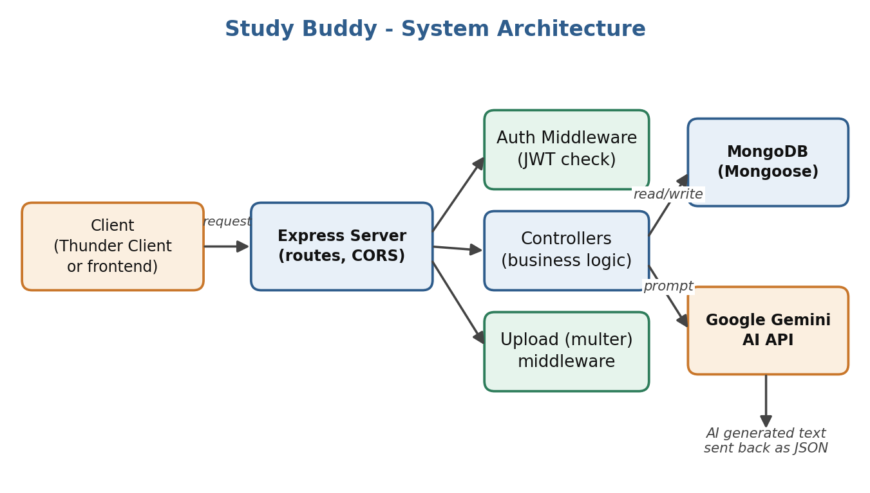
Figure 1: Overall architecture of Study Buddy

Main Components
- Client: Thunder Client during testing, or any frontend that can call REST APIs.
- Express server: receives requests, applies middleware and sends them to the right route.
- Auth middleware: reads the Bearer token, verifies it, and blocks the request if the token is missing or expired.
- Controllers: contain the logic for register, login, materials and summaries.
- Gemini helper: a small file that sends a prompt to Gemini and returns the text.
- MongoDB with Mongoose: stores users and study materials.

ER Diagram
The database has two collections. One user can save many study materials, and each material belongs to one user.
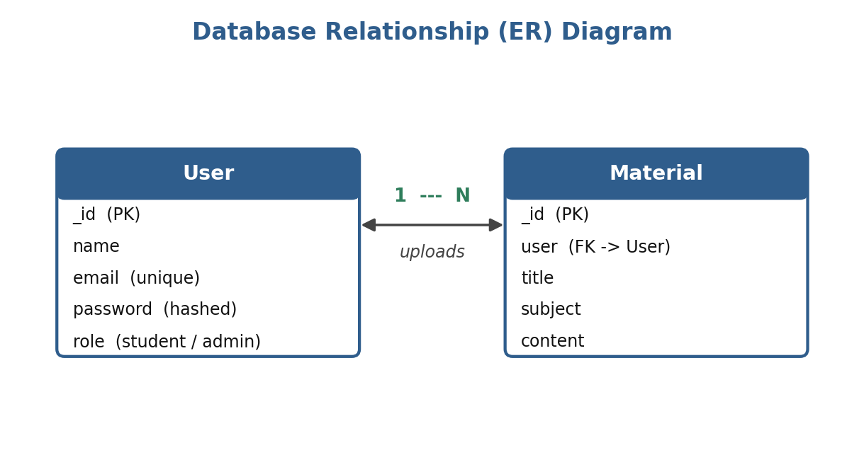
Figure 2: Relationship between User and Material

Key Features
- Register and login with email and password.
- Passwords are hashed with bcrypt, so the real password is never stored.
- JWT based protection for private routes.
- Role based access (student and admin).
- Saving study materials with a title, subject and content.
- AI summary of a saved material using Google Gemini.

User Flow
The user registers or logs in and gets an access token. That token has to be sent in the Authorization header for every protected request. If it is missing or has expired, the server answers with 401 Unauthorized.
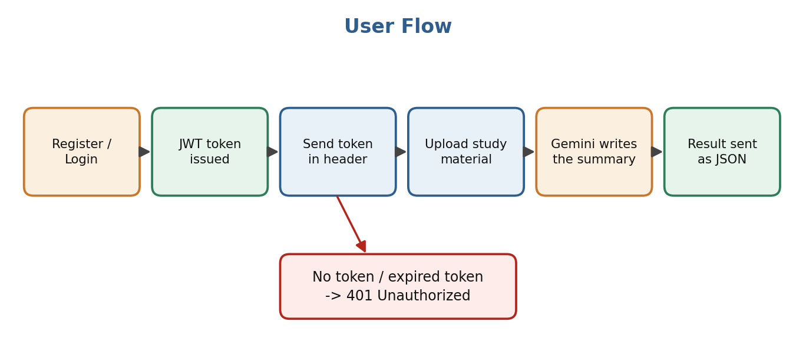
Figure 3: Flow of a typical request

MVC Pattern
I followed the MVC idea to keep the code tidy. Models define the data, controllers hold the logic, and since this is only a backend, the "view" is just the JSON that the API sends back.
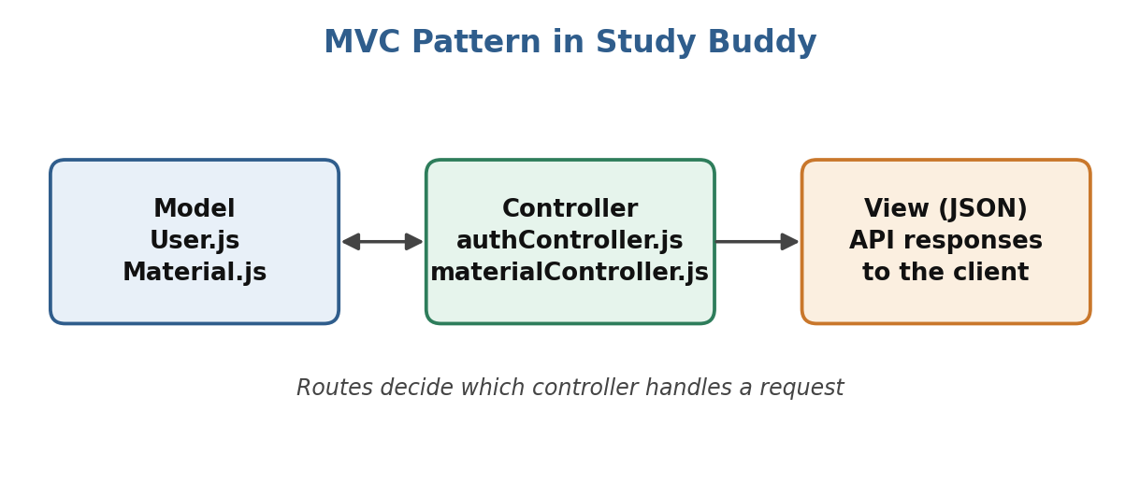
Figure 4: MVC structure used in the project

Epic 2: Project Setup

Creating the Project
- Create a folder named Study Buddy and open it in VS Code.
- Open the terminal and initialise the project.
- Install the packages the project needs.
npm init -y

npm install express mongoose bcryptjs jsonwebtoken cors dotenv multer @google/genai

npm install --save-dev nodemon

Folder Structure
Inside the project I made a src folder and split the code by job: controllers, middleware, models, routes and utils.
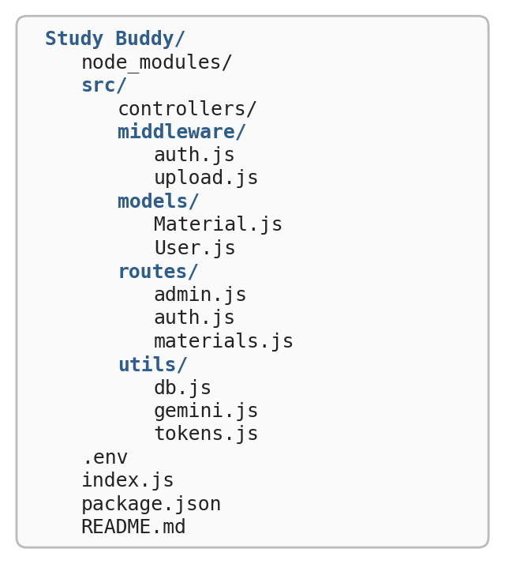
Figure 5: Project folder structure

Environment File
The secret values are kept in a .env file in the project root, so they never sit inside the code. The real values are not shown here.
PORT=5000
MONGO_URI=your_mongodb_connection_string
JWT_SECRET=your_jwt_secret
GEMINI_API_KEY=your_gemini_api_key

Epic 3: Backend Development
Each file has one clear job. This table shows what every important file does.
File | What it does
index.js | Entry point. Loads the .env file, connects to the database, registers the routes and starts the server on port 5000.
src/utils/db.js | Connects the app to MongoDB using Mongoose.
src/utils/tokens.js | Creates the JWT access token after a successful login.
src/utils/gemini.js | Sends the prompt to the Gemini API and returns the generated text.
src/middleware/auth.js | Checks the Bearer token and stops requests that are not allowed.
src/middleware/upload.js | Handles file uploads with multer.
src/models/User.js | Schema for users, with password hashing.
src/models/Material.js | Schema for study materials.
src/routes/ | auth.js, materials.js and admin.js. They map URLs to controller functions.
src/controllers/ | authController.js and materialController.js. The main logic lives here.

Password Hashing in User.js
The User model hashes the password in a pre-save hook, just before the user is stored. It also has a comparePassword method that uses bcrypt to check the password typed at login against the hashed one in the database.
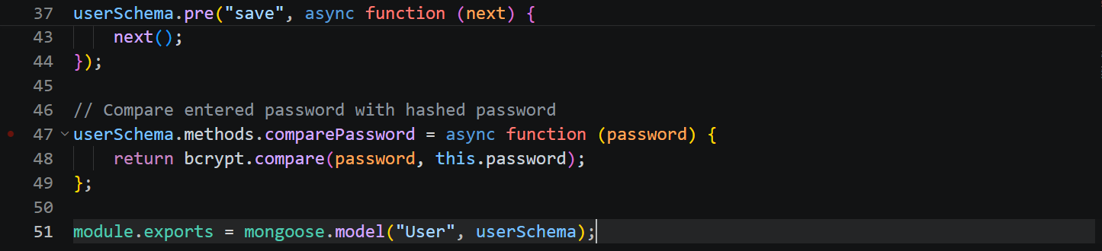
Figure 6: User.js with the comparePassword method

Epic 4: Database Configuration
I used a free MongoDB Atlas cluster. The connection string goes into the .env file as MONGO_URI, and db.js uses Mongoose to connect when the server starts. One small tip: free clusters can get paused after a period of inactivity, so if the server cannot connect, check Atlas and resume the cluster first.

User collection
Field | Type | Notes
name | String | Required
email | String | Required, unique
password | String | Stored as a bcrypt hash
role | String | student or admin (default is student)

Material collection
Field | Type | Notes
title | String | Name of the material
subject | String | Subject or topic
content | String | The study text that is sent to Gemini
user | ObjectId | Reference to the User who saved it

Epic 5: Project Execution

Starting the Server
Before running, make sure the .env file is filled in and the Atlas cluster is running. Then start the server from the project folder:
node index.js

If everything is fine, the terminal shows that MongoDB is connected and the server is listening on port 5000.
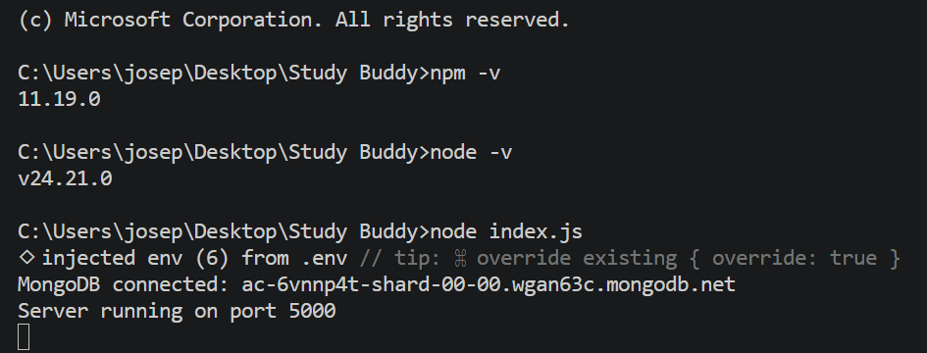
Figure 7: Server started and connected to MongoDB

API Endpoints
Method | Endpoint | Access | Purpose
POST | /api/auth/register | Public | Create a new account
POST | /api/auth/login | Public | Log in and receive an access token
GET | /api/protected | Token | Check that the token works
POST | /api/materials | Token | Save a study material
POST | /api/materials/:id/summarize | Token | Get an AI summary of a material

1. Register
A new user sends name, email and password. The password is hashed and the user is saved in MongoDB.

2. Login
The user sends email and password. If they match, the server replies with a success message, an access token and the basic user details.
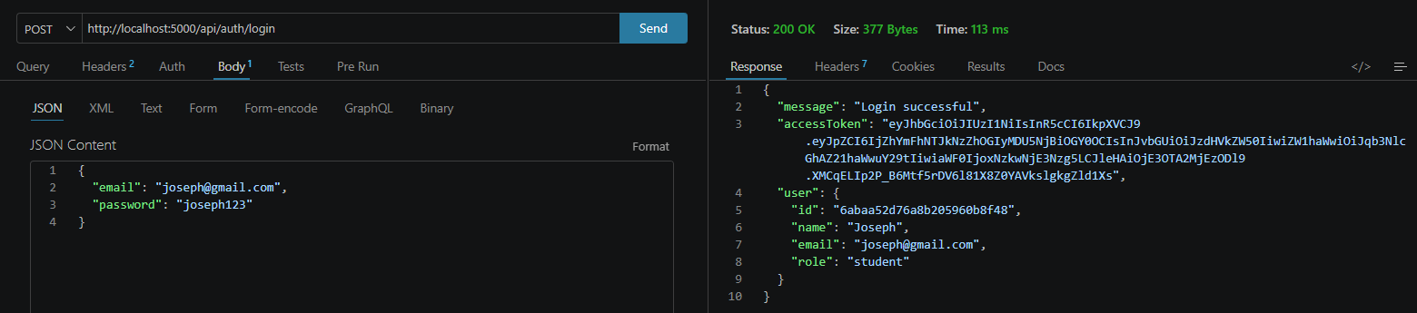
Figure 8: Login request and response

3. Protected Route
The access token is sent in the Authorization header as "Bearer <token>". When the token is valid, the server returns the user details that were stored inside the token, together with the issue and expiry times. In my setup the token lasts one hour.
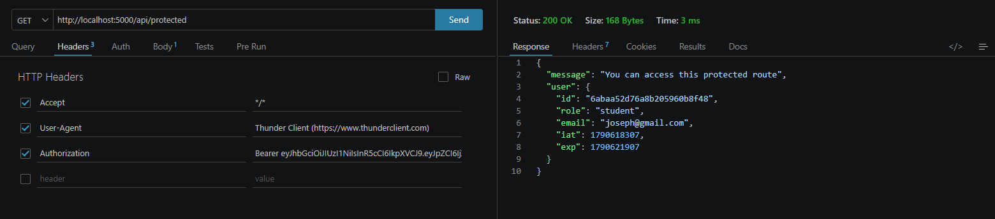
Figure 9: Protected route accessed with a valid token

4. Save a Study Material
A logged in user sends a title, subject and content. The material is saved and linked to that user.

5. AI Summary
The user calls the summarize endpoint with the id of a saved material. The backend reads the content, asks Gemini for a summary and returns it.

Problems I Faced
Problem | Cause and fix
Protected route did not accept my token | In Thunder Client I had typed the whole "Authorization: Bearer ..." text into the header name box. The name (Authorization) and the value (Bearer token) must go in separate boxes.
401 Invalid or expired token | The access token only lasts one hour. After that I had to log in again and use the new token.
Summary request failed with a 404 from Gemini | The Gemini model name I first used was no longer available for new users. I changed the model name in gemini.js to a current one and restarted the server.

Conclusion
Study Buddy covers the basic backend needed for an AI study tool: secure login, protected routes, stored study materials and AI generated summaries. Because the code is split into small modules, more features can be added easily. Some ideas for the future are flashcards, quizzes and study plans built from the same saved materials, plus a proper frontend.
- Drive Link:
- GitHub Link:
This Project is Developed by the Team:
- Joseph Vasanthan [ Team Leader]
- Ari Murugan
- Sanjay
- Vivek
- Yokesh

