Task 3: Implement SARSA
Where Q-learning and SARSA differ? The two algorithms differ most near the hazard. They differ in (1, 2), (4, 1), (4, 2), and (3, 3).
Does the difference align with the discussion about behavior near hazards? It does not. By the solution, SARSA in (4, 2) should go south and then west to avoid the hazard, which would align with the discussion. Q-learning is a bit closer to the solution, but there are issues there, too.

Task 4: Plot Learning Curves
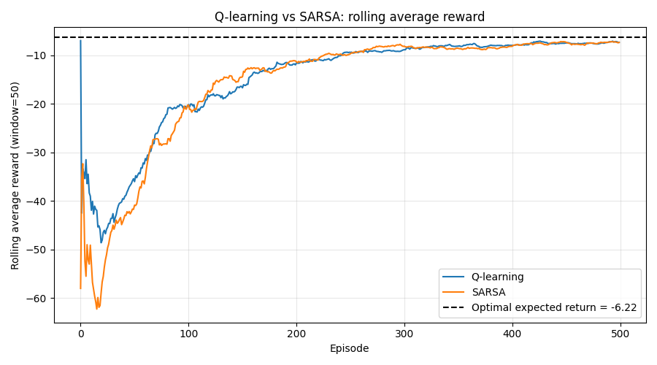
Fig 1. Learning Curves

Task 5: Compare to Value Iteration
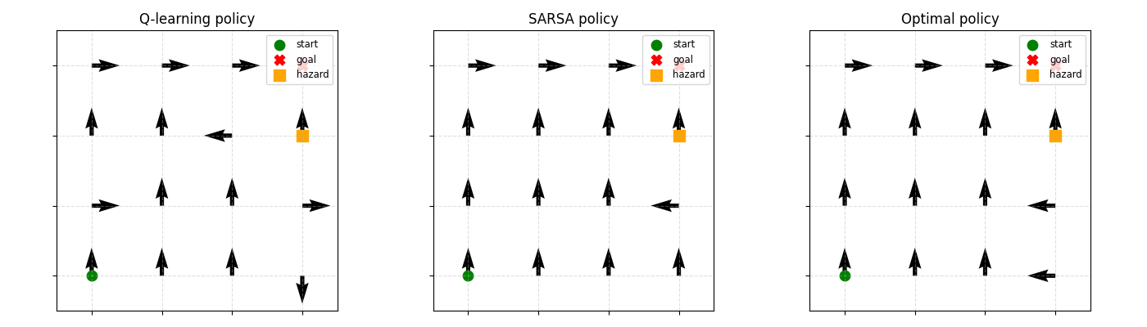
Fig 2. Comparison with Optimal Policy

Table 1. Comparison With Optimal Policy
State | Q | SARSA | Optimal | Q match | SARSA match
(0 0) | 1 | 1 | 1 | True | True
(0 1) | 1 | 1 | 1 | True | True
(0 2) | 1 | 1 | 1 | True | True
(1 0) | 0 | 0 | 0 | True | True
(1 1) | 0 | 0 | 0 | True | True
(1 2) | 3 | 0 | 0 | False | True
(1 3) | 0 | 0 | 0 | True | True
(2 0) | 1 | 0 | 0 | False | True
(2 1) | 0 | 0 | 0 | True | True
(2 2) | 0 | 0 | 0 | True | True
(2 3) | 1 | 3 | 3 | False | True
(3 0) | 0 | 0 | 0 | True | True
(3 1) | 0 | 0 | 0 | True | True
(3 2) | 0 | 0 | 0 | True | True
(3 3) | 2 | 0 | 3 | False | False

Task 6: Hyperparameter experiment
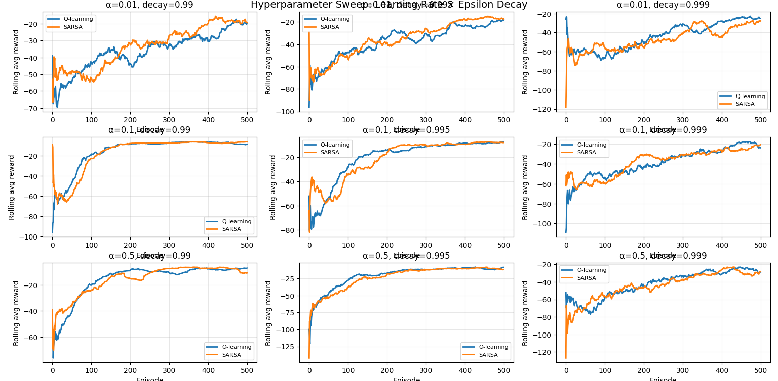
Fig 3. Hyperparameter Comparison
Which combination converges fastest? It looks like α = 0.5 and ρ = 0.995 converges the quickest.
Which fails to converge? Those with high decay rates have a hard time converging. It also looks like a small learning rate and a small decay rate fail to converge, too.

