Task 3: Neural Network Cross Validation
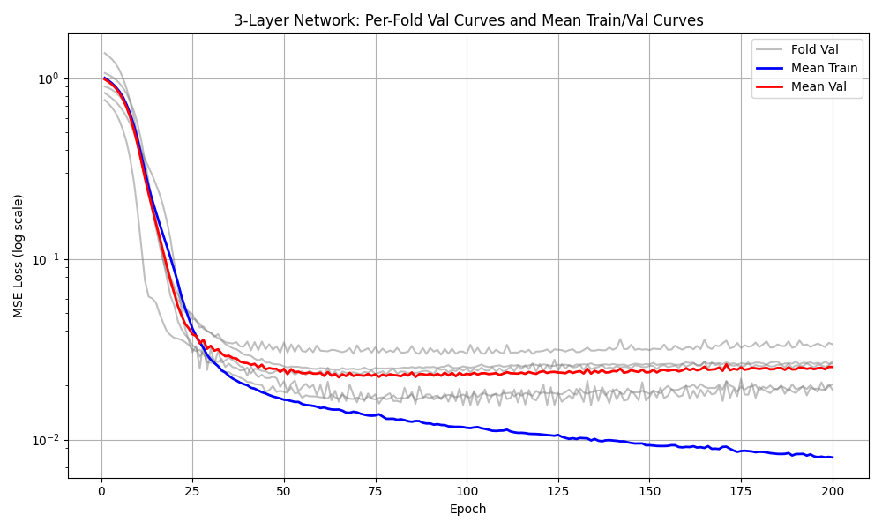
Fig 1. 5-Fold CV Training Scores. RMSE: 2.6956 ± 0.2422 seconds
Does the validation loss plateau or begin to increase? The validation curve plateaus and even seems to increase. The training curve keeps decreasing meaning that the model is overfitting.

Task 4 and 5: Compare RMSE for Neural Net and Linear Model
Final Test RMSE: 2.3824
Linear Regression Test RMSE: 4.0933
How much does the neural network improve? The neural network only has 58.2% of the error of the linear model.

Task 6: Compare Predictions for Neural Network and Linear Model
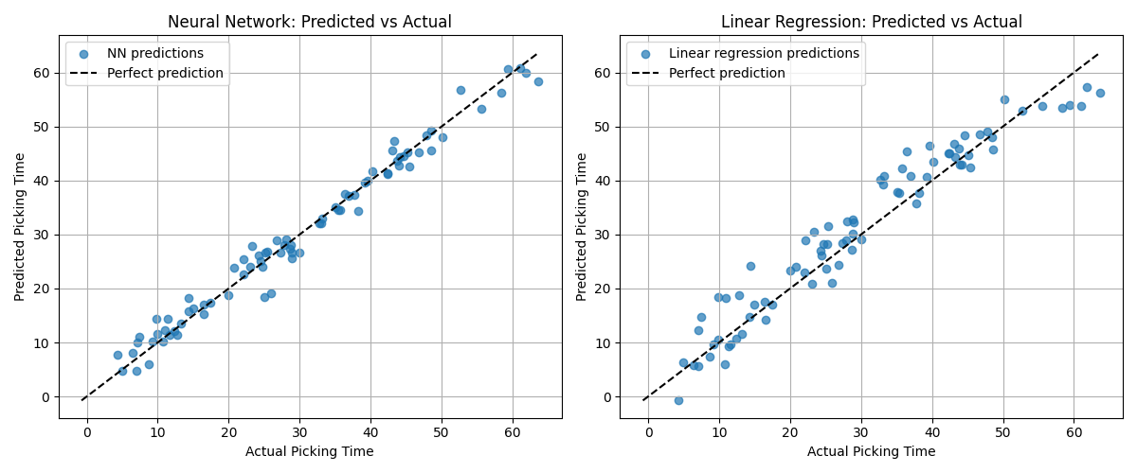
Fig 2. Predicted v. Actual Scatter plots
Where does the linear model fail? The linear model seems to predict a lot higher than the actual. The neural network is more accurate. Without the nonlinear activation, the linear model doesn’t do as well.
FROM SOLUTION: The linear model “under-predicts for high-congestion/far-distance examples (where the interaction term dominates) and misses the battery-threshold step entirely.”

Task 7: Depth Experiment
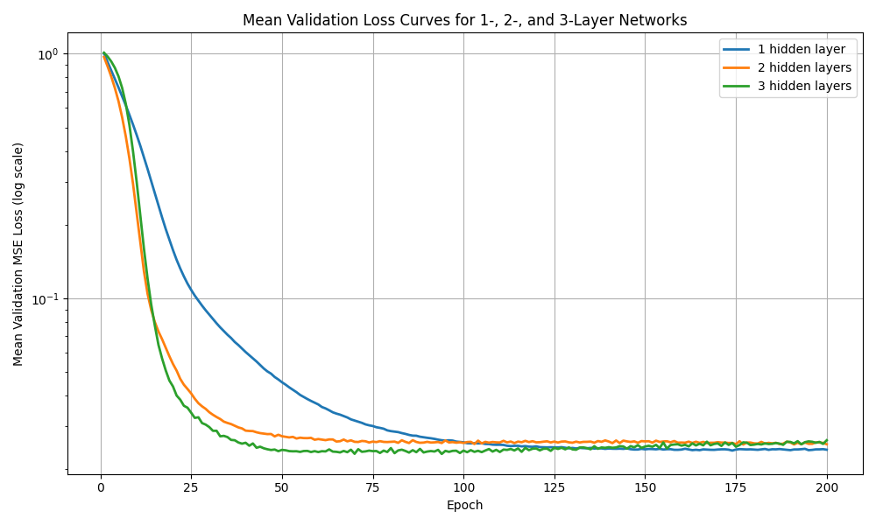
Fig 3. Depth Experiment Validation Curves
Does depth help for this dataset? Depth helps the model converge faster, but all three depths were close the same within 100 epochs. It’s worth noting that the model with only one hidden layer reached a slightly lower mean validation MSE at the end.

