AFYALINK PROPOSAL
(Chapter One and Chapter Two)
Prepared by: JOSEPH OGWE WERE
Title: Founder & CEO
Phone: 0712462780
Email: werejosephogwe@gmail.com
Company: AfyaLink by Goldege
Company email: goldegelabs@gmail.com
Address: Nairobi, Kenya

CHAPTER ONE: PROJECT PLANNING AND ANALYSIS (WORKPLAN)

Statement of Problem
Healthcare facilities in Kenya still rely on fragmented systems and manual processes to run clinical workflows, manage staff, process approvals, track diagnostics, and handle billing. This fragmentation creates slow patient flow, poor visibility into departmental performance, weak inter-hospital continuity, and inconsistent reporting. Data is often duplicated across multiple systems, making it difficult to maintain auditability, enforce consent, or support cross-facility transfers. The result is higher operational cost, delayed care decisions, and preventable revenue leakage.

Study Justification
AfyaLink addresses these gaps by unifying hospital operations, workforce management, and patient continuity into a single role-based system. It provides dashboards for clinical, administrative, and support teams; enforces consent and audit trails; and introduces readiness, observability, and resilience practices from the deployment layer. The platform also prepares for interoperability (FHIR/HL7) and AI-assisted workflows via the NeuroEdge integration plan. This creates a modern operational backbone that improves care delivery, staff accountability, and continuity across facilities.

System Objectives
General Objective
To design and implement a unified hospital operations and workforce platform (AfyaLink) that improves care delivery, operational visibility, and inter-facility continuity.

Specific Objectives
1. Build role-based dashboards for clinical, administrative, and support teams.
2. Implement patient, staff, and hospital identity separation for clean governance.
3. Provide workflows for appointments, consultations, diagnostics, pharmacy, and referrals.
4. Implement HR and payroll workflows including approvals, leave, and training.
5. Enforce security, auditability, and consent-aware access across the platform.
6. Support operational reporting, SLA monitoring, and readiness gates.

Assumptions and Constraints
- Stable internet in facilities, with offline support for field workers.
- Hospitals have basic workstation or tablet availability.
- Data privacy and consent requirements must be enforced per hospital policy.
- Integrations (SHA, eTIMS, M-PESA) require regulatory approvals and partner onboarding.
- Change management and staff training are required for adoption.

Functional Requirements
User Roles and Activities
User | User Activities | Features
Hospital Admin | Manage staffing, approvals, patient flow | Dashboards, approvals, staffing modules
Doctor/Nurse | Consult, order labs, document care | Clinical workflows, notes, orders
Lab/Pharmacy | Process tests, dispense meds | Lab queue, pharmacy dispensing
HR/Payroll | Recruit, approve leave, run payroll | HR workflows, payroll inputs
Community Health Worker | Field visits and follow-ups | Offline capture, sync queue

Tools and Resources
Category | Items
Hardware | Servers/VMs, workstations, tablets/phones
Backend | Node.js, Express, MongoDB, Redis, Socket.IO
Frontend | React, Vite, React Router, LocalForage
Integrations | FHIR/HL7, SendGrid, Africa's Talking, Twilio
Observability | Prometheus, Grafana, Alerting rules

Project Schedule Breakdown (Illustrative)
Milestone | Weeks
Planning & Analysis (Chapter One) | Week 1-2
Design & Modeling (Chapter Two) | Week 3-4
Development & Testing | Week 5-7
Deployment & Readiness | Week 8
Documentation & Presentation | Week 9

Risk Analysis and Mitigation
Risk | Impact | Mitigation
Integration delays (SHA/eTIMS/M-PESA) | Delayed go-live | Early partner onboarding and sandbox testing
Staff adoption challenges | Low usage | Role-based training + 7-day onboarding
Data privacy breaches | Compliance risk | ABAC, audit logs, step-up auth
Infrastructure downtime | Service interruption | Readiness gates, failover drills

Test Strategy and Acceptance Criteria
Test Area | Strategy | Acceptance Criteria
Authentication & Roles | Unit + integration tests | Roles enforce access, audit logs captured
Clinical Workflows | End-to-end flows | Appointment->consult->lab->pharmacy succeeds
HR/Payroll | Regression tests | Leave approvals and payroll inputs consistent
Transfers/Continuity | Scenario-based tests | Transfer packet complete with consent
Offline Sync | Replay and conflict tests | No data loss after sync

Data Privacy and Legal Compliance (Kenya)
AfyaLink aligns with the Kenya Data Protection Act (DPA) by enforcing consent controls, purpose limitation, data minimization, and auditability. Personal health data is protected through role-based access controls, ABAC policies, and step-up authentication for sensitive actions. Data residency and retention are addressed through configurable policies, and all high-risk workflows (export, transfer) require explicit consent and audit trails. The system supports secure logging, encryption in transit, and controlled third-party integrations.

CHAPTER TWO: DESIGN AND MODELING

Introduction to Modeling
This chapter presents the design and modeling of AfyaLink using a layered architecture, role-driven workflows, and hospital-entity separation. The model reflects the platform's core system components and the operational workflows defined in AfyaLink documentation.

System Architecture (High-Level)
- Presentation Layer: React/Vite frontend with role-based dashboards and routing.
- Application Layer: Node/Express backend with domain modules (appointments, billing, HR, pharmacy, diagnostics, transfers).
- Data Layer: MongoDB with Mongoose models for hospital, user, patient, encounters, orders, and audit logs.
- Integration Layer: HL7/FHIR transformation, AI gateway, SMS/Email, and payment services.
- Observability Layer: Prometheus metrics, Grafana dashboards, alerting rules.

Core Modules
1. Identity and Access: hospital, user, staff/patient separation, ABAC, audit.
2. Clinical Operations: appointments, consultation notes, diagnostics, prescriptions.
3. Pharmacy and Inventory: dispensing, stock status, alerts.
4. HR and Payroll: staffing, leave approvals, payroll inputs, training.
5. Transfers and Continuity: referral packets, consent scope, handover SLAs.
6. Reporting and Dashboards: role KPIs, queue status, SLA panels.
7. Offline Operations: CHW capture, sync queue, conflict resolution.
8. AI Integration: NeuroEdge gateway for extraction, triage, and analytics.

Use Case Overview
- Register patient and create appointment.
- Doctor consultation, lab order, and pharmacy dispense.
- HR onboarding and leave approval workflow.
- Transfer patient with consent-scoped packet and audit trail.
- Community health worker visit and offline sync.

Entity Overview (ERD Summary)
- Hospital: profile, features, plans, departments.
- User: identity with role, hospital linkage, security controls.
- Staff: clinical and admin profiles, schedules, credentials.
- Patient: demographics, encounters, insurance, consent.
- Appointment, Encounter, Order, LabResult, Prescription.
- Billing, Payment, Inventory, Transfer, AuditLog.
- Notification, Consent, Insurance/Claims.

Data Dictionary (Key Entities)
Entity | Key Fields | Notes
Hospital | name, county, plan, features | Tenant boundary
User | name, role, hospitalId | Role-based access
Patient | demographics, insurance, consent | Non-staff identity
Staff | credentials, department, status | Linked to hospital
Appointment | patientId, clinicianId, time | Queue and scheduling
Encounter | patientId, notes, orders | Clinical session
Order | type, status, results | Lab/radiology/pharmacy
Transfer | fromHospital, toHospital, consent | Continuity workflows
AuditLog | actor, action, timestamp | Compliance evidence

Data Flow Description
1. User logs in and is routed to a role-specific dashboard.
2. Actions trigger API calls; backend enforces ABAC/consent rules.
3. Domain services write to MongoDB and emit audit events.
4. Notifications and queues handle async workflows (billing, messaging).
5. Observability stack captures metrics and alerts on SLA breaches.

Interface Design
- Dashboards for Super Admin, Hospital Admin, Doctor, Nurse, Lab, Pharmacy, HR, Payroll, CHW, Patient.
- Priority UI goals: fewer clicks, clear queues, mobile-first readability.

UI Screens (Actual)

Deployment Diagram and Network Topology

Security and Governance Model
- Role-based access with ABAC and consent scopes.
- Audit logs for all critical actions.
- Step-up controls for sensitive export and transfer workflows.
- Separation of hospital identity and user identity for clean governance.

Conclusion
The AfyaLink design integrates clinical care workflows, workforce management, and operational governance into one platform. The design aligns with AfyaLink's documented feature registry, role training playbooks, and deployment readiness practices, positioning AfyaLink as a complete proposal for hospital operations modernization.

Data Flow Diagram (DFD) - Level 0
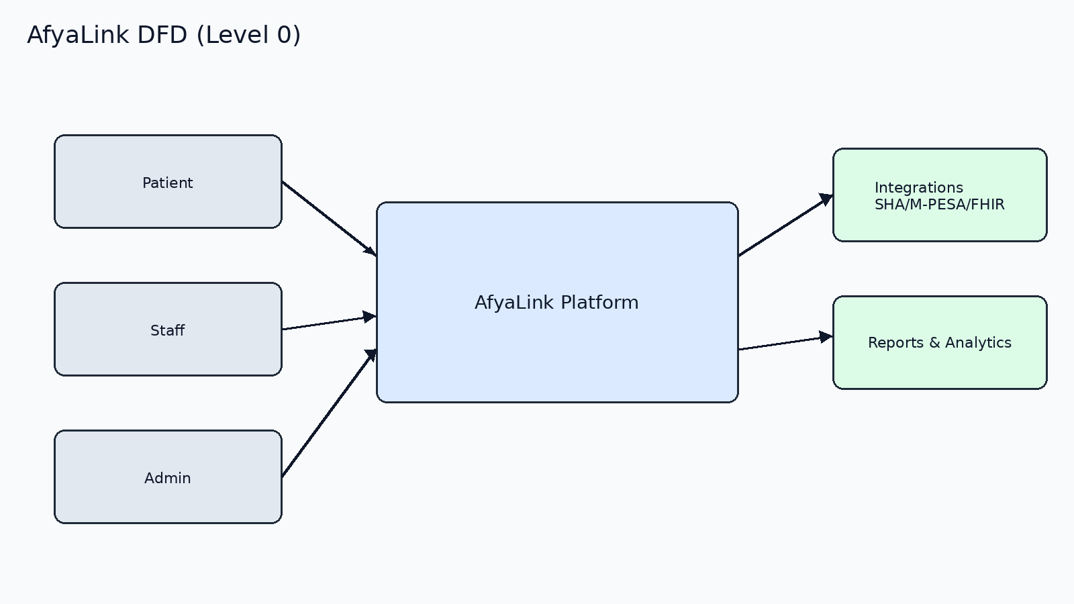

Data Flow Diagram (DFD) - Level 1
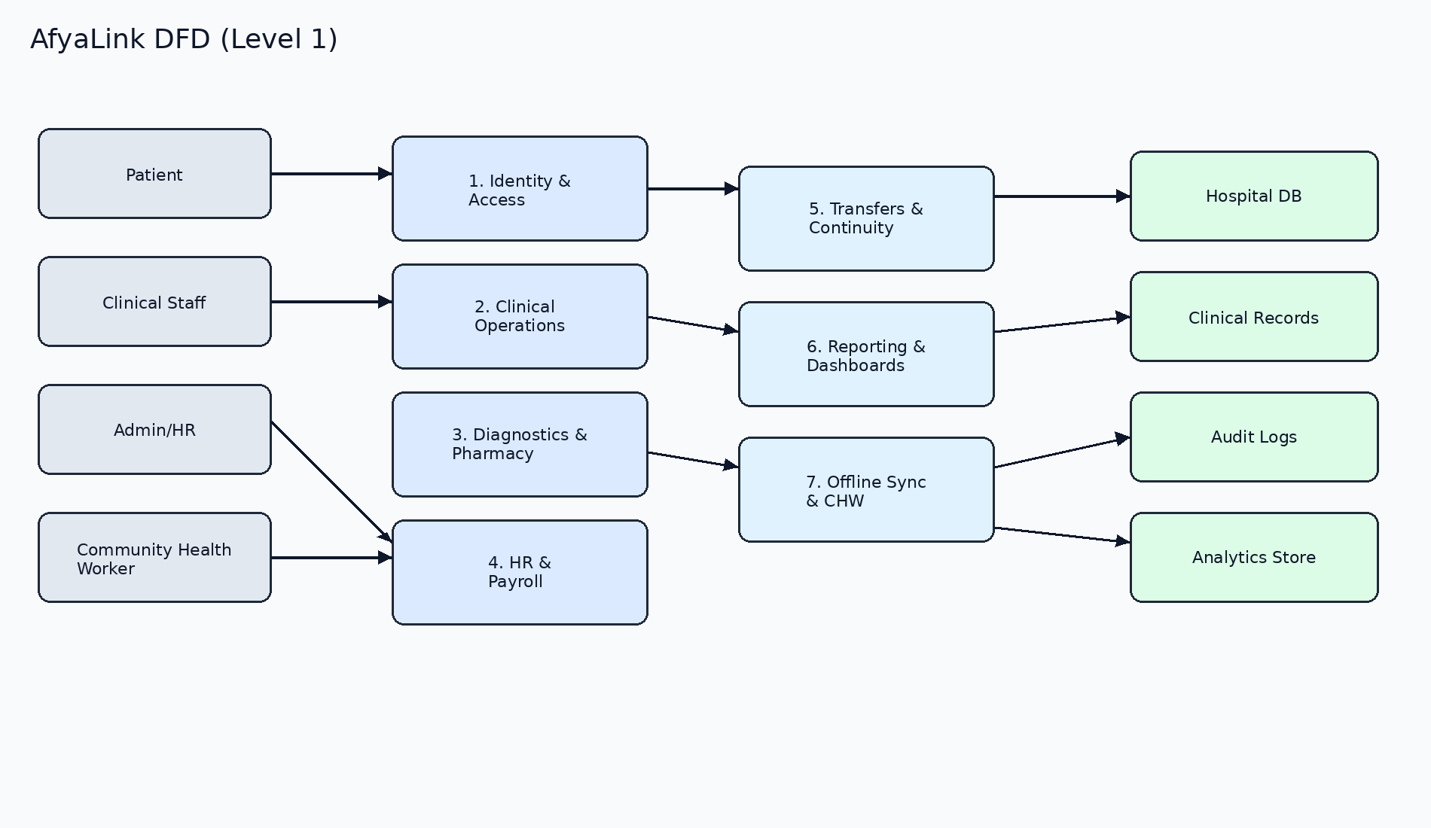

Data Flow Diagram (DFD) - Level 2 (Transfers Module)
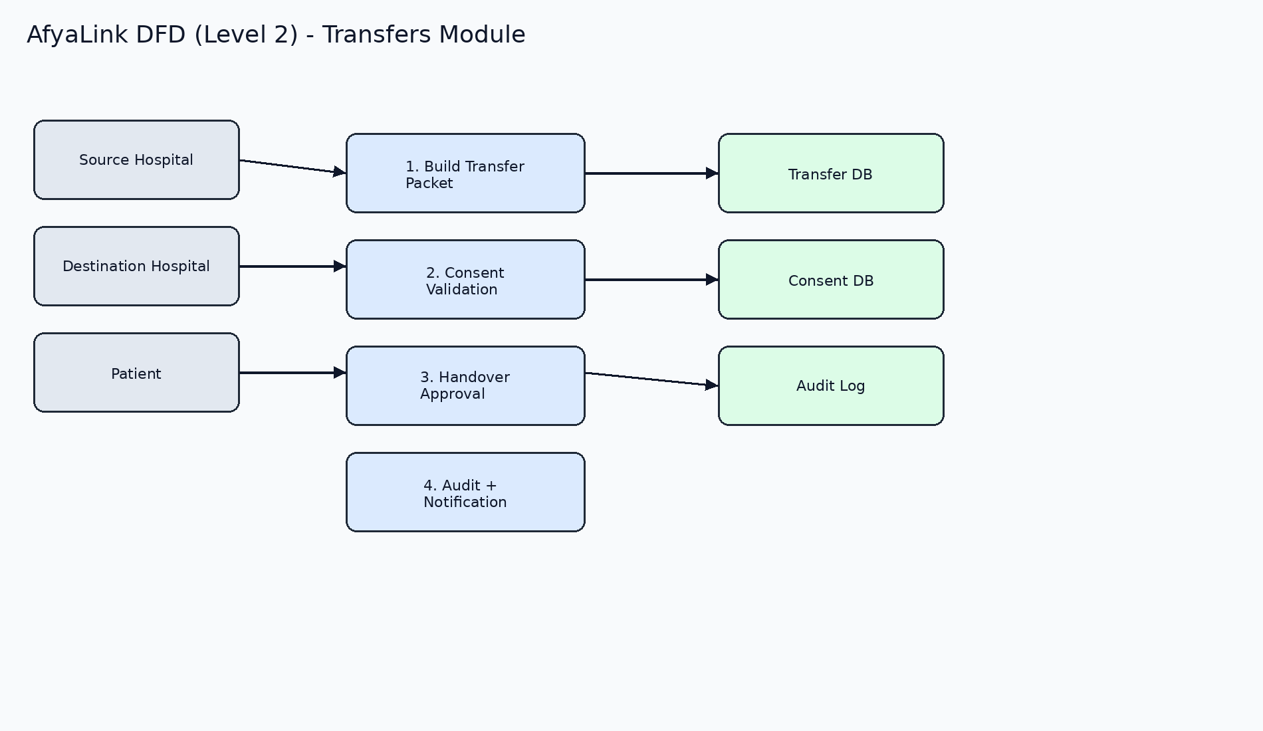

Entity Relationship Diagram (ERD) - Detailed
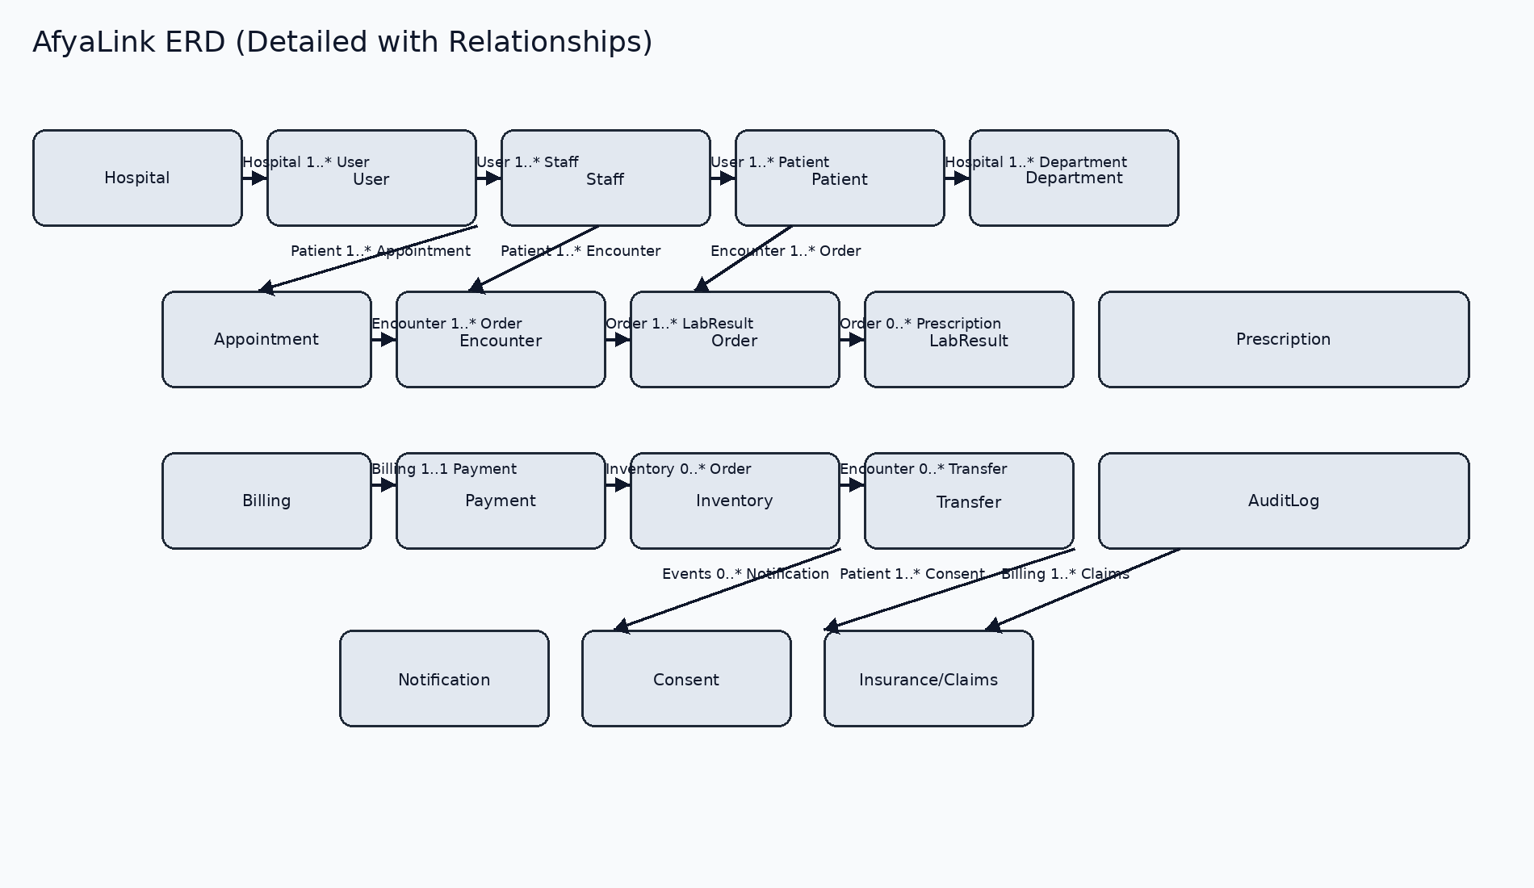

Use Case Diagram
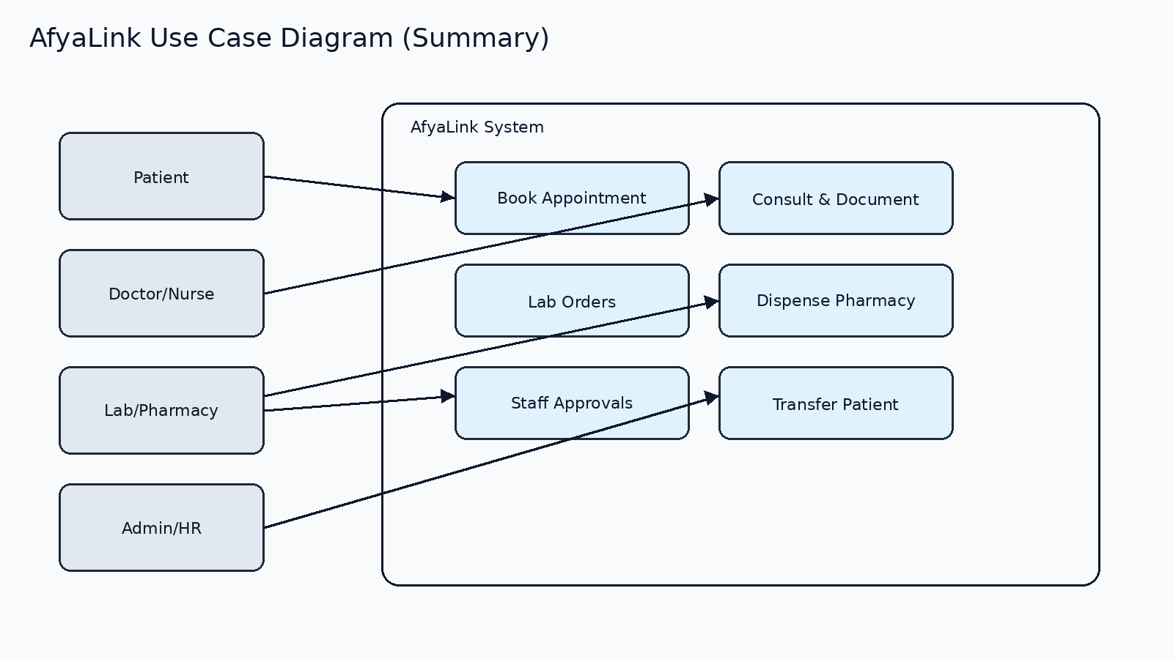

UI Screens (Actual)
Login Screen
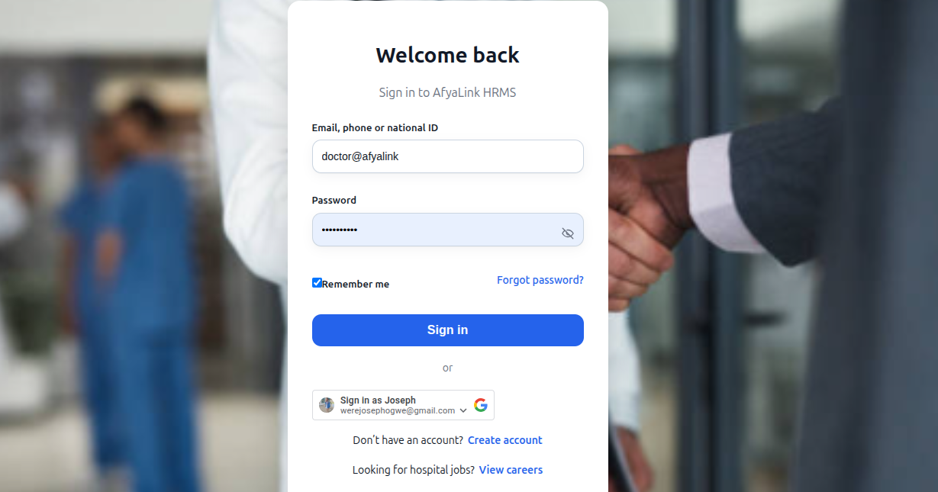
Patient Self-Service Portal
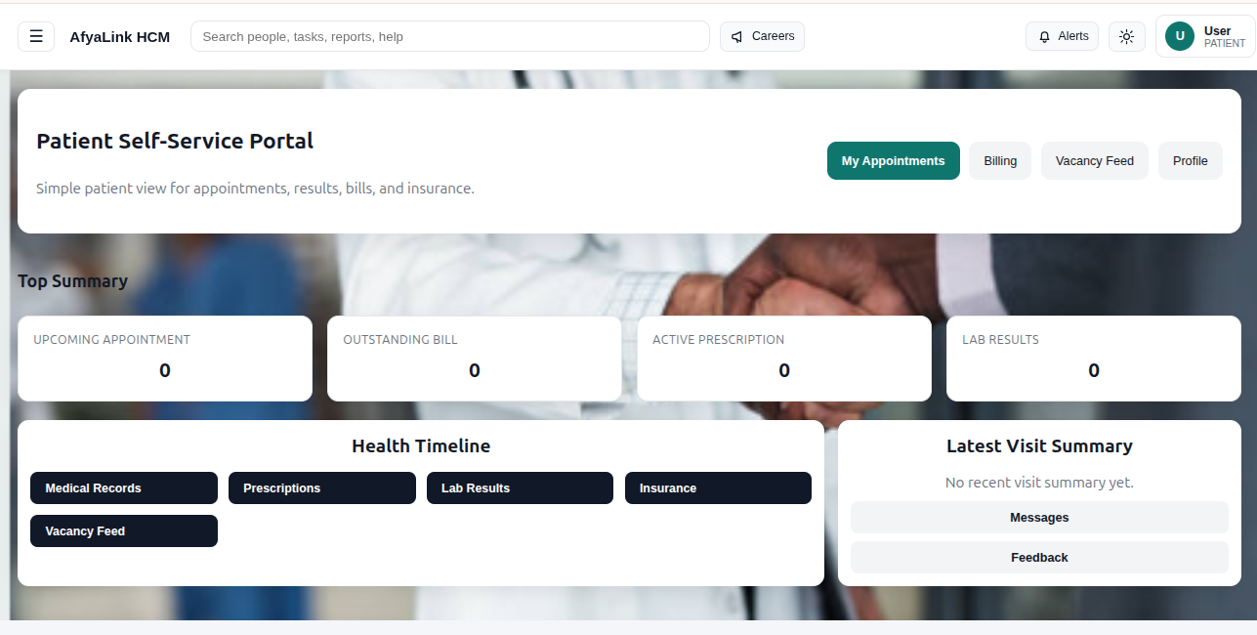
Super Admin Dashboard
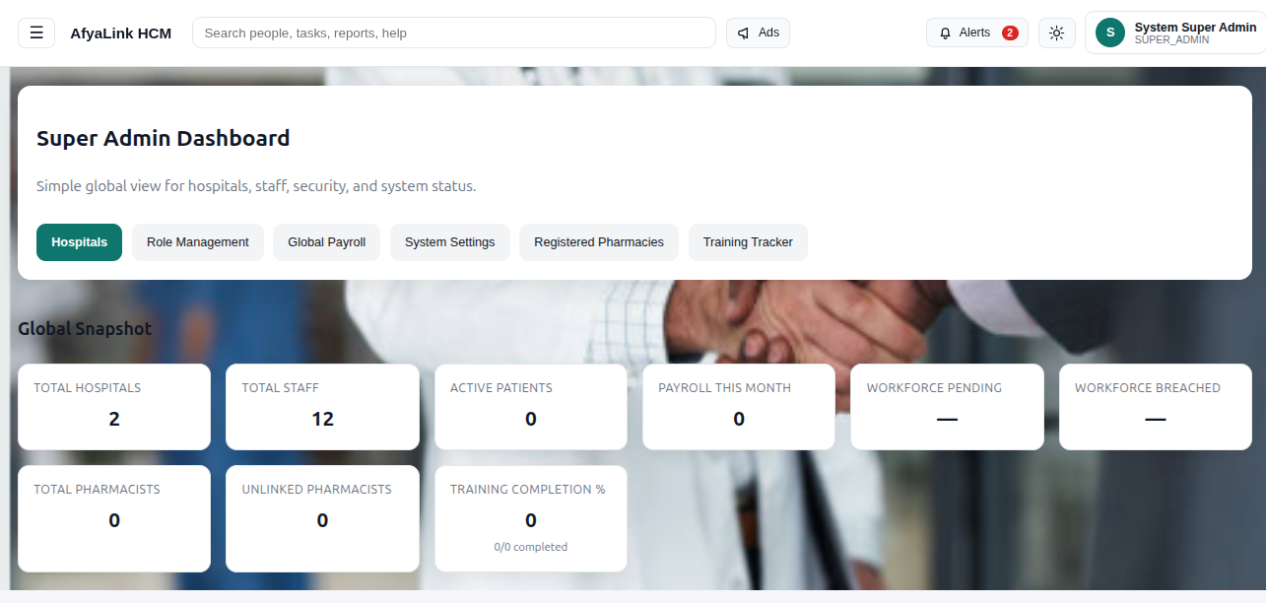

Deployment Diagram and Network Topology
