AFYALINK HEALTHCARE MANAGEMENT SYSTEM

SYSTEM DOCUMENTATION

SUBMITTED BY
JOSEPH OGWE WERE
DCS-03-8586/2024

A SYSTEM DOCUMENTATION SUBMITTED IN PARTIAL FULFILMENT OF THE REQUIREMENTS FOR THE AWARD OF THE DIPLOMA IN COMPUTER SCIENCE OF ZETECH UNIVERSITY
AUGUST 2026

DECLARATION
I declare that this system documentation is my original work and has not been presented in any other university or institution for academic award. All sources of information used in the preparation of this report have been duly acknowledged.
Student Name: Joseph Ogwe Were
Admission Number: DCS-03-8586/2024
Signature: ______________________
Date: ___________________________

Supervisor's Declaration
This project documentation has been submitted for examination with my approval as the appointed project supervisor.
Supervisor's Name: _______________________
Signature: _______________________________
Date: ___________________________________

DEDICATION
This project is dedicated to my family for their encouragement, sacrifices, and unwavering support throughout my academic journey. I also dedicate this work to my lecturers, friends, and classmates whose guidance, motivation, and constructive criticism contributed greatly to the successful completion of this project. Above all, I dedicate this work to God for granting me wisdom, strength, and perseverance during the development of the AfyaLink Healthcare Management System.

ACKNOWLEDGEMENT
I sincerely thank the Almighty God for granting me good health, wisdom, and strength throughout this project.
I express my heartfelt appreciation to my project supervisor for the continuous guidance, valuable suggestions, and professional support provided during the planning, design, implementation, testing, and documentation of this project.
I also acknowledge the lecturers in the Department of Computer Science at Zetech University for equipping me with the technical knowledge and practical skills that made this project possible.
Special appreciation goes to my family, classmates, and friends for their encouragement, patience, and support throughout the project period.
Finally, I acknowledge the open-source software community whose technologies, documentation, and development tools greatly contributed to the successful development of AfyaLink Healthcare Management System.

ABSTRACT
Healthcare institutions continue to experience challenges in managing patient records, appointments, billing information, healthcare services, and administrative operations efficiently. Many small and medium-sized healthcare facilities still rely on manual processes or disconnected software systems, resulting in duplicated records, delayed service delivery, poor communication, and limited access to accurate healthcare information.
The AfyaLink Healthcare Management System was developed to provide a centralized web-based platform that improves healthcare service delivery through secure authentication, patient self-service, appointment scheduling, medical record management, billing management, and role-based administration.
The system was developed using React.js for the frontend, Node.js and Express.js for backend services, MongoDB as the primary database, and Redis (Upstash) for caching frequently accessed information. Version control was managed using Git and GitHub, while deployment was achieved using Vercel for the frontend and Render for the backend services.
The completed system provides secure login, patient registration, appointment booking, medical records management, billing services, administrative dashboards, and healthcare staff dashboards. Role-Based Access Control ensures that every authorized user accesses only the services relevant to their responsibilities.
Testing conducted during development confirmed that the system satisfies its functional requirements, provides reliable performance, and offers an improved user experience compared to manual healthcare management processes.
The project demonstrates how modern web technologies can improve healthcare service management while providing a scalable foundation for future enhancements such as telemedicine, electronic prescriptions, artificial intelligence support, and mobile healthcare services.

DEFINITION OF KEY TERMS
Application Programming Interface (API) – A collection of protocols and rules that allow software applications to communicate with one another.
Authentication – The process of verifying the identity of a user before granting access to system resources.
Authorization – The process of determining the resources and services a verified user is permitted to access.
Backend – The server-side component of an application responsible for business logic, processing, and database communication.
Database – An organized collection of data stored electronically for efficient retrieval and management.
Electronic Medical Record (EMR) – A digital version of a patient's medical history maintained by a healthcare provider.
Frontend – The client-side interface through which users interact with the application.
MongoDB – A NoSQL document-oriented database used to store application data.
Redis – An in-memory data store used to improve application performance by caching frequently accessed information.
Role-Based Access Control (RBAC) – A security mechanism that restricts access to system resources according to assigned user roles.
REST API – A web service architecture that enables communication between clients and servers using HTTP methods.
System Deployment – The process of making a software application available for use in a production environment.
Web Application – Software that is accessed through a web browser over the Internet.

ABBREVIATIONS AND ACRONYMS
Abbreviation | Meaning
API | Application Programming Interface
CSS | Cascading Style Sheets
DBMS | Database Management System
DFD | Data Flow Diagram
ERD | Entity Relationship Diagram
HTML | HyperText Markup Language
HTTP | HyperText Transfer Protocol
IDE | Integrated Development Environment
JSON | JavaScript Object Notation
NoSQL | Not Only SQL
RBAC | Role-Based Access Control
REST | Representational State Transfer
UI | User Interface
UML | Unified Modeling Language
URL | Uniform Resource Locator
VS Code | Visual Studio Code

TABLE OF CONTENTS
(Generate automatically in Microsoft Word after applying Heading styles.)
- Declaration
- Dedication
- Acknowledgement
- Abstract
- Definition of Key Terms
- Abbreviations and Acronyms
- Table of Contents
- List of Figures
- List of Tables

CHAPTER ONE: PROJECT PLANNING AND ANALYSIS
1.1 Introduction
1.2 Background of the Study
1.3 Statement of the Problem
1.4 Justification of the Study
1.5 Objectives
1.6 Scope of the Study
1.7 Limitations of the Study
1.8 Functional Requirements
1.9 Non-Functional Requirements
1.10 Tools and Resources
1.11 Project Schedule (Gantt Chart)

CHAPTER TWO: DESIGN AND MODELLING
2.1 Introduction
2.2 User Interface Models
2.3 Logic Models
2.4 System Design Models
2.5 Chapter Summary

CHAPTER THREE: SYSTEM IMPLEMENTATION, DEPLOYMENT AND TESTING
3.1 Introduction
3.2 Development Environment
3.3 Frontend Development
3.4 Backend Development
3.5 Database Development
3.6 Role-Based Dashboards
3.7 Frontend and Backend Integration
3.8 System Deployment
3.9 Debugging Activities
3.10 System Testing
3.11 Chapter Summary

CHAPTER FOUR: CONCLUSION AND RECOMMENDATIONS
4.1 Introduction
4.2 Summary of the Project
4.3 Achievements
4.4 Challenges Encountered
4.5 Limitations of the System
4.6 Recommendations
4.7 Areas for Future Improvement
4.8 Conclusion
References
Appendices

LIST OF FIGURES
(Update automatically after inserting figures.)
Figure 2.2.1 Login Page
Figure 2.2.2 Create Account Page
Figure 2.2.3 Forgot Password Page
Figure 2.2.4 Patient Dashboard
Figure 2.2.5 Appointment Page
Figure 2.2.6 Medical Records Page
Figure 2.2.7 Billing Page
Figure 2.3.1 Login Flowchart
Figure 2.3.2 System Flowchart
Figure 2.3.3 Data Flow Diagram
Figure 2.3.4 Entity Relationship Diagram
Figure 2.3.5 Use Case Diagram
Figure 2.3.6 Class Diagram

LIST OF TABLES
Table 1.1 Functional Requirements
Table 1.2 Non-Functional Requirements
Table 1.3 Tools and Resources
Table 1.4 Project Schedule
Table 3.1 Development Environment
Table 3.2 Testing Results

CHAPTER ONE

PROJECT PLANNING AND ANALYSIS

1.1 Introduction
Healthcare systems play a critical role in improving the quality of life by providing timely medical services, maintaining patient records, and supporting healthcare professionals in delivering efficient care. As healthcare institutions continue to expand, the volume of patient information, appointments, billing records, prescriptions, laboratory reports, and administrative activities also increases. Managing these processes manually has become increasingly difficult due to the large amount of information generated daily.
The rapid advancement of Information and Communication Technology (ICT) has transformed the healthcare sector by introducing digital solutions that automate routine activities, improve communication, enhance data security, and support evidence-based decision-making. Healthcare Management Systems have become essential tools that integrate different healthcare services into one centralized platform, allowing patients, healthcare workers, and administrators to interact efficiently.
AfyaLink Healthcare Management System was developed as a web-based platform that provides secure access to healthcare services through role-based authentication. The system enables patients to register, book appointments, access medical records, monitor billing information, and manage personal profiles, while healthcare professionals and administrators can efficiently manage healthcare operations through dedicated dashboards.
This chapter presents the planning and analysis phase of the project by discussing the background of the study, problem statement, justification, objectives, scope, limitations, system requirements, resources, and project schedule.

1.2 Background of the Study
Healthcare institutions have traditionally relied on paper-based documentation and isolated computer systems for managing patient information, appointments, financial records, and healthcare operations. Although these methods have served healthcare facilities for many years, they have become inadequate due to increasing patient populations and the growing demand for efficient healthcare services.
Manual systems often result in misplaced patient records, delayed appointment scheduling, duplicated information, inefficient communication, and limited access to accurate medical data. Healthcare workers spend considerable time retrieving files, updating records, and coordinating patient care across different departments. These inefficiencies negatively affect service delivery and patient satisfaction.
The increasing availability of cloud computing, modern web technologies, and secure databases has enabled healthcare organizations to migrate from manual processes to integrated digital healthcare platforms. Such systems improve data accessibility, support secure communication, minimize paperwork, and enhance collaboration among healthcare providers.
AfyaLink Healthcare Management System was therefore developed to address these challenges by providing an integrated healthcare platform that centralizes patient management, appointment scheduling, billing services, medical records, authentication, and administrative management within a secure web application.

1.3 Statement of the Problem
Many healthcare facilities continue to experience operational challenges because of fragmented information systems and manual record management. Patient records are often stored in physical files or disconnected digital systems, making retrieval slow and increasing the likelihood of data duplication and loss.
Patients frequently experience difficulties when booking appointments, accessing medical records, viewing billing information, or obtaining updates regarding healthcare services. In many cases, patients are required to physically visit healthcare facilities to complete tasks that could otherwise be performed electronically.
Healthcare administrators also encounter challenges in monitoring system users, managing access permissions, tracking service delivery, and maintaining accurate healthcare information. As the number of patients increases, manual processes become increasingly inefficient, leading to delays, poor coordination, reduced productivity, and increased security risks.
The absence of a centralized healthcare management platform therefore creates inefficiencies that negatively affect both healthcare providers and patients. These challenges motivated the development of AfyaLink Healthcare Management System, which provides secure, centralized, and efficient management of healthcare services.

1.4 Justification of the Study
The development of AfyaLink Healthcare Management System is justified by the increasing need for healthcare institutions to adopt digital technologies that improve service delivery, operational efficiency, and information security.
The system reduces dependence on manual paperwork by providing centralized electronic management of patient records, appointments, billing information, and healthcare services. This significantly reduces delays, minimizes duplication of records, and improves accessibility of healthcare information.
AfyaLink also enhances patient satisfaction by allowing users to register online, schedule appointments, access medical records, monitor billing information, and manage their healthcare profiles through a secure web interface.
From an administrative perspective, the system improves accountability by implementing role-based access control, secure authentication, audit logging, and centralized management of healthcare resources.
Furthermore, the project demonstrates the practical application of modern software engineering principles using React.js, Node.js, Express.js, MongoDB, Redis, GitHub, Render, and Vercel, thereby providing valuable learning experience and a scalable solution for future healthcare innovations.

1.5 Objectives

1.5.1 General Objective
To develop a secure web-based Healthcare Management System that improves patient self-service, appointment scheduling, medical record management, billing services, and administrative operations within healthcare institutions.

1.5.2 Specific Objectives
The project seeks to:
- Develop a secure user registration and authentication module using Role-Based Access Control.
- Design a patient portal that enables users to manage appointments, billing information, medical records, and personal profiles.
- Develop healthcare staff dashboards for doctors, nurses, administrators, and community health workers.
- Implement appointment scheduling and healthcare service management.
- Develop a secure backend API for processing healthcare operations.
- Integrate MongoDB database services for permanent healthcare data storage.
- Implement Redis caching to improve system performance.
- Deploy the application using cloud hosting technologies.
- Test the system to ensure reliability, usability, security, and performance.

1.6 Scope of the Study
The study focuses on the analysis, design, development, deployment, and testing of AfyaLink Healthcare Management System.
The system provides functionality for:
- User registration
- Secure authentication
- Patient dashboard
- Appointment booking
- Medical records
- Billing management
- Role-based dashboards
- Administrative management
- Database integration
- Cloud deployment
The project does not include integration with national health information systems, medical laboratory equipment, pharmacy inventory management, mobile applications, or artificial intelligence diagnosis modules. These features are recommended for future development.

1.7 Limitations of the Study
Several limitations were experienced during the development of the project.
The project was constrained by limited development time available within the academic calendar.
Financial limitations restricted access to premium cloud services and commercial healthcare APIs.
Some advanced healthcare functionalities such as telemedicine, online consultations, electronic prescriptions, insurance integration, laboratory management, and payment gateway integration could not be fully implemented due to time constraints.
System testing was conducted using a limited number of users and therefore may not fully represent large-scale healthcare deployment.
Despite these limitations, the completed system successfully satisfies its intended objectives.

1.8 Functional Requirements
Table 1.8.1 Functional Requirements
User | Activity | System Feature
Patient | Register account | Registration Module
Patient | Login | Authentication Module
Patient | Manage profile | Patient Dashboard
Patient | Book appointment | Appointment Module
Patient | View medical records | Medical Records Module
Patient | View bills | Billing Module
Doctor | Manage patients | Doctor Dashboard
Nurse | Update care records | Nurse Dashboard
Administrator | Manage users | Admin Dashboard
Super Administrator | Manage entire system | Super Admin Dashboard
System | Store healthcare data | MongoDB Database
System | Improve response speed | Redis Cache

1.9 Non-Functional Requirements
Table 1.9.1 Non-Functional Requirements
Requirement | Description
Security | Secure authentication, password encryption, RBAC
Performance | Fast response through Redis caching
Reliability | Stable backend and database connectivity
Availability | Accessible via the Internet
Scalability | Supports future expansion
Maintainability | Modular React and Express architecture
Usability | Responsive and user-friendly interface
Portability | Compatible with desktop and mobile browsers

1.10 Tools and Resources Used

Software Tools
- React.js
- Node.js
- Express.js
- MongoDB Atlas
- Redis (Upstash)
- Git
- GitHub
- Visual Studio Code
- Postman
- Vercel
- Render

Hardware Requirements
- Laptop/Desktop Computer
- Internet Connection
- Cloud Servers
- Smartphones for Testing

Human Resources
- System Developer
- Project Supervisor
- Test Users
- Healthcare Professionals (for requirements validation)

1.11 Project Schedule
Table 1.11.1 Project Schedule (Gantt Chart)
 | PROJECT MILESTONES
WEEKS | Project Planning & Analysis  (System Documentation: Cover page & Chapter One) | Project Design & Modeling  (System Documentation Chapter Two) | Project Development & Testing  (System Documentation Chapter Three) | Project Deployment  (System Documentation Chapter Three) | Final Touches of System Documentation  (Preliminary Pages, Chapter Four & References) | Project Presentation
Week 1

Week 2

Week 3

Week 4

Week 5

Week 6

Week 7

Week

Week 9

Week 10

Week 11

Week 12

Week 13

1.12 Chapter Summary
This chapter presented the planning and analysis activities undertaken during the development of the AfyaLink Healthcare Management System. It discussed the background of the study, the existing problems affecting healthcare information management, the justification for developing the system, the project objectives, scope, limitations, functional and non-functional requirements, development tools, required resources, and the project schedule. The analysis established the need for a centralized, secure, and scalable healthcare management solution. The next chapter presents the design and modelling of the system, including the user interface prototypes, flowcharts, data flow diagrams, entity relationship diagram, use case diagram, and class diagram, which provide the blueprint for the implementation of the system.

CHAPTER TWO

DESIGN AND MODELLING

2.1 Introduction
System design is an essential phase in software development because it transforms user requirements identified during system analysis into a technical blueprint for implementation. It defines the architecture, user interactions, data flow, and relationships between system components before coding begins. A well-designed system reduces implementation errors, improves maintainability, and ensures that the final product satisfies user requirements.
This chapter presents the design models developed for the AfyaLink Healthcare Management System. These include user interface models, system flowcharts, data flow diagrams, entity relationship diagrams, use case diagrams, and class diagrams. Together, these models describe how users interact with the system, how information flows between system components, and how healthcare data is organized and processed.

2.2 User Interface Models
The user interface was designed to provide a simple, intuitive, and responsive experience for all categories of users. Each interface was developed with usability, accessibility, and consistency in mind to ensure efficient navigation across the system.

2.2.1 Login Page
Figure 2.2.1 Login Page
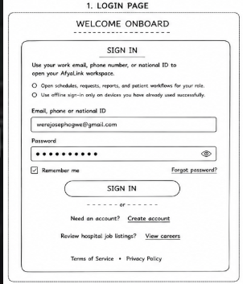
The login page provides secure access to AfyaLink Healthcare Management System. Users authenticate using their registered email address, phone number, or national identification number together with their password. Authentication is performed by the backend server before users are redirected to their respective dashboards according to their assigned roles.

Features
- Secure authentication
- Password encryption
- Role-based access control
- Forgot password option
- Responsive interface
- Form validation

2.2.2 Create Account Page
Figure 2.2.2 Create Account Page
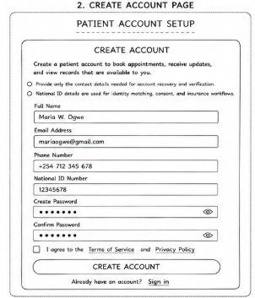
The registration page enables new patients to create accounts within the healthcare system. Personal information entered during registration is securely stored in the database after validation.

Features
- Patient registration
- National ID validation
- Email verification
- Phone number validation
- Password confirmation
- Insurance information (optional)

2.2.3 Forgot Password Page
Figure 2.2.3 Forgot Password Page
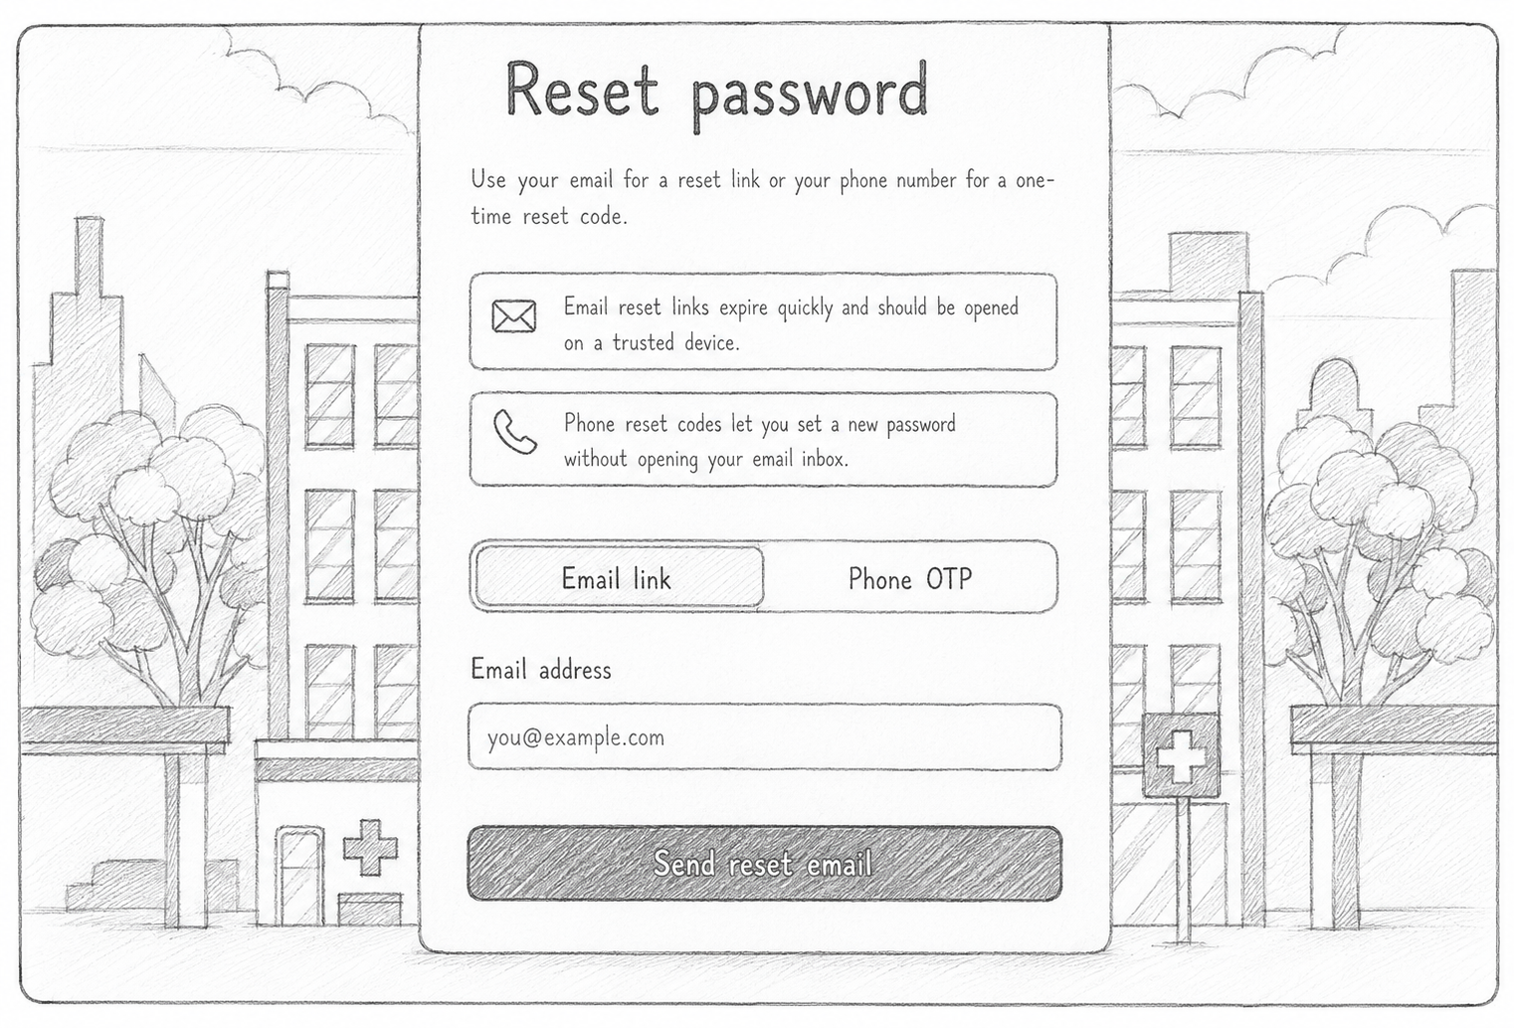
The Forgot Password page enables registered users to recover access to their accounts securely by requesting password reset instructions through the configured authentication process.

2.2.4 Home Page
Figure 2.2.4 Home Page
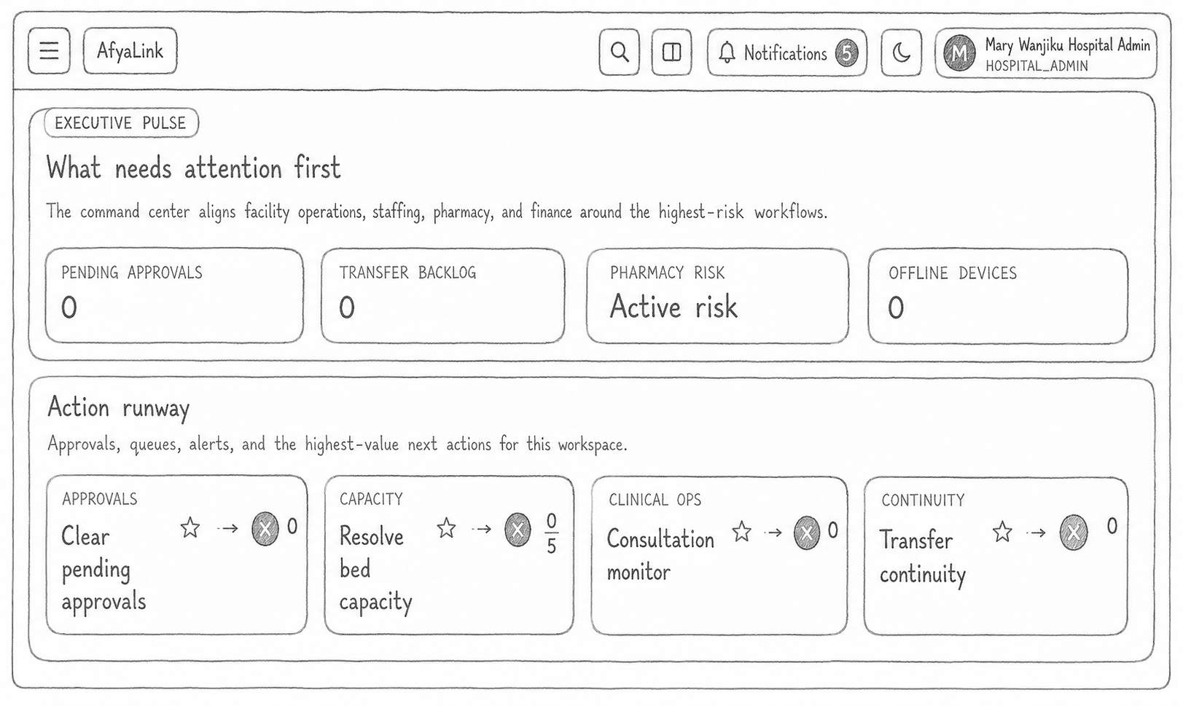

The home page introduces visitors to the healthcare management platform. It provides information about healthcare services, navigation menus, featured healthcare facilities, and quick links to registration and login.

2.2.5 Patient Dashboard
Figure 2.2.5 Patient Dashboard
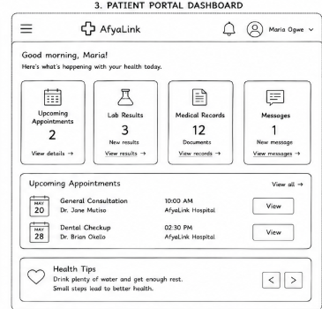
The patient dashboard serves as the primary workspace after successful authentication. It provides centralized access to all patient services through an organized and responsive interface.

Available Modules
- Dashboard overview
- Profile management
- Appointment booking
- Medical records
- Billing
- Notifications
- Insurance information
- Care documents

2.2.6 Appointment Management Page
Figure 2.2.6 Appointment Management
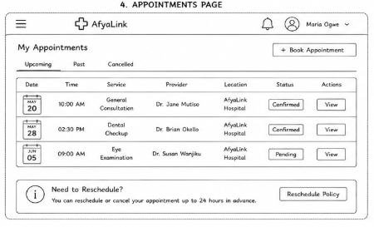
The appointment module enables patients to search healthcare facilities, select doctors, choose appointment dates, and monitor appointment status.

Features
- Search hospitals
- Select healthcare provider
- Appointment scheduling
- Appointment history
- Appointment cancellation

2.2.7 Medical Records Page
Figure 2.2.7 Medical Records
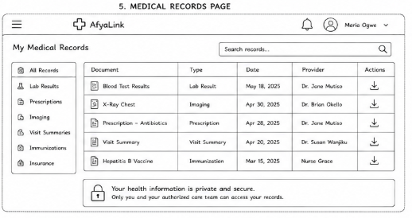
The medical records page allows authorized users to access patient healthcare history in an organized format.
Information displayed includes:
- Diagnoses
- Laboratory results
- Prescriptions
- Treatment history
- Clinical notes
- Patient encounters

2.2.8 Billing Page
Figure 2.2.8 Billing Page
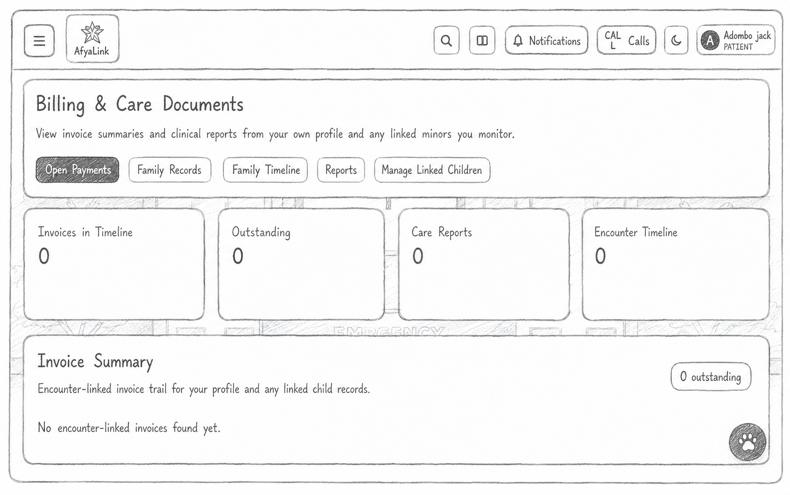

The billing module enables patients to review invoices, payment history, outstanding balances, insurance information, and downloadable billing documents.

2.2.9 Administrator Dashboard
Figure 2.2.9 Administrator Dashboard
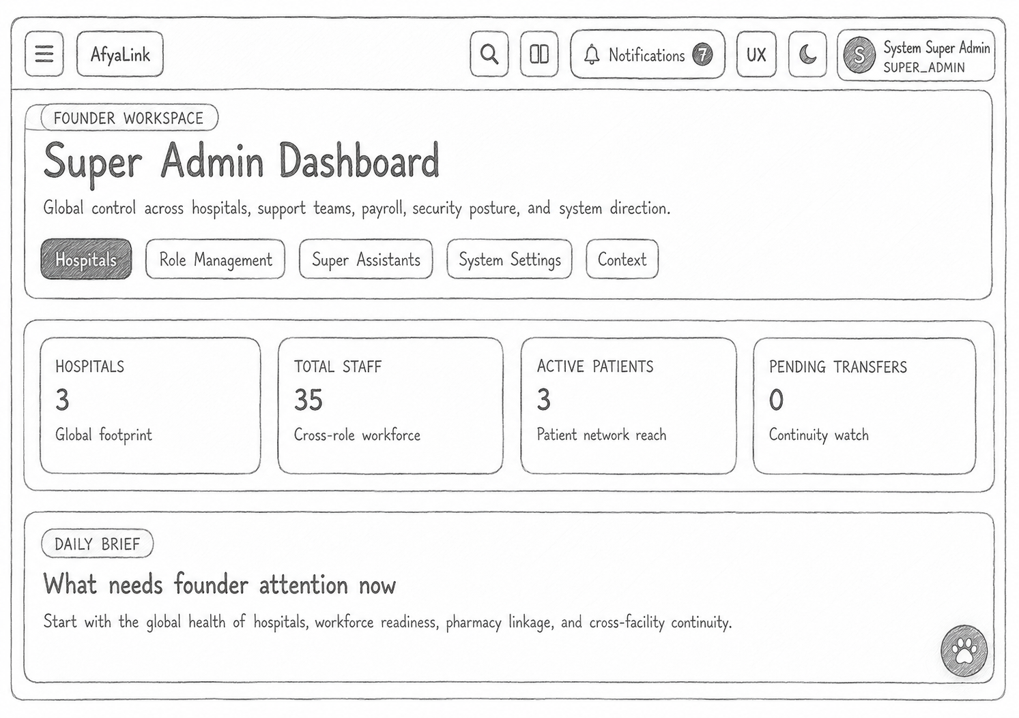

The Administrator Dashboard enables authorized administrators to manage users, assign system roles, monitor system activities, review audit logs, and maintain overall platform security.

2.2.10 Doctor Dashboard
Figure 2.2.10 Doctor Dashboard
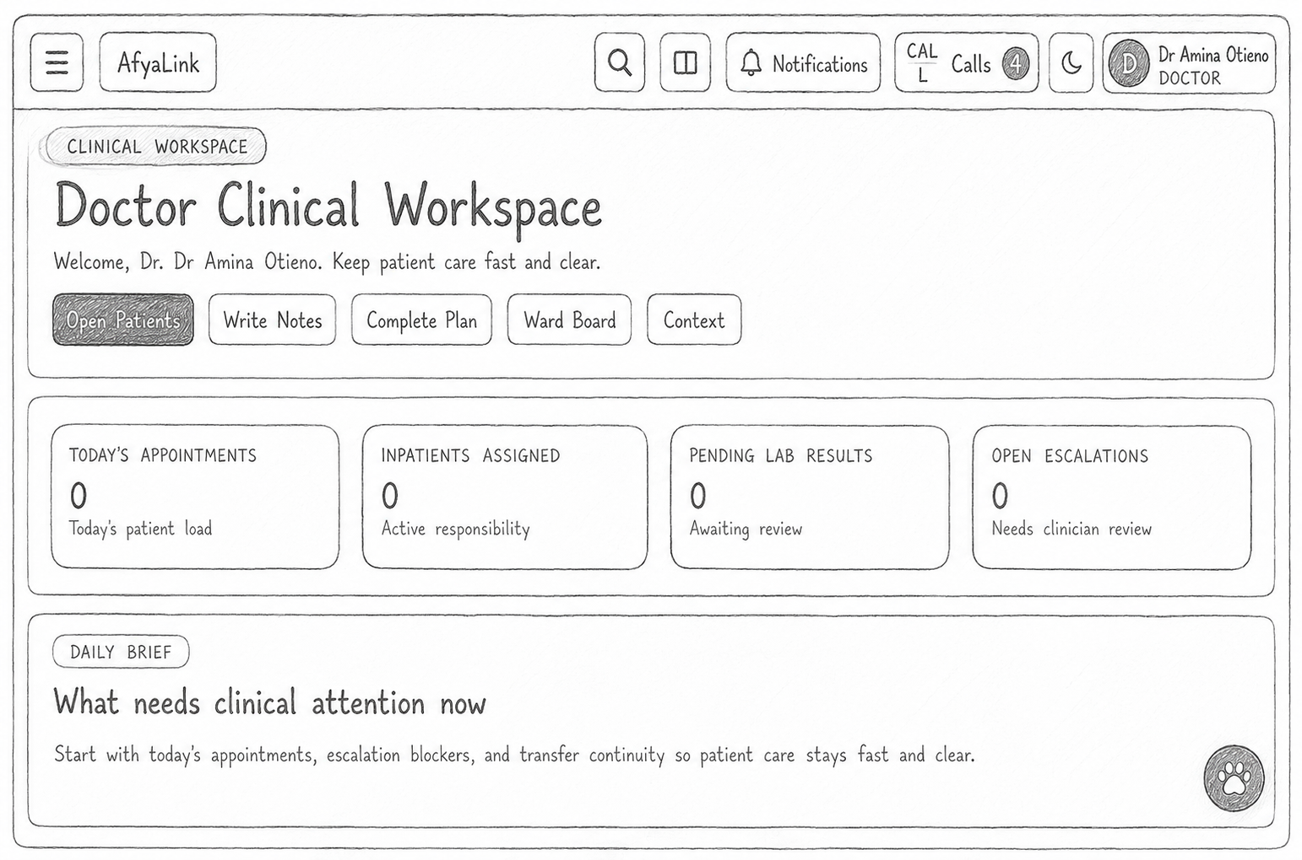
The Doctor Dashboard provides healthcare practitioners with secure access to assigned patients, appointments, medical records, prescriptions, laboratory reports, and clinical documentation.

2.2.11 Nurse Dashboard
Figure 2.2.11 Nurse Dashboard
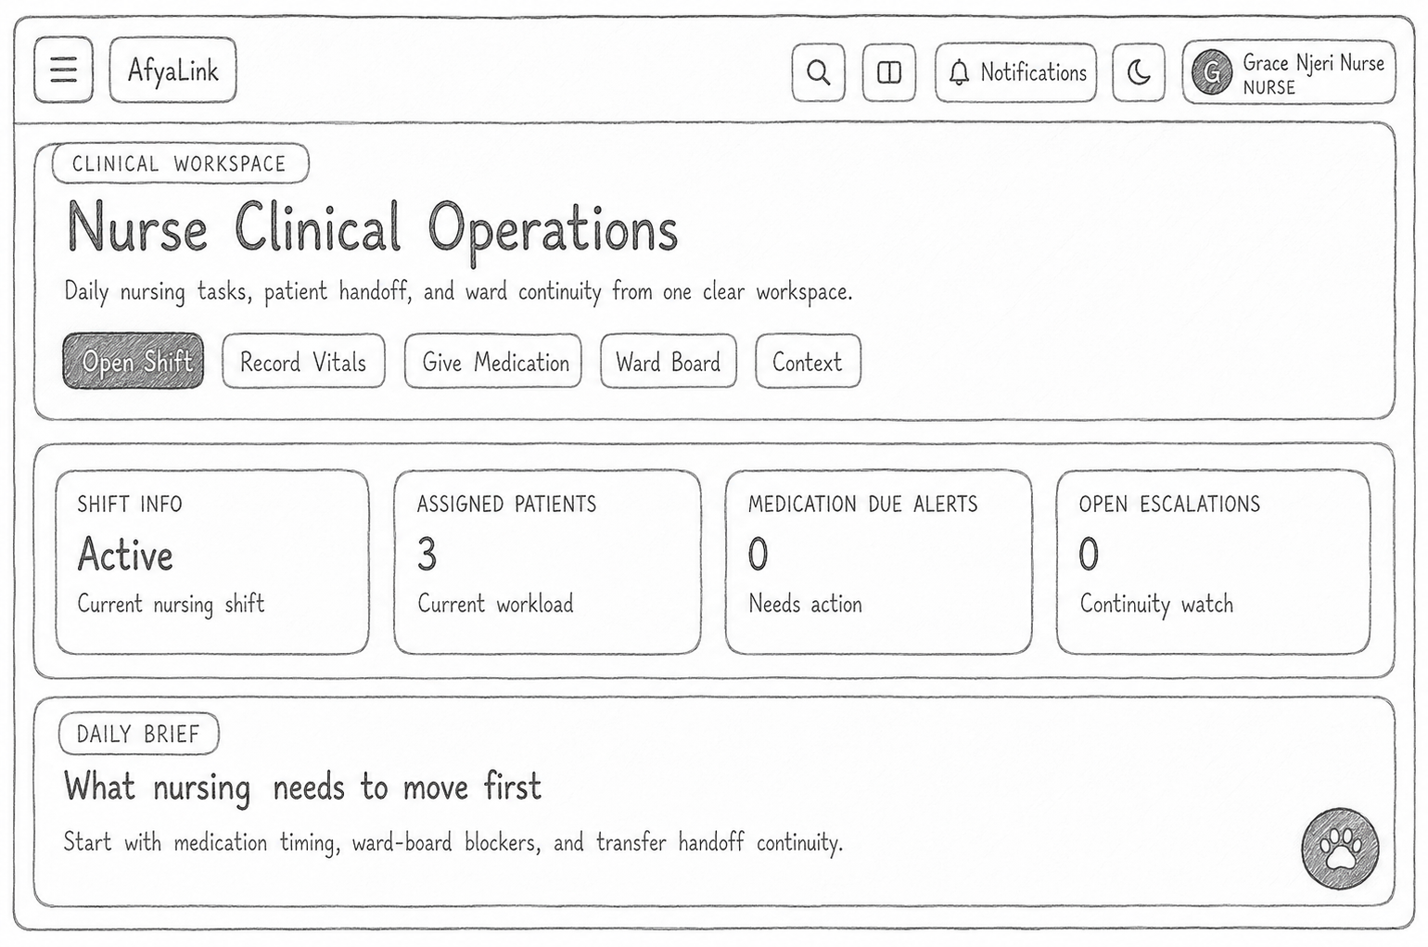
The Nurse Dashboard supports nursing workflows by providing access to patient monitoring information, care documentation, appointments, and assigned clinical tasks.

2.2.12 Community Health Worker Dashboard
Figure 2.2.12 Community Health Worker Dashboard
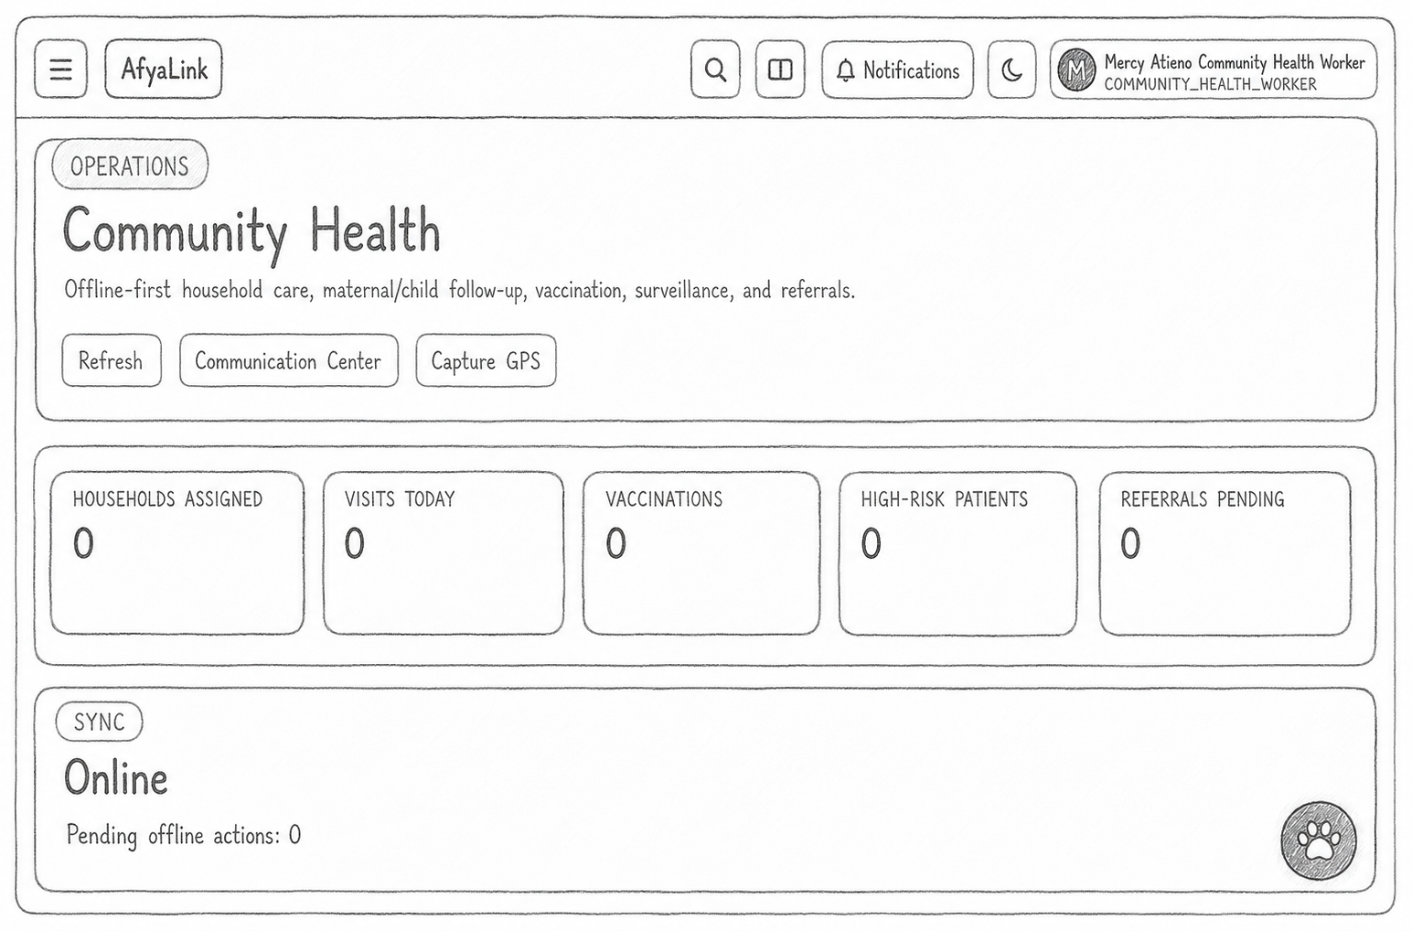
This dashboard enables community health workers to manage outreach activities, follow-up visits, community health records, and patient education programmes.

2.3 System Flow Models
Flow models describe the sequence of activities performed within the system and illustrate how users interact with various modules.

2.3.1 Login Process Flowchart
Figure 2.3.1 Login Flowchart
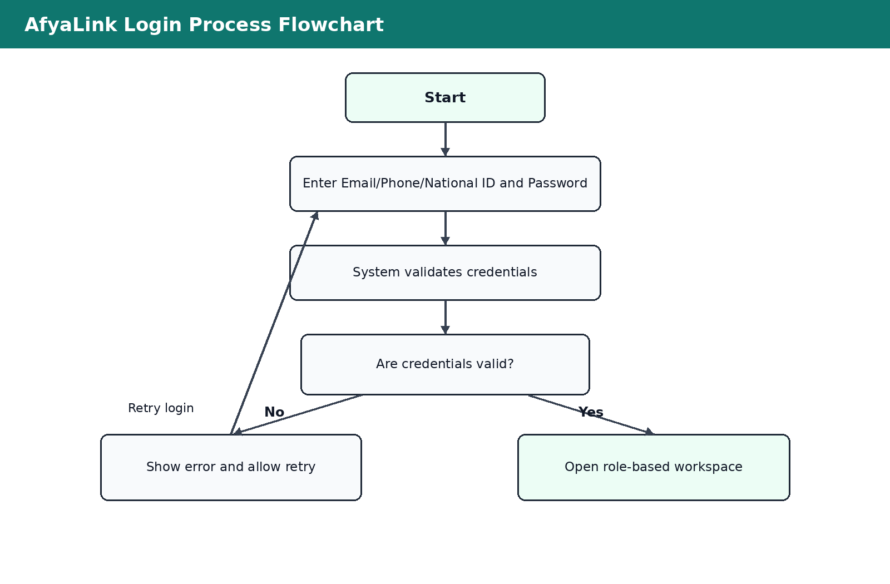
The flowchart illustrates the authentication process beginning with credential submission, validation, role verification, session creation, and redirection to the appropriate dashboard.

2.3.2 Overall System Flowchart
Figure 2.3.2 System Flowchart
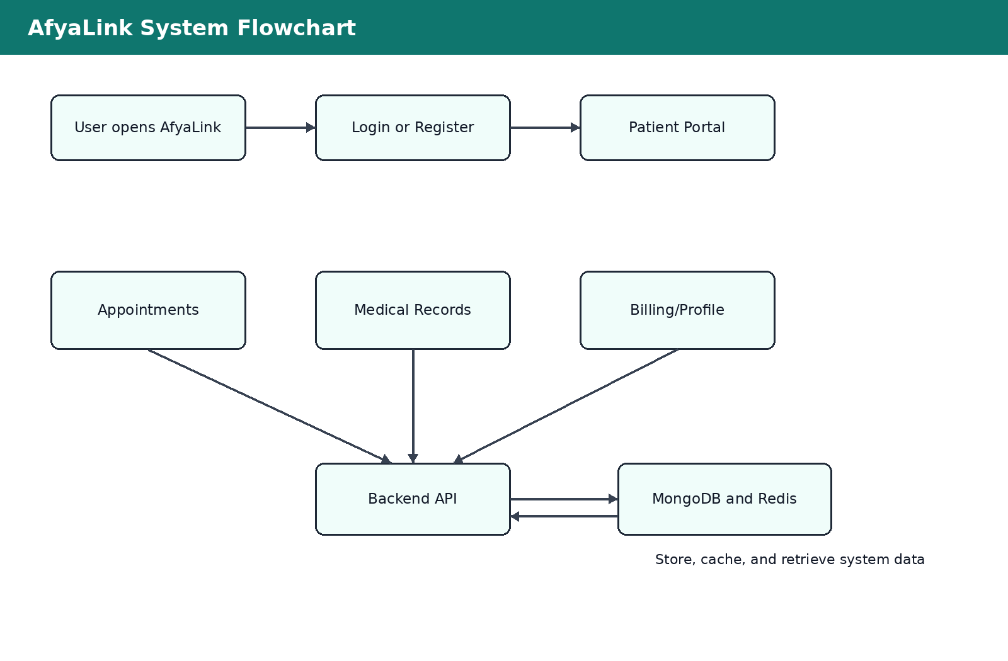
The system flowchart illustrates the movement of users through registration, authentication, dashboard access, service modules, backend processing, database interaction, and response generation.

2.4 System Design Models

2.4.1 Data Flow Diagram (DFD)
Figure 2.4.1 Data Flow Diagram
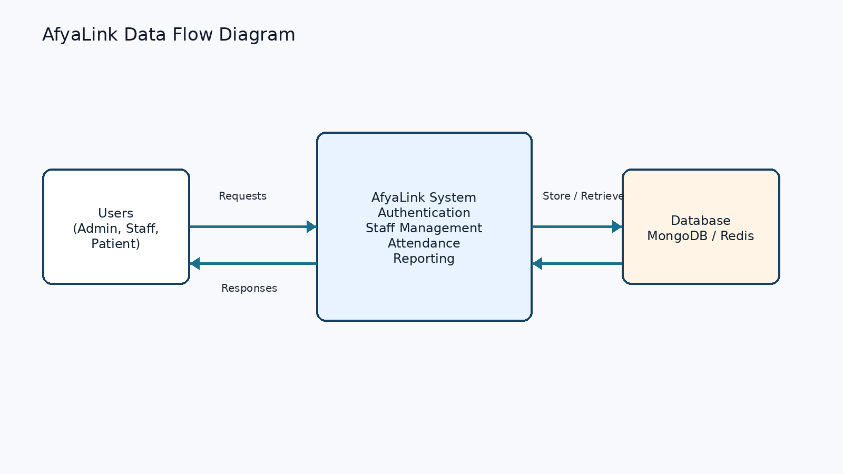
The Data Flow Diagram illustrates how information moves between users, frontend interfaces, backend services, MongoDB, Redis, and external services.

2.4.2 Entity Relationship Diagram (ERD)
Figure 2.4.2 Entity Relationship Diagram
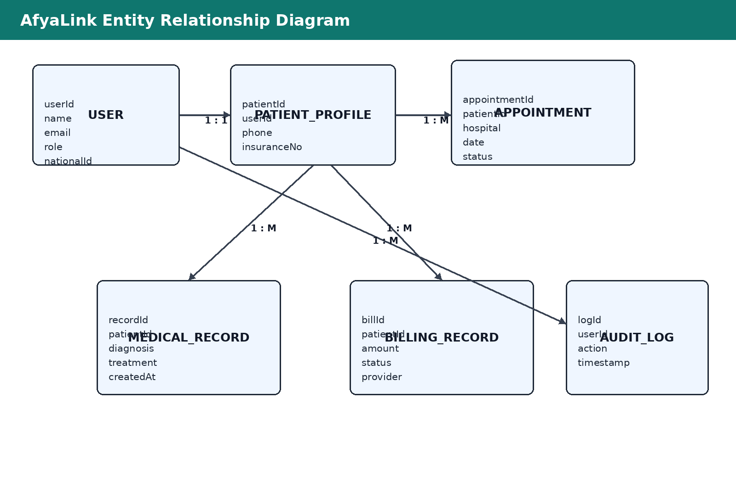
The ERD illustrates the relationships among the primary database entities.
Major entities include:
- User
- Patient
- Appointment
- MedicalRecord
- BillingRecord
- Hospital
- Insurance
- AuditLog
- Notification

2.4.3 Use Case Diagram
Figure 2.4.3 Use Case Diagram
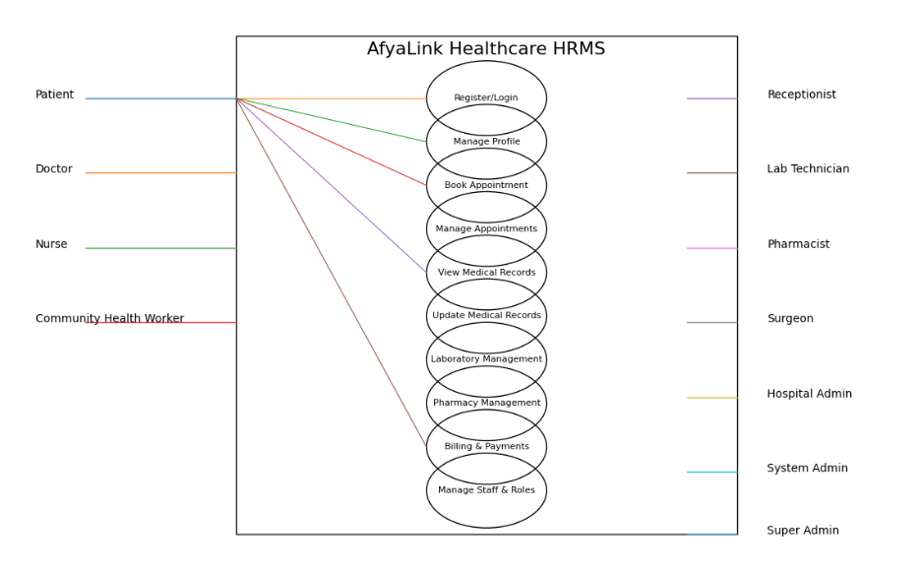
Actors represented include:
- Patient
- Doctor
- Nurse
- Administrator
- Super Administrator
- Community Health Worker
Primary use cases include:
- Register
- Login
- Book Appointment
- View Medical Records
- View Billing
- Update Profile
- Manage Users
- Generate Reports
- Manage Healthcare Facilities

2.4.4 Class Diagram
Figure 2.4.4 Class Diagram
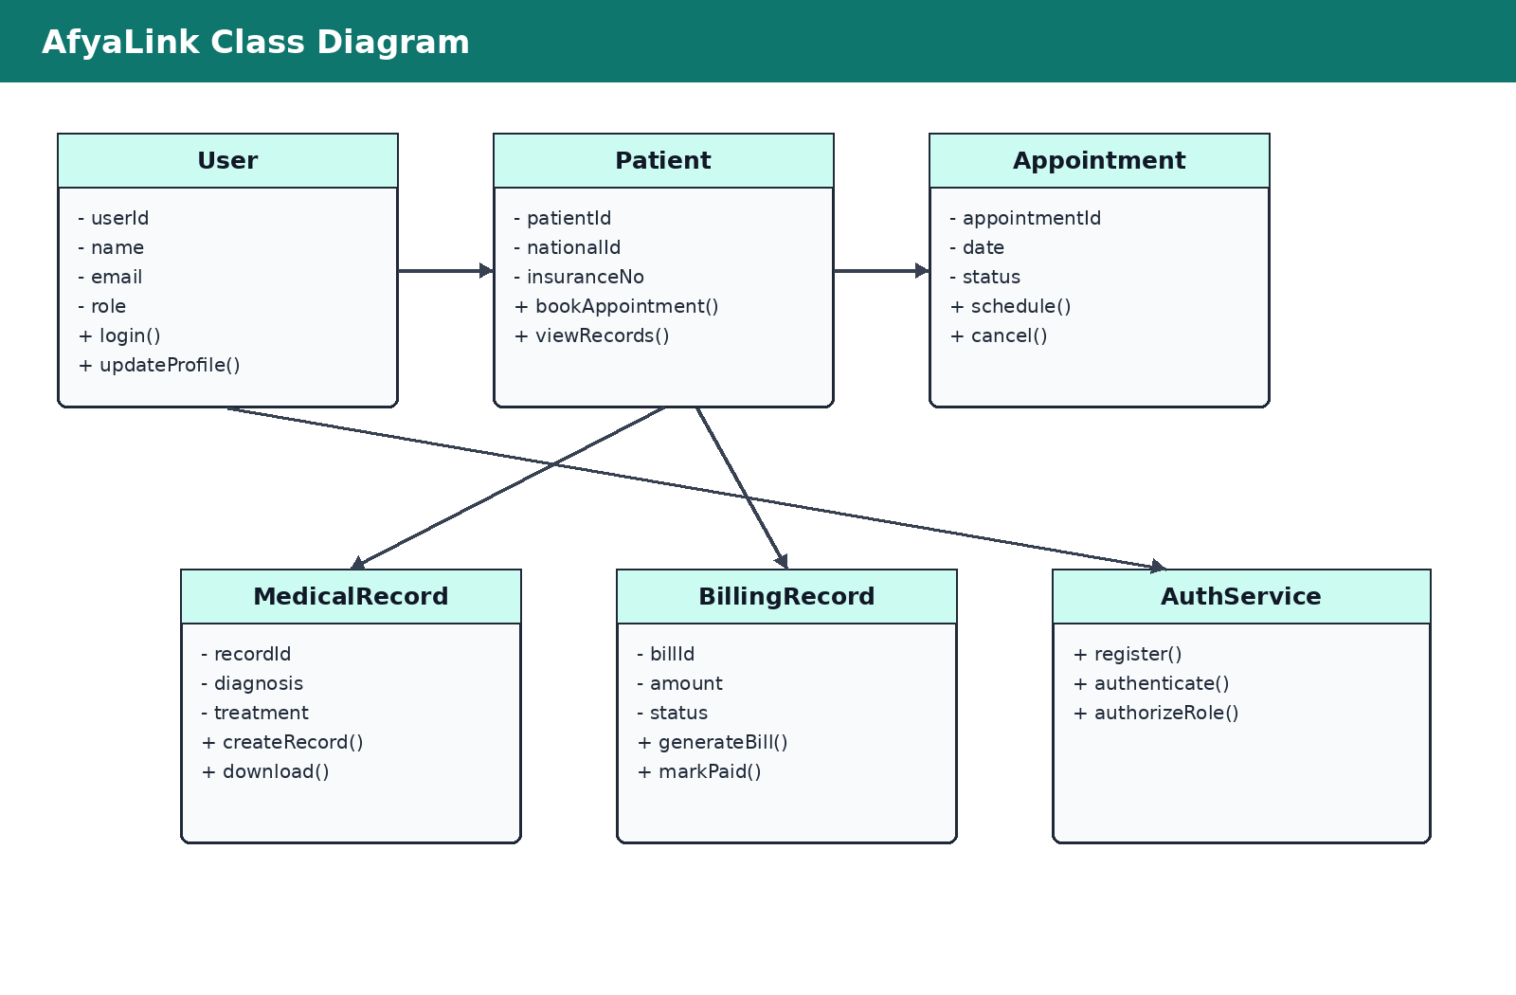
The Class Diagram models the object-oriented structure of the application.
Major classes include:
- User
- Patient
- Doctor
- Nurse
- Appointment
- MedicalRecord
- Billing
- Hospital
- AuthenticationService
- NotificationService
Relationships between these classes support inheritance, aggregation, and associations required by the application.

2.5 System Architecture
Figure 2.5.1 System Architecture
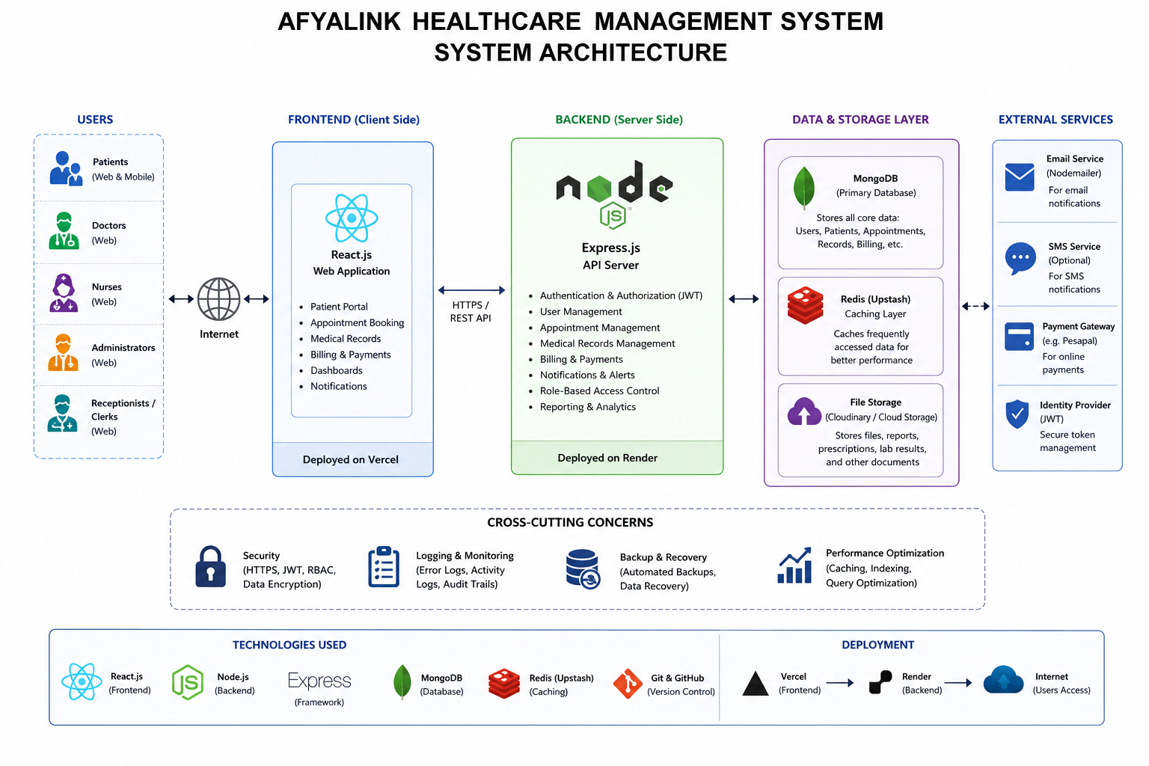
The AfyaLink Healthcare Management System follows a modern three-tier architecture comprising the presentation layer, application layer, and data layer.

Presentation Layer
- React.js frontend
- HTML5
- CSS3
- JavaScript

Application Layer
- Node.js
- Express.js
- RESTful APIs
- Authentication services
- Business logic
- Role-Based Access Control

Data Layer
- MongoDB Atlas
- Redis (Upstash)
- Cloud storage services
Deployment is achieved using Vercel for the frontend and Render for backend services, with secure communication over HTTPS.

2.6 Chapter Summary
This chapter presented the design and modelling of the AfyaLink Healthcare Management System. User interface models described the interaction between users and the application, while flowcharts and system models illustrated the movement of data and control throughout the system. The Data Flow Diagram, Entity Relationship Diagram, Use Case Diagram, Class Diagram, and System Architecture provide the technical blueprint that guided implementation. These designs ensured that the system was structured, scalable, secure, and aligned with the project objectives established in Chapter One.

CHAPTER THREE

SYSTEM IMPLEMENTATION, DEPLOYMENT AND TESTING

3.1 Introduction
This chapter presents the implementation, deployment, debugging, integration, and testing activities carried out during the development of the AfyaLink Healthcare Management System. Following the completion of system analysis and design presented in Chapter Two, the implementation phase focused on transforming the designed models into a fully functional web-based healthcare management platform.
The implementation process involved frontend development, backend development, database integration, authentication services, appointment management, patient record management, billing services, administrative dashboards, deployment to cloud platforms, and comprehensive system testing. Throughout development, emphasis was placed on security, usability, maintainability, scalability, and system performance.

3.2 Development Environment
The AfyaLink Healthcare Management System was developed using modern web technologies and cloud-based development tools. These technologies were selected because they support scalable application development, secure data management, responsive user interfaces, and efficient deployment.

Table 3.2.1 Development Environment
Component | Technology Used
Frontend Framework | React.js
Backend Framework | Node.js
Web Framework | Express.js
Programming Language | JavaScript
Markup Language | HTML5
Styling | CSS3
Database | MongoDB Atlas
Cache | Redis (Upstash)
Source Control | Git
Repository Hosting | GitHub
Code Editor | Visual Studio Code
API Testing | Postman
Frontend Deployment | Vercel
Backend Deployment | Render
Operating System | Ubuntu Linux
These technologies enabled rapid development while ensuring that the application remained modular, maintainable, and easy to scale as new healthcare services are introduced.

3.3 Frontend Development
Frontend development focused on creating a responsive and user-friendly interface that allows different categories of users to interact efficiently with the healthcare system. React.js was selected because of its reusable component architecture, virtual DOM implementation, and ability to build highly interactive single-page applications.
Development began by creating reusable layouts, navigation components, authentication pages, dashboards, and healthcare service modules.
The frontend was designed to support desktop computers, tablets, and mobile devices using responsive web design techniques.

3.3.1 Login Page Development
The login page was implemented as the secure entry point into the healthcare management system.

Implemented Features
- Secure authentication
- Email login
- Phone number login
- National ID login
- Password validation
- Remember Me option
- Forgot Password functionality
- Responsive interface
- Client-side validation
- Secure communication with backend API

Figure 3.3.1 Login Page
[INSERT LOGIN PAGE SCREENSHOT HERE]

Figure 3.3.2 Login Source Code
[INSERT LOGIN SOURCE CODE SCREENSHOT HERE]

3.3.2 Registration Module
The registration module enables new patients to create secure accounts within the healthcare system.
Patient information is validated before submission to ensure data integrity.

Registration Fields
- Full Name
- Email Address
- Phone Number
- National ID
- Password
- Confirm Password
- Insurance Information (Optional)

Figure 3.3.3 Registration Page
[INSERT REGISTRATION PAGE SCREENSHOT HERE]

Figure 3.3.4 Registration Code
[INSERT REGISTRATION SOURCE CODE HERE]

3.3.3 Forgot Password Module
The password recovery module assists users in regaining access to their accounts.
Implemented functionality includes:
- Identity verification
- Password reset request
- Secure token validation
- Password update

Figure 3.3.5 Forgot Password
[INSERT FORGOT PASSWORD PAGE HERE]

3.3.4 Patient Dashboard Development
The Patient Dashboard serves as the central workspace after successful authentication.
Major components developed include:
- Welcome section
- Profile overview
- Healthcare statistics
- Appointment management
- Medical records
- Billing
- Notifications
- Insurance information

Figure 3.3.6 Patient Dashboard
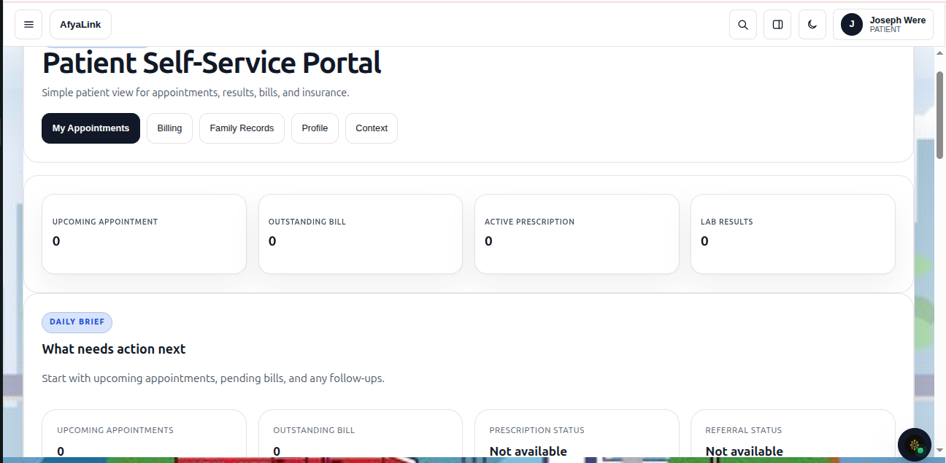

Figure 3.3.7 Dashboard Source Code
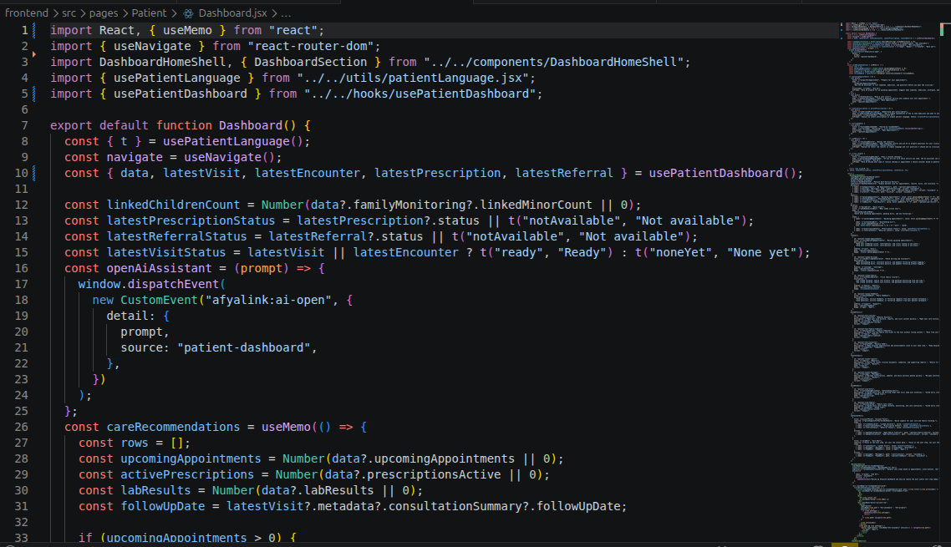

3.3.5 Appointment Module
The appointment module allows patients to search hospitals, select doctors, schedule appointments, and monitor booking status.
Implemented Features
- Hospital search
- Doctor selection
- Appointment scheduling
- Appointment history
- Appointment cancellation

Figure 3.3.8 Appointment Module
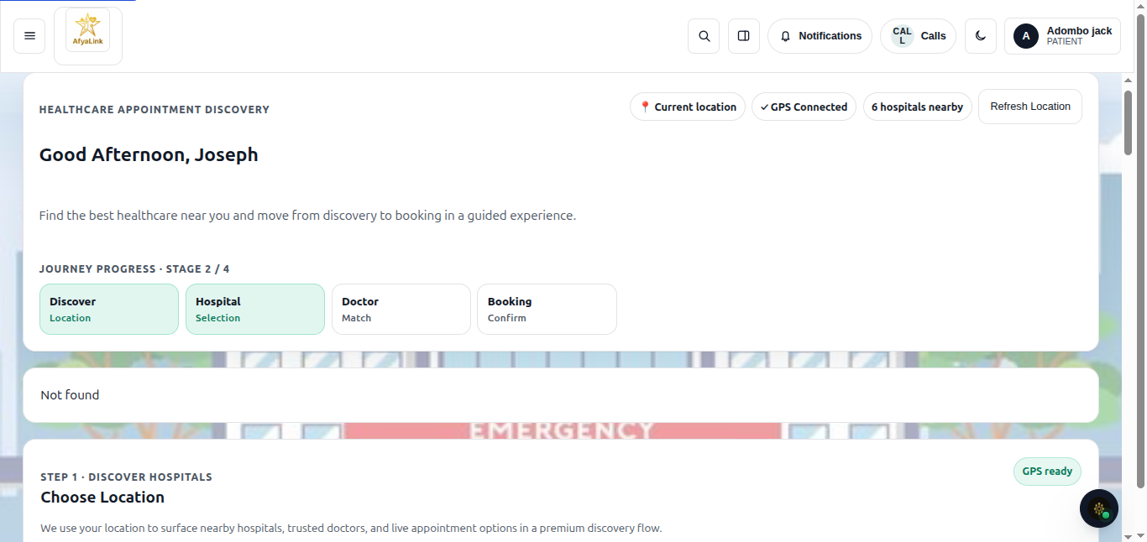

3.3.6 Medical Records Module
The Medical Records module enables secure viewing of patient healthcare information.
Available records include:
- Diagnoses
- Laboratory reports
- Prescriptions
- Treatment history
- Clinical notes

Figure 3.3.9 Medical Records
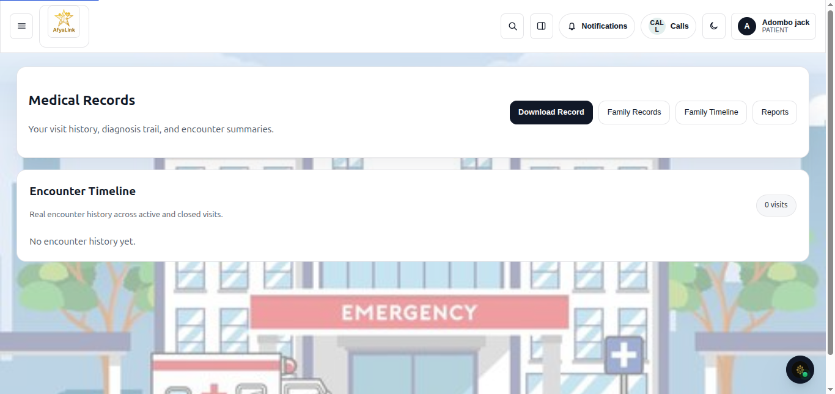

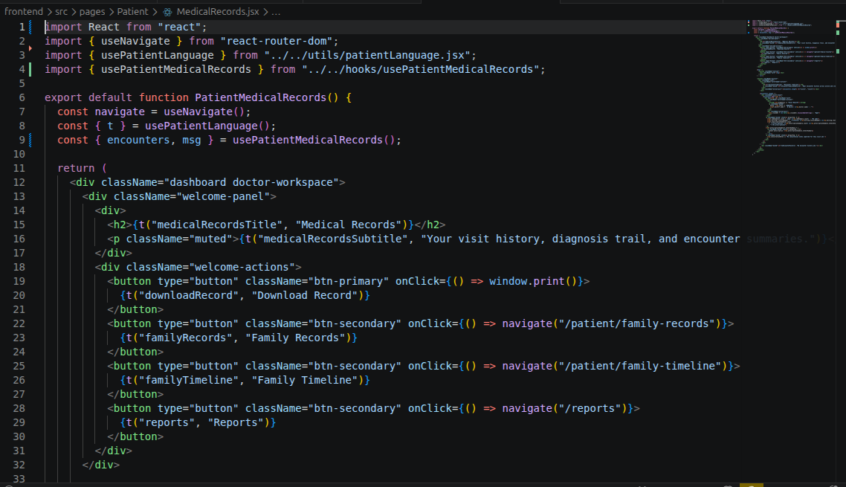
3.3.7 Billing Module
The Billing module enables patients to monitor healthcare expenses.
Implemented Features
- Billing history
- Outstanding balances
- Insurance information
- Payment status
- Downloadable invoices

Figure 3.3.10 Billing Module
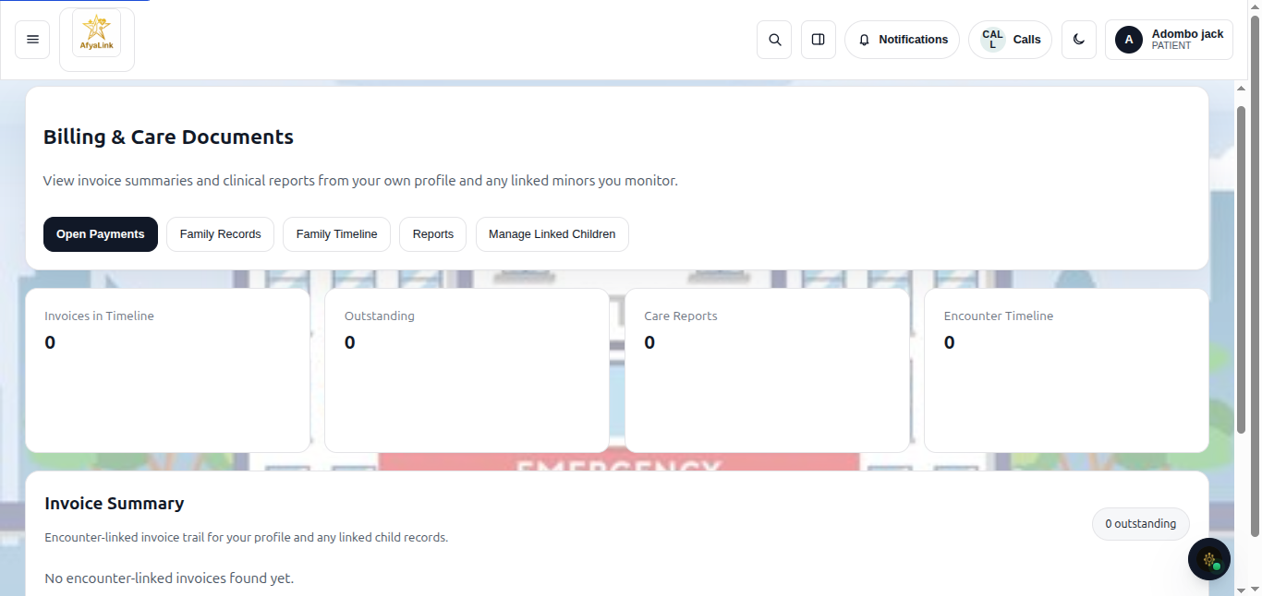

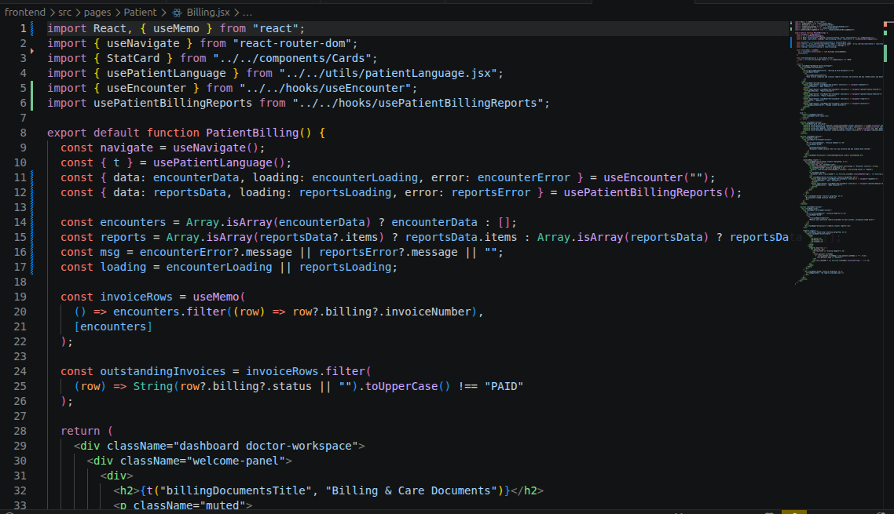
3.4 Backend Development
Backend development was implemented using Node.js and Express.js.
The backend performs the core business logic of the application, including authentication, authorization, appointment scheduling, medical record management, billing processing, and communication with MongoDB.
The application follows a RESTful API architecture that separates frontend presentation from backend processing.

3.4.1 Authentication Module
Authentication was implemented using secure login mechanisms and Role-Based Access Control.
Implemented Features
- User registration
- Secure login
- Password hashing
- JWT authentication
- Session validation
- Access token generation
- Role verification

Figure 3.4.1 Authentication API
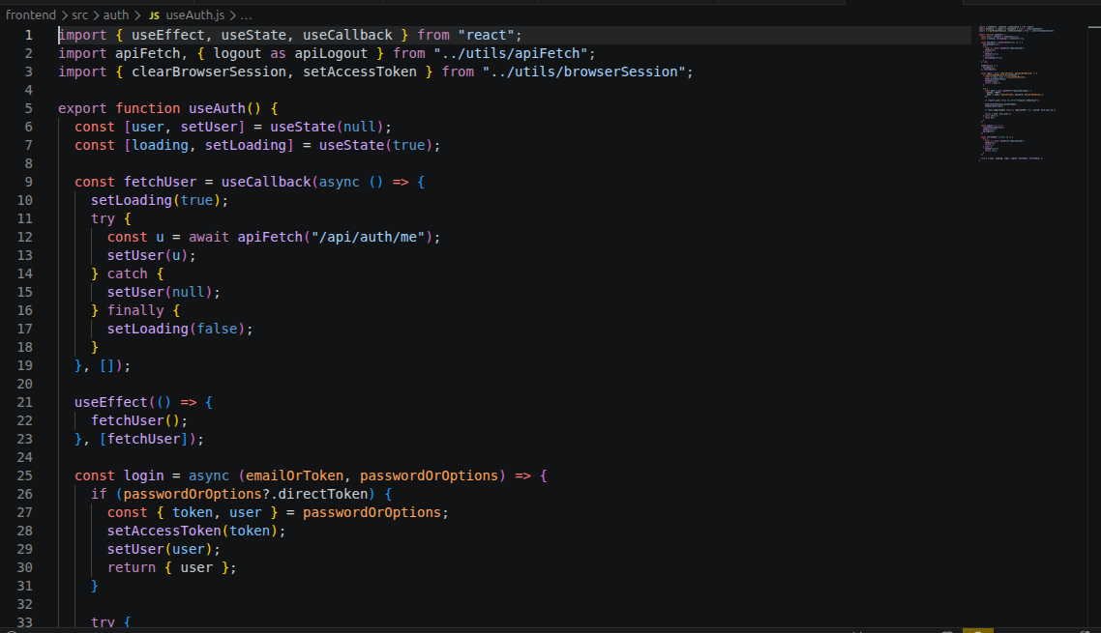

3.4.2 User Management Module
The User Management module enables administrators to create, modify, suspend, activate, and delete user accounts.
Implemented Features
- User creation
- User update
- User deletion
- Role assignment
- Profile management
- Password reset

Figure 3.4.2 User Management Code
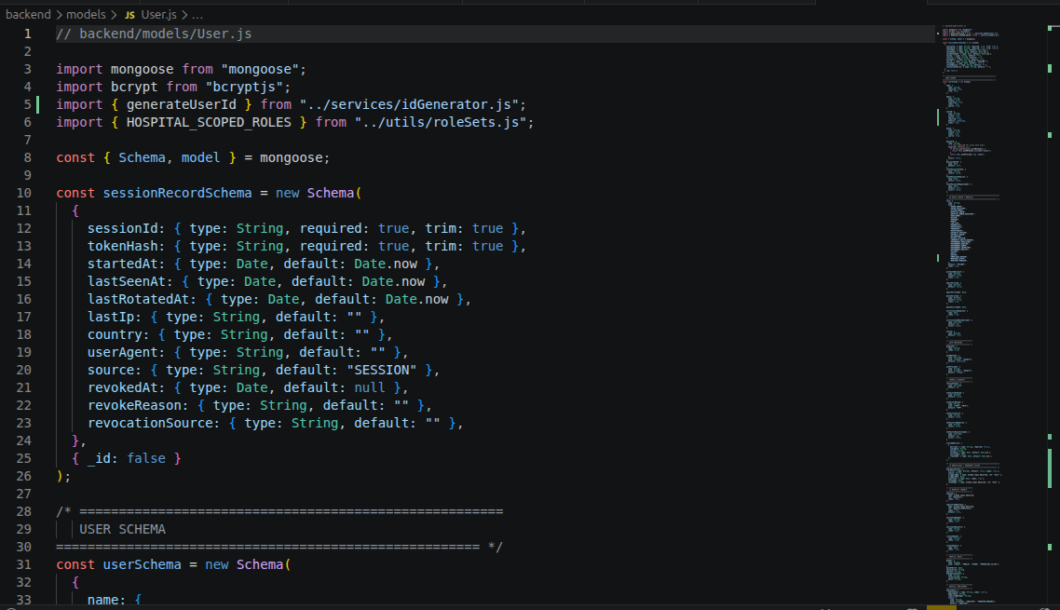

3.4.3 Appointment Service
Backend appointment services process appointment requests submitted by patients.
Features include:
- Appointment creation
- Availability checking
- Appointment approval
- Cancellation
- Appointment reminders

Figure 3.4.3 Appointment Service Code
[INSERT APPOINTMENT API CODE HERE]

3.4.4 Medical Records Service
This module securely processes healthcare records between healthcare professionals and patients.
Functions include:
- Record creation
- Record retrieval
- Record updating
- Secure authorization
- Audit logging

Figure 3.4.4 Medical Records Backend
[INSERT MEDICAL RECORDS API HERE]

3.4.5 Billing Service
The Billing Service calculates patient charges and stores billing transactions.
Implemented functionality includes:
- Invoice generation
- Payment tracking
- Billing history
- Outstanding balance calculation

Figure 3.4.5 Billing Backend
[INSERT BILLING SERVICE CODE HERE]

3.5 Database Development
MongoDB Atlas was selected as the primary database because of its scalability, flexibility, cloud accessibility, and support for JSON document storage.
The database structure follows the Entity Relationship Diagram presented in Chapter Two.

Collections Implemented

Users Collection
Stores:
- User ID
- Name
- Email
- Phone Number
- National ID
- Password Hash
- User Role

Patients Collection
Stores:
- Patient Information
- Insurance Details
- Contact Information
- Medical History

Appointments Collection
Stores:
- Appointment Date
- Healthcare Provider
- Appointment Status
- Consultation Details

Medical Records Collection
Stores:
- Diagnoses
- Treatments
- Laboratory Results
- Prescriptions

Billing Collection
Stores:
- Invoice Details
- Payment Status
- Charges
- Insurance Coverage

Audit Logs Collection
Stores:
- Login Records
- User Activities
- Security Events
- System Logs

3.5.1 Database Integration
Database integration involved connecting backend services to MongoDB Atlas through secure database connections.
The integration process included:
- Schema creation
- Data validation
- CRUD operations
- Connection pooling
- Error handling
- Authentication integration

Figure 3.5.1 MongoDB Collections
[INSERT DATABASE SCREENSHOT HERE]

Figure 3.5.2 MongoDB Schema
[INSERT DATABASE SCHEMA HERE]

3.5.2 Redis Cache Integration
Redis (Upstash) was implemented to improve application performance.
Redis stores frequently requested data temporarily, reducing unnecessary database queries.
Benefits achieved include:
- Faster authentication
- Session management
- Reduced database load
- Improved response time

Figure 3.5.3 Redis Dashboard
[INSERT REDIS DASHBOARD SCREENSHOT HERE]

3.6 Role-Based Dashboard Development
One of the major objectives of the AfyaLink Healthcare Management System was to provide different categories of users with workspaces that match their responsibilities. To achieve this, Role-Based Access Control (RBAC) was implemented. Every authenticated user is directed to a dashboard based on their assigned role, ensuring that only authorized features and information are accessible.
This approach improves security, minimizes unauthorized access, and provides a customized user experience for each category of user.

3.6.1 System Administrator Dashboard
The System Administrator Dashboard provides centralized control over the healthcare management platform. It enables administrators to monitor the overall performance of the system, manage user accounts, configure roles, and review audit logs.

Implemented Features
- User account management
- Role assignment and modification
- Account activation and suspension
- System monitoring
- Audit log management
- Security configuration
- Report generation
- Dashboard analytics

Figure 3.6.1 System Administrator Dashboard
[INSERT SYSTEM ADMINISTRATOR DASHBOARD SCREENSHOT HERE]

Figure 3.6.2 Administrator Source Code
[INSERT ADMINISTRATOR DASHBOARD SOURCE CODE HERE]

3.6.2 Super Administrator Dashboard
The Super Administrator Dashboard provides the highest level of access within the AfyaLink platform. This dashboard enables complete control of all healthcare facilities, users, and system configurations.

Features Implemented
- Complete system oversight
- Hospital registration
- Global user management
- Facility management
- System configuration
- Performance monitoring
- Audit reporting
- Security management

Figure 3.6.3 Super Administrator Dashboard
[INSERT SUPER ADMIN DASHBOARD SCREENSHOT HERE]

3.6.3 Doctor Dashboard
The Doctor Dashboard was designed to provide healthcare practitioners with quick access to patient information and clinical services.

Features
- Patient profile access
- Appointment management
- Medical record review
- Treatment documentation
- Prescription management
- Laboratory report review
- Clinical notes

Figure 3.6.4 Doctor Dashboard
[INSERT DOCTOR DASHBOARD SCREENSHOT HERE]

3.6.4 Nurse Dashboard
The Nurse Dashboard supports nursing operations within healthcare facilities.

Features
- Patient monitoring
- Clinical observations
- Appointment viewing
- Care documentation
- Assigned task management
- Ward information

Figure 3.6.5 Nurse Dashboard
[INSERT NURSE DASHBOARD SCREENSHOT HERE]

3.6.5 Community Health Worker Dashboard
Community Health Workers require access to community healthcare information outside traditional hospital environments.

Features
- Community patient management
- Follow-up scheduling
- Outreach reports
- Community education records
- Household visit tracking

Figure 3.6.6 Community Health Worker Dashboard
[INSERT COMMUNITY HEALTH WORKER DASHBOARD SCREENSHOT HERE]

3.6.6 Hospital Staff Dashboards
Additional dashboards were developed for specialized hospital personnel to improve operational efficiency.
These dashboards include:
- Reception Dashboard
- Pharmacist Dashboard
- Laboratory Dashboard
- Radiology Dashboard
- Finance Dashboard
- Security Dashboard
- Surgeon Dashboard
Each dashboard exposes only the information required by its respective user role.

Figure 3.6.7 Hospital Staff Dashboards
[INSERT HOSPITAL STAFF DASHBOARD SCREENSHOTS HERE]

3.7 REST API Development
Communication between the frontend application and backend services was achieved using RESTful APIs. These APIs receive requests from the React frontend, process the requests through the Express.js server, interact with MongoDB Atlas, and return responses in JSON format.
The REST API architecture enables loose coupling between the frontend and backend, making the application easier to maintain, scale, and extend.

3.7.1 Authentication API
The Authentication API manages user registration, login, logout, password recovery, token validation, and session management.

Endpoints Developed
- Register User
- Login User
- Logout User
- Refresh Token
- Forgot Password
- Reset Password

Figure 3.7.1 Authentication API
[INSERT AUTHENTICATION API SCREENSHOT OR SOURCE CODE HERE]

3.7.2 Patient API
The Patient API handles all patient-related operations.
Implemented endpoints include:
- Create Patient
- Retrieve Patient Profile
- Update Patient Information
- Delete Patient
- View Dashboard

Figure 3.7.2 Patient API
[INSERT PATIENT API SOURCE CODE HERE]

3.7.3 Appointment API
This API manages appointment scheduling between patients and healthcare providers.
Endpoints include:
- Create Appointment
- Update Appointment
- Cancel Appointment
- Retrieve Appointment History
- Search Healthcare Providers

Figure 3.7.3 Appointment API
[INSERT APPOINTMENT API CODE HERE]

3.7.4 Medical Records API
The Medical Records API processes secure healthcare information.
Functions include:
- Create Medical Record
- Retrieve Medical Record
- Update Record
- Laboratory Report Upload
- Prescription Management

Figure 3.7.4 Medical Records API
[INSERT MEDICAL RECORDS API HERE]

3.7.5 Billing API
The Billing API manages invoices and financial records.
Implemented functionality includes:
- Invoice generation
- Billing retrieval
- Payment status
- Billing reports

Figure 3.7.5 Billing API
[INSERT BILLING API HERE]

3.8 Frontend and Backend Integration
After implementing the frontend and backend independently, integration activities were conducted to establish communication between user interfaces and server-side services.
Integration was achieved using RESTful APIs over HTTPS. React.js components send requests to the Express.js backend, where business logic is executed before data is stored in or retrieved from MongoDB Atlas. Frequently accessed data is cached using Redis to improve response times.
The integration phase included:
- API endpoint configuration
- Authentication token handling
- Dashboard data retrieval
- Database transactions
- Session management
- Error handling
- Notification processing
Successful integration ensured seamless interaction between all application components.

Figure 3.8.1 Frontend–Backend Integration
[INSERT SYSTEM INTEGRATION DIAGRAM HERE]

3.9 System Deployment
Deployment is the process of making the developed application available for end users in a production environment. Cloud deployment was selected to improve accessibility, scalability, and reliability while simplifying application maintenance.

3.9.1 Frontend Deployment
The React.js frontend application was deployed using Vercel. Vercel was selected because it provides automated deployments from GitHub, global content delivery, HTTPS support, and fast performance for modern web applications.
Deployment activities included:
- Connecting the GitHub repository
- Configuring build settings
- Setting environment variables
- Deploying production builds
- Verifying frontend accessibility

Figure 3.9.1 Vercel Deployment Dashboard
[INSERT VERCEL DEPLOYMENT SCREENSHOT HERE]

3.9.2 Backend Deployment
The backend application was deployed using Render, which hosts the Node.js and Express.js server.
Deployment tasks included:
- Linking the GitHub repository
- Configuring runtime settings
- Defining environment variables
- Installing project dependencies
- Deploying backend services
- Monitoring application logs

Figure 3.9.2 Render Deployment Dashboard
[INSERT RENDER DASHBOARD SCREENSHOT HERE]

3.9.3 MongoDB Atlas Configuration
MongoDB Atlas served as the primary cloud-hosted database.
Configuration activities included:
- Creating a MongoDB cluster
- Creating project databases
- Configuring database users
- Setting IP access rules
- Connecting the application using connection strings
- Testing CRUD operations

Figure 3.9.3 MongoDB Atlas Dashboard
[INSERT MONGODB ATLAS SCREENSHOT HERE]

3.9.4 Redis (Upstash) Configuration
Redis was configured using Upstash to improve application performance through caching and session management.
Configuration included:
- Redis database creation
- Secure credential configuration
- Session storage
- Temporary data caching
- Performance optimization

Figure 3.9.4 Redis Configuration
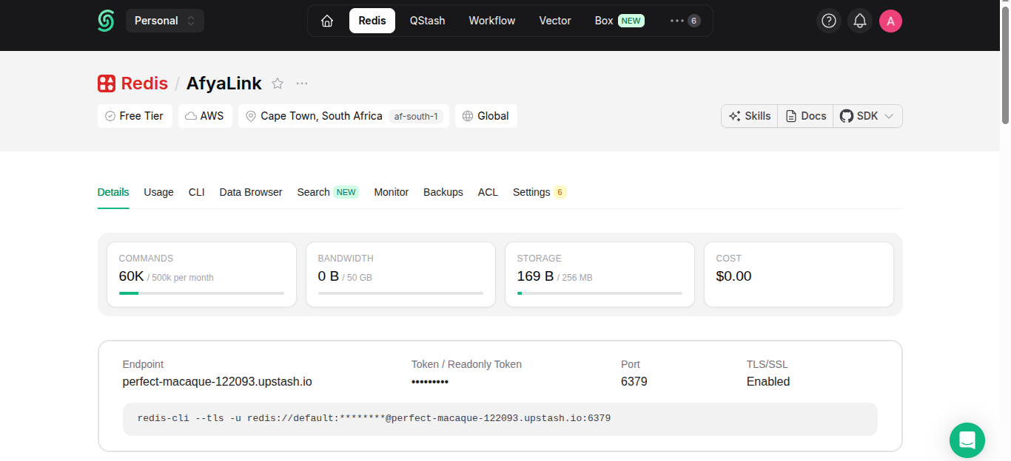

3.9.5 GitHub Repository Management
Git and GitHub were used throughout the project to manage source code versions, facilitate collaboration, and maintain a complete history of development changes.
Activities included:
- Repository initialization
- Branch management
- Commit tracking
- Pull requests (where applicable)
- Version control
- Source code backup

Figure 3.9.5 GitHub Repository
[INSERT GITHUB REPOSITORY SCREENSHOT HERE]

3.10 Debugging Activities
Throughout development, continuous debugging was carried out to improve application stability, reliability, and user experience. Visual Studio Code debugging tools, browser developer tools, server logs, and API testing software were used to identify and resolve issues.

User Interface Issues Resolved
- Component rendering inconsistencies
- Responsive layout adjustments
- Navigation menu alignment
- Form validation improvements
- Accessibility enhancements

Backend Issues Resolved
- API routing errors
- Authentication failures
- Token validation issues
- Session management improvements
- Error handling refinement

Database Issues Resolved
- Database connection failures
- Schema validation errors
- Duplicate record prevention
- Query optimization
- Data consistency improvements

Deployment Issues Resolved
- Environment variable configuration
- Build failures
- API endpoint connectivity
- Cross-Origin Resource Sharing (CORS) configuration
- Production environment testing

Figure 3.10.1 Debugging Session
[INSERT DEBUGGING SCREENSHOT OR LOG OUTPUT HERE]

3.12 System Testing

3.12.1 Introduction
System testing was conducted to verify that the AfyaLink Healthcare Management System met its functional and non-functional requirements as specified during the analysis phase. Testing was performed continuously throughout development to identify software defects, improve system reliability, validate business logic, and ensure that users could successfully interact with the application.
The testing process focused on ensuring that each module operated correctly both independently and as part of the complete healthcare management platform. Testing also confirmed that communication between the frontend, backend, database, and cache services functioned correctly under different operating conditions.

3.12.2 Testing Objectives
The objectives of system testing were to:
- Verify that all functional requirements were successfully implemented.
- Validate user authentication and authorization mechanisms.
- Ensure accurate storage and retrieval of healthcare information.
- Confirm successful communication between frontend and backend services.
- Evaluate system responsiveness and usability.
- Detect and eliminate software defects.
- Verify deployment in the production environment.
- Confirm that user roles access only authorized resources.

3.12.3 Testing Environment
Testing was performed using both local development and cloud deployment environments.

Table 3.12.1 Testing Environment
Component | Environment
Frontend | React.js
Backend | Node.js & Express.js
Database | MongoDB Atlas
Cache | Redis (Upstash)
Browser | Google Chrome
API Testing | Postman
Source Control | GitHub
Frontend Hosting | Vercel
Backend Hosting | Render
Operating System | Ubuntu Linux

3.12.4 Unit Testing
Unit testing involved testing individual modules independently before integrating them into the complete application. Each component was evaluated to ensure it performed its intended function correctly.
The following modules were tested:
- Login Form
- Registration Form
- Forgot Password Module
- Dashboard Components
- Appointment Module
- Medical Records Module
- Billing Module
- User Profile Module
- Navigation Components
- Notification Module

Figure 3.12.1 Unit Testing
[INSERT UNIT TEST SCREENSHOT HERE]

3.12.5 Integration Testing
Integration testing verified communication between multiple system modules after they had been combined into a complete application.
The following integrations were tested:
- React.js ↔ Express.js
- Express.js ↔ MongoDB Atlas
- Express.js ↔ Redis
- Authentication ↔ Dashboard
- Patient Module ↔ Appointment Module
- Appointment Module ↔ Billing Module
- Billing Module ↔ Database
- Medical Records ↔ Database
- User Management ↔ Authentication
Testing confirmed successful interaction among all software components.

Figure 3.12.2 Integration Testing
[INSERT INTEGRATION TEST SCREENSHOT HERE]

3.12.6 Functional Testing
Functional testing was carried out to determine whether each feature satisfied its specified requirements.

Table 3.12.2 Functional Testing Results
Module | Function Tested | Expected Result | Actual Result | Status
Login | User Authentication | User logs in successfully | Successful | Passed
Registration | Account Creation | New account created | Successful | Passed
Forgot Password | Password Recovery | Reset process initiated | Successful | Passed
Dashboard | Dashboard Loading | Dashboard displayed | Successful | Passed
Profile | Update Profile | Information updated | Successful | Passed
Appointment | Book Appointment | Appointment created | Successful | Passed
Medical Records | View Records | Records displayed | Successful | Passed
Billing | View Bills | Billing information displayed | Successful | Passed
Logout | User Logout | Session terminated | Successful | Passed

3.12.7 User Interface Testing
User interface testing evaluated the visual appearance, usability, accessibility, and responsiveness of the application across different devices.
Areas tested included:
- Responsive layouts
- Navigation menus
- Buttons
- Forms
- Input validation
- Typography
- Colour consistency
- Accessibility
- Mobile responsiveness
Testing devices included:
- Desktop Computers
- Laptop Computers
- Tablets
- Android Smartphones

Figure 3.12.3 Responsive Testing
[INSERT RESPONSIVE TEST SCREENSHOT HERE]

3.12.8 API Testing
Application Programming Interfaces (APIs) were tested using Postman to ensure that requests and responses were processed correctly.
The following endpoints were verified:
- Register User
- Login User
- Retrieve User Profile
- Update Patient Information
- Create Appointment
- Retrieve Medical Records
- Billing Information
- Logout
Each endpoint was evaluated for:
- HTTP Status Codes
- Authentication
- Authorization
- Request Validation
- Response Time
- Error Handling

Figure 3.12.4 Postman API Testing
[INSERT POSTMAN SCREENSHOT HERE]

3.12.9 Database Testing
Database testing confirmed that MongoDB Atlas correctly stored, updated, deleted, and retrieved application data.
Operations tested included:
- Insert
- Update
- Delete
- Read
- Authentication Records
- Appointment Records
- Medical Records
- Billing Information
- Audit Logs
Database testing confirmed data consistency and integrity.

Figure 3.12.5 MongoDB Testing
[INSERT DATABASE TESTING SCREENSHOT HERE]

3.12.10 Performance Testing
Performance testing was conducted to evaluate the responsiveness and stability of the application under normal operating conditions.
Performance indicators evaluated included:
- Login response time
- Dashboard loading speed
- Appointment retrieval
- Database query performance
- API response time
- Redis cache performance
The system maintained acceptable response times and remained stable throughout testing.

3.12.11 Security Testing
Security testing ensured that sensitive healthcare information remained protected against unauthorized access.
Security mechanisms verified included:
- Password hashing
- Secure authentication
- JWT Token validation
- Role-Based Access Control
- Session management
- Input validation
- HTTPS communication
- Protected API routes
- Database authorization
No critical security vulnerabilities were identified during testing.

3.12.12 User Acceptance Testing (UAT)
User Acceptance Testing was conducted with a sample of intended users to verify that the system met operational expectations.
Participants evaluated:
- Ease of navigation
- Interface appearance
- Appointment booking
- Medical records access
- Billing information
- Login process
- Dashboard usability
Feedback indicated that the application was intuitive, responsive, and suitable for healthcare service delivery. Suggestions received mainly focused on adding future enhancements such as mobile applications, SMS notifications, and online consultation features.

Figure 3.12.6 User Acceptance Testing
[INSERT USER ACCEPTANCE TESTING SCREENSHOT HERE]

3.12.13 Overall Testing Results

Table 3.12.3 Overall Testing Results
Module | Test Conducted | Result
Login Module | Authentication Testing | Passed
Registration Module | Form Validation | Passed
Forgot Password | Password Recovery | Passed
Patient Dashboard | Navigation Testing | Passed
Administrator Dashboard | Role Access Testing | Passed
Doctor Dashboard | Clinical Module Testing | Passed
Nurse Dashboard | Patient Care Testing | Passed
Community Health Worker Dashboard | Outreach Module Testing | Passed
Appointment Module | Booking Process | Passed
Medical Records | CRUD Operations | Passed
Billing Module | Billing Information | Passed
MongoDB Database | CRUD Operations | Passed
Redis Cache | Cache Performance | Passed
REST APIs | API Testing | Passed
Frontend Deployment | Production Testing | Passed
Backend Deployment | Production Testing | Passed
System Integration | End-to-End Testing | Passed
Security | Access Control Testing | Passed

3.13 Deployment Verification
Following successful deployment, production verification was carried out to ensure that the live application functioned correctly.
The verification process confirmed:
- Frontend successfully deployed on Vercel.
- Backend successfully deployed on Render.
- MongoDB Atlas connected successfully.
- Redis cache functioning correctly.
- HTTPS enabled.
- Authentication working correctly.
- Database transactions completed successfully.
- API endpoints responding correctly.
- Role-based dashboards accessible according to user permissions.

Figure 3.13.1 Live System
[INSERT LIVE APPLICATION SCREENSHOT HERE]

Figure 3.13.2 Vercel Deployment
[INSERT VERCEL DEPLOYMENT SCREENSHOT HERE]

Figure 3.13.3 Render Deployment
[INSERT RENDER DEPLOYMENT SCREENSHOT HERE]

3.14 Challenges Encountered During Development
Several challenges were encountered during implementation and deployment.
These included:
- Authentication token management.
- Route protection for different user roles.
- Responsive design adjustments across devices.
- API communication errors during development.
- MongoDB connection configuration.
- Redis integration and cache synchronization.
- Environment variable management.
- Cloud deployment configuration.
- Dependency compatibility issues.
- Performance optimization of database queries.
Each challenge was addressed through debugging, code refactoring, documentation review, and repeated testing.

3.15 Chapter Summary
This chapter presented the implementation, deployment, and comprehensive testing of the AfyaLink Healthcare Management System. Frontend interfaces were developed using React.js, backend services using Node.js and Express.js, and persistent data storage was implemented with MongoDB Atlas, complemented by Redis caching for improved performance. Role-based dashboards, RESTful APIs, and cloud deployment were successfully completed, while extensive unit, integration, functional, performance, security, and user acceptance testing confirmed that the system met its objectives. The successful deployment and verification of the application demonstrate that AfyaLink provides a secure, scalable, and reliable healthcare management platform. The next chapter presents the overall conclusions, limitations, recommendations, and future enhancements for the project.

CHAPTER FOUR

CONCLUSION AND RECOMMENDATIONS

4.1 Introduction
This chapter presents the overall conclusion of the AfyaLink Healthcare Management System project. It summarizes the work carried out from the planning and analysis phase through system design, implementation, deployment, and testing. The chapter also discusses the achievements of the project, challenges encountered during development, limitations of the current system, recommendations for improvement, and possible future enhancements.
The purpose of this chapter is to evaluate whether the project objectives established in Chapter One were achieved and to provide guidance for future development of the system.

4.2 Project Summary
The AfyaLink Healthcare Management System was developed to provide an integrated, secure, and web-based platform for managing healthcare services. The project was initiated after identifying challenges associated with manual healthcare management, fragmented information systems, delayed service delivery, and limited access to patient information.
The development process followed the Software Development Life Cycle (SDLC), beginning with requirements gathering and system analysis. The project progressed through system design, frontend and backend implementation, database integration, deployment, debugging, and comprehensive testing.
The completed system provides secure authentication, role-based access control, patient registration, appointment scheduling, medical record management, billing services, administrative management, and healthcare staff dashboards. The application integrates React.js for the frontend, Node.js and Express.js for backend services, MongoDB Atlas for database management, and Redis (Upstash) for caching and performance optimization. The solution was successfully deployed using Vercel and Render, making it accessible over the Internet.
The project demonstrated the effectiveness of modern web technologies in addressing healthcare management challenges and provided a scalable platform for future enhancements.

4.3 Achievement of Project Objectives
The general objective of the project was to develop a secure web-based healthcare management system that improves patient services, healthcare administration, and information management.
The following specific objectives were successfully achieved:

Objective 1
To develop a secure authentication and authorization system.
Achievement
A secure authentication system was implemented using encrypted passwords, JSON Web Tokens (JWT), and Role-Based Access Control (RBAC). Users are authenticated before accessing system resources, and permissions are granted according to assigned roles.

Objective 2
To develop an online patient management platform.
Achievement
Patients can register, log in securely, update their profiles, manage appointments, access medical records, and view billing information through a centralized dashboard.

Objective 3
To develop dashboards for healthcare professionals.
Achievement
Dedicated dashboards were successfully developed for system administrators, super administrators, doctors, nurses, community health workers, and other healthcare personnel, enabling each category of user to access only authorized resources.

Objective 4
To implement appointment scheduling services.
Achievement
Patients can search healthcare providers, schedule appointments, and monitor appointment status through the appointment management module.

Objective 5
To develop secure backend services.
Achievement
RESTful APIs were successfully implemented using Node.js and Express.js to process authentication, appointments, billing, patient information, and medical records.

Objective 6
To implement cloud database services.
Achievement
MongoDB Atlas was successfully integrated as the primary cloud database, while Redis improved system performance through caching.

Objective 7
To deploy the application online.
Achievement
The frontend application was deployed on Vercel, while backend services were deployed on Render, making the application accessible over the Internet.

Objective 8
To test the developed system.
Achievement
Comprehensive testing, including unit testing, integration testing, functional testing, user acceptance testing, performance testing, and security testing, confirmed that the system operates as intended.

4.4 Benefits of the System
The implementation of AfyaLink Healthcare Management System provides several advantages over traditional manual healthcare management methods.
The system offers:
- Centralized healthcare information management.
- Faster patient registration.
- Secure authentication.
- Efficient appointment scheduling.
- Improved healthcare record management.
- Better billing management.
- Reduced paperwork.
- Improved communication between patients and healthcare providers.
- Increased data security.
- Enhanced administrative efficiency.
- Better reporting capabilities.
- Improved scalability through cloud deployment.
These benefits contribute to improved healthcare service delivery and operational efficiency.

4.5 Challenges Encountered
Several challenges were encountered during the development and deployment of the project.
These included:
- Configuring secure authentication.
- Managing role-based permissions.
- Debugging frontend and backend integration.
- Connecting MongoDB Atlas to deployed backend services.
- Configuring Redis caching.
- Managing environment variables across development and production environments.
- Resolving deployment configuration issues.
- Ensuring responsive layouts across different screen sizes.
- Testing APIs with authentication tokens.
- Optimizing database queries for improved performance.
Each challenge was successfully addressed through debugging, software documentation, testing, and code optimization.

4.6 Limitations of the Current System
Although the project achieved its intended objectives, several limitations remain.
These include:
- No mobile application is currently available.
- Laboratory equipment integration has not been implemented.
- Payment gateway integration is not yet available.
- SMS notification services are not implemented.
- Artificial intelligence support has not been incorporated.
- National health information systems are not integrated.
These limitations present opportunities for future development.

4.7 Recommendations
To improve the effectiveness of AfyaLink Healthcare Management System, the following recommendations are proposed:
- Develop native Android and iOS mobile applications.
- Integrate laboratory information systems.
- Integrate secure online payment gateways.
- Introduce SMS notification services.
- Develop analytical reporting dashboards.
- Strengthen cybersecurity monitoring.
- Introduce machine learning models for healthcare analytics.
- Integrate national health insurance systems where applicable.
- Expand multilingual support to improve accessibility.
Implementing these recommendations would significantly enhance the functionality and usability of the system.

4.8 Areas for Future Research
Future research may focus on the integration of emerging technologies into healthcare management systems.
Possible research areas include:
- Artificial Intelligence for disease prediction.
- Machine learning for appointment optimization.
- Blockchain for secure healthcare records.
- Internet of Things (IoT) integration with medical devices.
- Predictive healthcare analytics.
- Cloud-native healthcare infrastructure.
- Mobile healthcare applications.
- Electronic prescription automation.
- Voice-assisted healthcare systems.
- Smart hospital management.
These technologies have the potential to improve healthcare quality, reduce operational costs, and enhance patient outcomes.

4.9 Conclusion
The AfyaLink Healthcare Management System successfully achieved its primary goal of providing a secure, centralized, and web-based healthcare management platform. The system integrates patient management, appointment scheduling, medical records, billing, role-based dashboards, and administrative functions within a modern software architecture.
The application demonstrates the practical use of contemporary web technologies, including React.js, Node.js, Express.js, MongoDB Atlas, Redis, GitHub, Vercel, and Render, to solve real-world healthcare challenges. The implementation of Role-Based Access Control, secure authentication, cloud deployment, and comprehensive testing has resulted in a reliable and scalable solution capable of supporting healthcare institutions.
Overall, the project provides a strong foundation for digital healthcare management and offers significant opportunities for future expansion through mobile applications, artificial intelligence, telemedicine, and integration with external healthcare services. The successful completion of this project demonstrates that the objectives established at the beginning of the study were achieved and that AfyaLink Healthcare Management System is suitable for deployment in healthcare environments.

REFERENCES
(Format these according to your institution's required citation style, such as APA 7th Edition.)
- Fielding, R. T. (2000). Architectural Styles and the Design of Network-Based Software Architectures. University of California.
- Gamma, E., Helm, R., Johnson, R., & Vlissides, J. (1994). Design Patterns: Elements of Reusable Object-Oriented Software. Addison-Wesley.
- MDN Web Docs. HTML, CSS and JavaScript Documentation.
- MongoDB Inc. MongoDB Atlas Documentation.
- Node.js Foundation. Node.js Documentation.
- Oracle. JavaScript Documentation.
- Postman Inc. Postman API Platform Documentation.
- React Team. React Documentation.
- Redis Ltd. Redis Documentation.
- Render. Render Deployment Documentation.
- Vercel. Vercel Documentation.
- World Health Organization (WHO). Digital Health Strategy.
- Zetech University. Diploma in Computer Science Project Guidelines.

