CHAPTER TWO: DESIGN AND MODELING

Introduction to Modelling
This chapter presents the system designs and models developed to visualize the AfyaLink Healthcare Human Resource Management System before full implementation. The models show how users interact with the system, how data moves between the frontend, backend, database, and cache services, and how the main modules support patient self-service, appointment booking, medical records, billing, and secure access control.

User Interface Models

Login page
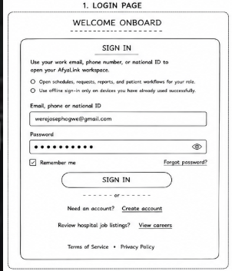

Figure 2.2.1 Login page
The login page allows registered AfyaLink users to access the system securely by entering their email address, phone number, or national ID together with their password. The page is the first security point and directs authenticated users to the correct workspace based on their account role.

Create account page
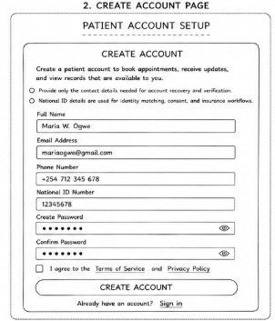

Figure 2.2.2 Create account page
The create account page enables new patients to register for AfyaLink by providing their personal identification and contact details. The form captures details such as name, email, phone number, national ID, password, and optional insurance information so that the patient can later use self-service features in the system.

Patient portal dashboard
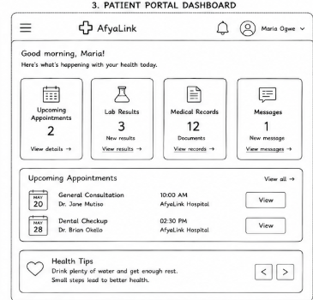

Figure 2.2.3 Patient portal dashboard
The patient portal dashboard acts as the main working area for a logged-in patient. It provides quick access to appointments, medical records, bills, insurance details, profile information, and important alerts, making it easy for a patient to monitor their healthcare activities from one screen.

Appointments page
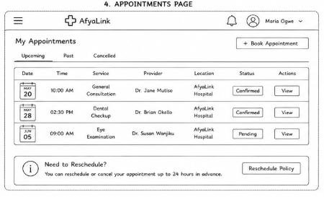
Figure 2.2.4 Appointments page
The appointments page supports searching for nearby hospitals and booking healthcare visits. A patient can enter their location, select consultation options, and begin the appointment process without visiting the facility physically, which improves service access and planning.

Medical records page
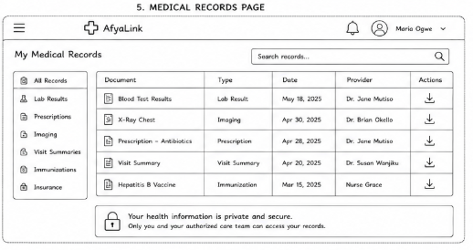

Figure 2.2.5 Medical records page
The medical records page displays the patient health history in an organized way. It shows encounter details, diagnoses, treatment information, laboratory results, and other records that help patients and authorized healthcare staff follow treatment history accurately.

Logic Models

Log in process flowchart.
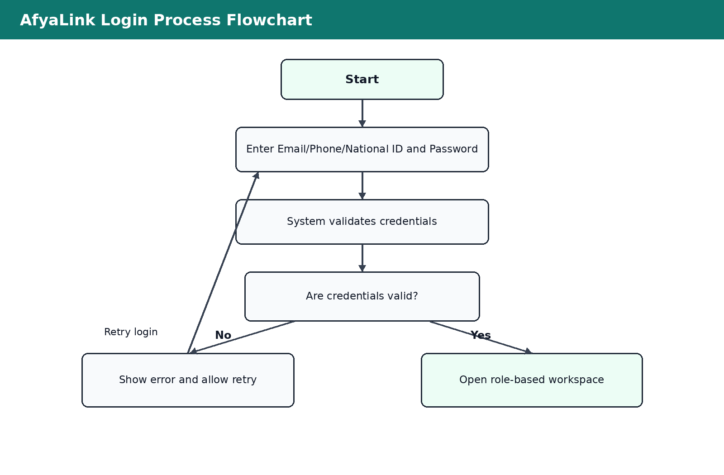
Figure 2.3.1 Login process flowchart
The login process flowchart shows the steps followed when a user attempts to access AfyaLink. The system receives login details, validates them through the backend, rejects invalid attempts with an error message, and allows valid users into the correct role-based workspace.

System flow chart
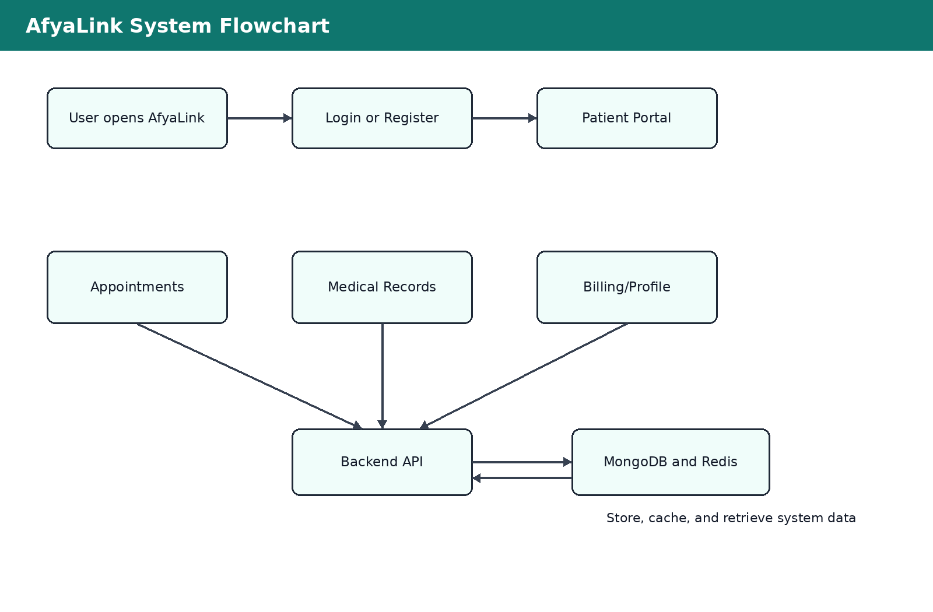
Figure 2.3.2 System flowchart
The system flowchart shows the general movement of users through AfyaLink. After login or registration, users access the patient portal and select modules such as appointments, medical records, billing, or profile management. The backend processes requests, stores and retrieves records from MongoDB, and uses Redis for fast access to temporary or frequently used data.

Data flow diagrams
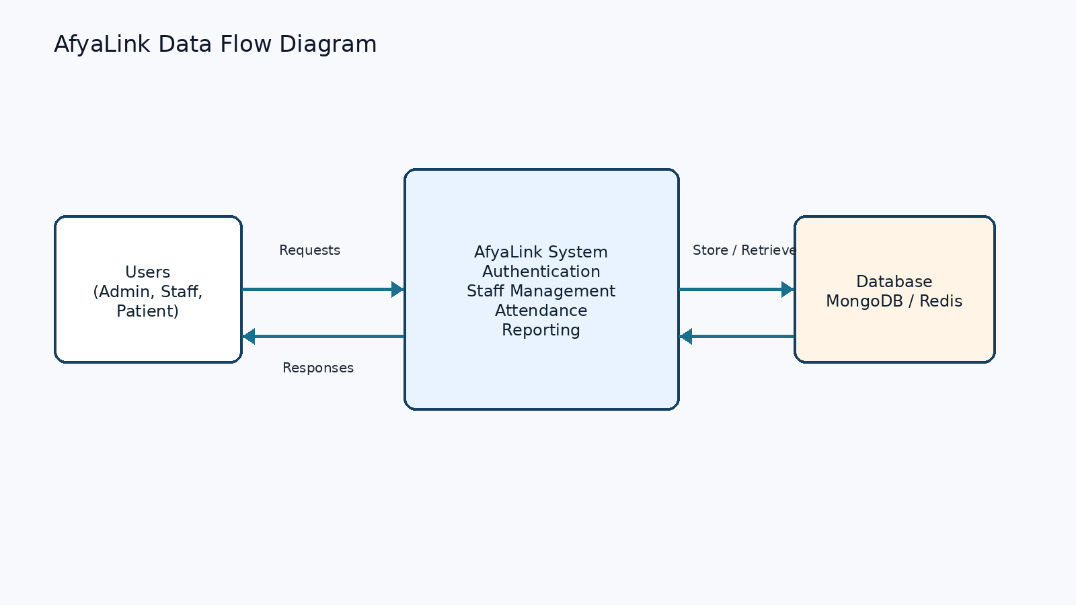
Figure 2.3.3 Data Flow Diagram
The data flow diagram illustrates how information moves between the patient, the AfyaLink frontend, the backend services, and the database. Patient requests such as registration, login, appointment booking, and medical record viewing are processed by the backend before responses are returned to the user interface.

Entity relationship diagram
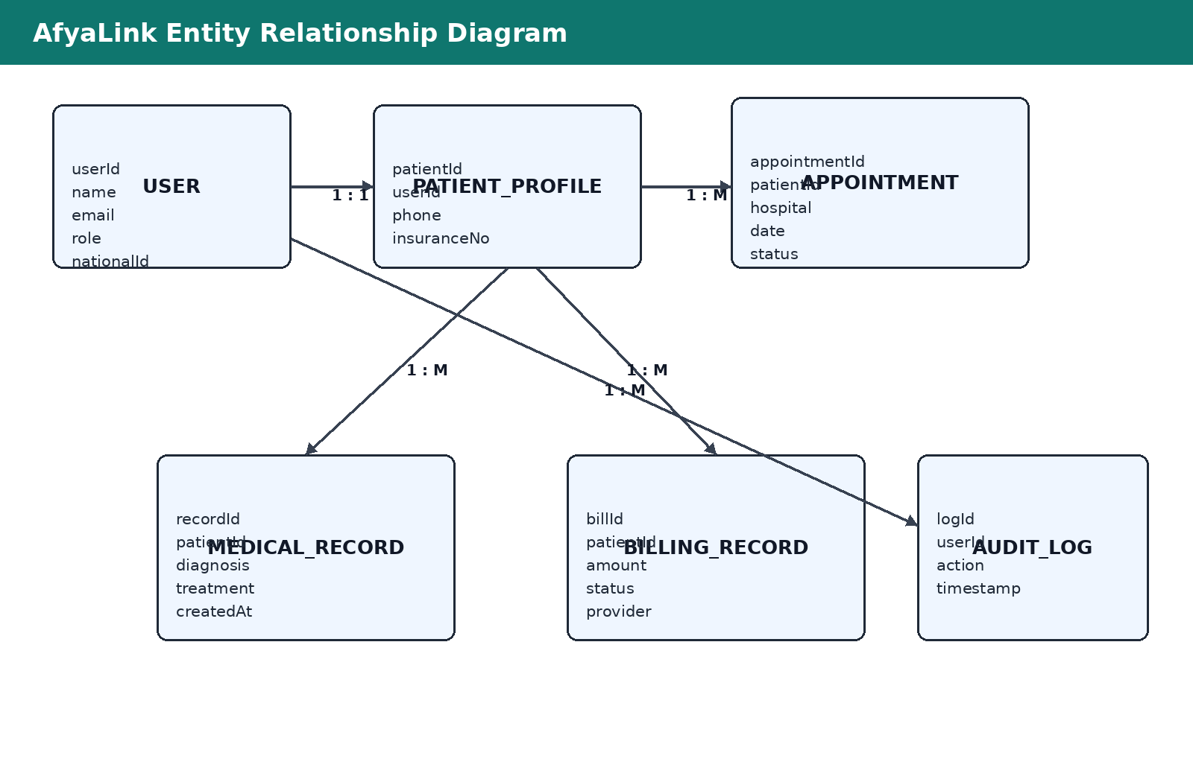
Figure 2.3.4 ER Diagram
The entity relationship diagram shows how the main data entities relate to each other. A user may have a patient profile, and the patient profile is connected to appointments, medical records, billing records, and audit logs. These relationships support organized storage and retrieval of healthcare information.

Use case diagram
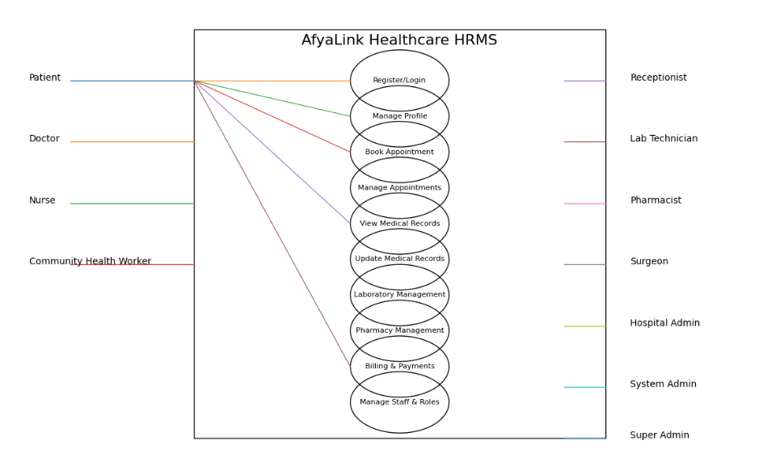
Figure 2.3.5 Use case diagram
The use case diagram presents the main interactions between AfyaLink and its users. Patients can register, log in, manage their profile, book appointments, view medical records, and check billing details, while authorized staff and administrators manage healthcare records and system operations according to their assigned roles.

Class diagrams
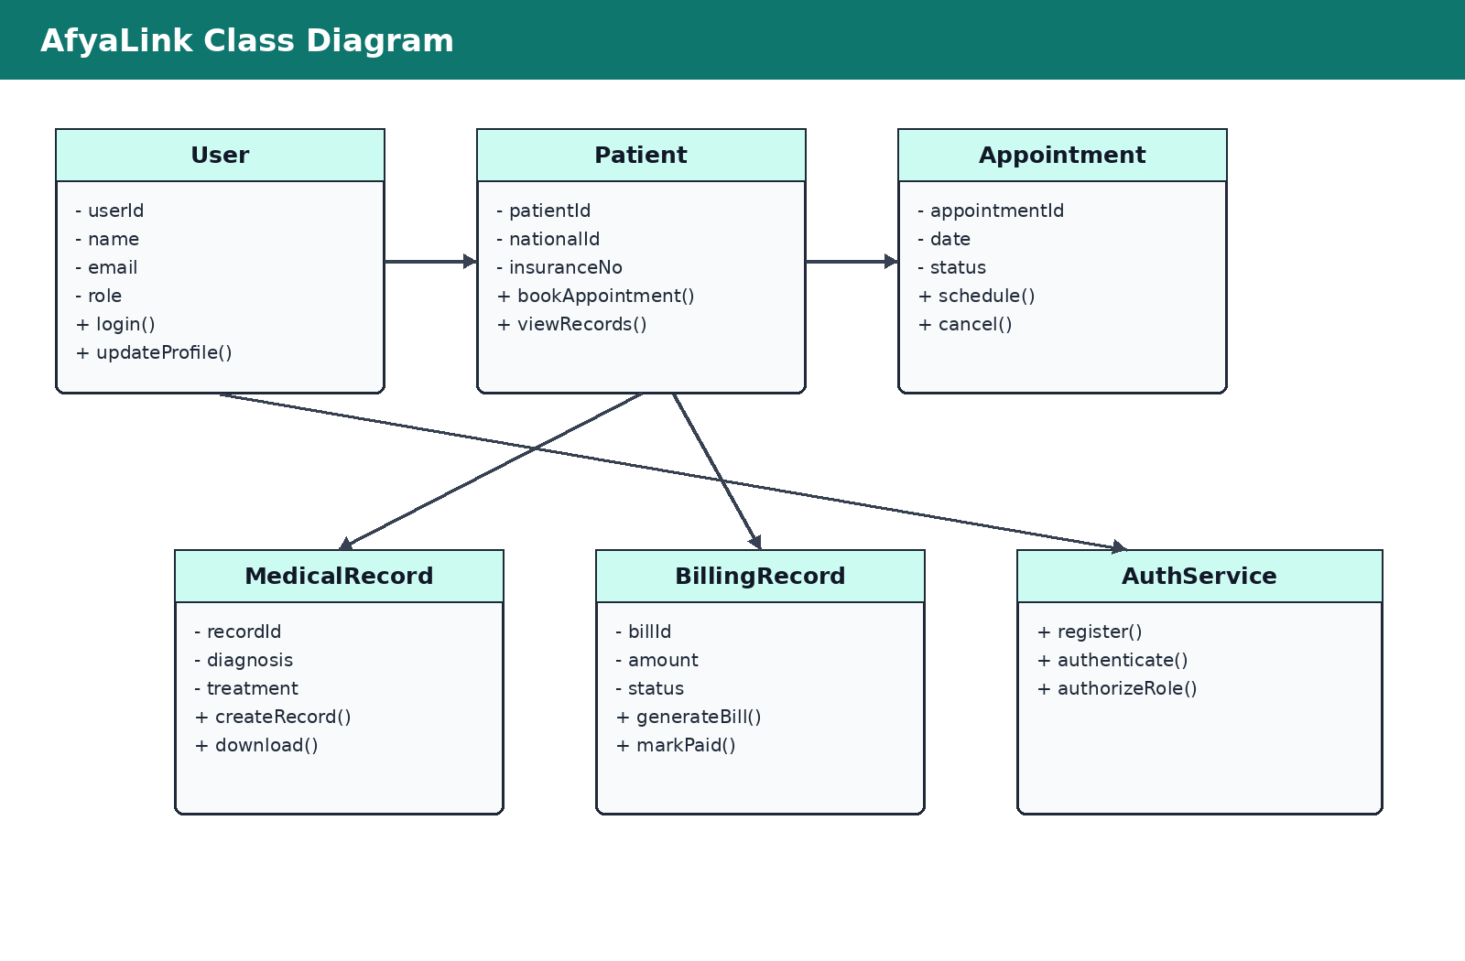
Figure 2.3.6 Class diagram
The class diagram identifies the major classes used in the system design, including User, Patient, Appointment, MedicalRecord, BillingRecord, and AuthService. These classes show the attributes and operations required to support secure authentication, patient services, appointment scheduling, record access, and billing management.

