ZETECH UNIVERSITY
RESEARCH METHODS IN I.T. (DSE 222)
FINAL RESEARCH PROPOSAL
AfyaLink: A Web-Based Healthcare Human Resource Management System (HRMS)
SUBMITTED BY
Joseph Ogwe Were
Registration Number: DCS-03-8586/2024

A research proposal submitted in partial fulfilment of the requirements for the award of Diploma in Computer Science by Zetech University.

MAY 2026

DECLARATION
I, Joseph Ogwe Were, declare that this research proposal is my original work and has not been submitted to any other university, institution, or examining body for academic award. All sources used in this proposal have been acknowledged appropriately.
Student Name: | Joseph Ogwe Were
Registration Number: | DCS-03-8586/2024
Signature: | ____________________________
Date: | ____________________________

APPROVAL
This research proposal has been submitted for examination with the approval of the undersigned supervisor.
Supervisor Name: | ____________________________
Signature: | ____________________________
Date: | ____________________________

DEDICATION
This proposal is dedicated to my family, mentors, and healthcare professionals whose daily commitment to patient care continues to inspire the development of better digital health systems.

ACKNOWLEDGEMENT
I acknowledge my lecturer, classmates, and the healthcare practitioners whose experiences informed this proposal. I also appreciate the support received during the analysis and design of AfyaLink.

ABSTRACT
Healthcare institutions depend on accurate staff records, secure access control, reliable attendance management, and timely reporting in order to deliver quality services. Many facilities still rely on paper-based records, spreadsheets, or fragmented digital tools that create data inconsistency, weak accountability, and delayed decision-making. This research proposes AfyaLink, a web-based Healthcare Human Resource Management System designed to improve staff management, role-based access, attendance tracking, compliance monitoring, and administrative reporting in healthcare institutions. The study adopts a design and development research approach supported by interviews, observation, and document analysis. Agile methodology is proposed for iterative system development, while the system design is illustrated using architecture, data flow, and use case models. The expected outcome is a secure and centralized platform that improves administrative efficiency, data accuracy, transparency, accountability, and service delivery in healthcare organizations.

DEFINITION OF KEY TERMS
Term | Definition
AfyaLink | The proposed web-based Healthcare Human Resource Management System for healthcare institutions.
Human Resource Management System (HRMS) | A digital system used to manage employee records, attendance, roles, reports, and related HR operations.
Role-Based Access Control (RBAC) | A security approach that grants system access according to a user role and assigned permissions.
Audit Trail | A record of user actions used to support accountability, monitoring, and compliance.
Web-Based System | An information system accessed through a web browser over a network.

ABBREVIATIONS AND ACRONYMS
Abbreviation | Meaning
API | Application Programming Interface
DFD | Data Flow Diagram
ERD | Entity Relationship Diagram
FHIR | Fast Healthcare Interoperability Resources
HL7 | Health Level Seven
HRMS | Human Resource Management System
ICT | Information and Communication Technology
IT | Information Technology
RBAC | Role-Based Access Control
UAT | User Acceptance Testing

TABLE OF CONTENTS
DECLARATION
APPROVAL
DEDICATION
ACKNOWLEDGEMENT
ABSTRACT
DEFINITION OF KEY TERMS
ABBREVIATIONS AND ACRONYMS
CHAPTER ONE: PROJECT PLANNING AND ANALYSIS
1.1 Introduction
1.2 Background of the Study
1.3 Statement of the Problem
1.4 Study Justification
1.5 System Objectives
1.6 Research Questions
1.7 Scope of the Study
1.8 Target Users
1.9 Expected Outcomes
CHAPTER TWO: LITERATURE REVIEW
CHAPTER THREE: RESEARCH METHODOLOGY AND SYSTEM DESIGN
CHAPTER FOUR: PROJECT IMPLEMENTATION PLAN
REFERENCES
APPENDICES

LIST OF FIGURES
Figure 3.1: AfyaLink system architecture.
Figure 3.2: AfyaLink data flow diagram.
Figure 3.3: AfyaLink use case diagram.

LIST OF TABLES
Table 1.1: Functional requirements of AfyaLink.
Table 3.1: Functional and non-functional requirements of AfyaLink.
Table 4.1: AfyaLink development tools and platform components.
Table 4.2: Project schedule breakdown.
Table 4.3: Proposed budget for the AfyaLink research proposal.

CHAPTER ONE: PROJECT PLANNING AND ANALYSIS

1.1 Introduction
The healthcare sector relies heavily on efficient management of human resources to deliver quality patient care. Hospitals and healthcare institutions require accurate staff records, attendance tracking, role-based access, compliance monitoring, and secure communication. This research proposes AfyaLink, a web-based Healthcare Human Resource Management System designed to automate and streamline human resource operations in healthcare institutions.

1.2 Background of the Study
Healthcare institutions manage diverse personnel such as doctors, nurses, laboratory technicians, pharmacists, community health workers, and administrative staff. Traditional HR practices such as paper-based records, spreadsheets, and disconnected systems lead to challenges such as data redundancy, loss of records, delayed decision-making, and poor accountability. With advances in information technology, web-based systems offer secure, scalable, and efficient solutions. AfyaLink aims to provide a centralized platform for managing healthcare staff, improving efficiency, transparency, and compliance with data protection requirements.

1.3 Statement of the Problem
Many healthcare institutions face challenges in managing human resources effectively. Manual record-keeping leads to data loss and inaccuracies, access control remains weak, attendance and performance tracking are inconsistent, compliance and audit trails are difficult to monitor, and HR processes are poorly integrated with digital systems. These challenges negatively affect operational efficiency and the quality of healthcare services. There is therefore a need for a secure, reliable, and automated healthcare HR management system.

1.4 Study Justification
The development of AfyaLink is justified by the need to improve administrative efficiency, data accuracy, accountability, and secure access to healthcare staff records. The system will help healthcare administrators reduce manual paperwork, monitor attendance, generate timely reports, and maintain audit trails. It also supports better decision-making by providing centralized information for HR officers and management.

1.5 System Objectives

1.5.1 General Objective
To design and propose AfyaLink, a web-based Healthcare Human Resource Management System that improves efficiency, security, and accountability in healthcare institutions.

1.5.2 Specific Objectives
- To analyze existing HR management challenges in healthcare institutions.
- To design a secure user authentication and role-based access system.
- To develop a centralized staff management and record-keeping system.
- To implement attendance monitoring, audit logging, and compliance support features.
- To evaluate the effectiveness of the proposed system in improving HR operations.

1.6 Research Questions
- What challenges do healthcare institutions face in managing human resources using existing systems?
- How can a web-based HRMS improve efficiency and data accuracy in healthcare institutions?
- What security mechanisms are required to protect sensitive healthcare staff data?
- How effective is AfyaLink in supporting healthcare HR operations compared to traditional systems?

1.7 Scope of the Study
This proposal focuses on the design of a web-based HRMS for healthcare institutions. The scope covers user authentication, role-based access control, staff record management, attendance tracking, reporting, and compliance support. The proposal does not cover detailed financial accounting, patient clinical management, or national production deployment beyond the project design stage.

1.8 Target Users
- Hospital administrators
- Human resource officers
- Healthcare staff such as doctors, nurses, and laboratory personnel
- Compliance and audit officers
- System administrators

1.9 Expected Outcomes
- Improved accuracy of staff records and attendance data.
- Reduced delays caused by manual HR processes.
- Stronger access control and accountability through role-based permissions.
- Faster generation of HR reports for management decision-making.
- A reusable system design that can be improved into a working prototype.

1.10 Functional Requirements
Table 1.1: Functional requirements of AfyaLink.
User | User Activities | System Features
Administrator | Create users, assign roles, and monitor system use | Authentication, role management, and audit trail module
HR Officer | Register staff, update staff records, and generate reports | Staff management and reporting module
Healthcare Staff | View assigned profile details and attendance records | Staff self-service module
Supervisor | Review attendance and approve HR actions | Attendance monitoring and approval module
Compliance Officer | Review audit records and access reports | Compliance dashboard and audit logs

CHAPTER TWO: LITERATURE REVIEW

2.1 Introduction
This chapter reviews existing literature related to Healthcare Human Resource Management Systems, digital transformation in healthcare institutions, information security in web-based systems, and role-based access control mechanisms. The purpose of the literature review is to examine previous studies, theoretical foundations, and existing systems in order to identify gaps that justify the development of AfyaLink.

2.2 Objectives of the Literature Review
- To examine existing Human Resource Management Systems used in healthcare institutions.
- To explore the role of information technology in improving healthcare administrative efficiency.
- To analyze security mechanisms used in web-based HR systems.
- To identify gaps in current systems that justify the development of AfyaLink.

2.3 Key Concepts

2.3.1 Human Resource Management System (HRMS)
A Human Resource Management System is a digital platform designed to automate and manage human resource processes such as employee records, attendance, recruitment, performance evaluation, and compliance monitoring. HRMS platforms improve organizational efficiency by reducing manual paperwork, minimizing human error, and enabling centralized data management (Laudon & Laudon, 2022). In healthcare institutions, HRMS is important because of the complexity of staffing structures, regulatory obligations, and the need for accurate scheduling of clinical personnel.

2.3.2 Healthcare Information Systems
Healthcare Information Systems are integrated systems used to manage healthcare data, including patient information, staff records, billing, and hospital operations. Many healthcare systems focus primarily on patient management and neglect human resource management, creating administrative inefficiencies. AfyaLink seeks to bridge this gap by focusing specifically on healthcare human resource operations while still aligning with broader digital hospital workflows.

2.3.3 Web-Based Systems
A web-based system is an application accessed through a web browser over a network. Web-based systems offer remote accessibility, centralized data storage, real-time updates, scalability, and reduced installation and maintenance costs. According to Sommerville (2016), web-based information systems provide a practical architecture for organizations that need shared access and centralized control across multiple users and departments.

2.3.4 Role-Based Access Control (RBAC)
Role-Based Access Control is a security mechanism that restricts system access based on user roles. Instead of assigning permissions individually, permissions are grouped into roles such as Administrator, HR Officer, Doctor, or Nurse. Sandhu, Coyne, Feinstein, and Youman (1996) argue that RBAC enhances data security and administrative efficiency by ensuring users access only information relevant to their responsibilities. In healthcare environments where staff data is sensitive, RBAC is essential for maintaining confidentiality and compliance.

2.3.5 Information Security in Healthcare Systems
Healthcare institutions handle sensitive personal and professional data. Information security principles such as confidentiality, integrity, and availability are critical in protecting healthcare information systems. Cybersecurity threats such as unauthorized access, data breaches, and system misuse can compromise institutional trust and operational efficiency. The Kenya Data Protection Act, 2019 reinforces the need for lawful data handling, security safeguards, and responsible processing of personal data in digital systems.

2.3.6 Digital Transformation in Healthcare Administration
Digital transformation refers to the integration of digital technologies into all aspects of organizational operations. In healthcare administration, digital transformation improves decision-making speed, record accuracy, transparency, compliance monitoring, and resource allocation. Despite global trends toward digitization, many institutions still rely on manual HR processes. This creates a need for affordable, secure, and scalable digital HR solutions such as AfyaLink.

2.4 Summary of Literature Review
The reviewed literature demonstrates that HRMS improves efficiency and reduces administrative errors. Web-based systems provide scalability and accessibility advantages, while security mechanisms such as RBAC are essential in healthcare environments. However, there remains a gap in specialized, secure, and healthcare-focused HR management systems tailored to institutional needs. AfyaLink addresses this gap by providing a centralized, web-based, and secure HRMS designed specifically for healthcare institutions.

CHAPTER THREE: RESEARCH METHODOLOGY AND SYSTEM DESIGN

3.1 Introduction
This chapter describes the research methodology used in the development of AfyaLink. It outlines the research design, data collection methods, system development methodology, system design approach, requirements, and testing techniques used in the study.

3.2 Research Design
This study adopts a design and development research approach. The approach is appropriate because it focuses on designing, developing, and evaluating a functional system to solve real-world challenges in healthcare human resource management. The process involves problem identification, requirements analysis, system design, system development, and testing.

3.3 Data Collection Methods

3.3.1 Interviews
Interviews are proposed with healthcare administrators, HR officers, and staff members in order to gather detailed information on current HR practices, pain points, reporting needs, and expectations for a digital solution.

3.3.2 Observation
Observation is used to examine how HR activities such as staff registration, attendance tracking, approvals, and report preparation are carried out in practice. This helps identify actual workflow gaps that may not be captured fully through interviews alone.

3.3.3 Document Analysis
Document analysis is used to review existing staff records, attendance logs, policy documents, and related administrative forms. The reviewed documents help identify duplication, delays, and control weaknesses in the current process.

3.4 System Development Methodology
The system is developed using Agile methodology because Agile supports iterative delivery, regular feedback, and continuous refinement during development (Pressman & Maxim, 2020). This is suitable for AfyaLink because system requirements can be validated progressively with intended users during the design and prototyping stages.

3.5 System Design

3.5.1 System Architecture
AfyaLink uses a client-server architecture in which users access the system through web browsers, business logic is processed by a Node.js and Express backend, and data is stored in MongoDB and Redis. The project also supports observability and integration services that improve reliability and extensibility.
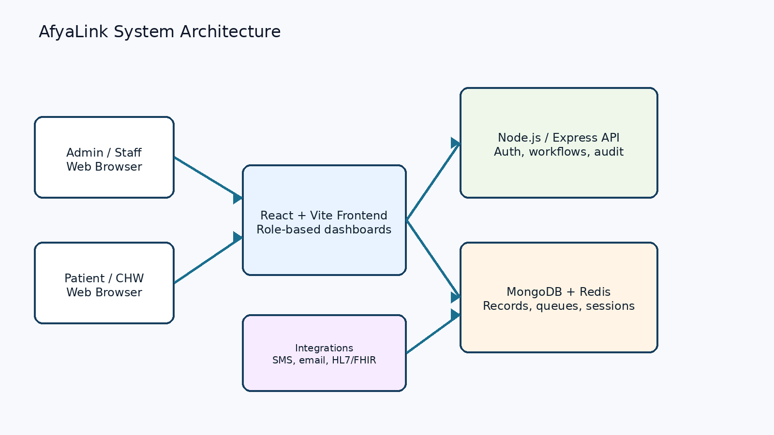
Figure 3.1: AfyaLink system architecture.

3.5.2 Data Flow Diagram
The data flow diagram shows how users submit requests to the AfyaLink system, how the system processes those requests, and how data is stored and retrieved from the database to support staff administration, attendance management, and reporting.
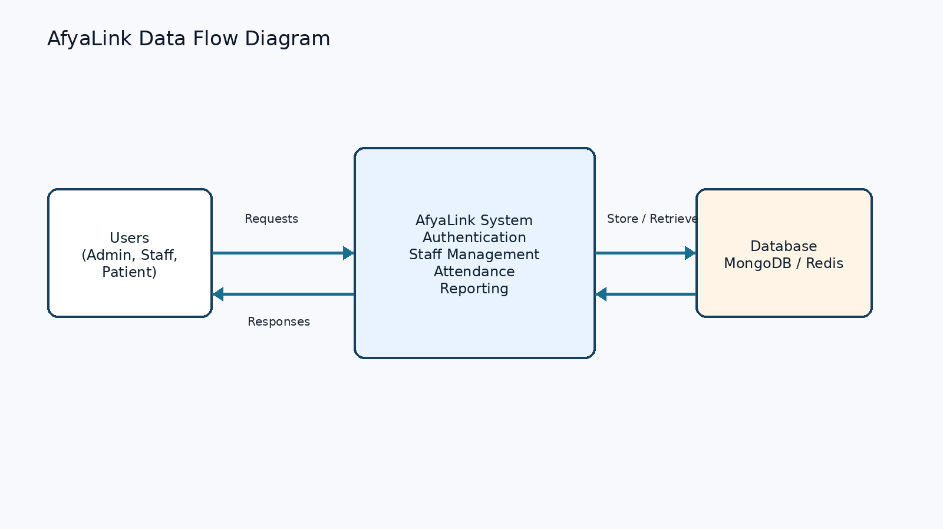
Figure 3.2: AfyaLink data flow diagram.

3.5.3 Use Case Diagram
The use case diagram summarizes the main interactions between users and the system. Administrative users are expected to log in, manage staff details, track attendance, and generate reports, while staff interact with the relevant modules based on their assigned roles.
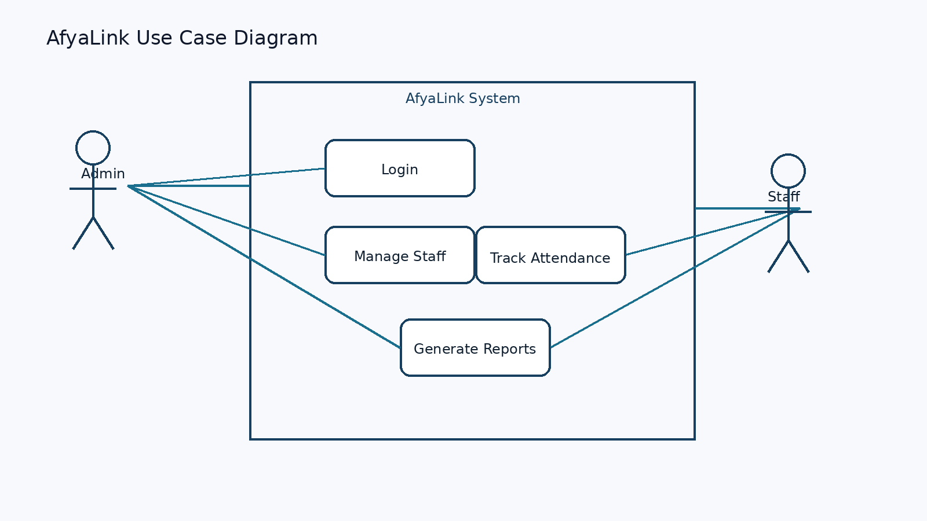
Figure 3.3: AfyaLink use case diagram.

3.6 System Requirements
Table 3.1: Functional and non-functional requirements of AfyaLink.
Category | Requirements
Functional Requirements | User authentication, role-based access control, staff management, attendance tracking, audit logging, and reporting.
Non-Functional Requirements | Security, scalability, usability, reliability, maintainability, and data integrity.

3.7 System Testing

3.7.1 Unit Testing
Individual components are tested independently to confirm that each module performs its expected function correctly.

3.7.2 Integration Testing
Modules are tested together to ensure that data passes correctly between authentication, staff management, attendance, and reporting workflows.

3.7.3 User Acceptance Testing
Intended users review the prototype to confirm that the system meets operational requirements and is usable in real administrative settings.

3.8 Ethical Considerations
Ethical standards are observed throughout the proposed study. Information obtained from respondents is treated confidentially and used strictly for academic purposes. The proposal also recognizes the need to comply with the Kenya Data Protection Act, 2019 when handling personal data collected during system analysis and future deployment.

3.9 Summary
This chapter has described the methodology used in developing AfyaLink, including the research design, data collection methods, system design approach, requirements, development methodology, and testing techniques. The methodology provides a structured foundation for implementing the proposed system.

CHAPTER FOUR: PROJECT IMPLEMENTATION PLAN

4.1 Breakdown of Tools and Resources to Be Used
Table 4.1: AfyaLink development tools and platform components.
Component | Tools / Technologies
Frontend | React, Vite, React Router,, HTML, CSS, and JavaScript.
Backend | Node.js, Express, Socket.IO, and secure API services.
Database | MongoDB for records and Redis for sessions, queues, and caching.
Integration Support | HL7/FHIR tooling, SendGrid, Africa's Talking, and Twilio for communication support.
Development Environment | Visual Studio Code, Git, GitHub, browser developer tools, and local testing tools.
Hardware Resources | Laptop, internet access, and test devices such as smartphones or tablets.
Human Resources | System developer, project supervisor, healthcare staff respondents, and test users.

4.2 Project Schedule Breakdown
The schedule below follows the project-planning style used in the approved sample and shows how AfyaLink activities can be completed in phases.
Table 4.2: Project schedule breakdown.
Weeks | Project Planning and Analysis | Design and Modelling | Development and Testing | Documentation and Presentation
Week 1 | Topic approval, problem statement, objectives, and scope
Week 2 | Requirements gathering, interviews, observation, and document analysis
Week 3 |  | Architecture, DFD, use case diagram, and database planning
Week 4 |  | Interface planning and module design | Prototype setup
Week 5 |  |  | Authentication, staff records, attendance, and reporting modules
Week 6 |  |  | Unit testing, integration testing, and user acceptance review
Week 7 |  |  | Final fixes and validation | Final proposal editing and references
Week 8 |  |  |  | Submission and project presentation preparation

4.3 Proposed Budget
Table 4.3: Proposed budget for the AfyaLink research proposal.
Item | Quantity | Unit Cost (KES) | Total (KES)
Printing and stationery | 1 | 3,00 | 3,00
Internet and data bundles | 3 months | 2,50 | 7,50
Transport for data collection | 6 visits | 200 | 1200
Airtime and communication | 3 months | 150 | 450
Software and hosting tests | 1 | 800 | 800
Contingency | 1 | 500 | 500
Total |  |  | 4000

4.4 Potential Challenges
- Limited access to real healthcare HR records because of confidentiality requirements.
- Resistance from users who are used to manual or spreadsheet-based processes.
- Internet reliability challenges during system testing or demonstration.
- Need to ensure strong data security and compliance with data protection requirements.
- Limited project time for developing and testing every advanced feature.

4.5 Sustainability Plan
AfyaLink can be sustained by designing it as a modular system that allows future improvements without rebuilding the whole platform. The system can be maintained through regular backups, user training, secure role management, and continuous feedback from healthcare administrators. Future sustainability may also be supported through partnerships with healthcare institutions, ICT departments, and digital health stakeholders.

4.6 Summary
This chapter has presented the tools, resources, project schedule, budget, challenges, and sustainability plan for AfyaLink. These sections strengthen the project planning component and align the proposal more closely with the approved samples.

REFERENCES
Government of Kenya. (2019). Data Protection Act, 2019. Nairobi, Kenya: Government Printer.
Laudon, K. C., & Laudon, J. P. (2022). Management information systems: Managing the digital firm (17th ed.). Pearson.
Pressman, R. S., & Maxim, B. R. (2020). Software engineering: A practitioner's approach (9th ed.). McGraw-Hill.
Sandhu, R. S., Coyne, E. J., Feinstein, H. L., & Youman, C. E. (1996). Role-based access control models. Computer, 29(2), 38-47.
Sommerville, I. (2016). Software engineering (10th ed.). Pearson.

APPENDICES

Appendix A: Questionnaire / Interview Guide

Section A: Respondent Profile
- What is your role in the healthcare institution?
- How long have you worked in your current position?

Section B: Current HR Practices
- How are staff records currently created, stored, and updated in your institution?
- What challenges do you experience when managing staff attendance and reporting?
- What delays or errors are common in the current HR process?

Section C: Security and Access Control
- Who is allowed to access staff records, and how is access currently controlled?
- What security concerns do you have about the current process?

Section D: Expectations for AfyaLink
- Which HR activities should be prioritized in a digital system for your institution?
- What reports or dashboards would help management make better decisions?
- What features would make a new HR system easier for staff to adopt?

