Compiled by
Zach Molnar
Kole Keller-Morris
William Casey

Dungeon Bourne

Last updated: July 30, 2019

Overview - Executive summary

Elevator Pitch / High Concept
Name is a top down looter shooter where players stay alive and obtain currency to purchase improved gear to better survive and kill bosses so that they can unlock unique, stranger gear.

Genre
Top down looter shooter

Key/Exotic Features
Multiple weapons
- Varying ammo types and weapon gimmicks
Active items
- Items that effect how weapons or you interact within the world
Powerup drops
- Strong drops that are timed that drop on enemy kill

Target Audience
Primary:
Casual players
Secondary:
Newer people to rouge-lites

Play Action and Cadence
Fast paced combat and replayability

Win Condition / Player Goal
Kill the final boss and unlock more weapons.
A declaration of winning, providing either a physical show, or cutscene

Loss Condition / Continuation
Death when HP hits zero. You run out of HP, with that, you start over fresh if you wish, allowing the player to play again, using some tools in a future run that they had unlocked.

Comparable products

Enter the Gungeon
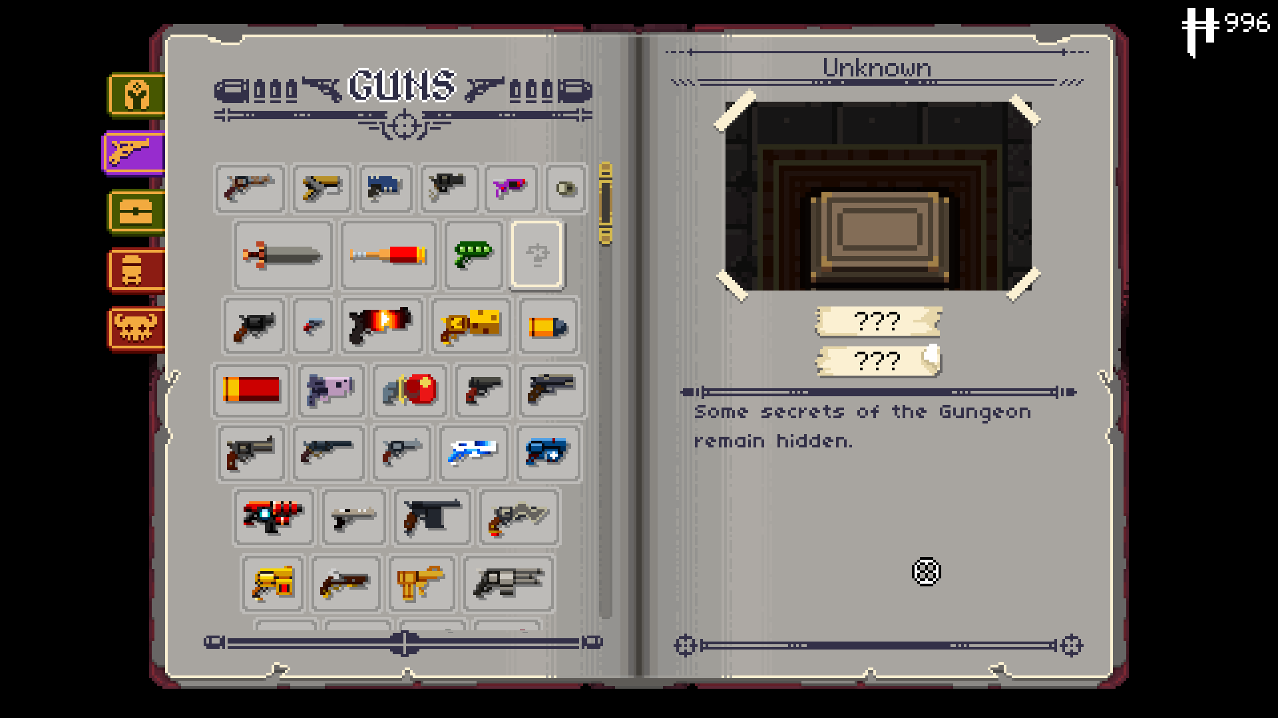
Similar style to the gameplay. Chests and shooting with interesting outcomes. No experience but currency. Active item and a dodge. Camera movement.

Binding of isaac
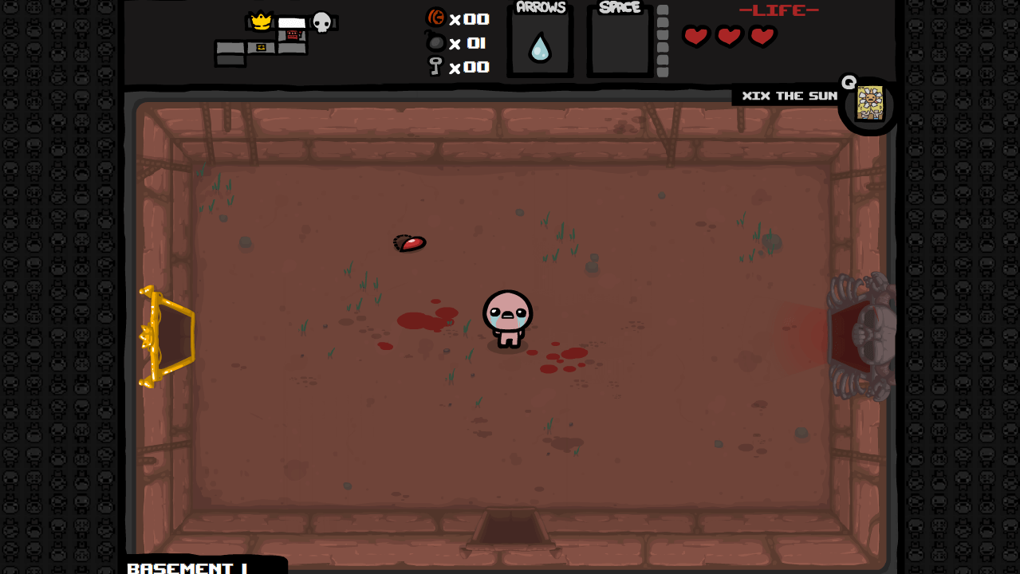
Similar UI

Risk of Rain
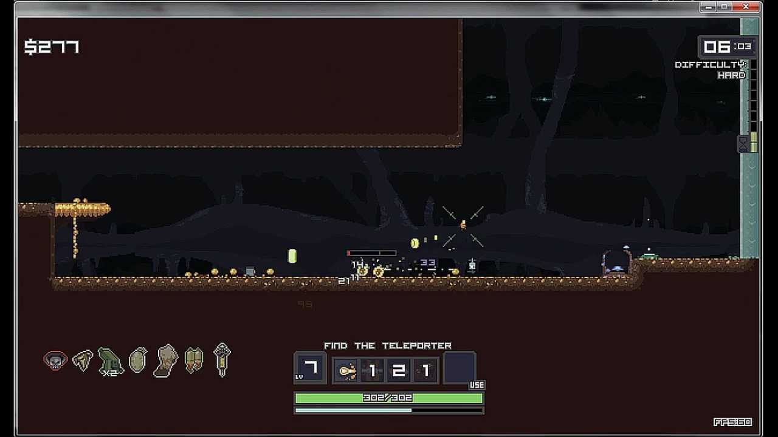
Inventory system along with the chance of items dropped by enemies.

Art and Production Design

Art / visual Style
Low poly, multiple gun styles like mythical, realistic, scifi etc.
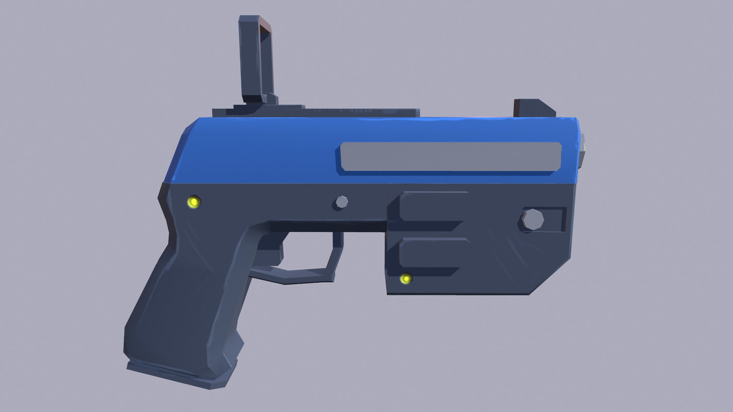
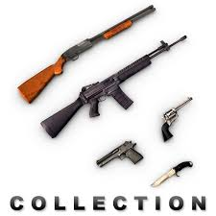

Music Style
Instrumental with large buildups
https://westarmusic.sourceaudio.com/#!details?id=21842459

SFX Style
Bit style
https://soundideas.sourceaudio.com/#!details?id=11516829

Interactivity

Camera Logic
Camera lock on center of each room, zoomed out enough to see whole room. Allow player to move around the room freely without camera following along.
<Quick camera mockup below>
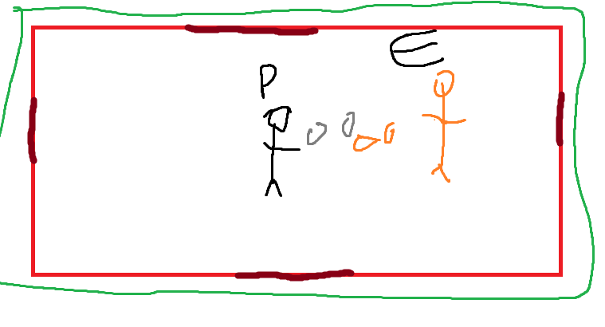
Smaller player. Brown is exits, green is roughly camera distance,
If the room is “Active” (enemies in and not cleared)
Lock camera to center of room. Let player move around freely.
Once room clear, zoom in slightly on player and follow as they move

Controls

PC Controls

- WASD: Movement
- E: Interact
- Q: Active item
- Space Bar: Dodge
- Shift: Sprint
- ESC: Menu
- Tab: Inventory (Toggle)
- LMB: Shoot
- Scroll Wheel: Change Weapon
- R: Reload

Tablet

- Movement: On Screen Joystick
- Menu/Inventory: On Screen Button
- Interact: on screen button
- Aim and Shoot: On screen Joystick
- Auto Sprint
- Active Item: On Screen button
- Auto Reload
- Dodge: Button on screen
- Switch: Button on screen

Scope

Game Progress – Player Milestones
- Tutorial-Basic movement and combat systems/Interaction
- Beat first base level – encounter basic enemies and first miniBoss
- Multiple levels beat, Getting decent gear and to 3rd level
- Beat first boss and earn new weapon
- Repeat until 10th level aka final boss

Worlds/Levels
<Break down of the various environments of the game>’
Tutorial 1-2 Minutes
3-5 Minutes per base level
2-4 Minutes boss level
Final boss 4-6 minutes
45 Minutes total playtime

Mechanics
<List out and describe in complete detail the game mechanics here>

Combat
The character can aim with the mouse. A crosshair will be given in the direction that they aim. LMB will be used to fire in the direction of the crosshair. Enemies will fire at the player also. Or path towards them if melee. The goal is for the player to kill the enemies before they kill them. Guns will have limited ammo, along with a magazine size, making it so they will have to reload. Active items can be used to apply buffs, damage, or apply de-buffs to enemies.
How fast you can shoot. Caps on stats like a maximum possible HP or maximum fire rate on weapons.
Combat starts when walking into an “active” room. The doors lock and you must eliminate all enemies within room to progress. Combat ends when all enemies have been killed (HP reduced to zero) or you have been killed (HP reduced to zero)

Character creation
Mainly color changes to the player model. No out of this world stuff, including no model changes beyond the basic character.
The players shirt color and hair color, along with possible hat modifications.
The player will be able to do this before each run after heading back to the menu. A quick start option will use the current character customization the player made last run.

Resources
Currency will drop from enemies the player kills. The amount varies on the enemy and the floor. The harder the enemy, more money will drop. The farther in the game the more money drops also.
You can use it to open chests and use it to buy either health or ammo or at a shop.

Muliple Rooms and floors
Floors will be sectioned into several rooms, each room, if it has enemies within it, will lock the player in until all enemies die, or the player dies.
Gear and chests have a chance drop on enemy kill or room clear and guaranteed on boss kill. This adds to the steady progression and reward of the player.
Each floor will end with a mini boss fight, the mini boss is a stronger basic enemy that has separate attack powers and is more powerful.

Enemies
All enemies are scifi themed. Most of them are ranged but there are some melee enemies involved to add a challenge. They all will have varying attack patterns and different damage and hp values.
Bosses will comprise of two types: Major bosses and minor bosses. Major bosses will be unique with 3 phases each. They will have specific attack patterns that will need to be learned to be able to be beaten. Minor bosses will be stronger enemies found throughout the levels. They will have more HP, deal more damage, and have different attacks to make it harder than if they were normal enemies.

Gear/items
The player will be using gear, labeled as passive, active, and weapons.
Weapons will be used by the player to defeat enemies by firing different projectiles. The weapons will all do different things, along with having different stats. The variation will allow the game to not feel stale every run.
Passive items are items that modify weapons, change player stats, add more interactions with the world, and change how the player plays the game.
Active items are items the player can activate to do special effects like healing, doing an action that can damage, or even applying a stat boost to the player.

