Coursework 1 Group (text)
Complete the following information
Group number: 19
Student names and k-numbers:
- Sai Priyadharsini Vijayan - k2027098
- Jose Praveen Karuppiah - k2447781
- Tanaya Ravindra Katkar - k2453041
- Daniels Zazerskis - k1801606

Load modules (code)
# add code for loading modules
import numpy as np
# Import of the dataset used for the exercise
from sklearn.datasets import load_digits
# Import for data pre-processing
from sklearn.preprocessing import label_binarize
from sklearn.preprocessing import StandardScaler
# Import of the training and testing split function which will be used for fair evaluation of the model
from sklearn.model_selection import train_test_split
from sklearn.multiclass import OneVsRestClassifier
# Importing the clasification models
from sklearn.svm import SVC
from sklearn.ensemble import AdaBoostClassifier
from sklearn.ensemble import RandomForestClassifier
from sklearn.naive_bayes import GaussianNB
# --------------------------
from sklearn.gaussian_process import GaussianProcessClassifier
from sklearn.gaussian_process.kernels import RationalQuadratic, RBF, Matern, WhiteKernel
from sklearn.discriminant_analysis import QuadraticDiscriminantAnalysis
#---------------------------
from sklearn.tree import DecisionTreeClassifier
from sklearn.neighbors import KNeighborsClassifier
# Importing grid search for parameter tuning
from sklearn.model_selection import GridSearchCV
# Importing the evaluation metrics
import matplotlib.pyplot as plt
import pandas as pd
from pandas.plotting import table
from sklearn.preprocessing import LabelBinarizer
from sklearn.metrics import balanced_accuracy_score
from sklearn.metrics import roc_auc_score
from sklearn.metrics import roc_curve
from sklearn.metrics import auc
from sklearn.metrics import RocCurveDisplay
from sklearn.metrics import confusion_matrix, ConfusionMatrixDisplay

Load data (code)
# add code for loading data
data = load_digits(n_class=10)
X = data.data
y = data.target
# Scale the data
scaler = StandardScaler()
X = scaler.fit_transform(X)
# Unbinorized train split to run GridCV later
# This has been done because Grid search does not accept binarized data
# Data is split to 80% training and 20% testing
# Split stratified to avoid missing some classes in the testing
X_train_cv, X_test_cv, y_train_cv, y_test_cv = train_test_split(X, y, test_size=0.2, random_state=0, stratify=y)
y = label_binarize(y, classes=[0,1,2,3,4,5,6,7,8,9])
X_train, X_test, y_train, y_test = train_test_split(X, y, test_size=0.2, random_state=0, stratify=y)

Classification

Classification methods used (text)
Mention the classification methods used below. You should not describe them, but if they have not been discussed in the class, you should cite the source:
- SVC - discussed in Hearst, M A. et al. (1998)
- AdaBoost - explained by Josh Starmer (2019)
- Random Forest - explained by Josh Starmer (2018)
- Gaussian Naive Bayse - explained by Josh Starmer (2020)
- Gaussian Process - explained by MacKay, D.J. (1998)
- Quadratic Discriminant Analysis - available at scikit-learn (2025)
- Decission Trees - explained by Josh Starmer (2021)
- K Nearest Neighbours - proposed by Hodges, J.L., (1950)
All of these methods have been tested in the classification workshop material

Training (code)
#add code for training
# The pipeline for training was first training the default model
# then using gridsearch with range of parameters to tune the model
# then using the best parameters to train model with tuned parameters
# because grid search is a very long proccess it has been commented out as it will require hours to compute due to models like Gaussian Process and QDA
# GridSearch has been discussed in the lectures, however some usefull exploration has been provided by (codebasics, 2019)
# OneVsRestClassifier provided by scikit-learn documnetation at (scikit-learn, 2025) has been used to make it easier to macro-averaged ROC curve display
# after visiting the thread available at (ROC for multiclass classification, 2022)
# SVC training
SVCModel = OneVsRestClassifier(SVC())
SVCModel.fit(X_train,y_train)
# Hyper-parameter tuning SVC
paramGrid = dict(C=np.logspace(-2,10,13),max_iter=[1000,2000,3000],kernel=["rbf","poly","sigmoid","linear"])
SVCCVGrid = GridSearchCV(SVC(), param_grid=paramGrid, verbose=2)
#SVCCVGrid.fit(X_train_cv,y_train_cv)
#print(
# "The best parameters are %s with a score of %0.2f"
# % (SVCCVGrid.best_params_, SVCCVGrid.best_score_)
#)
# SVC tuned training
TunedSVCModel = OneVsRestClassifier(SVC(C=1,max_iter=1000,kernel="rbf"))
TunedSVCModel.fit(X_train,y_train)
# AdaBoost training
AdaBoostModel = OneVsRestClassifier(AdaBoostClassifier())
AdaBoostModel.fit(X_train,y_train)
# Hyper-parameter tuning AdaBoost
paramGrid = dict(n_estimators=[50,100,250,400],learning_rate=np.logspace(-3,1,5))
AdaBoostCVGrid = GridSearchCV(AdaBoostClassifier(), param_grid=paramGrid, verbose=2)
#AdaBoostCVGrid.fit(X_train_cv,y_train_cv)
#print(
# "The best parameters are %s with a score of %0.2f"
# % (AdaBoostCVGrid.best_params_, AdaBoostCVGrid.best_score_)
#)
# AdaBoost tuned training
TunedAdaBoostModel = OneVsRestClassifier(AdaBoostClassifier(n_estimators=400,learning_rate=1))
TunedAdaBoostModel.fit(X_train,y_train)
# RandomForest training
RandomForestModel = OneVsRestClassifier(RandomForestClassifier())
RandomForestModel.fit(X_train,y_train)
# Hyper-parameter tuning RandomForest
paramGrid = dict(n_estimators=[50,75,125,175,250],max_depth=[10,100,1000,None])
RandomForestCVGrid = GridSearchCV(RandomForestClassifier(), param_grid=paramGrid, verbose=2)
#RandomForestCVGrid.fit(X_train_cv,y_train_cv)
#print(
# "The best parameters are %s with a score of %0.2f"
# % (RandomForestCVGrid.best_params_, RandomForestCVGrid.best_score_)
#)
# RandomForest tuned training
TunedRandomForestModel = OneVsRestClassifier(RandomForestClassifier(n_estimators=250,max_depth=None))
TunedRandomForestModel.fit(X_train,y_train)
# GausianNaiveBaise training
GaussianNBModel = OneVsRestClassifier(GaussianNB())
GaussianNBModel.fit(X_train,y_train)
# Hyper-parameter tuning GaussianNaiveBaise
paramGrid = dict(var_smoothing=np.logspace(-12,1,14))
GaussianNBCVGrid = GridSearchCV(GaussianNB(), param_grid=paramGrid, verbose=2)
#GaussianNBCVGrid.fit(X_train_cv,y_train_cv)
#print(
# "The best parameters are %s with a score of %0.2f"
# % (GaussianNBCVGrid.best_params_, GaussianNBCVGrid.best_score_)
#)
# GausianNaiveBaise tuned training
TunedGaussianNBModel = OneVsRestClassifier(GaussianNB(var_smoothing=0.1))
TunedGaussianNBModel.fit(X_train,y_train)
# Gaussian Process training
kernel_rbf = 1.0 * RBF()
kernel_qd = 1.0 * RationalQuadratic()
kernel_matern = 1.0 * Matern()
kernel_white = 1.0 * WhiteKernel()
GaussianProcessModel = OneVsRestClassifier(GaussianProcessClassifier(kernel=kernel_rbf))
GaussianProcessModel.fit(X_train,y_train)
# Hyper-parameter tuning Gaussian Process
paramGrid = dict(kernel=[kernel_rbf,kernel_qd,kernel_matern,kernel_white])
GaussianProcessCVGrid = GridSearchCV(GaussianProcessClassifier(), param_grid=paramGrid, verbose=2)
#GaussianProcessCVGrid.fit(X_train_cv,y_train_cv)
#print(
# "The best parameters are %s with a score of %0.2f"
# % (GaussianProcessCVGrid.best_params_, GaussianProcessCVGrid.best_score_)
#)
# Gaussian Process tuned training
TunedGaussianProcessModel = OneVsRestClassifier(GaussianProcessClassifier(kernel=kernel_qd))
TunedGaussianProcessModel.fit(X_train,y_train)
# Quadratic Discriminant Analysis training
QDAModel = OneVsRestClassifier(QuadraticDiscriminantAnalysis())
QDAModel.fit(X_train,y_train)
# Hyper-parameter tuning Quadratic Discriminant Analysis
paramGrid = dict(reg_param=[0,0.1,0.2,0.3,0.4,0.5,0.6,0.7,0.8,0.9,1])
QDACVGrid = GridSearchCV(QuadraticDiscriminantAnalysis(), param_grid=paramGrid, verbose=2)
#QDACVGrid.fit(X_train_cv,y_train_cv)
#print(
# "The best parameters are %s with a score of %0.2f"
# % (QDACVGrid.best_params_, QDACVGrid.best_score_)
#)
# Quadratic Discriminant Analysis tuned training
TunedQDAModel = OneVsRestClassifier(QuadraticDiscriminantAnalysis(reg_param=0.1))
TunedQDAModel.fit(X_train,y_train)
# Decission Tree training
DecisionTreeModel = OneVsRestClassifier(DecisionTreeClassifier())
DecisionTreeModel.fit(X_train,y_train)
# Hyper-parameter tuning Decission Tree
paramGrid = dict(criterion=["gini","entropy","log_loss"],splitter=["best","random"],max_depth=[5,15,20,50,100,500,1000,2000,None])
DecisionTreeCVGrid = GridSearchCV(DecisionTreeClassifier(), param_grid=paramGrid, verbose=2)
#DecisionTreeCVGrid.fit(X_train_cv,y_train_cv)
#print(
# "The best parameters are %s with a score of %0.2f"
# % (DecisionTreeCVGrid.best_params_, DecisionTreeCVGrid.best_score_)
#)
# Decission Tree tuned training
TunedDecisionTreeModel = OneVsRestClassifier(DecisionTreeClassifier(criterion="entropy",splitter="random",max_depth=20))
TunedDecisionTreeModel.fit(X_train,y_train)
# K Nearest Neighbors training
KNNModel = OneVsRestClassifier(KNeighborsClassifier())
KNNModel.fit(X_train,y_train)
# Hyper-parameter tuning K Nearest Neighbors
paramGrid = dict(n_neighbors=[5,10,20,50],weights=["uniform","distance"],algorithm=["auto","ball_tree","kd_tree","brute"],leaf_size=[10,30,50,100,150,200])
KNNCVGrid = GridSearchCV(KNeighborsClassifier(), param_grid=paramGrid, verbose=2)
#KNNCVGrid.fit(X_train_cv,y_train_cv)
#print(
# "The best parameters are %s with a score of %0.2f"
# % (KNNCVGrid.best_params_, KNNCVGrid.best_score_)
#)
# K Nearest Neighbors tuned training
TunedKNNModel = OneVsRestClassifier(KNeighborsClassifier(n_neighbors=5,algorithm="auto",weights="distance",leaf_size=10))
TunedKNNModel.fit(X_train,y_train)
# We have created a list with all the trained models so that it would be easy to make a loop to display all the information for them
models = [["SVC",SVCModel,"red"],
["AdaBoost",AdaBoostModel,"green"],
["Random Forest",RandomForestModel,"blue"],
["Gaussian Naive Baise",GaussianNBModel,"black"],
["Gaussian Process",GaussianProcessModel,"lime"],
["Quadratic Discriminant Analysis",QDAModel,"olive"],
["Decision Tree",DecisionTreeModel,"slategrey"],
["K Nearest Neighbors",KNNModel,"purple"],
["Tuned SVC",TunedSVCModel,"yellow"],
["Tuned AdaBoost",TunedAdaBoostModel,"brown"],
["Tuned Random Forest",TunedRandomForestModel,"grey"],
["Tuned Gaussian Naive Baise",TunedGaussianNBModel,"orange"],
["Tuned Gaussian Process",TunedGaussianProcessModel,"azure"],
["Tuned Quadratic Discriminant Analysis",TunedQDAModel,"plum"],
["Tuned Decision Tree",TunedDecisionTreeModel,"steelblue"],
["Tuned K Nearest Neighbors",TunedKNNModel,"seagreen"],]
/usr/local/lib/python3.11/dist-packages/sklearn/gaussian_process/kernels.py:452: ConvergenceWarning: The optimal value found for dimension 0 of parameter k2__alpha is close to the specified upper bound 100000.0. Increasing the bound and calling fit again may find a better value.
warnings.warn(
/usr/local/lib/python3.11/dist-packages/sklearn/gaussian_process/kernels.py:452: ConvergenceWarning: The optimal value found for dimension 0 of parameter k2__alpha is close to the specified upper bound 100000.0. Increasing the bound and calling fit again may find a better value.
warnings.warn(
/usr/local/lib/python3.11/dist-packages/sklearn/discriminant_analysis.py:1024: LinAlgWarning: The covariance matrix of class 0 is not full rank. Increasing the value of parameter `reg_param` might help reducing the collinearity.
warnings.warn(
/usr/local/lib/python3.11/dist-packages/sklearn/discriminant_analysis.py:1024: LinAlgWarning: The covariance matrix of class 1 is not full rank. Increasing the value of parameter `reg_param` might help reducing the collinearity.
warnings.warn(
/usr/local/lib/python3.11/dist-packages/sklearn/discriminant_analysis.py:1024: LinAlgWarning: The covariance matrix of class 0 is not full rank. Increasing the value of parameter `reg_param` might help reducing the collinearity.
warnings.warn(
/usr/local/lib/python3.11/dist-packages/sklearn/discriminant_analysis.py:1024: LinAlgWarning: The covariance matrix of class 1 is not full rank. Increasing the value of parameter `reg_param` might help reducing the collinearity.
warnings.warn(
/usr/local/lib/python3.11/dist-packages/sklearn/discriminant_analysis.py:1024: LinAlgWarning: The covariance matrix of class 0 is not full rank. Increasing the value of parameter `reg_param` might help reducing the collinearity.
warnings.warn(
/usr/local/lib/python3.11/dist-packages/sklearn/discriminant_analysis.py:1024: LinAlgWarning: The covariance matrix of class 1 is not full rank. Increasing the value of parameter `reg_param` might help reducing the collinearity.
warnings.warn(
/usr/local/lib/python3.11/dist-packages/sklearn/discriminant_analysis.py:1024: LinAlgWarning: The covariance matrix of class 0 is not full rank. Increasing the value of parameter `reg_param` might help reducing the collinearity.
warnings.warn(
/usr/local/lib/python3.11/dist-packages/sklearn/discriminant_analysis.py:1024: LinAlgWarning: The covariance matrix of class 1 is not full rank. Increasing the value of parameter `reg_param` might help reducing the collinearity.
warnings.warn(
/usr/local/lib/python3.11/dist-packages/sklearn/discriminant_analysis.py:1024: LinAlgWarning: The covariance matrix of class 0 is not full rank. Increasing the value of parameter `reg_param` might help reducing the collinearity.
warnings.warn(
/usr/local/lib/python3.11/dist-packages/sklearn/discriminant_analysis.py:1024: LinAlgWarning: The covariance matrix of class 1 is not full rank. Increasing the value of parameter `reg_param` might help reducing the collinearity.
warnings.warn(
/usr/local/lib/python3.11/dist-packages/sklearn/discriminant_analysis.py:1024: LinAlgWarning: The covariance matrix of class 0 is not full rank. Increasing the value of parameter `reg_param` might help reducing the collinearity.
warnings.warn(
/usr/local/lib/python3.11/dist-packages/sklearn/discriminant_analysis.py:1024: LinAlgWarning: The covariance matrix of class 1 is not full rank. Increasing the value of parameter `reg_param` might help reducing the collinearity.
warnings.warn(
/usr/local/lib/python3.11/dist-packages/sklearn/discriminant_analysis.py:1024: LinAlgWarning: The covariance matrix of class 0 is not full rank. Increasing the value of parameter `reg_param` might help reducing the collinearity.
warnings.warn(
/usr/local/lib/python3.11/dist-packages/sklearn/discriminant_analysis.py:1024: LinAlgWarning: The covariance matrix of class 1 is not full rank. Increasing the value of parameter `reg_param` might help reducing the collinearity.
warnings.warn(
/usr/local/lib/python3.11/dist-packages/sklearn/discriminant_analysis.py:1024: LinAlgWarning: The covariance matrix of class 0 is not full rank. Increasing the value of parameter `reg_param` might help reducing the collinearity.
warnings.warn(
/usr/local/lib/python3.11/dist-packages/sklearn/discriminant_analysis.py:1024: LinAlgWarning: The covariance matrix of class 1 is not full rank. Increasing the value of parameter `reg_param` might help reducing the collinearity.
warnings.warn(
/usr/local/lib/python3.11/dist-packages/sklearn/discriminant_analysis.py:1024: LinAlgWarning: The covariance matrix of class 0 is not full rank. Increasing the value of parameter `reg_param` might help reducing the collinearity.
warnings.warn(
/usr/local/lib/python3.11/dist-packages/sklearn/discriminant_analysis.py:1024: LinAlgWarning: The covariance matrix of class 1 is not full rank. Increasing the value of parameter `reg_param` might help reducing the collinearity.
warnings.warn(
/usr/local/lib/python3.11/dist-packages/sklearn/discriminant_analysis.py:1024: LinAlgWarning: The covariance matrix of class 0 is not full rank. Increasing the value of parameter `reg_param` might help reducing the collinearity.
warnings.warn(
/usr/local/lib/python3.11/dist-packages/sklearn/discriminant_analysis.py:1024: LinAlgWarning: The covariance matrix of class 1 is not full rank. Increasing the value of parameter `reg_param` might help reducing the collinearity.
warnings.warn(

Evaluation (code)
#add code for evaluation
# For each model display ROC curve
fig, ax = plt.subplots(figsize=(10, 10))
table_data = [[],[]]
for model_item in models:
# Data extraction from the list created in the training
modelName = model_item[0]
model = model_item[1]
color = model_item[2]
y_pred = model.predict(X_test)
y_score = None
# Some models do not have a decision function so probabilities are used instead
if (modelName == "Random Forest" or modelName == "Gaussian Naive Baise" or modelName == "Tuned Random Forest" or modelName == "Tuned Gaussian Naive Baise" or modelName == "Gaussian Process" or modelName == "Decision Tree" or modelName == "K Nearest Neighbors" or modelName == "Tuned Gaussian Process" or modelName == "Tuned Decision Tree" or modelName == "Tuned K Nearest Neighbors"):
y_score = model.predict_proba(X_test)
else:
y_score = model.decision_function(X_test)
# Scores are computed and stored in a panda data-frame so that print would work easily to display data correctly
balanced_score = balanced_accuracy_score(y_true=y_test.argmax(axis=1),y_pred=y_pred.argmax(axis=1))
macro_roc_score = roc_auc_score(y_true=y_test,y_score=y_score,multi_class="ovr",average="macro")
table_data[0].append(balanced_score)
table_data[1].append(macro_roc_score)
# Plotting the macro-averaged ROC
# This method of macro-averaged ROC curve display was taken from scikit-learn documentation (scikit-learn, 2025)
# -----------------------------------------------Code Start-----------------------------------------------------
fpr = dict()
tpr = dict()
roc_auc = dict()
for i in range(10):
fpr[i], tpr[i], _ = roc_curve(y_test[:, i], y_score[:, i])
roc_auc[i] = auc(fpr[i], tpr[i])
fpr_grid = np.linspace(0.0, 1.0, 1000)
# Interpolate all ROC curves at these points
mean_tpr = np.zeros_like(fpr_grid)
for i in range(10):
mean_tpr += np.interp(fpr_grid, fpr[i], tpr[i]) # linear interpolation
# Average it and compute AUC
mean_tpr /= 10
fpr["macro"] = fpr_grid
tpr["macro"] = mean_tpr
roc_auc["macro"] = auc(fpr["macro"], tpr["macro"])
plt.plot(
fpr["macro"],
tpr["macro"],
label=f"{modelName} (AUC = {roc_auc['macro']:.4f})",
color=color)
plt.legend()
a = ax.set(
xlabel="False Positive Rate",
ylabel="True Positive Rate",)
# -----------------------------------------------Code End-------------------------------------------------------
plt.show()
# Display the balanced accuracy and the AUC scores for all 16 models
table_data = pd.DataFrame(table_data,columns=["SVC","AdaBoost","Random Forest","Gaussian Naive Baise","Gaussian Process","Quadratic Discriminant Analysis","Decision Tree","K Nearest Neighbors","Tuned SVC","Tuned AdaBoost","Tuned Random Forest","Tuned Gaussian Naive Baise","Tuned Gaussian Process","Tuned Quadratic Discriminant Analysis","Tuned Decision Tree","Tuned K Nearest Neighbors"],index=["Balanced Accuracy","AUC Score"])
print(table_data)
# Create confusion matrix for all 16 models on one plot
# Confusion matrix display provided by the scikit-learn documentation at (scikit-learn, 2025)
fig, axs = plt.subplots(2, 8, figsize=(30,10))
i = 0
y = 0
for model_item in models:
# Confusion Matrix
modelName = model_item[0]
model = model_item[1]
y_pred = model.predict(X_test)
y_score = None
if (modelName == "Random Forest" or modelName == "Gaussian Naive Baise" or modelName == "Tuned Random Forest" or modelName == "Tuned Gaussian Naive Baise" or modelName == "Gaussian Process" or modelName == "Decision Tree" or modelName == "K Nearest Neighbors" or modelName == "Tuned Gaussian Process" or modelName == "Tuned Decision Tree" or modelName == "Tuned K Nearest Neighbors"):
y_score = model.predict_proba(X_test)
else:
y_score = model.decision_function(X_test)
model_CM = confusion_matrix(y_test.argmax(axis=1), y_pred.argmax(axis=1), labels=model.classes_)
disp = ConfusionMatrixDisplay(confusion_matrix=model_CM, display_labels=model.classes_)
disp.plot(ax=axs[i,y],colorbar=False)
disp.ax_.set_title(modelName)
if (i == 1):
i=0
y+=1
else:
i+=1
plt.show()
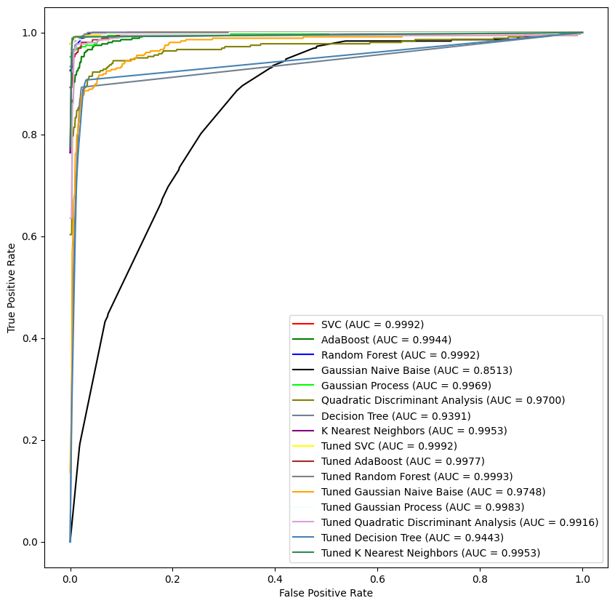
SVC AdaBoost Random Forest Gaussian Naive Baise \
Balanced Accuracy 0.958166 0.880363 0.877660 0.320193
AUC Score 0.999242 0.994445 0.999188 0.851286
Gaussian Process Quadratic Discriminant Analysis \
Balanced Accuracy 0.952610 0.511152
AUC Score 0.996875 0.970069
Decision Tree K Nearest Neighbors Tuned SVC \
Balanced Accuracy 0.861148 0.977615 0.958166
AUC Score 0.939066 0.995260 0.999242
Tuned AdaBoost Tuned Random Forest \
Balanced Accuracy 0.924974 0.880363
AUC Score 0.997773 0.999342
Tuned Gaussian Naive Baise Tuned Gaussian Process \
Balanced Accuracy 0.650650 0.958091
AUC Score 0.974917 0.998318
Tuned Quadratic Discriminant Analysis Tuned Decision Tree \
Balanced Accuracy 0.918730 0.860755
AUC Score 0.991771 0.944278
Tuned K Nearest Neighbors
Balanced Accuracy 0.977615
AUC Score 0.995286
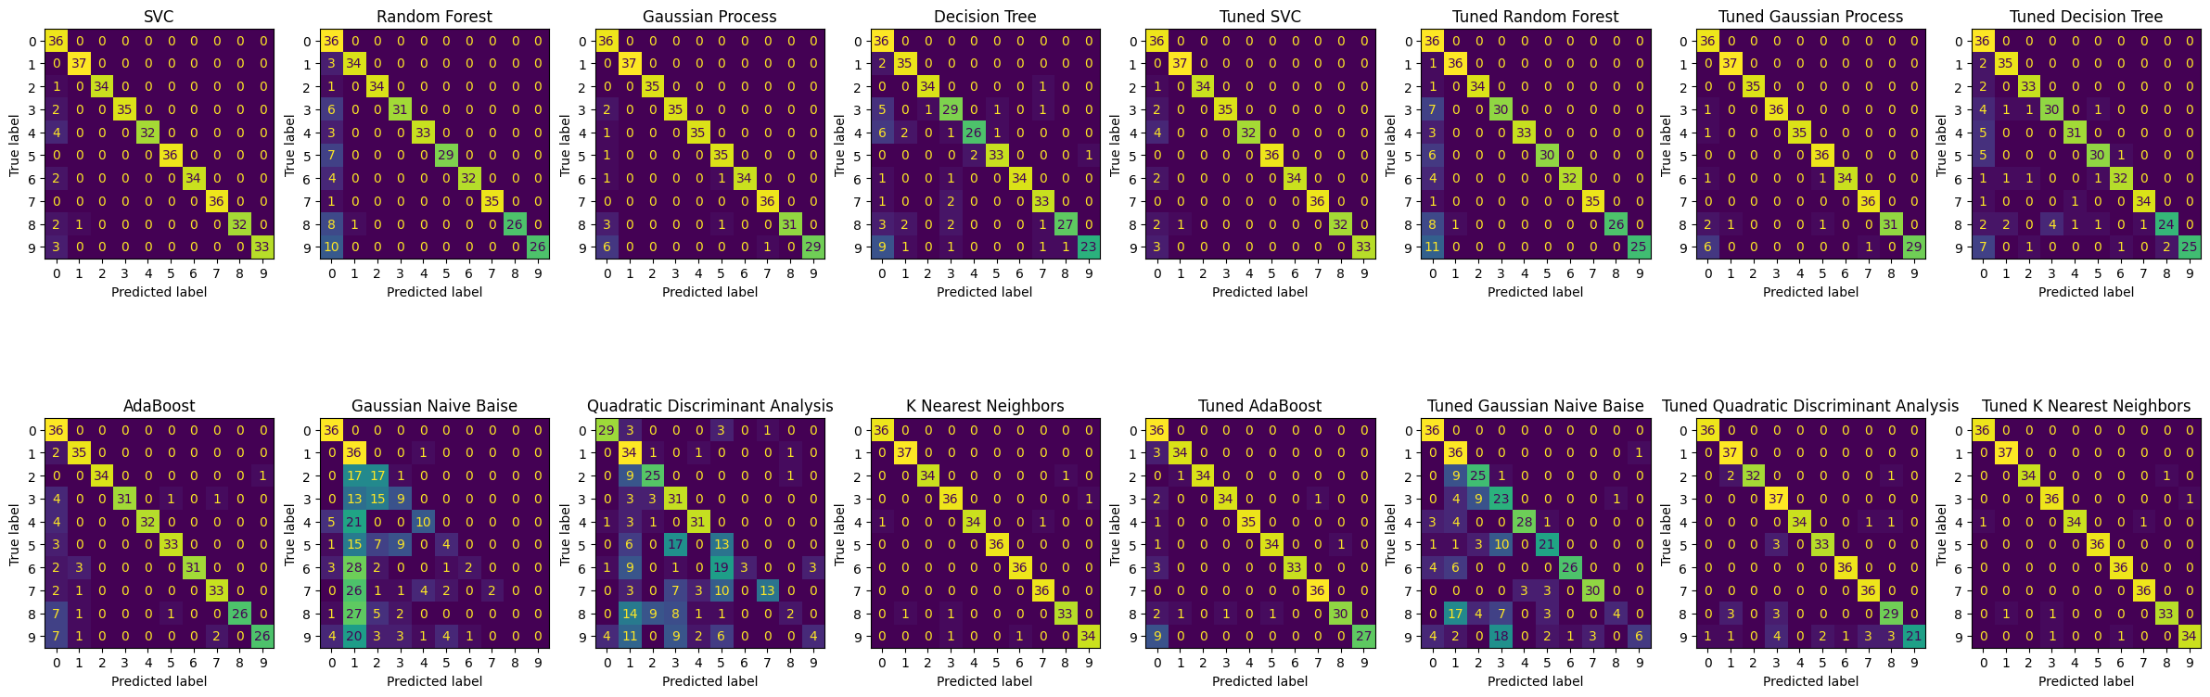

References (text)
List any references you may have used in your document before, using one of the established referencing system (e.g. IEEE, Harvard, etc).
Josh Starmer (2019) AdaBoost, Clearly Explained. 14 January. Available at: https://www.youtube.com/watch?v=LsK-xG1cLYA&list=PLFSbc3edX07urDn1pGESP0R-8USiNHZQ4 (Accessed: 03.03.2025).
Josh Starmer (2018) StatQuest: Random Forests Part 1 - Building, Using and Evaluating. 5 February. Available at: https://www.youtube.com/watch?v=J4Wdy0Wc_xQ&list=PLFSbc3edX07urDn1pGESP0R-8USiNHZQ4&index=2 (Accessed: 03.03.2025).
Josh Starmer (2020) Naive Bayes, Clearly Explained!!!. 3 June. Available at: https://www.youtube.com/watch?v=O2L2Uv9pdDA&list=PLFSbc3edX07urDn1pGESP0R-8USiNHZQ4&index=3 (Accessed: 03.03.2025).
Josh Starmer (2020) Gaussian Naive Bayes, Clearly Explained!!!. 3 June. Available at: https://www.youtube.com/watch?v=H3EjCKtlVog&list=PLFSbc3edX07urDn1pGESP0R-8USiNHZQ4&index=4 (Accessed: 03.03.2025).
Josh Starmer (2019) ROC and AUC, Clearly Explained!. 11 July. Available at: https://www.youtube.com/watch?v=4jRBRDbJemM&list=PLFSbc3edX07urDn1pGESP0R-8USiNHZQ4&index=5 (Accessed: 03.03.2025).
codebasics (2019) Machine Learning Tutorial Python - 16: Hyper parameter Tuning (GridSearchCV). 23 November. Available at: https://www.youtube.com/watch?v=HdlDYng8g9s&list=PLFSbc3edX07urDn1pGESP0R-8USiNHZQ4&index=6 (Accessed: 03.03.2025).
Josh Starmer (2016) StatQuest: Linear Discriminant Analysis (LDA) clearly explained. 10 July. Available at: https://www.youtube.com/watch?v=azXCzI57Yfc&list=PLFSbc3edX07urDn1pGESP0R-8USiNHZQ4&index=7 (Accessed: 03.03.2025).
Converting LinearSVC's decision function to probabilities (2023) Available at: https://stackoverflow.com/questions/26478000/converting-linearsvcs-decision-function-to-probabilities-scikit-learn-python (Accessed: 03.03.2025).
scikit-learn (2022) Receiver Operating Characteristic. Available at: https://scikit-learn.org/1.1/auto_examples/model_selection/plot_roc.html (Accessed: 03.03.2025).
ROC for multiclass classification (2022) Available at: https://stackoverflow.com/questions/45332410/roc-for-multiclass-classification (Accessed: 03.03.2025).
scikit-learn (2025) OneVsRestClassifier. Available at: https://scikit-learn.org/stable/modules/generated/sklearn.multiclass.OneVsRestClassifier.html (Accessed: 03.03.2025).
scikit-learn (2025) Multiclass Receiver Operating Characteristic (ROC). Available at: https://scikit-learn.org/stable/auto_examples/model_selection/plot_roc.html (Accessed: 03.03.2025).
scikit-learn (2025) Gaussian process classification (GPC) on iris dataset. Available at: https://scikit-learn.org/stable/auto_examples/gaussian_process/plot_gpc_iris.html (Accessed: 03.03.2025).
scikit-learn (2025) SVC. Available at: https://scikit-learn.org/stable/modules/generated/sklearn.svm.SVC.html (Accessed: 03.03.2025).
Hearst, M A. et al. (1998) 'Support vector machines', IEEE Intelligent Systems and their Applications, vol. 13, pp. 18-28. Available at: 10.1109/5254.708428
Hodges, J.L., (1950). Discriminatory analysis (No. 11). USAF School of Aviation Medicine.
MacKay, D.J., 1998. Introduction to Gaussian processes. NATO ASI series F computer and systems sciences, 168, pp.133-166.
Josh Starmer (2021) Decision and Classification Trees, Clearly Explained!!!. 26 April. Available at: https://www.youtube.com/watch?v=_L39rN6gz7Y&t=0s (Accessed: 03.03.2025).

