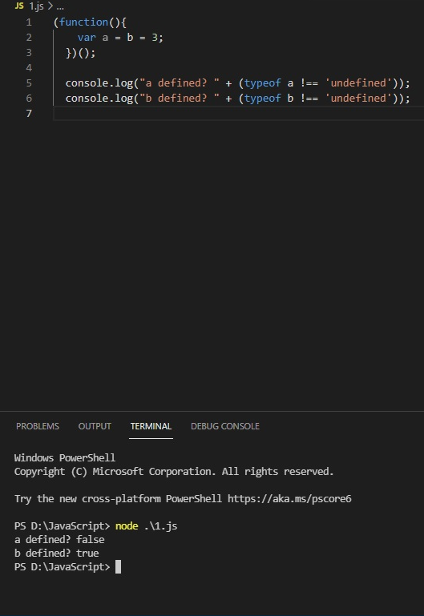

Since var a=b=3;

It means b=3 & a=b

Since a is variable and b has global scope type of a is defined and type of b is undefined.