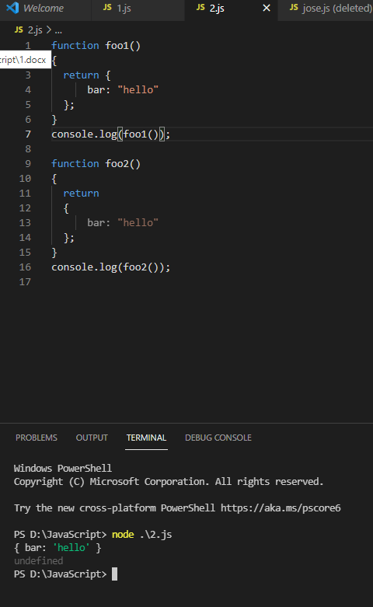

In foo2 function the return statement automatically will contain a “;” and return nothing.

In foo1 the return statement have valid {} (braces) so executes successfully.