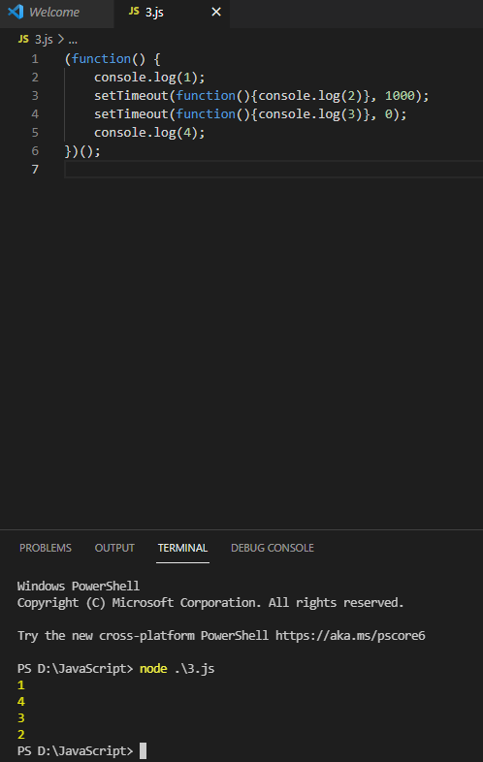

1 and 4 are logged by simple calls so they execute first, then 3 executes because of only 0 ms and then 2 executes because of having 1000 ms timeout.