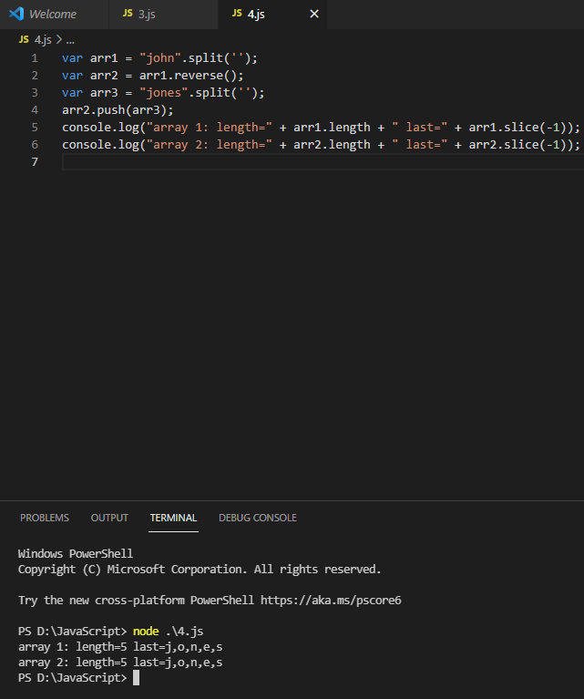

Variable arr1 & arrr2 becomes the same since they have references between them. It makes arr1 also get to be reversed and push operation to arr2 also be affected on arr1. Then there is a slicing of last element of both arrays which gives the result.