C Code to Assembly Level (code in c files)

Hello vsdiat:
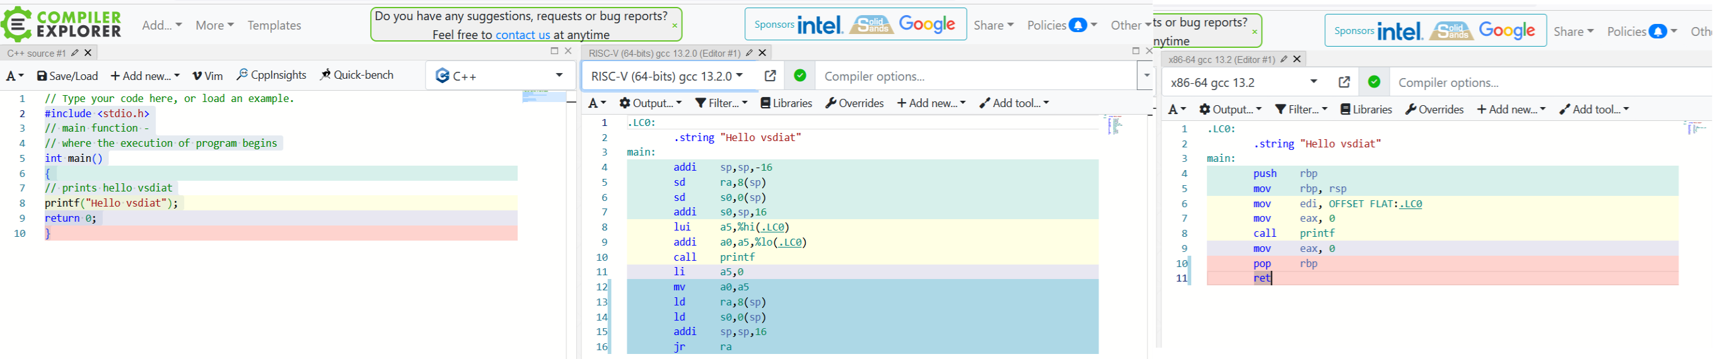
It looks like x86 produces a more compact code. Uses better push-pop instructions. RISC uses sp register for the same purpose. Move instructions on x86 seem to be also more powerful (addressing modes).

Sum of natural numbers:

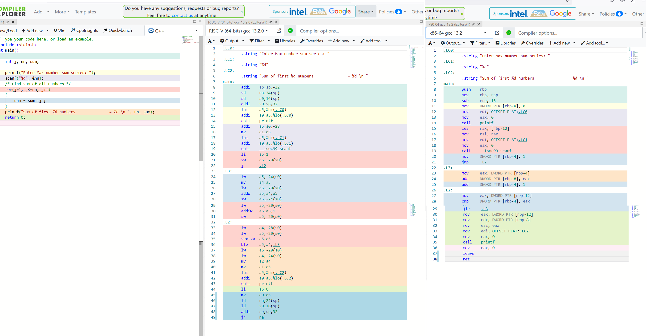
Same observation here x86 seems to produce shorter code, less instructions

Matrix Multiplication 4x4 times Identity matrix: Same observation here x86 seems to produce shorter code almost half of size, this program has 2 internal loops so more computational complexity. It will run faster in x86. More powerful addressing modes to access operands.

