**Understanding the player experience through two different game controllers**

Érica Mourão¹, Guilherme Gonçalves¹ and Daniela Trevisan¹

¹Fluminense Federal University, Computing Institute. Rua Passos da Pátria 156, Niterói, Rio de Janeiro, Brazil.

{ericamourao,galves,daniela}@ic.uff.br

**Abstract.** Emerging technologies offer exciting new ways of interacting with digital games to create fantastic play experiences. Evaluating entertainment technology is challenging because success isn’t defined in terms of productivity and performance, but in terms of enjoyment and gameplay experience. In this direction, the success criteria here has been evaluated in an exploratory user experience and usability study that used a within non-players design investigating a commercial joystick as input device compared to a novel adaptive touch-based controller. This new adaptive controller is able to dynamically change buttons size and position according to the user behavior. The evaluation methodology is based on the capture and analysis of objective and subjective user’s data. Results of this exploratory study indicate that while the general user experience and usability were similarly perceived in both controllers, the physiological measures indicate that the user's emotions were greater with the adaptive controller. The findings are subsequently discussed and implications of using the adaptive touch-based controller as input for digital games are discussed.

**Keywords:** User Experience based approaches; Evaluation Methods / Usability Evaluation; Human Factors and HCI; Adaptive Interfaces.

# 1. Introduction

Quando se está jogando, duas das principais características que irão definir a percepção do usuário sobre a sua experiência são a qualidade e a fluência do controle do jogo [7], responsável por realizar as ações durante o jogo. Por causa disso, a concepção dos controles ou do projeto destes é um fator muito importante para a projeção de uma experiência de jogo envolvente.

Nos últimos anos tem-se visto que grandes desenvolvedoras de jogos estão investindo na produção de tecnologias para seguir as tendências, as quais se encontram em um momento de rápida expansão e de profunda mudança tecnológica [9]. Exemplos como a Nintendo, com o seu Wiimote[1] e a Microsoft com o Kinect[2], deixam claro como a exploração de novos meios de interação por meio de dispositivos que capturam gestos, movimentos e até mesmo smartphones podem ser bem recebidos pelo público alvo desejado [5].

Digital games constitute an extremely varied set of applications with a rich range of experiences offered to players. This diversity makes difficult to devise a unique approach to their conceptualization and measurement. Terms such as fun, flow and gameplay are widely used to explain the user experience in game design [1]. However, there is an open discussion to include other relevant factors to the games. Emotion is often cited as a key element of the user experience [25]. Emotions in digital games act as a motivator for the cognitive decisions players make during gameplay and they drive user experience in digital games [15].In this direction to reach success in a digital game is related to providing a successful user experience with it. Part of such gaming experience success is regarding to the input device used to control the game interaction. Control is the player learning to manipulate the game. It is about the player learninghow the objects in the game move, understanding the goals of the game andkeeping the player occupied. It is also learning about the controllers, getting used tothe objects and angles in which the objects are displayed, and the ability of the playerto memorise the relationship between controllers and the actions of the game.

While some work has been conducted regarding the development ofinput devices and how they affect user performance [5, 6, 18, 20] the effects of gamecontrollers on user experience is yet to be explored in deeply.

Recently Torok et al [4, 7] propose a novel adaptive controller for digital game called SmartController[3]. SmartController with its adaptive interface consists of a mobile *app* available for Android e iOS. It is able to dynamically change buttons size and position according to the user’s behavior. User’s behavior is here interpreted as user’s touches on the screen.

Motivated by the demand from innovation in games controllers and the lack of techniques to assess the player experience with those devices,in this work the productsuccess criteria isevaluated in an exploratory user experience and usability study that used a within non-players design investigating a commercial joystick as input device compared to a novel adaptive touch-based controller (e.g. SmartController).Our goal is to advance the theoretical understanding of user experience and controllers in digital games. In this work we are focusing on the measurement of user experience, usability and physiology in a game. However, one limitation of current psychophysiological studies is that they cannot precisely classify UX in digital games since many experiential phenomena in digital games lack standardized quantitative measurements [12]. Hence, another purpose of this study is to provide acorrelation study between subjective user experience (estimated with AttrakDiff questionnaire) and objective physiological data (collected with EEG sensors).

# 2. How to evaluate UX in games

The current ISO definition on user experience focuses on a person’s perception and the responses resulting from the use or anticipated use of a product, system, or service. User experience includes all the users' emotions, beliefs, preferences, perceptions, physical and psychological responses, behaviors and accomplishments that occur before, during and after use [REF]. It is a vague definition and from a psychological perspective, these responses are actively generated in a psychological and emotional evaluation process, and it has to be decided which concepts can best represent the psychological aspects in games to allow to measure the characteristics of user experience.

Furthermore, user experience is a highlighted research topic inside the HCI community, which became present in many different fronts and themes, including digital games where the successful relationship between user and product is considered quite seriously. In literature exists many works whose goal is perform user experience evaluations in games [1]. In addition there are several ways to execute those evaluations, e.g. user tests by collecting objective and subjective data. In the following text we highlighted researches using questionnaires to capture the subjective perceived UX in games as well as those using psychophysiological data to derive the emotional state of player. Special attention is given to those researches dedicated in evaluating the players’ experiences with game controllers.

## 2.1 User Experience Questionnaires

Many works [12,15] have investigated different components of game experience using the game experience questionnaire (GEQ) [24]. The questionnaire was developed on the basis of focus group research [30] and following investigations among frequent players. The questionnaire consists of different modules: 1) Core module - concerns actual experiences during game play; 2) social presence module - concerns gaming with others; 3) post game module - concerns experiences once a player has stopped gaming. For instance in Nacke *et.al*. [15] participants played a fast-paced, immersive first-person shooter (FPS) game modification, in which sound (on/off) and music (on/off) were manipulated. As a result they found significant main effect of sound on all GEQ dimensions (immersion, tension, competence, flow, negative affect, positive affect, and challenge) concluding that subjective measures could advance the understanding of sonic UX in digital games.

Another widely used questionnaire is the Player Experience of Need Satisfaction (PENS)[ REFS games using PENS ]. The proprietary PENS-questionnaire, developed by Ryan and colleagues [37] investigates the intrinsic motivation of players [37]. This approach is based on self-determination theory (SDT) and focuses on the three basic human needs for either intrinsic or extrinsic motivation: Autonomy(volitional aspects of an activity), Competence (perception of challenge) and Relatedness (connection to others). Two additional factors - Presence (the sense that one is within the game world) and Intuitive controls – were included in the PENS measurement because they are seen as important aspects of gaming [37]. The PENS-questionnaire measures these needs and the additional factors on 7-point Likert-scales.

Recent research [14] investigated the factorial structure of both questionnaires PENS [37] and GEQ [24]. They found the factor structure of the PENS appears to be consistent and invariant across two different games, the GEQ reveals weaknesses in fulfilling these requirements.

Brown *et al.* [26] explored the experience, functionality and usability through standard and innovative gamepads, in order to evaluate these components. Subjective Mental Effort Questionnaire (SMEQ) [31] and Consumer Product Questionnaire (CPQ) [32] were respectively used in their work to measure effectiveness and satisfaction as subjective methods of usability evaluation. In other hand, Critical Incidents Technique (CIT) [33] was used to collect qualitative data, describing the user feelings and perceptions about its experience. CIT consists of a detailed analysis discourse technique.

In addition attractiveness has been used to measure UX in games [25,36]. Attractiveness in UX is described as a set of four dimensions: (1) Pragmatic Quality (PQ), (2) Hedonic Quality - Stimulation (HQS), (3) Hedonic Quality - Identity (HQI) and (4) Attractiveness (ATT) [11, 23]. The first one (PQ) represents traditional usability aspects, i.e. efficiency, effectiveness and learnability. It focuses on task related design aspects and indicates if the users reached their goals on a interaction. Following, the Hedonic Quality dimensions (HQS and HQI) describes quality aspects, which are not directly related to the tasks the user wants to accomplish with the software, for example originality and beauty. Both qualities are subjective aspects of a user interface. Thus, users may differ in their evaluation of these aspects. For instance in Lankees *et. al*. [25] they applied the AttrackDiff questionnaire to understand how emotional stimuli (facial expressions by Embodied Conversational Agents and emotion-eliciting situations) in interactive system affect the (more general) user experience. In another work [36]….

## 2.2 Psychophysiological Measures and its Correlation with Subjective User’s Data

The use of objective data collecting, like physiological measures (e.g. galvanic skin response, muscles contraction, respiratory and cardiovascular signals), are widely employed in the literature to evaluate the UX and the user engagement in digital games [12, 13, 15]. Moreover, the user emotional and mental state data can be retrieved from these measures, being useful in many recent researches in HCI community.

Some works have focused on studying the correlation between subjective users response and objective physiological data while assessing the player experience. For instance, in the work described by Mandryk et al [13] they collect galvanic skin response (GSR), electrocardiography (EKG), electromyography of the jaw (EMG), and respiration. Heart rate (HR) was computed from the EKG signal, while respiration amplitude (RespAmp) and respiration rate (RespRate) were computed from the raw respiration data. In theirfirst experiment, they found many inconsistent correlations across participants. The main reason for the inconsistent results is likely the experimental manipulation that was chosen, however, there were also some methodological issues that contributed to irregular patterns of physiological activity. Primarily, the act of conducting the experiment produced different phases in the experiment (e.g. play, interview, rest) that created greater physiological responses than the experimental manipulations themselves. In addition, the experimental manipulation that was chosen (e.g participants played in four different conditions of difficulty: beginner, easy, medium, and difficult.) did not produce consistent subjective results across all participants. Without consistent subjective results, it is not possible to expect consistent physiological results. They observed the participants were responding more to the experimental situation than the experimental manipulations. Mainly methodological issues that had influenced those results were: high resting baseline, order and interview effects, subjects enjoyed playing in all conditions. In a second experiment they decided for maximizing the user experience and now the participants played in two conditions: against another co-located player, and against the computer. This time they could normalize and correlate the data showing that the amount by which participants increased their subjective ratings corresponded to the amount by whichtheir mean physiological data increased.

Nacke *et.al*. [15]tried to correlate the GEQ dimensions with electrodermal activity (EDA) and facial muscle activity (EMG) to assess the player experience while music or sound is present or absent in a FPS game. They did not find any main effects of either sound or music on tonic psychophysiological data. Therefore, as in Mandrky *et. al* [13] they discussed whetherphysiological measures are indicated to assess such complex stimuli.There are many factors potentially affecting the interpretation and experience of perceptual stimuli: prior experience of the stimuli, cultural and societal experience and milieu, age, gender and present mood, for example.

# 3. Method

## 

## 3.1. Research Goals and Hypotheses

The goal of our research is to evaluate the user experience and usability in the use of a virtual adaptive control (SmartController) and traditional control in a digital game. Our approach is unique and unpublished in that it is the first, in our knowledge, to evaluate the user experience in the adaptive control versus the traditional control. The motivation of research goal is the demand from innovation in games controls and of how to evaluate it. We aim to study the user experience (e.g. attractiveness and emotions) and usability factors in the use of controls and the correlation between subjective users’ responses and physiological and performance data. In more detail, our researcher questions are:

**RQ1)** How the user experience (analyzed by users’ attractiveness and emotion) and usability are perceived in the use of SmartController and traditional joystick in the digital game?

Firstly we assume that a separate analysis of the game controllers could have an effect on the user experience dimensions and usability factors for the non-players users. Then the following hypotheses were formed:

**H1:** The user experience (e.g attractiveness and emotion criteria) withSmartController is greater than with the traditional one.

**H2:** Overall, the user preference is greater on SmartController rather than the traditional one.

**H3:** Overall, the game performance for non-players is similar in both controllers.

**RQ2)** Which dimensions of user experience (measured with Attrakdiff questionnaire) correlate with user emotions (measured with physiological EEG data) in the use of SmartController and traditional joystick?

Secondly, we are looking for potentials correlations between Attrakdiff data and EEG data. For instance, here we are interested in answering questions such as:

**H4**: When Hedonic Quality - Identity (HQI) scores raises, interest emotion levels increases.

Lastly, other insights can be derived for further investigation of the interrelations between different indicators captured. They are:

* Are the user’s emotions affecting the game performance?
* Are the user preference and attractiveness dimensions correlated?

## 3.2 Evaluation Criteria

Our approach is basedon the capture and analysis of subjective and objective user’s data. In order to understanding how the user experience is perceived through two game controllers usage we applied two methods: the AttrakDiff questionnaire [11, 27] used to analyze the attractiveness criteria and EEG data [21] used to estimate the user’s emotional state. Besides that, user preference is captured by applying the System Usability Scale (SUS) [28] questionnaire and the player performance is analyzed from game data log.

### 3.2.1 Attractiveness

Observing the nature of many questionnaires existent in literature (see the Section 2.How to evaluate UX in games) to evaluate user experience in games we chosen to use AttrakDiff based on two main reasons: (a) in most of the questionnaires are focused on measuring gameplay aspects and it is difficulty to separate quality aspects only related to the game controllers’ interaction. (b) AttrakDiff has been effectively used in various studies to investigate the perceived pragmatic and hedonic quality of many kinds of interactive and innovative products [23,25,29,36].

The model presented by Hassenzahl [11] assumes that pragmatic and hedonic quality are two independent quality factors of an interactive product. In addition, the model splits the hedonic quality into the two aspects stimulation and identity. Stimulation focuses on the human need for personal development, i.e. the need to improve personal skills and knowledge. A product can support this human need, for example, by providing new and stimulating functionalities. Identity focuses on the human need to identify itself on a product and the feeling of connection to it. At last, the attractiveness dimension fits to the global perception of how attractive a product is to the users [23].The AttrakDiff questionnaire [27] represents this attractiveness dimensions model. It contains twenty-eight items paired by words with a semantic differential scale, where each of these pairs means a questionnaire question [23]. The scales have seven scores and range the interval of -3 to 3. Also, the questionnaire questions are divided into seven items to each dimension.

### 3.2.2 User`s Preference and Performance

Usability and satisfaction or user preference do not exist in an absolute sense, which means they are strictly linked to their context [28]. The System Usability Scale (SUS) questionnaire was designed to evaluate the overall user satisfaction during a software system interaction [28]. The SUS score are calculated from all questions answers. It is desirable to obtain a mean score above 68, because a score below that indicates usability problems [28]. In addition, the SUS questionnaire was applied in our experiment to all participants after each controller test as a post-test evaluation method.

Looking at some research into controllers in general reveals that the performance is highly linked to the development process of these input devices [18, 20, 26]. Our focus in this context was to verify how the performance between both controllers is perceived. We used four metrics to represent the performance in-game: time spent in each stage, quantity of “lifes” at the end of the stage and the quantity of deaths in each stage. Moreover, we also collected the number of help requests from each participant.

### 3.2.3 Emotion Detection

Emotions in a psychophysiological context can be understood as connected physiological and psychological affective processes, which can be induced by perception, imagination, anticipation, or action triggers [34]. Perceptual emotions can be triggered by sensory information, such visual, acoustic, tactile, olfactory, or gustatory signals [35]. This distinction between emotional triggers is especially relevant when analyzing psychophysiological reactions together with game metrics.

The raw EEG signals were recorded with the Emotiv EPOC+ device [21] using the Xavier software platform, responsible for managing the recording sessions, processing and generating statistical reports from ten participants. The device has 16 electrons in total, where 14 are used for data capture and 2 for reference and positioning (as seen in Figure 1). The EEG signals can be transmitted via usb or wireless connection to a receiver computer, where they are processed to generate reports with the mean value of each emotion (Engagement, Excitement, Interest, Relaxment, Stress and Focus) [16, 17].

Engagement and Excitement are emotions with mixed characteristics. Excitement is experienced as a consciousness or feeling of physiological excitement, i.e. animation, nervousness, anxiety. Engagement is experienced as alertness and conscious attention, directed to some stimuli, i.e. vigilance, concentration, stimulation, interest. This emotion is characterized by increased physiological excitation and EEG Beta waves along with EEG Alpha waves attenuation [22].

# 4. Experiment

## 4.1. Participants

Data were recorded from 10 volunteers with little or no experience in digital games. Participants were recruited in the University campus and no financial compensation was given. Their age ranged from 18 to 30 years. Six participants were male. None participants had previous experiences with the chosen game and most of them informed an experience above two years with smartphones.We also asked about the smartphone usage for gaming, where only 3 of 10 informed do not play games on smartphones. About the game console usage, 4 0f 10 informed they play games on a console at least twice a week, 2 of 10 informed a usage up to six days a week and others 4 informed they do not play on game consoles. Furthermore, we also collected their game gender preference resulting in (70%) Adventure, (50%) Strategy, (40%) Casuals, (40%) Simulation, (30%) Fight. Other genders took a percentage between 10-20%. The participants could choose more than one gender.We performed 3 pilot tests in order to improve the experiment.

## 4.2. Procedure

## 4.2.1. Experiment screenplay

The experiment proceed on the following steps. First, we applied the agreement term to the participants. This term requested permission to use the data obtained during the experiment, containing audios, images and video recordings, in order to produce technical and scientific papers always guaranteeing the anonymity. After that, we introduced the profile mapping questionnaire with the purpose to obtain personal data from participants. We fixed the Emotiv Epoc helmet as follows with the objective of capturing the physiological data during the test session. Before the game experiment starts, the participant was requested to close his eyes and concentrated his attention on the music playing during two minutes. Since physiological data has very large individualdifferences, this step serves as individual baseline capture. After that the participant received briefly instruction of how to interact with each controller. Finally, after theses steps the game experience started which took 10 minutes to each controller (as seen in Figure 1). At the end, the participants filled the SUS and AttrakDiff questionnaires for each controller experience. The alternance usage of controllers between participants was applied to avoid the learning effect of game mechanics.

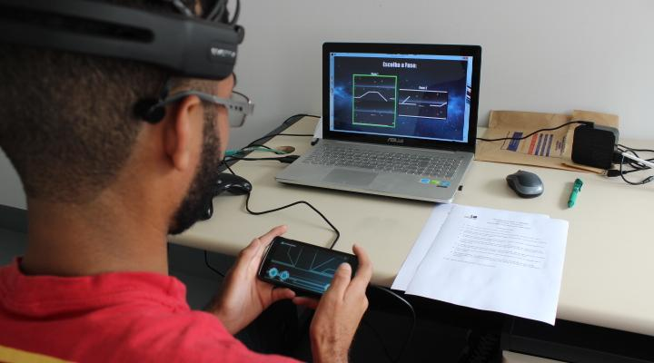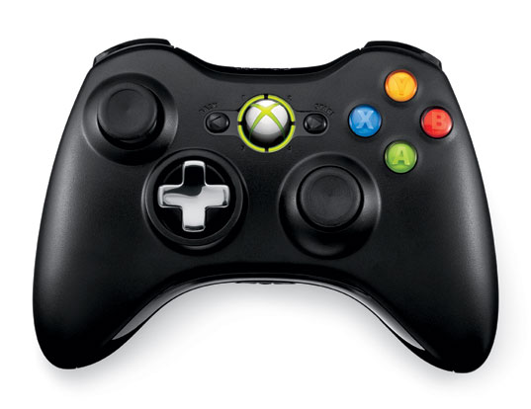

(a) (b)

Figure 1. Input devices used in the users sessions. (a) Participant playing the game with the SmartController and using the Emotiv headset. (b) Traditional Xbox controller.

### 4.2.2. The Game

For the experiment section was selected a game with both controllers compatibility, called Guardian of Eternity, The objective is to escape the planet with the main character. It’s a simple game, with two stages. The player just has to reach the far right of the stage to finish it, avoiding getting hit by enemies or colliding with obstacles. Each hit decreases its health bar (or kills it instantly on stage 2). The player’s character starts with 3 lifes and have the possibility to gather more ‘life orbs’ during the stage. If the player dies, he will return from the last checkpoint. In stage 1, the player controls a robot and has to perform simple *platforming* tasks to defeat enemies and avoid hazards. The controller uses a simple layout with two directional arrows and a jump button, plus a transform button. Pressing the latter one changes the character to the spaceship form. Now the gameplay is a classic dual-stick shooter and the controller layout changes to two analog sticks (left one to move the ship and right one to shoot at any direction). Figure 3 shows the game stages screens, while Figure 4 show the respective adaptive controller layouts used to play [30].

After completing the stage 1, the main character is too damaged to keep going and it is necessary to disable several of its weapons and powers. In Figure 3 (c) we can see the minigame screen, where the player has to turn off the switches on the controller and turn down the power using the dial. This is an example of the kind of direct and natural interaction that this controller provides (as shown on Figure 4 (c)), mapping a real-world action to an interface that is way more similar to real devices than mere buttons on a gamepad. The player, now stuck in the spaceship form, proceeds to enter a maze, where he has to avoid colliding with walls or asteroids. The weakened guardian has troubles to fight the effects of gravity. The player must constantly press "up" to avoid falling to the ground. The controller (as seen in Figure 4) has buttons to controls the vertical and horizontal movements separated in the opposing sides of the interface, an attempt to provide a more ergonomic alternative to a regular d-pad [30].

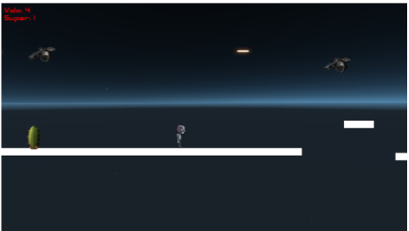

1. Robot at Stage 1 (b) Spaceship at Stage 1

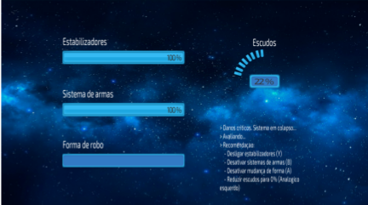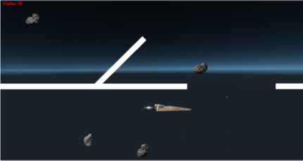

(c) Minigame (d) Spaceship at Stage 2

Figure 3. Game screens for both stages. Stage 1 has two gameplay modes: platforming as robot (a) and dual-stick shooter with the spaceship (b). After finishing this level, the player enters a minigame (c) that precedes the second stage (d).

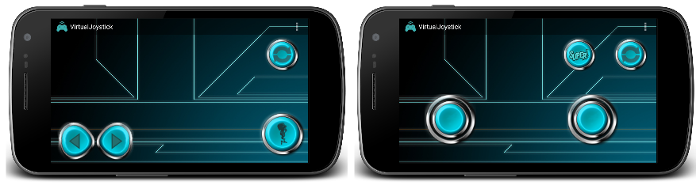

1. Robot at Stage 1 (b) Spaceship at Stage 1

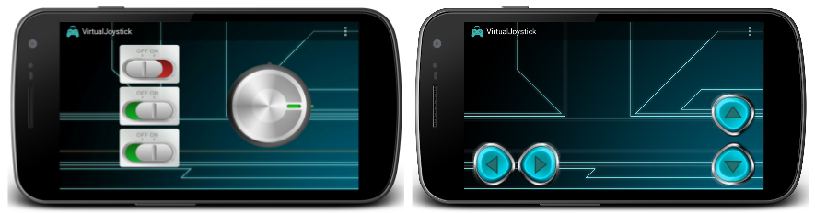

(c) Minigame (d) Spaceship at Stage 2

Figure 4: The layout displayed by the SmartController during the different stages of the game.

## 4.3. Equipaments

The experiments were made in a controlled environment in a computing institute room at Fluminense Federal University. Were used the Emotiv Epoc+ (Model 1.1) for physiological recordings, a Xbox controller device, a smartphone (Nexus 5) used as gamepad and two notebook computers, one Core i7 3th generation CPU, 8 GB of RAM and a Nvidia GeForce 745M GPU for running the game and other Core i7 6th generation CPU, 16 GB of RAM and a Nvidia GeForce 940M GPU for receive the Epoc+ data stream. The operating system was Windows 10.

# 6. Conclusion and future works

In summary, have found out that evaluate the user experience is not an easy task. Through this first comparative study between a traditional controller and the adaptive one, we collected data from 10 participants while they were playing with both controllers. A methodological result of the research presented in this paper indicates that while the general user experience and usability were similarly perceived in both controllers, the physiological measures indicate that the user's emotions were greater with the SmartController. In addition, … [descrever mais resultados]

Fatores que podem ter influenciado na UX dos jogadores: tamanho da mão e dedos, experiência previa.  the play style of each player differs according to personal characteristics (like hand size) or past gaming experiences

# Acknowledgements

We would like to express our gratitude to Adriel Araújo, Bruno Olímpio and José Santos for helping in this study. We also would like to thank all our participants.

# 8. References

1. Bernhaupt. R.  2015. Game User Experience Evaluation. Human Computer Interaction Series, Springer.
2. Hotho, S., McGregor, N. 2013. Changing the Rules of the Game: Economic, Management and Emerging Issues in the Computer Games Industry. Springer.
3. YoYo Games: GameMaker. http://www.yoyogames.com/gamemaker. Accessed 23/11/2016.
4. Torok, L., Pelegrino, M., Lessa, J., Trevisan, D.G., Vasconcelos, C.N., Clua, E. and Montenegro, A. 2015. Evaluating and customizing user interaction in an adaptive game controller. Design, User Experience, and Usability: Interactive Experience Design, DUXU 2015. LNCS, vol 9188. Springer, pp. 315-326.
5. Malfatti, S. M., Dos Santos, F.F. & Dos Santos, S.R. 2011, Using mobile phones to control desktop multiplayer games, Proceedings - 2010 Brazilian Symposium on Games and Digital Entertainment, SBGames 2010, pp. 230.
6. Vajk, T., Coulton, P., Bamford, W., Edwards, R., 2007. Using a Mobile Phone as a “Wii-like” Controller for Playing Games on a Large Public Display, International Journal of Computer Games Technology 2008*,*e539078.
7. Torok, L., Pelegrino, M., Trevisan, D.G., Clua, E. & Montenegro, A. 2015, A mobile game controller adapted to the gameplay and user’s behavior using machine learning. Entertainment Computing - ICEC 2015, Springer, pp. 3-16.
8. Pelegrino, M., Torok, L., Trevisan, D. & Clua, E. 2014, Creating and Designing Customized and Dynamic Game Interfaces Using Smartphones and Touchscreen, Brazilian Symposium on Games and Digital Entertainment, SBGAMES, pp. 133.
9. VentureBeat, 2016. PwC: Game industry to grow nearly 5% annually through 2020. Available at: http://venturebeat.com/2016/06/08/the-u-s-and-global-game-industries-will-grow-a-healthy-amount-by-2020-pwc-forecasts/. Accessed: 20/01/2017.
10. Steam Community: GestureWorks Gameplay. <https://steamcommunity.com/app/296610>. Accessed 20/01/2017.
11. Hassenzahl, M. 2005, Hedonic, emotional, and experiential perspectives on product quality. In Encyclopedia of Human Computer Interaction, pp. 266-272.
12. Nacke, L., E., Grimshaw, M., N., Lindley, C., A., 2010, More than a feeling: Measurement of sonic user experience and psychophysiology in a first-person shooter game. Interacting with Computers, Springer, pp. 336-343.
13. Mandryk, R. L., Inkpen, K. M., & Calvert, T. W. 2006. Using psychophysiological techniques to measure user experience with entertainment technologies. In Behaviour and Information Technology. vol. 25 no. 2, pp. 141-158.
14. Brühlmann, F. and Schmid, GM. 2015. How to Measure the Game Experience?: Analysis of the Factor Structure of Two Questionnaires. In Proceedings of the 33rd Annual ACM Conference Extended Abstracts on Human Factors in Computing Systems (CHI EA '15). ACM, New York, NY, USA, 1181-1186.
15. Nacke, L., E. and Lindley, C. 2009. Affective Ludology, Flow and Immersion in a First- Person Shooter: Measurement of Player Experience. The Journal of the Canadian Game Studies Association. Vol 3, No 5, pp. 1-21.
16. Ramirez, R. and Vamvakousis, Z. 2012, Detecting Emotion from EEG Signals Using the Emotive Epoc Device. In Brain Informatics, Springer. pp. 175-184.
17. Cernea, D., Kerren, A., and Ebert, A. 2011. Detecting Insight and Emotion in Visualization Applications with a Commercial EEG Headset. In Conference on Evaluations of Graphics and Visualization - Efficiency, Usefulness, Accessibility, Usability, pp.53-60.
18. Zhang, Z. Microsoft Kinect Sensor and Its Effect. 2012. IEEE Multimedia, vol. 19, no. 2, pp. 4-10.
19. Emotiv: Epoc Brain Activity Map. <https://www.emotiv.com/product/epoc-brain-activity-map/>. Access 18/11/2016.
20. Natapov, D., Castellucci, Steven J. and MacKenzie, I. Scott. 2009. ISO 9241-9 evaluation of video game controllers. In Proceedings of Graphics Interface 2009 (GI '09). Canadian Information Processing Society, Toronto, Canada, pp.223-230.
21. Emotiv. <https://www.emotiv.com/> Access 18/11/2016.
22. Emotiv: User Manual for Emotiv Xavier Control Panel Epoc. <https://www.emotiv.com/>. Access 18/11/2016.
23. Schrepp, M., Held, T. and Laugwitz, B. 2006. The influence of hedonic quality on the attractiveness of user interfaces of business management software. In Interacting with Computers, 18, 5, pp. 1055-1069.
24. IJsselsteijn, W., van den Hoogen, W., Klimmt, C., de Kort, Y., Lindley, C., Mathiak, K., Poels, K., Ravaja, N., Turpeinen, M., and Vorderer, P. 2008. Measuring the experience of digital game enjoyment. In Proc. of Measuring Behavior, Maastricht, Netherlands, pp.88-89.
25. Lankes, M., Bernhaupt, R., Tscheligi, M. 2015. Evaluating User Experience Factors using Experiments: Expressive Artificial Faces Embedded in Contexts. In Game User Experience Evaluation p:113-133. Springer.
26. Brown, M. A., Kehoe, A., Kirakowski, J. and Pitt, I. 2015. Beyond the Gamepad: HCI and Game Controller Design and Evaluation. In Game User Experience Evaluation, pp. 263-285, Springer.
27. AttrakDiff. <http://attrakdiff.de/index-en.html>. Access 08/12/2016.
28. Brooke, J. 1996. SUS-A quick and dirty usability scale. Usability evaluation in industry, v. 189, n. 194, p. 4-7.
29. Bernhaupt, R. Desnos, A., Pirker,M., Schwaiger. D. TV Interaction Beyond the Button Press - Exploring the Implications of Gesture, Pressure and Breath as Interaction Mechanisms for a TV User Interface. IFIP TC13 Conference on Human-Computer Interaction 2015 (INTERACT). p:1-8. Springer.
30. Poels, K., de Kort, Y.A.W., & IJsselsteijn, W.A. (2007). It is always great fun! Exploring dimensions of digital game experience using focus group methodology. Proceedings of the 2007 Conference on Future Play (Toronto, Canada, 14-18 November 2007), 83-89.
31. Arnold, A. 1999 Mental effort and evaluation of user interfaces: A questionnaire approach. In: Proceedings of 8th International Conference on Human-Computer Interact, ACM, New York, pp. 1003–1007.
32. McNamara, N. and Kirakowski, J. 2011. Measuring user-satisfaction with electronic consumer products: The Consumer Products Questionnaire. In: International Journal of Human-Computer Studies, 69, 6, pp. 375-386.
33. Flanagan, J. C. 1954. The Critical Incident Technique. Psychological Bulletin. pp. 1-33.
34. Nacke, L. E. 2013. An Introduction to Physiological Player Metrics for Evaluating Games. In Game Analytics: Maximizing the Value of Player Data. pp 585-619.
35. Bradley, M. M., & Lang, P. J. 2007. Emotion and motivation. In J. T. Cacioppo, L. G. Tassinary, & G. G. Berntson (Eds.), Handbook of psychophysiology (3rd ed., pp. 581–607). New York: Cambridge University Press.
36. Christou, G. 2012. Exploring player perceptions that contribute to the appeal of World of Warcraft. In Proceedings of the 4th International Conference on Fun and Games (FnG '12). ACM, New York, NY, USA, 105-108.
37. Ryan, R., Rigby, C., and Przybylski, A. 2006. The motivational pull of video games: A self-determination theory approach. Motivation andEmotion 30, 4, pp. 344-360.

1. Wiimote: http://wii.com/
2. Kinect: https://developer.microsoft.com/en-us/windows/kinect
3. SmartController: http://smartcontrollerapp.com/