* MOSFETS
  + MOSFETs are more durable than relays. The price is comparable. The galvanic isolation rises a question [?].
  + The replaceability – a custom connector can be produced. The advantage is robustness and the possibility to sell dedicated MOSFET modules. The disadvantage is the additional price of the connector (and the satellite PCB). There are TO-220 connectors available, but they are expensive and does not seem to be durable.
  + MOSFET-based solution is much smaller:
    - 3.4 x 3.4 x 0.9 mm (MOSFET) +   
       23.1 x 15.4 x 7.3 mm (MR30PW connector ~2.5€/pair)  
      OR 13.9 x 7.9 x 2.5 mm (angled goldpin connector ~0.2€/pair)
    - 28.5 x 27.2 x 24.8 mm (relay) + 27 x 25 x 20 mm (connector)
  + Possible solution(s):
    - PSMN013-30MLC
  + Using 25A MOSFETS might be an overkill [?] a bit. 25A*8=200A -> PCB and the connector can be unable to handle it.
* The connector
  + 2 power pins
  + 4 (2*2) thermocouple pins
  + 16 (8*2) relays/MOSFETs pins
  + Separate powers pins [?] (XT-60)
  + The expected current [?] must be taken into account.
  + Possible solution(s):
    - DSUB-25 (female, horizontal) – 3A
    - ECU (aliexpress) – expensive, 3-4A
* Voltage regulator
  + LD1085D2T33R (3A, 4.9-30V, D2PAK)

**THE RESULTS**

* **ESP32** + needed passive elements
* MOSFETs -> **PSMN013-30MLC** (<https://eu.mouser.com/ProductDetail/Nexperia/PSMN013-30MLC115?qs=qs9S9JrzwyZJD0ZHBCqfpw==>)

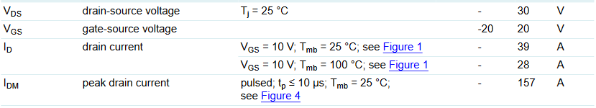

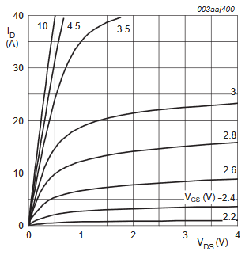

* Satellite boards for the MOSFETs
* LEDs to indicate MOSFETs states
* 8*2 MOSFET outputs + 2*2 thermocouple inputs
* The connector -> **DSUB-25** (<https://eu.mouser.com/ProductDetail/Amphenol-FCI/D25S23A4GV00LF?qs=V0y2QjpmBGS4pav1UJlQNQ%3D%3D>) for signals + **XT60PW-M** ([link](https://www.tme.eu/pl/details/xt60pw-m/zlacza-dc/amass/)) for power
* Voltage regulator -> **LD1085D2T33R** ([link](https://www.tme.eu/pl/details/ld1085d2t33r/stabilizatory-napiecia-nieregulowane-ldo/stmicroelectronics/?gclid=Cj0KCQjw-O35BRDVARIsAJU5mQXOf7SSlpjJuLuSLFXYVsLFqU0o_188xc3pDSI3qLoMHaixzmj93Q4aAnOTEALw_wcB)) 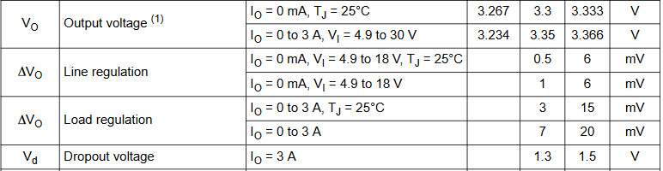
* Powering traces run parallelly on both PCB sides, unmasked, covered with solder