Environmental variablity in three major mediterranean tuna spawning grounds

Alvarez-Berastegui D [1], B. Mourre1, S. Saber[2], J. Ortiz de Urbina2, D. Macías2, P.Reglero[3]

SUMMARY

We propose four different environmental indicators, three related to temperature variability in three major spawning grounds of tuna species in the Mediterranean, and one related to the salinity variability in the Balearic Sea. These indicators show the annual variability of environmental parameters affecting growth and survival of tuna eggs and larval. The indicators are intended to provide quick access to assessment working groups and fisheries scientist to identify potentially anomalous years.

KEYWORDS

Mediterranean, spawning grounds, mixed layer depth, temperature, salinity, spawning season

1. Introduction

Environmental variability at the spawning grounds of tuna species in the Mediterranean Sea affects a number of ecological processes driving the location of the spawning sites, egg hatching and larval survival. One of the most relevant hydrographic variables driving these processes is the temperature within the mixed layer depth, (Alvarez-Berastegui et al. 2016; Reglero et al. 2018a), which provide information on environmental drivers affecting recruitment processes and timing of spawning (Harford 2017, Reglero 2018a). It is a common issue of discussion in SCRS working groups whether a particular year shows specific anomalies in temperature and how they can affect interpretability of the catches by the fleets and recruitments observed in the assessment models. Therefore, it should be useful to have quick access to time series of sea temperature in the mixed layer depth at the most relevant spawning grounds of tuna species in the Mediterranean during their spawning seasons. This would provide fisheries scientists with a reference data set to explore temperature trends and to identify potentially anomalous years. Recent hydrodynamic models covering the entire Mediterranean basin provide temperature data at various depths that can be used for comparison of the trends in difference areas for long time series. Sea surface temperature is accurately estimated from these models (Simoncelly et al. 2014)

The mean water salinity in the mixed layer depth provides a proxy for the water masses distribution in the Balearic Sea (Western Mediterranean, see figure 1), which affects the spatial distribution of the spawning areas (Alemany et al. 2010; Alvarez-Berastegui 2014; Reglero et al. 2017). This variable has proved to improve standardization of larval abundance indices in the Balearic Sea, both for bluefin tuna *Thunnus thynnus* (Ingram et al. 2017) and for *T. alalunga* albacore (Alvarez-Berastegui 2017). Nevertheless, the hydrodynamic models at the Mediterranean basin show lower capabilities to provide good estimations of the salinity distributions than for temperature, therefore when this variable has to be assessed it is necessary to apply validated models for this parameter. In the Balearic Sea, the Western Mediterranean Sea Operational Forecasting System (WMOP) provides this characteristic covering a time series from 2009 to present for the Balearic Sea (Juza et al., 2016).

Considering the relevance of these two hydrographical parameters and the hydrodynamic models available, we propose two indicators to assess the environmental variability of spawning grounds in the Mediterranean. The two indicators provide information on:

1) The mean water temperature in the mixed layer depth in the main tuna spawning areas in the Mediterranean during the spawning season. The temperature data from a Mediterranean regional scale hydrodynamic model (Simoncelly et al. 2014). This indicator is computed at three different spawning areas, the Balearic Sea in the Western Mediterranean, the Tunisia-Malta in the Central and Cyprus in the Eastern Mediterranean (**Figure 1**).

2) The mean water salinity in the mixed layer depth in the Balearic Sea spawning ground during the spawning season from the WMOP high resolution hydrodynamic model (Juza et al. 2016)

2. Methods

2.1. Indicators

A- Mean temperature in the Balearic Sea Spawning ground (Western Mediterranean), acronym: “Temp_Bal_SG”

B- Mean temperature in the Tunisia-Malta Spawning ground (Central Mediterranean), acronym: “Temp_Tunisia-Malta_SG”

C- Mean temperature in the Cyprus Spawning ground (Eastern Mediterranean), acronym “Temp_Cyprus_SG”

These three indicators (A,B,C) are computed from the temperature field of the “Mediterranean Forecasting System” hydrodynamic model (Simoncelly et al. 2014), that provides two different datasets: i) the Mediterranean Sea Physics Reanalysis product, covering the period for 1990 to 2014 period, and ii) the Mediterranean Sea Physics Analysis and Forecast product covering the period from 2015 to present (see details below).

Details on the “Mediterranean Forecasting System” Mediterranean Sea Physics Reanalysis product. Values estimated from 1990 to 2014. The data set and complete description of the modeling process are available at: http://marine.copernicus.eu/services-portfolio/access-to-products/?option=com_csw&view=details&product_id=MEDSEA_REANALYSIS_PHYS_006_004

Details on the “Mediterranean Forecasting System” Mediterranean Sea Physics Analysis and Forecast. Values estimated from 2015 to 2016. The data set and complete description of the modeling process are available at: http://marine.copernicus.eu/services-portfolio/access-to-products/?option=com_csw&view=details&product_id=MEDSEA_ANALYSIS_FORECAST_PHY_006_013

Data was extracted from the daily resolution product at the 10.5 meter depth, as a proxy for the mean temperature for the mixed layer depth, which is about 25 meters during reproduction in the Western spawning ground (Alemany et al., 2010). This depth has been selected in the basis of the vertical distribution of tuna larvae from vertical-resolution sampling and experimental work (Reglero et al., 2018b). The diary temperature data for each spatial region presented in Figure 2 are averaged along the months of May to August, both included. This time coverage has been selected as it covers the spawning season of most tuna species in the region (Reglero et al., 2018a, Saber et al., 2015). Values were scaled to represent the indicators.

D- Mean Salinity in the Western Mediterranean Spawning ground (Balearic Sea), acronym “Sal_Bal_SG”.

This indicator is computed from the salinity field of the Western Mediterranean Sea Operational Forecasting System (WMOP). In order to provide better approximations of salinity fields the WMOP is based on a 2km-resolution regional ocean configuration of the ROMS model implemented over the Western Mediterranean Sea.  The model is forced by high-resolution winds (5 km, 3 hours).

Data is extracted from the diary resolution product at the surface. The diary temperatures for the Western spawning ground (Balearic Sea, Figure 3) are averaged along the months of May to August, both included. This time coverage has been selected as it covers the spawning season of most tuna species in the region (Alemany et. al., 2010, Saber et al,. 2015). Values are scaled to represent the indicators.

Values from 2009 to 2015 are obtained from the “WMOP reanalysis” provided by SOCIB ([www.socib.es](http://www.socib.es)) under request.  
Values from 2016 to 2017 are obtained from the “WMOPforecast” provided online by SOCIB at:

http://thredds.socib.es/thredds/catalog/operational_models/oceanographical/hydrodynamics/wmop_3d/catalog.html.

Detailed information on the model configuration can be found at http://www.socib.es/?seccion=modelling&facility=modelling_overview

The operational validation of the model, including salinity can be accessed real time at: <http://www.socib.es/?seccion=modelling&facility=wmedvalidation>

2.2 Data

All data is available on-line or by request, as indicated in the previous section. Each indicator is a combination of different data sources providing reanalysis data in previous years or forecast data for the last 2 or 3 years (for further detail see Section 2.1)

2.3 Regions

The indicators proposed provide information on the environmental variability in the Mediterranean spawning grounds of main tuna species. Indicators must be interpreted at regional scale.

2.4 Goals and Objectives

The objective of these indicators is to provide the ICCAT/SCRS assessment working groups with quick access to information on the environmental variability at the spawning grounds, facilitating the identification of anomalous years and the task of CPUE standardization.. These indicators also helps interpreting the outputs of the assessment models.

3. Interpretation

The three indicators based on temperature data (Temp_Bal_SG; Temp_Tunisia-Malta_SG; Temp_Cyprus_SG) provide information on the potential effects of environmental variability on tuna eggs and larval survival and growth (Reglero et al. 2018) in the three different Mediterranean spawning grounds, and the potential recruitment scenarios (Harford et al. 2017). The variability of salinity in the Balearic Sea (Sal_Bal_SG) provides information on the water masses distribution in the area, which are associated to the spatial distribution of larval habitats (Alvarez-Berastegui et al. 2016). Higher mean salinity is related to larval habitats located south of the archipelago which favors dispersal out of the area.

4. Acknowledgements

This work has been carried on in the framework of the bluefin tuna project, a SOCIB/IEO funded initiative. This work has received funding from the European Union’s Horizon 2020 research and innovation programme under Grant Agreement No 678193 (CERES) and No 773713 (PANDORA). The collaboration of all the staffinvolved in the extensive field sampling is also enormously appreciated as is the kindly assistance of, the people involved in the laboratory work, , in particular Melissa Martin. We acknowledge the CLIOTOP task team (Ref: 2016/04) OOSTOP for providing a collaborative framework.

References

Alemany, F., Quintanilla, L., Velez-Belchí, P., García, A., Cortés, D., Rodríguez, J. M., ... & López-Jurado, J. L. (2010). Characterization of the spawning habitat of Atlantic bluefin tuna and related species in the Balearic Sea (western Mediterranean). Progress in Oceanography, 86(1-2), 21-38.

Alvarez-Berastegui D., Ciannelli L., Aparicio-Gonzalez A., Reglero P., Hidalgo M., López-Jurado J. L., Tintoré J., & Alemany F. (2014) Spatial Scale, Means and Gradients of Hydrographic Variables Define Pelagic Seascapes of Bluefin and Bullet Tuna Spawning Distribution. PloS one 9: e109338.

Alvarez-Berastegui D., Hidalgo M., Tugores M. P., Reglero P., Aparicio-González A., Ciannelli L., Juza M., Mourre B., Pascual A., López-Jurado J. L., García A., Rodríguez J. M., Tintoré J., & Alemany F. (2016) Pelagic seascape ecology for operational fisheries oceanography: modelling and predicting spawning distribution of Atlantic bluefin tuna in Western Mediterranean. ICES Journal of Marine Science: Journal du Conseil.

Alvarez-Berastegui D., Ingram G.W., Reglero P., Macías D. and Alemany F., 2017, Albacore (Thunnus alalunga) larval index in the Western Mediterranean Sea (2001-2015), SCRS/2017/122, SCRS ALBACORE INTERSSESSIONAL MEETING, Madrid, Spain 5-9 June, 2017

Harford, W. J., Karnauskas, M., Walter, J. F., & Liu, H. (2017). Non‐parametric modeling reveals environmental effects on bluefin tuna recruitment in Atlantic, Pacific, and Southern Oceans. Fisheries Oceanography, 26(4), 396-412.

Ingram G. W., Alvarez-Berastegui D., Reglero P., Balb+¡n R., Garc+¡a A., & Alemany F. (2017) Incorporation of habitat information in the development of indices of larval bluefin tuna (Thunnus thynnus) in the Western Mediterranean Sea (2001GÇô2005 and 2012GÇô2013). Deep Sea Research Part II: Topical Studies in Oceanography.

Juza M., Mourre B., Renault L., Gomara S., Sebastián K., Lora S., Beltran J. P., Frontera B., Garau B., Troupin C. 2016. SOCIB operational ocean forecasting system and multi-platform validation in the Western Mediterranean Sea. Journal of Operational Oceanography, 9: s155-s166.

Reglero P., Blanco E., Alemany F., Ferré C., Alvarez-Berastegui D., Ortega A., de la Gándara F., Aparicio-González A., & Folkvord A. (2018b) Vertical distribution of Atlantic bluefin tuna Thunnus thynnus and bonito Sarda sarda larvae is related to temperature preference. Marine Ecology Progress Series 594: 231-243.

Reglero P., Ortega A., Balbín R., Abascal F. J., Medina A., Blanco E., de la Gándara F., Alvarez-Berastegui D., Hidalgo M., & Rasmuson L. (2018a) Atlantic bluefin tuna spawn at suboptimal temperatures for their offspring. Proc.R.Soc.B 285: 20171405.

Reglero, P., Santos, M., Balbín, R., Laíz-Carrión, R., Alvarez-Berastegui, D., Ciannelli, L., ... & Alemany, F. (2017). Environmental and biological characteristics of Atlantic bluefin tuna and albacore spawning habitats based on their egg distributions. Deep Sea Research Part II: Topical Studies in Oceanography, 140, 105-116.

Saber S., de Urbina, J. O., Gómez-Vives, M. J., & Macías, D. (2015). Some aspects of the reproductive biology of albacore Thunnus alalunga from the western Mediterranean Sea. Journal of the Marine Biological Association of the United Kingdom, 95(08), 1705-1715.

Simoncelli, S., Fratianni, C., Pinardi, N., Grandi, A., Drudi, M., Oddo, P., & Dobricic, S. (2014). "Mediterranean Sea physical reanalysis (MEDREA 1987-2015) (Version 1)". [set](http://resources.marine.copernicus.eu/Data). E.U. Copernicus Marine Service Information. DOI: <https://doi.org/10.25423/medsea_reanalysis_phys_006_004>

**Table 1**. Indicators derived from the Mediterranean Copernicus model for the Western Mediterranean Spawning ground (Balearic Sea) “Temp_Bal_SG”; Central Mediterranean (Tunisia; Malta) “Temp_Tunisia-Malta_SG” and Eastern Mediterranean (Cyprus) “Temp_Cyprus_SG”.

|  |  |  |  |
| --- | --- | --- | --- |
| **Year** | **Temp_Bal_SG** | **Temp_Tunisia-Malta_SG** | **Temp_Cyprus_SG** |
| 1990 | 22,31326 | 22,48707 | 23,01869 |
| 1991 | 21,08693 | 21,31543 | 23,10998 |
| 1992 | 21,10479 | 21,45401 | 22,93647 |
| 1993 | 21,62844 | 22,414 | 22,76052 |
| 1994 | 22,20179 | 23,74159 | 23,64557 |
| 1995 | 21,87702 | 22,3482 | 23,28192 |
| 1996 | 21,97704 | 22,39694 | 23,64748 |
| 1997 | 21,88322 | 22,65884 | 22,78506 |
| 1998 | 22,0235 | 22,50415 | 23,52717 |
| 1999 | 22,38905 | 22,45661 | 24,1048 |
| 2000 | 22,25918 | 22,67464 | 24,10256 |
| 2001 | 22,196 | 22,45492 | 24,28715 |
| 2002 | 21,70595 | 22,21708 | 24,1185 |
| 2003 | 23,0975 | 22,77247 | 24,38149 |
| 2004 | 21,50611 | 22,01937 | 23,76087 |
| 2005 | 22,40847 | 22,5848 | 24,40889 |
| 2006 | 22,33461 | 22,82936 | 23,94056 |
| 2007 | 22,23789 | 22,79213 | 24,18599 |
| 2008 | 22,20893 | 23,04452 | 24,47711 |
| 2009 | 22,33265 | 23,01559 | 24,35793 |
| 2010 | 21,76708 | 22,52389 | 24,36406 |
| 2011 | 22,70065 | 22,70924 | 24,10992 |
| 2012 | 22,42244 | 23,36165 | 24,26414 |
| 2013 | 21,6483 | 22,47342 | 24,55104 |
| 2014 | 22,35795 | 22,48634 | 24,57975 |
| 2015 | 22,96503 | 22,83309 | 23,97105 |
| 2016 | 22,13526 | 22,20636 | 24,7757 |

**Table 2**. A subset of the indicators derived from the WMOP model for the Western spawning ground (Balearic Sea) data prior to scaling.

|  |  |  |
| --- | --- | --- |
| **Year** | **Temp_Bal_SG_wmop** | **Sal_Bal_wmop** |
| 2009 | 23,44416 | 37,60975 |
| 2010 | 22,40927 | 37,37421 |
| 2011 | 22,86239 | 37,23452 |
| 2012 | 23,17471 | 37,50134 |
| 2013 | 22,19917 | 37,81337 |
| 2014 | 22,64914 | 37,51789 |
| 2015 | 23,7575 | 37,31666 |
| 2016 | 22,41781 | 37,54759 |
| 2017 | 23,32326 | 37,38186 |

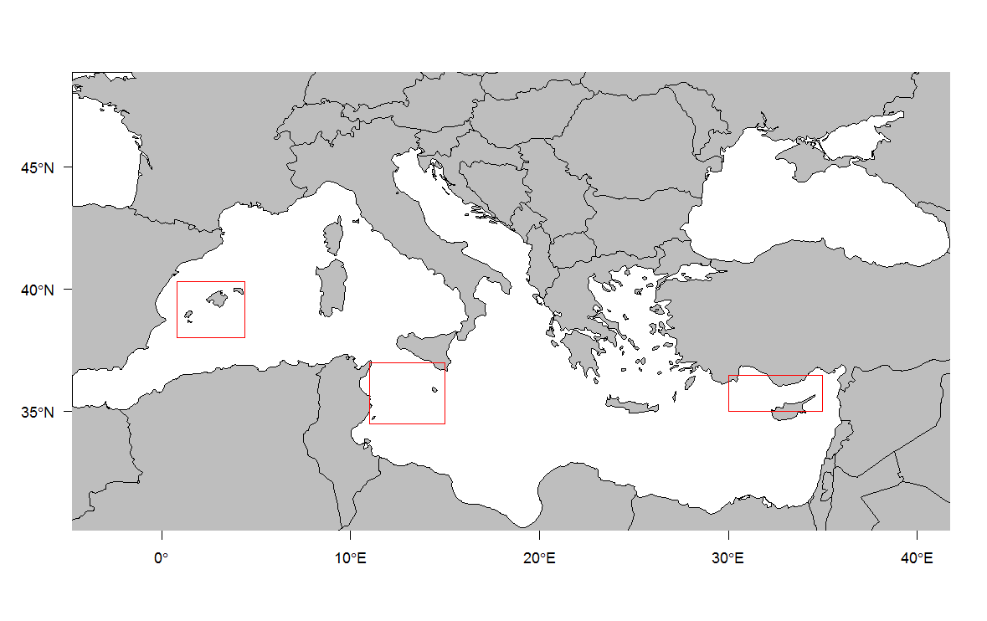

Cyprus Spawning ground (Eastern Mediterranean)

Tunisia-Malta Spawning ground (Central Mediterranean)

Balearic Spawning ground (Western Mediterranean)

**Figure 1.** The Mediterranean Sea showing the geographical limits of the spawning grounds (Balearic Sea in the Western, Tunisia-Malta in the Central, and Cyprus in the Eastern Mediterranean) used for the spatial integration of the oceanographic variables. The geographical areas also coincide with the ICCAT aerial surveys.

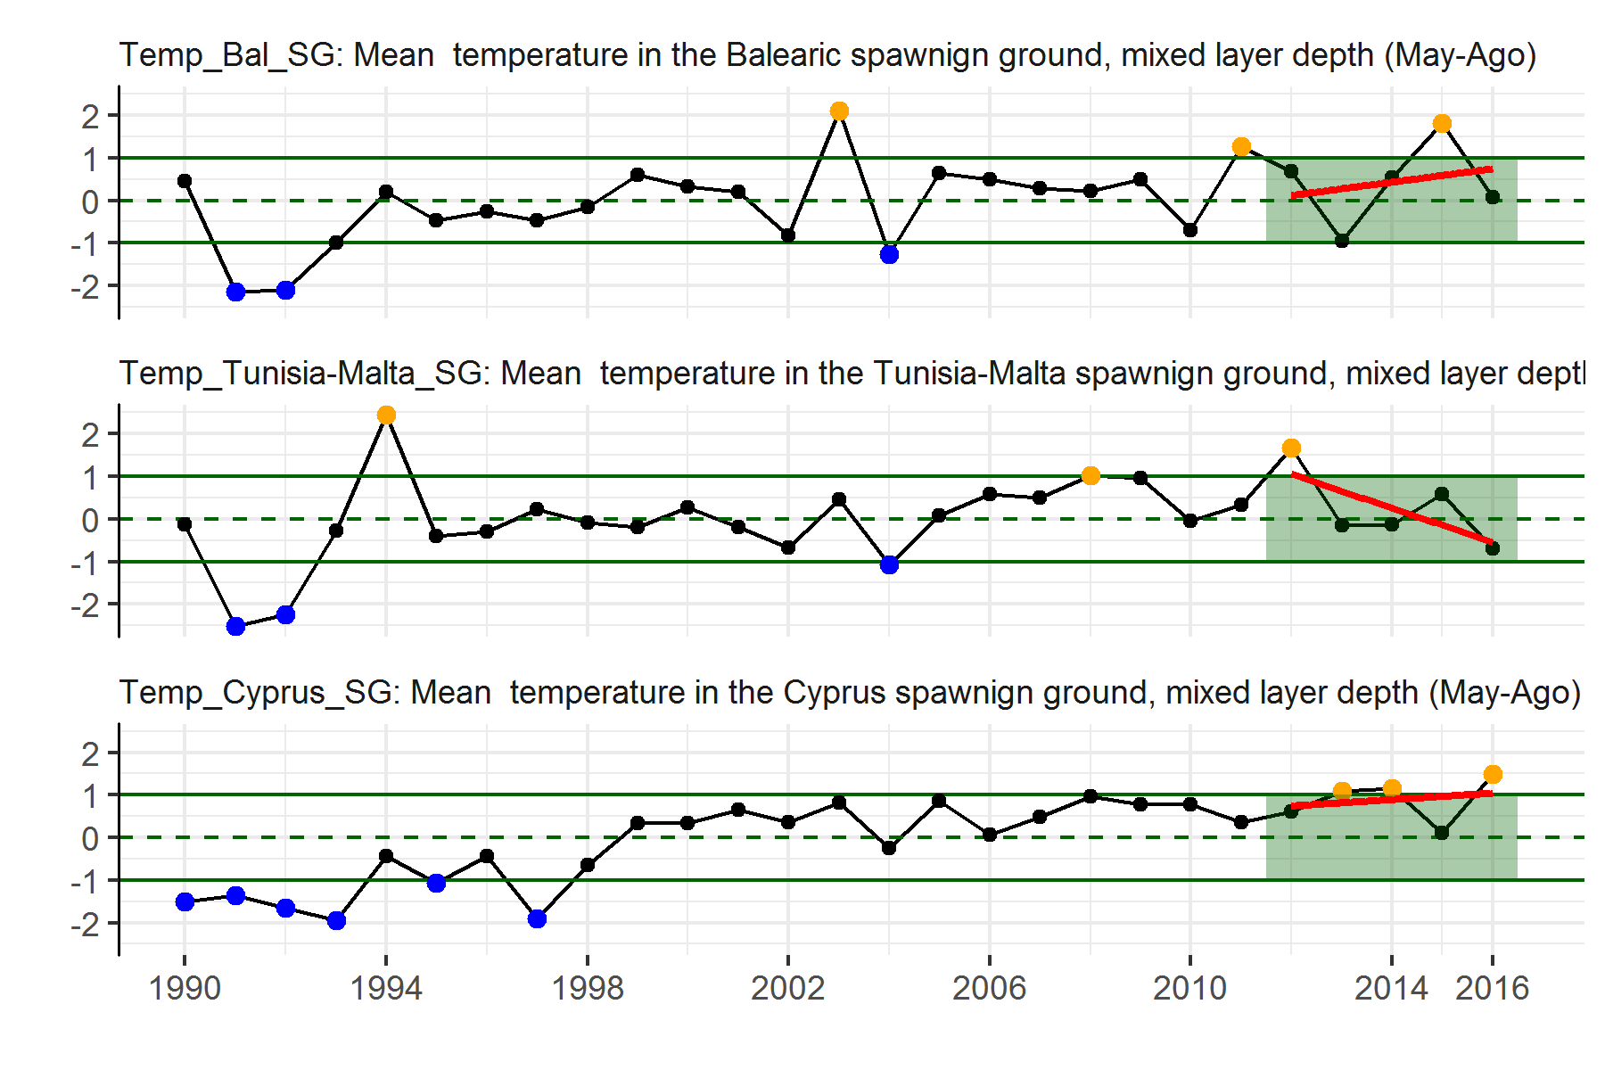

**Figure 2.** Mean temperature in the Western Mediterranean Spawning ground (Balearic Sea); Central Mediterranean (Tunisia; South Sicily) and Eastern Mediterranean (Cyprus). Data from the Copernicus MEDSEA hydrodynamic model. Indicators of ecosystem status. Values ≥1 std are orange. Values ≤-1 std are blue. Red trend lines are for the last 5 years and were fit with a linear model.

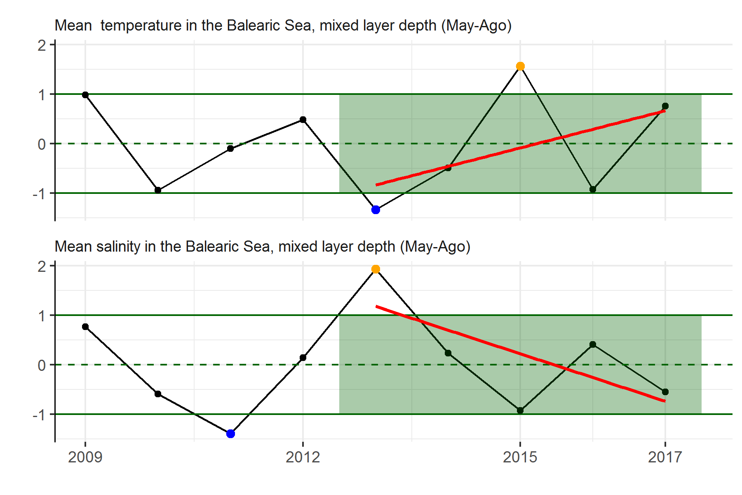

**Figure 3.** Mean temperature and salinity in the Balearic Spawning ground (Western Mediterranean). Data from the WMOP (Western Mediterranean Sea Operational Forecasting System). Indicators of ecosystem status. Values >= 1 std are orange. Values <= -1 std are blue. Red trend lines are for the last 5 years and were fit with a linear model.

1. S-SOCIB, Balearic Islands Coastal Observing and Forecasting System, Palma de Mallorca, SPAIN. E-07121.
2. Instituto Español de Oceanografía, Centro Oceanográfico de Málaga, Puerto Pesquero, s/n, 29640 Fuengirola, Málaga, Spain.
3. Instituto Español de Oceanografía, Centro Oceanográfico de Baleares, Ecosystem Oceanography Group (GRECO), Palma de Mallorca, Baleares, Spain.