|  |
| --- |
| This document is for the results of usability  of the webpage tim.it, so that to know  the problems and the hightlights |

Name: José Vega Díaz Email: josevega_eci@hotmail.com

Name: Nicolás Andrés Leiva Büchi Email: [nicolasleivab@gmail.com](mailto:nicolasleivab@gmail.com)

Name: David Soto Sánchez Email:david.soto.sanchez.94@gmail.com

Deliver Date: 7th May 2017

Usability

Usability for tim.it

Introduction

This usability is done for the webpage tim.it. This is a webpage used for the company TIM and you can buy mobile phones and you can contract service for your phone or ADSL or Fibra. This company is Italian. The phone services are to use your mobile phone in Italy or the rest of the world, although the prices are different, it’s more economic to contract for Italy only. On the other hand, we have measure the usability by the Milles method, so that all the heuristics are checked and we have chosen the most relevant ones for each page. It’s a laborious silly work to check all the heuristics because of the amount of them and some of them are insignificant for the actual page. So that we have decided to put a minimum of 2 heuristics by page.

Scenarios

*Scenario 1:* **The customer visits the webpage and firstly, she sees the homepage.**

**Then she sees the menu and she enters to the services. So that she sees the different services that there are in the clinic and she chooses cosmetic nose surgery. Now she sees a list of doctors who perform this surgery and at the bottom of the list, the prices appear. Then, she chooses a doctor and she sees the availability of the doctor. Moreover, at the bottom of the page she sees the contact page of the clinic and she can call for an appointment.**

Scenario 2: **A retired professional wants to make a medical appointment for checking his chronical hip problem. Since he has always been obsessive with choosing the best quality services-products, he deeply researched about this clinic (X) and decided to go for it. Now he wants to research about the medical team of the clinic that works at the area he is looking for, aiming to find about their formation and their work experience. When he enters the website, he finds the Doctors section in the homepage and finds the list of doctors by area. Once he selects the area regarding to his problem he reads the information available for each doctor, corresponding to their educational background and brief work experience. Finally he decides one of the doctors in the list according to his standards, returns to homepage and goes in the services page to make an appointment.**

Results

|  |  |  |  |  |  |  |
| --- | --- | --- | --- | --- | --- | --- |
| Scenario 1 | | | | | |  |
|  | Page | Heuristic | Person 1 | Person 2 | Person 3 | Group |
| Score | 1 | **Text** | 2 | 2 | 2 | 2 |
| Comment | Good coverage and conciseness but the content objectivity is ambiguous | Multimedia files and text are consistent with the subjects |  |  |
| Score | **Navigation within a Group of groups of topics** | 2 | 2 | 2 | 2 |
| Comment | Good navigation | Optimal |  |  |
| Score | **Overall Navigation** | 2 | 2 | 2 | 2 |
| Comment |  | Optimal |  |  |
| Score | **Overall graphic design** | 2 | 2 | 2 | 2 |
| Comment | Adequate | Optimal |  |  |
| Score | **Information architecture** | 2 | 2 | 2 | 2 |
| Comment |  | Optimal |  |  |
| Score | 2 | **Information architecture** | 2 | 2 | 2 | 2 |
| Comment | Good | Optimal |  |  |
| Score | **Text** | 2 | 2 | 2 | 2 |
| Comment | Good | Optimal |  |  |
| Score | 3  4 | **Overall Navigation** | 0 | 1 | 2 | 1 |
| Comment | We have clicked on TIM Special but we can see all the mobile offers | Lack of link consistency and topics presented | Optimal |  |
| Score | **Text** | 1 | 1 | 1 | 1 |
| Comment | You don’t know if the price and the content is forever or not. Moreover, a service contents TIM NEXT but it doesn’t explain anything. | There are is a lack of relevant information about the plans. | Only few information about the services |  |
| Score | **Text** | 0 | 1 | 1 | 1 |
| Comment | The most important thing is the cost and you must pay 20 euro but you don’t understand why this amount. | It is hard to understand the prices and services details | Confusing  and controversial information about prices |  |
| Score | **Backward navigation** | 0 | 0 | 0 | 0 |
| Comment | It doesn’t exist go back button. | No go back button | Absence of Go back button |  |
|  |  |  |  |  |  |
|  |  |  |  |  |

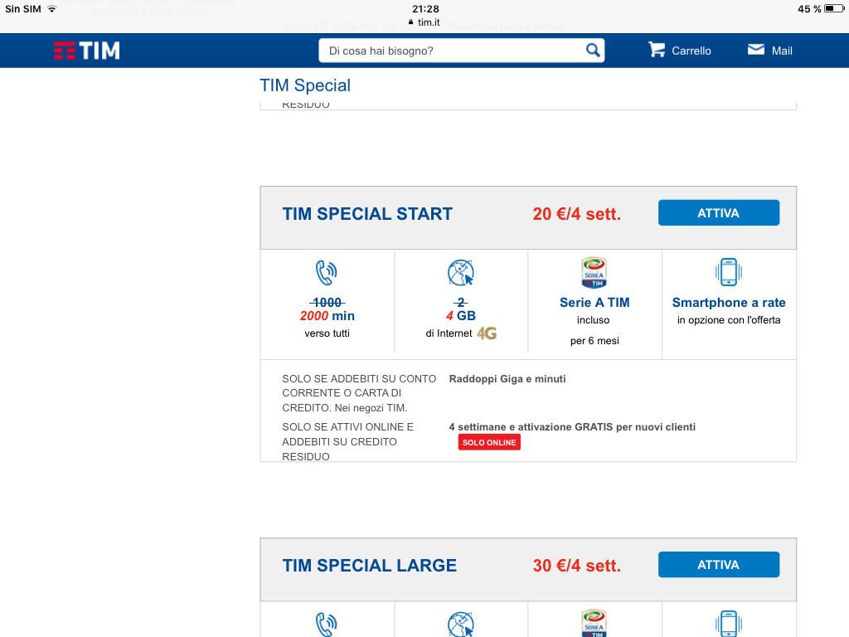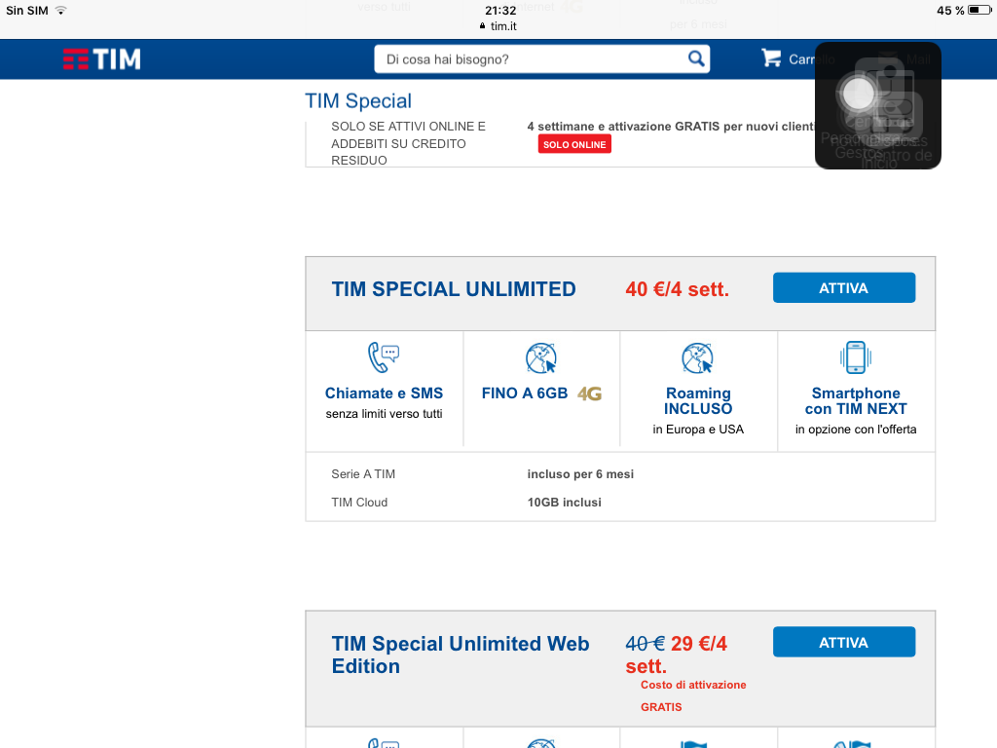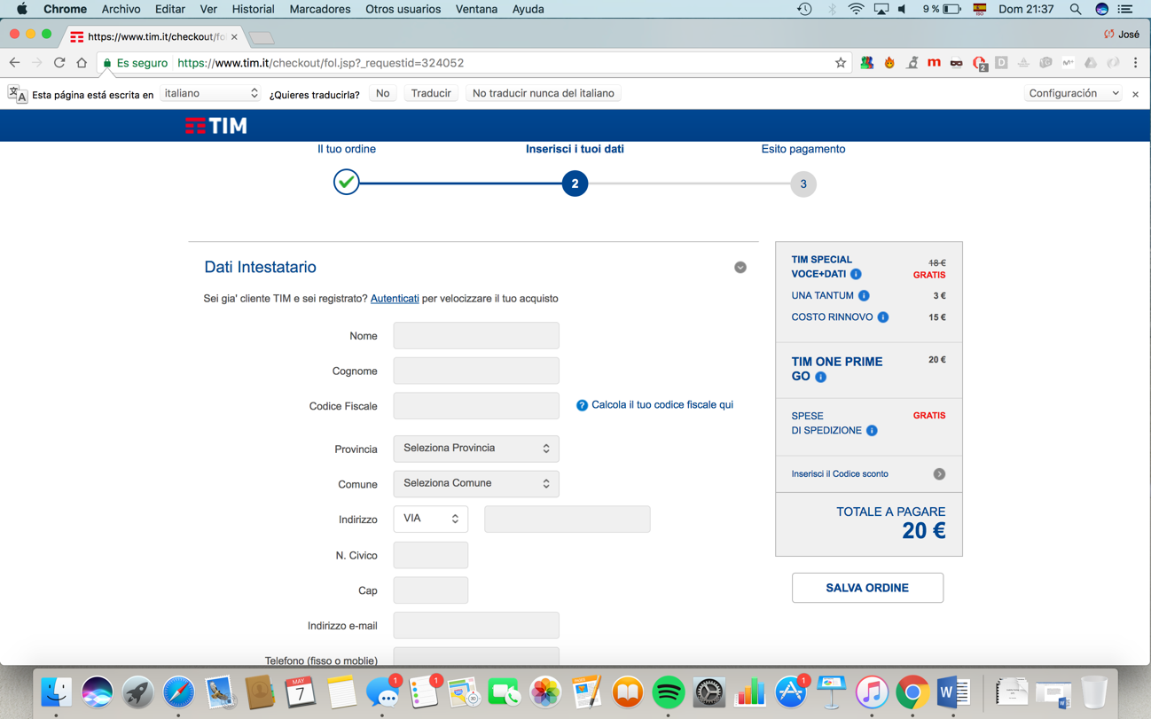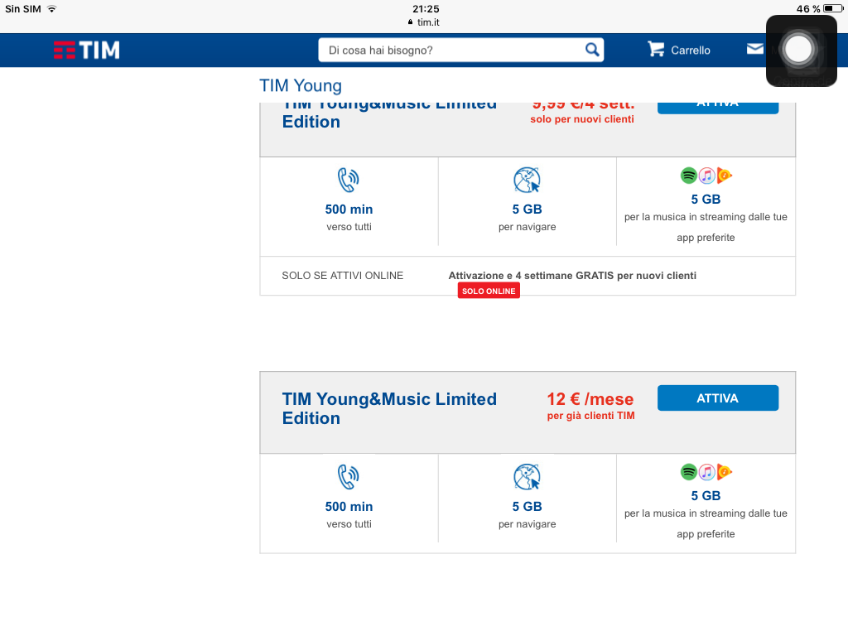

|  |  |  |  |  |  |  |
| --- | --- | --- | --- | --- | --- | --- |
| Scenario 2 | | | | | | Group |
|  | Page | Heuristic | Person 1 | Person 2 | Person 3 |  |
| Score | 1 | **Text** | 2 | 2 | 2 | 2 |
| Comment | Good coverage and conciseness but the content objectivity is ambiguous | Multimedia files and text are consistent with the subjects | Good consistency and coverage |  |
| Score | **Navigation within a Group of groups of topics** | 2 | 2 | 2 | 2 |
| Comment | Good navigation | Optimal | Adequate |  |
| Score | **Overall Navigation** | 2 | 2 | 2 | 2 |
| Comment |  |  |  |  |
| Score | **Overall graphic design** | 2 | 2 | 2 | 2 |
| Comment | Adequate | Optimal | Optimal |  |
| Score | **Information architecture** | 2 | 2 | 2 | 2 |
| Comment |  |  |  |  |
| Score | 2 | **Overall Navigation** | 2 | 2 |  | 2 |
| Comment | Good | Optimal | Good |  |
| Score | **Text** | 2 | 2 |  | 2 |
| Comment | Good | Optimal | Good |  |
| Score |  | **Single Page** |  | 0 |  | 0 |
| Comment |  |  | There is an overload of information and text that makes hard to understand the whole page |  |  |
| Score | 3 | **Information architecture** | 2 | 2 |  | 2 |
| Comment | Good |  |  |  |
| Score | **Navigation within a Group of groups of topics** | 2 |  | 2 | 2 |
| Comment | Good | Good | Optimal |  |
| Score | 4 | **Overall Navigation** | 2 |  | 2 |  |
| Comment | Good |  | Good |  |
| Score | **Backward Navigation** |  | 0 | 0 | 0 |
| Commnet |  | No go back button | No go back button |  |
| Score | **Overall graphic design** | 2 | 2 | 2 | 2 |
| Comment | Good | Optimal | Good |  |
| Score | 5 | **Information architecture** | 2 | 2 | 2 | 2 |
| Comment | Good | Good |  |  |
| Score | **Text** | 2 | 2 |  | 2 |
| Comment | Good | Good |  |  |
| Score | **Overall Navigation** | 2 |  | 2 | 2 |
| Comment | Good |  | Good |  |

