|  |  |  |  |  |  |
| --- | --- | --- | --- | --- | --- |
|  | Page | Heuristic | Person 1 | Person 2 | Person 3 |
| Score | 1 | General Comunication Quality | 2 |  |  |
| Comment | Multimedia files and text are consistent with the subjects |  |  |
| Score | Overall Navigation | 2 |  |  |
| Comment | Optimal |  |  |
| Score | Text | 2 |  |  |
| Commnet | Optimal |  |  |
| Score | Navigation within a Group of groups of topics | 2 |  |  |
| Commnet | Optimal |  |  |
| Score | Navigation within a transition (Navigation between topics) | 2 |  |  |
| Comment | Optimal |  |  |
|  |  |  |  |  |
|  | Page | Heuristic | Person 1 | Person 2 | Person 3 |
| Score | 2 | Page Layout | 2 |  |  |
| Comment | 2 | Page Layout  Single Page Information | Optimal |  |  |
| Score | 0 |  |  |
| Comment | Single Page Information | There is an overload of information and text that makes hard to understand the whole page |  |  |
|  |  |  |  |
|  | Page | Heuristic | Person 1 | Person 2 | Person 3 |
| Score | 3 | Information Architecture | 2 |  |  |
| Comment | 3 | Information Architecture  Navigation within a Group of groups of topics | Optimal |  |  |
| Score | 2 |  |  |
| Comment | Navigation within a Group of groups of topics | Optimal |  |  |
|  |  |  |  |
|  | Page | Heuristic | Person 1 | Person 2 | Person 3 |
| Score | 4 | Backward Navigation | 0 |  |  |
| Comment | 4 | Backward Navigation  Page Layout | There is not a “Go back” option that may generate problems in case of authentication errors |  |  |
| Score | 2 |  |  |
| Comment | Page Layout | Optimal |  |  |
|  |  |  |  |
|  | Page | Heuristic | Person 1 | Person 2 | Person 3 |
| Score | 5 | Single page | 2 |  |  |
| Comment | 5 | Single page  Page Layout | Optimal |  |  |
| Score | 2 |  |  |
| Comment | Page Layout | Optimal |  |  |
|  |  |  |  |
|  | Page | Heuristic | Person 1 | Person 2 | Person 3 |
| Score | 6 |  |  |  |  |
| Comment | 6 |  |  |  |  |
| Score |  |  |  |
| Comment |  |  |  |  |
|  |  |  |  |
|  | Page | Heuristic | Person 1 | Person 2 | Person 3 |
| Score | 7 |  |  |  |  |
| Comment | 7 |  |  |  |  |
| Score |  |  |  |
| Comment |  |  |  |  |
|  |  |  |  |
|  | Page | Heuristic | Person 1 | Person 2 | Person 3 |
| Score | 8 |  |  |  |  |
| Comment | 8 |  |  |  |  |
| Score |  |  |  |
| Comment |  |  |  |  |
|  |  |  |  |
|  | Page | Heuristic | Person 1 | Person 2 | Person 3 |
| Score | 9 |  |  |  |  |
| Comment | 9 |  |  |  |  |
| Score |  |  |  |
| Comment |  |  |  |  |
|  |  |  |  |
|  | Page | Heuristic | Person 1 | Person 2 | Person 3 |
| Score | 10 |  |  |  |  |
| Comment | 10 |  |  |  |  |
| Score |  |  |  |
| Comment |  |  |  |  |
|  |  |  |  |
|  | Page | Heuristic | Person 1 | Person 2 | Person 3 |
| Score | 11 |  |  |  |  |
| Comment | 11 |  |  |  |  |
| Score |  |  |  |
| Comment |  |  |  |  |
|  |  |  |  |
|  | Page | Heuristic | Person 1 | Person 2 | Person 3 |
| Score | 12 |  |  |  |  |
| Comment | 12 |  |  |  |  |
| Score |  |  |  |
| Comment |  |  |  |  |
|  |  |  |  |
|  | Page | Heuristic | Person 1 | Person 2 | Person 3 |
| Score | 13 |  |  |  |  |
| Comment | 13 |  |  |  |  |
| Score |  |  |  |
| Comment |  |  |  |  |
|  |  |  |  |
|  | Page | Heuristic | Person 1 | Person 2 | Person 3 |
| Score | 14 |  |  |  |  |
| Comment | 14 |  |  |  |  |
| Score |  |  |  |
| Comment |  |  |  |  |
|  |  |  |  |
|  | Page | Heuristic | Person 1 | Person 2 | Person 3 |
| Score | 15 |  |  |  |  |
| Comment | 15 |  |  |  |  |
| Score |  |  |  |
| Comment |  |  |  |  |
|  |  |  |  |
|  | Page | Heuristic | Person 1 | Person 2 | Person 3 |
| Score | 16 |  |  |  |  |
| Comment | 16 |  |  |  |  |
| Score |  |  |  |
| Comment |  |  |  |  |
|  |  |  |  |
|  | Page | Heuristic | Person 1 | Person 2 | Person 3 |
| Score | 17 |  |  |  |  |
| Comment | 17 |  |  |  |  |
| Score |  |  |  |
| Comment |  |  |  |  |
|  |  |  |  |
|  | Page | Heuristic | Person 1 | Person 2 | Person 3 |
| Score | 18 |  |  |  |  |
| Comment | 18 |  |  |  |  |
| Score |  |  |  |
| Comment |  |  |  |  |
|  |  |  |  |
|  | Page | Heuristic | Person 1 | Person 2 | Person 3 |
| Score | 19 |  |  |  |  |
| Comment | 19 |  |  |  |  |
| Score |  |  |  |
| Comment |  |  |  |  |
|  |  |  |  |
|  | Page | Heuristic | Person 1 | Person 2 | Person 3 |
| Score | 20 |  |  |  |  |
| Comment | 20 |  |  |  |  |
| Score |  |  |  |
| Comment |  |  |  |  |
|  |  |  |  |
|  |  |  |  |  |  |

**Page 2**

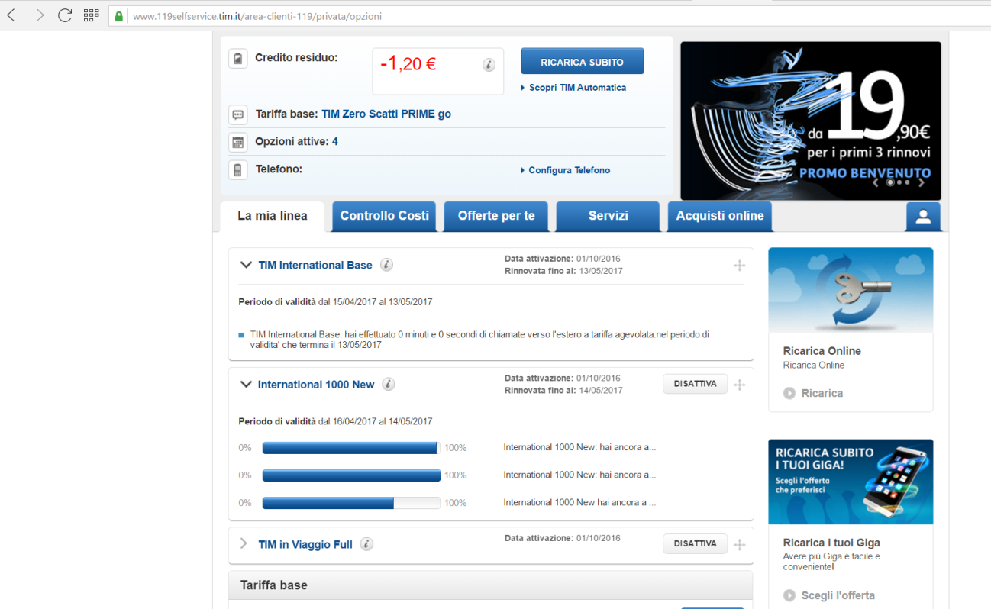

**Page 4**

