Taken from this udemy course:
https://www.udemy.com/course/advanced-skt-prog
TCP mock server made in C/C++ from scratch, in english
Our TCP server consists of 4 different components:
1) TCP controller,
2) Connection Acceptor service (CAS),
3) Client Database Manager Service (DBMS),
4) Client Data Request Service (DRS)
The user application (whichever it may be) interacts solely with the TCP controller, which this one delegates the other 3 services their own tasks.
The TCP controller is a set of APIs, which are invoked by “Application In Thread” (AppIn thread) or service threads, and APIs which manage service operations. Whatever functions the user application may need, are requested by the user application, and the TCP controller sends as many as needed. These functions are handled by CAS and DRS.
The Client Acceptor Service (CAS) is responsible for accepting new connection requests (with the call “accept 0”). It is a thread that is created and handled every time a client makes a new connection request (also called the “TCP handshake”). The handshake happens between the client and the CAS. CAS runs as a separate thread.
The client Database Management Service (DBMS) is responsible to store all connected clients and is a simple data structure. It is the repository where all accepted clients are stored, and will be assigned to all correspondent clients that request, or are connected to our TCP server.

The Client Data Request Service (DRS) is a threaded data structure, which is responsible for communicating with connected clients. It maintains one more copy of all connected clients, which means the client is stored both in the DBM and here. It also handles bidirectional data communication between the DRS and the client.
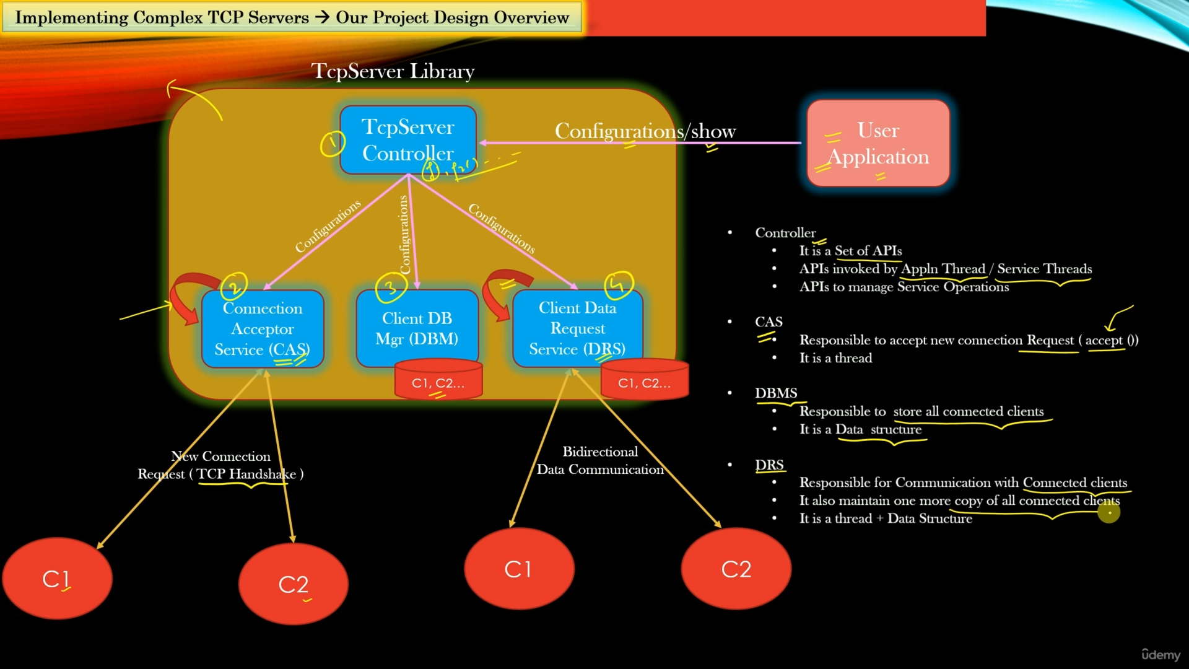
Both CAS and DRS both run as separate threads in an infinite loop. TCP controller acts as a central entity responsible to manage the service threads and the Client database (DB). When the user application requests it so, the TCP controller is instantiated and starts all service threads, as well as other resources required.
When TCP Controller is requested by the user application to shut down, the controller sends a shut down notification to all the current service threads, which these then follow by releasing all their resources before shutting down. The controller then purges the client DB.
The TCP Controller handles all communications between the service threads (CAS and DRS), these services do not communicate to each other, or rely of each other, but instead communicate directly to the TCP controller. This assures a simple design, which can be scalable, delegates responsibilities and requires no class dependency.
Lets discuss the steps in order to handle the New Client Connection Request (SYN):
1.- User Application is started, it calls TcpServerController() and creates an instance by using its constructor.
2.- All services of the TCP server are initialied but are not executed yet.
3.- The TcpServerController() method calls its own Start() method.
4.- All service threads are started and TCPServer is ready to go. It can now accept new connection requests (TCP handshakes) from new clients.
5.- Client C1 (for instance) sends SYN to CAS.
6.- CAS accepts a new connection and creates the TCPClient object.
7.- CAS sends notification to the user application, directly, to establish a new connection.
8.- CAS requests the controller to create a new ProcessNewClient object.
9.- The TCP controller submits the AddClientToDB request to DBMS, using the AddClientToDB API.
10.- DBMS stores the new TCPClient object in the DB.
11.- The TCPController then asks DRS to start listening to this new Client Object ClientFDStartListen through the API.

12.- DRS stores the copy of the Client Object in its own local DB and starts listening for new data requests for the newly created client (along with other connected clients, if needed). A bidirectional communication is created between DRS and the client (in this case C1).
All communications, once the aforementioned is done and running, is handled between the DRS and the client (C1 in our case).
We are now going to set up the TCPServerController firstly. This, along the other modules (CAS, DBMS, DRS) will have both their .cpp file and a .h (header) file. We will firstly write a testapp.cpp “mock user application” and gonna implement the TCPServerController.h and TCPServerController.cpp files firstly.
All the code of this project is already availabe at:
github.com/sachinites/TCPServerlib
But, in my case, I’ll try my best to write it out everything and comment as much of the code’s logic as possible. Otherwise, its all meaningless.
As opposed to the course, I will divide each “section” or service of this project to their respective directories, to make it cleaner and more modular. No one likes to see all that code cramped together, right?

