Identifying Key Drivers of Water Quality in the Tietê River
Using Random Forest and SHAP
WaterWeave-Tietê Project — August 2026
1. Introduction
The Tietê River, which crosses the São Paulo metropolitan region and an extensive agricultural and industrial corridor before reaching the Paraná River, is heavily polluted along most of its course. Multiple pressures act on its water quality simultaneously — urban and industrial effluent, agricultural runoff, and hydro-climatic factors such as rainfall, which acts as a transport agent for pollutants, and broader climate variability. Understanding which of these pressures actually determines water quality outcomes, and whether that answer differs along the river's course, is essential for targeting limited management resources effectively.
This study applies Explainable Machine Learning — a Random Forest regressor combined with SHAP (SHapley Additive exPlanations) — to identify the key drivers of two water-quality indicators along three study reaches of the Tietê (Upper, Middle and Lower), using real, multi-source environmental data. Unlike a standard forecasting model, whose objective is predictive accuracy, the explicit goal here is interpretability: ranking which exogenous factors most influence water quality, and in which direction, separately for each reach.
2. Related Work
Machine Learning has been increasingly applied to water-quality assessment and prediction over the past decade. Ahmed et al. (2019) compared several supervised algorithms — including tree ensembles — for Water Quality Index prediction, reporting strong performance from ensemble methods on structured monitoring data. Rajaee, Khani and Ravansalar (2020) reviewed single and hybrid AI-based models for river water-quality prediction, noting the growing adoption of tree-based ensembles for their robustness on comparatively small, noisy environmental datasets. Chen et al. (2020) combined several Machine Learning models with feature-importance analysis on large-scale water-quality data to identify key water parameters, an approach conceptually close to the present study. Most directly relevant, Castrillo and García (2020) used Random Forest together with model-agnostic explainability to estimate nutrient concentrations from surrogate variables, demonstrating that explainability techniques can recover physically meaningful relationships from environmental monitoring data rather than only optimizing predictive accuracy.
To the authors' knowledge, few published studies apply an explicit, reach-by-reach explainable-ML analysis to identify water-quality drivers on a Brazilian river basin at the scale of the Tietê. This study addresses that gap using SHAP, which — unlike a Random Forest's native impurity-based importance — attributes a signed contribution to every individual prediction, enabling both a ranking of drivers and a read on the direction of each effect (Lundberg & Lee, 2017).
3. Data
The study covers three river reaches (Upper, Middle and Lower Tietê), using annual data from real, multi-source records. The two target variables are the Water Quality Index (WQI) and Dissolved Oxygen (DO), both sourced from CETESB's real monitoring network (1978–2024, extended with a documented historical proxy for years without direct measurement). WQI follows the general normalized-parameter convention popularized by the U.S. National Sanitation Foundation index (Brown et al., 1970), but is a project-defined two-parameter simplification — not the official nine-parameter CETESB/NSF-WQI — computed as a weighted combination of normalized dissolved oxygen and BOD, with the BOD normalization referenced to the Class 3 threshold of Brazil's water-quality regulation (CONAMA, 2005); this specific weighting is an internal project choice, not drawn from external literature. DO is reported directly in mg/L, with no transformation. Seven exogenous predictors were used, listed in Table 1 together with their real data source.
Variable | Role | Real source | Description
Water Quality Index (WQI) | Target | CETESB | Proxy from dissolved oxygen and BOD
Dissolved Oxygen (DO) | Target | CETESB | Real concentration, mg/L
Year | Predictor | Derived | Calendar year (secular trend)
Average streamflow | Predictor | ANA/SNIRH | Annual average, m3/s
Average rainfall | Predictor | ANA/SNIRH | Annual average, mm
% Natural land cover | Predictor | MapBiomas | Share of reach buffer area
% Agricultural/Pasture land | Predictor | MapBiomas | Share of reach buffer area
% Urban/Industrial land | Predictor | MapBiomas | Share of reach buffer area
% Water | Predictor | MapBiomas | Share of reach buffer area

Land-use shares were derived from MapBiomas Collection 9 (real classification, 1985–2023, via Google Earth Engine) over a 5-kilometer buffer around each reach's real monitoring stations, aggregated to annual percentages by macro-category. After merging all sources by (reach, year), the dataset covers 1975–2025 and totals 46 annual observations for the Upper Tietê and 51 for the Middle and Lower Tietê. Years outside the 1985–2023 MapBiomas window — 1975–1984 and 2024–2025, 12 of the 46–51 rows per reach (23–26%) — carry the nearest real year's land-use values forward or backward (capped at 10 years) rather than a direct measurement for that year, each flagged by a companion indicator column. The dataset is split temporally into training (years before 2015) and test (2015 onward) sets.
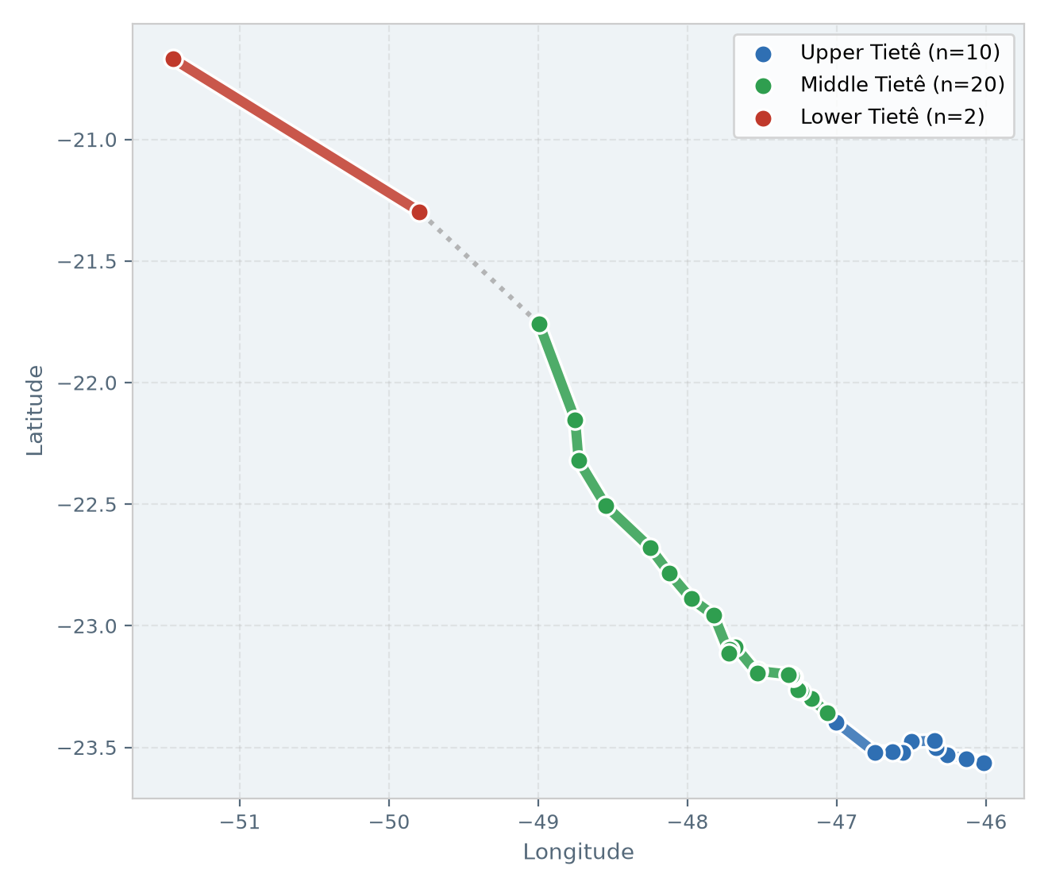
Figure 1. Study area: real monitoring stations along the three Tietê reaches used in this study.
4. Method
A Random Forest regressor (Breiman, 2001) was selected for two reasons: it handles non-linear relationships and moderate multicollinearity among predictors (the four land-use shares are compositional) without strong distributional assumptions, and it pairs with SHAP's TreeExplainer (Lundberg & Lee, 2017), which computes exact Shapley values efficiently — unlike model-agnostic explainers, which require a background reference dataset and are computationally heavier, an important consideration given the small sample size per reach.
One independent model is fitted per (reach, target) combination — six models in total — using only the seven exogenous predictors in Table 1, deliberately excluding any lag of the target variable itself. This choice isolates exogenous drivers from the target's own temporal autocorrelation, which would otherwise dominate the SHAP ranking without answering which external factors actually explain water-quality variation. Hyperparameters (300 trees, maximum depth of 4, minimum 2 samples per leaf) were fixed conservatively rather than tuned by grid search, since the goal is a stable diagnostic explanation rather than maximizing forecast accuracy on a dataset of this size. Each model is trained on years before 2015 and evaluated with SHAP on the held-out years from 2015 onward, following the same temporal split used throughout the wider project to avoid information leakage from the future into the training set.
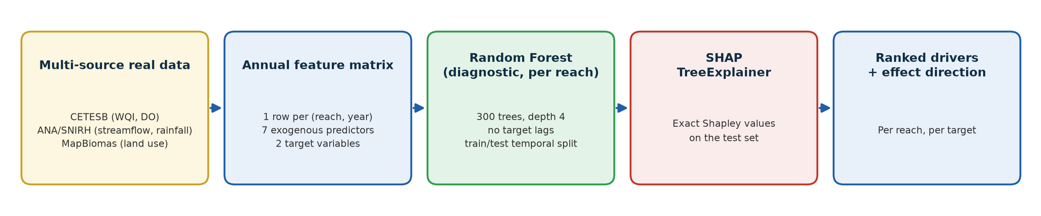
Figure 2. Method overview: from multi-source real data to ranked, reach-specific drivers of water quality.
5. Results
Table 2 summarizes the top three drivers per reach and target, ranked by mean absolute SHAP value. Figure 3 shows the full ranking for the Middle Tietê / WQI case, the reach with the clearest single dominant driver.
Reach | Target | Top 3 drivers (mean |SHAP|)
Upper Tietê | WQI | % Agricultural/Pasture land (3.92); Year (3.17); % Urban/Industrial land (2.92)
Upper Tietê | DO | % Agricultural/Pasture land (0.43); Year (0.40); % Urban/Industrial land (0.32)
Middle Tietê | WQI | % Agricultural/Pasture land (9.61); Year (4.71); % Urban/Industrial land (3.83)
Middle Tietê | DO | Year (0.33); % Urban/Industrial land (0.32); % Agricultural/Pasture land (0.25)
Lower Tietê | WQI | % Water (2.14); Average rainfall (0.56); % Natural land cover (0.49)
Lower Tietê | DO | % Natural land cover (0.21); % Water (0.20); % Agricultural/Pasture land (0.12)

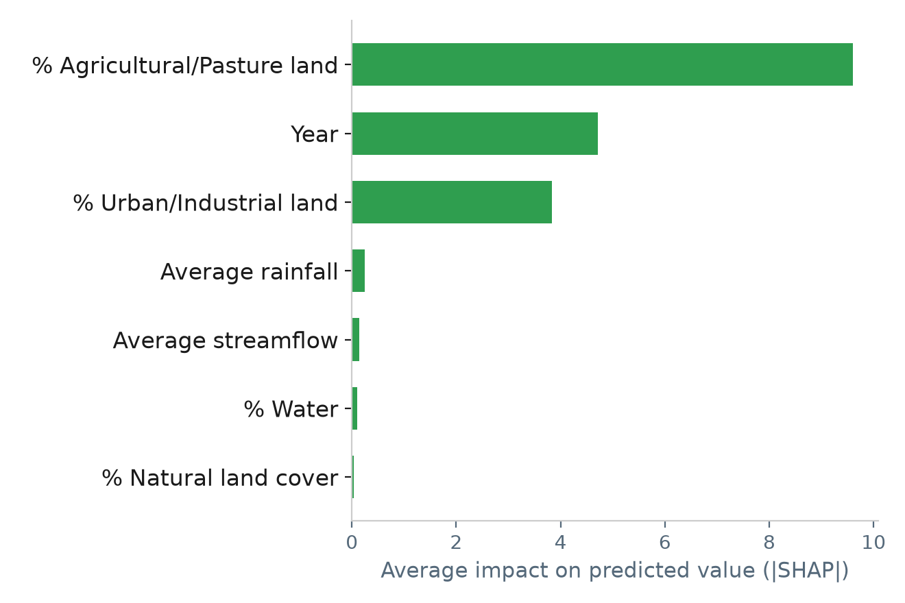
Figure 3. Driver importance for the Middle Tietê / WQI model — % Agricultural/Pasture land is the dominant driver, ahead of Year and % Urban/Industrial land.
The three reaches show genuinely different dominant drivers rather than a single river-wide pattern. In the Upper and Middle Tietê, the percentage of agricultural/pasture land is the top-ranked driver of WQI, ahead of the calendar year and the percentage of urban/industrial land — consistent with agricultural runoff as a dominant pressure in these reaches. In the Lower Tietê, by contrast, the percentage of water area is the dominant driver for both WQI and DO, well ahead of land use — reflecting the reservoir cascade present in this stretch of the river rather than a land-cover effect. Streamflow and rainfall rank low across all three reaches and both targets, suggesting that, at the annual aggregation used here, land use and long-term temporal trend explain more of the variation in water quality than short-term hydro-climatic variability.
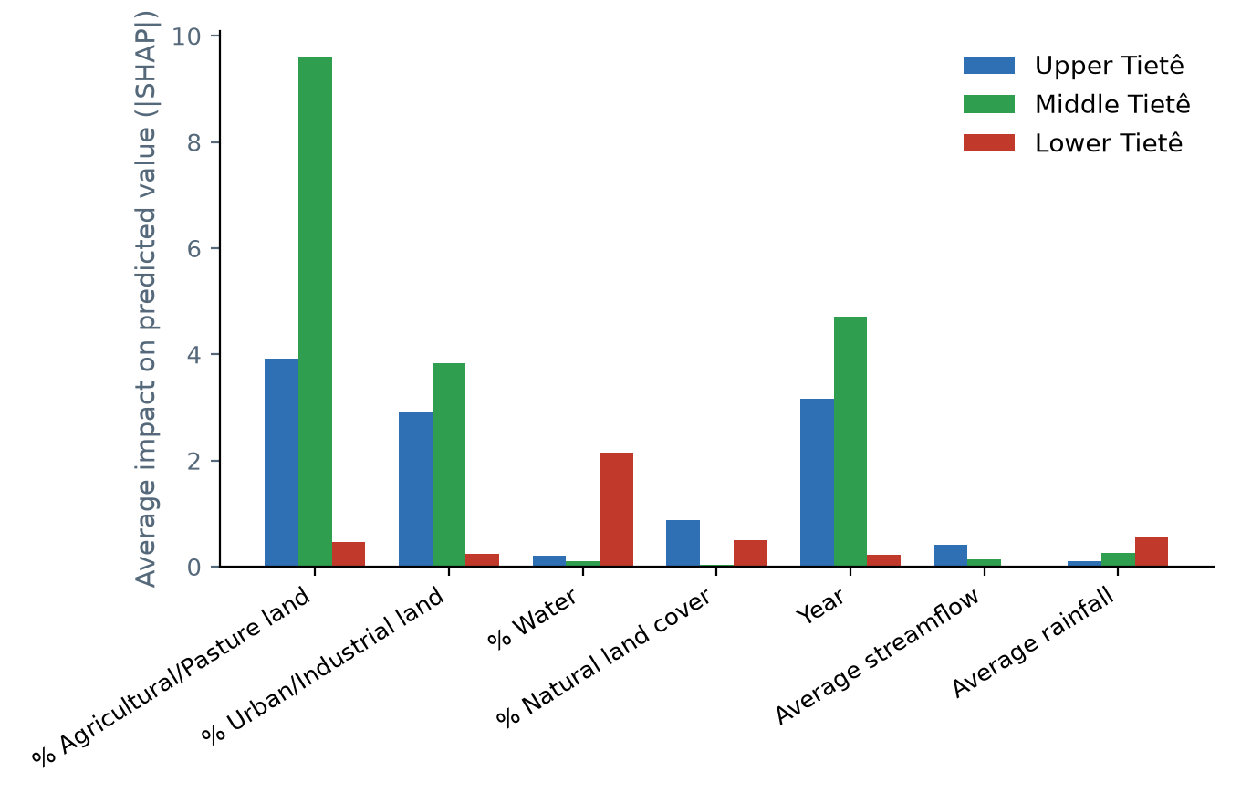
Figure 4. Cross-reach comparison of driver importance for WQI — agricultural/pasture land dominates the Upper and Middle Tietê, while water-surface share dominates the Lower Tietê.
6. Discussion and Conclusion
The central finding is that no single factor determines water-quality problems on the Tietê River uniformly — the dominant driver is reach-specific. Agricultural and pasture land use is the leading driver in the Upper and Middle Tietê, pointing to diffuse agricultural pollution — and, by extension, rainfall-driven runoff transport — as a priority target for management interventions in those stretches, alongside continued control of urban/industrial discharge, the second-ranked driver in both reaches. In the Lower Tietê, the dominance of the water-surface share, associated with the reservoir cascade, suggests that reservoir residence time and in-reservoir processes — rather than upstream land use directly — are the more relevant lever for water-quality management in that stretch.
For efficient management, these results argue against a single basin-wide policy and for reach-specific prioritization: agricultural best-management practices and riparian buffers in the Upper and Middle Tietê, and reservoir operation and in-reservoir water-quality management in the Lower Tietê. Because the explainable model used here isolates exogenous, policy-relevant drivers from the target's own autocorrelation, its reach-specific rankings are a more direct guide for action than a purely predictive model would offer.
As future work, these driver rankings can directly inform the calibration and structure of the project's Agent-Based Model (ABM): the relative weight the ABM's Farmer and Industry agents place on land-use change versus discharge control could be informed by the reach-specific SHAP rankings found here, and the Lower Tietê finding motivates adding an explicit reservoir-residence-time mechanism to the ABM, which currently models each reach independently without this effect. A further extension is repeating this analysis as more years of real data accumulate, to test whether the reach-specific rankings found here are stable over time or themselves shift under changing land-use and climate conditions.
References
Ahmed, U., Mumtaz, R., Anwar, H., Shah, A. A., Irfan, R., & García-Nieto, J. (2019). Efficient Water Quality Prediction Using Supervised Machine Learning. Water, 11(11), 2210.
Breiman, L. (2001). Random Forests. Machine Learning, 45(1), 5–32.
Castrillo, M., & García, Á. L. (2020). Estimation of high frequency nutrient concentrations from water quality surrogates using machine learning methods. Water Research, 172, 115490.
Chen, K., Chen, H., Zhou, C., Huang, Y., Qi, X., Shen, R., et al. (2020). Comparative analysis of surface water quality prediction performance and identification of key water parameters using different machine learning models based on big data. Water Research, 171, 115454.
CONAMA — Conselho Nacional do Meio Ambiente (Brazil). Resolução CONAMA n° 357, de 17 de março de 2005 — classification of water bodies and effluent discharge standards.
Lundberg, S. M., & Lee, S.-I. (2017). A Unified Approach to Interpreting Model Predictions. Advances in Neural Information Processing Systems (NeurIPS), 30.
Rajaee, T., Khani, S., & Ravansalar, M. (2020). Artificial intelligence-based single and hybrid models for prediction of water quality in rivers: A review. Chemometrics and Intelligent Laboratory Systems, 200, 103978.

Appendix — Additional SHAP Driver Charts
Driver-importance charts for the five reach/target combinations not shown in the main text, computed with the same diagnostic Random Forest and SHAP methodology described in Section 4.
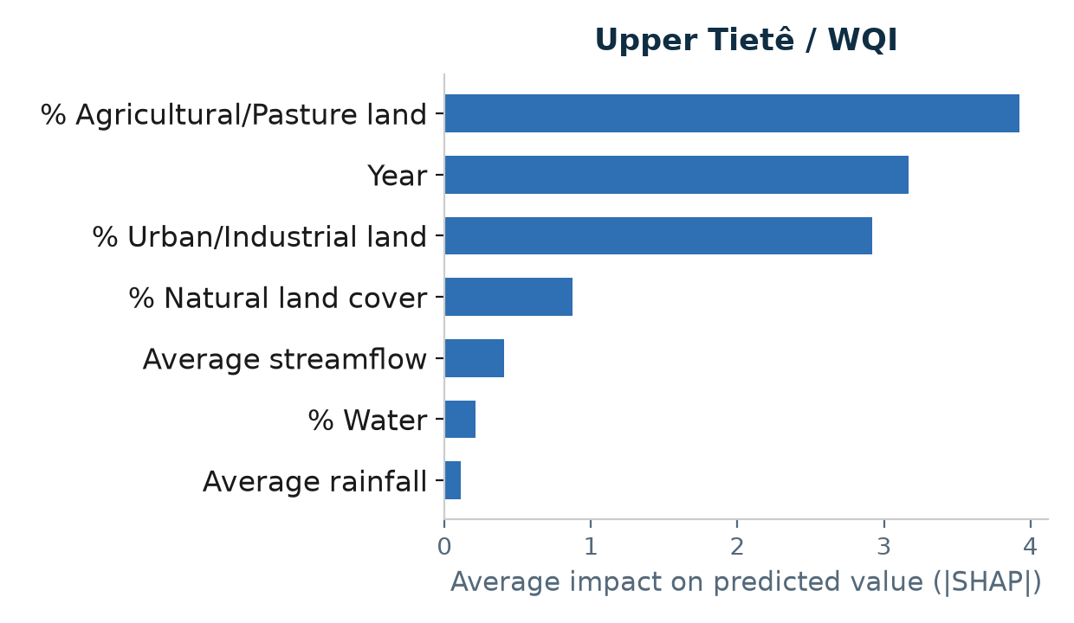
Figure A1. Upper Tietê / WQI.
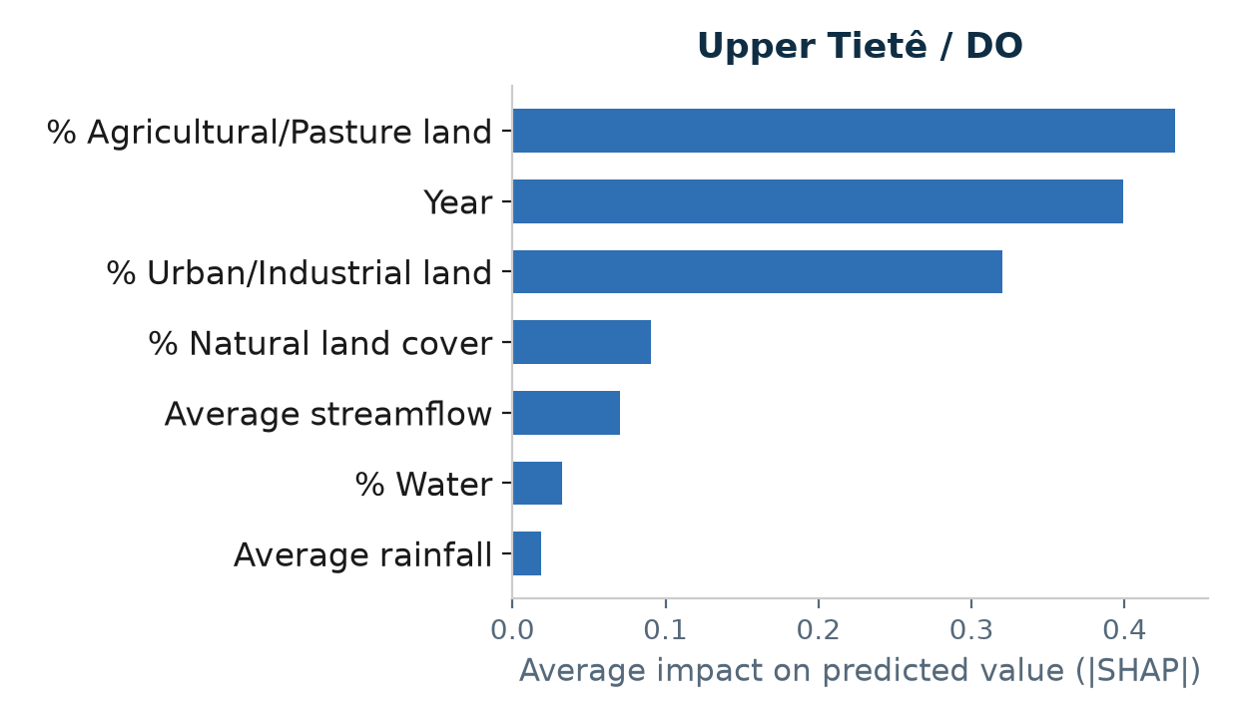
Figure A2. Upper Tietê / DO.
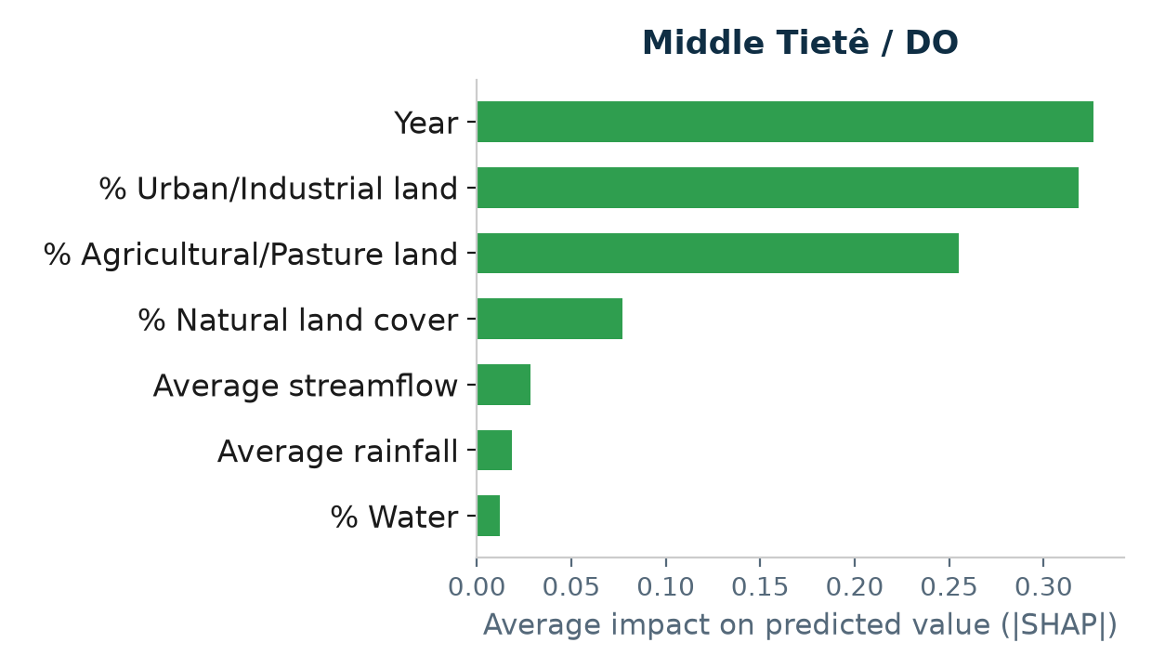
Figure A3. Middle Tietê / DO.
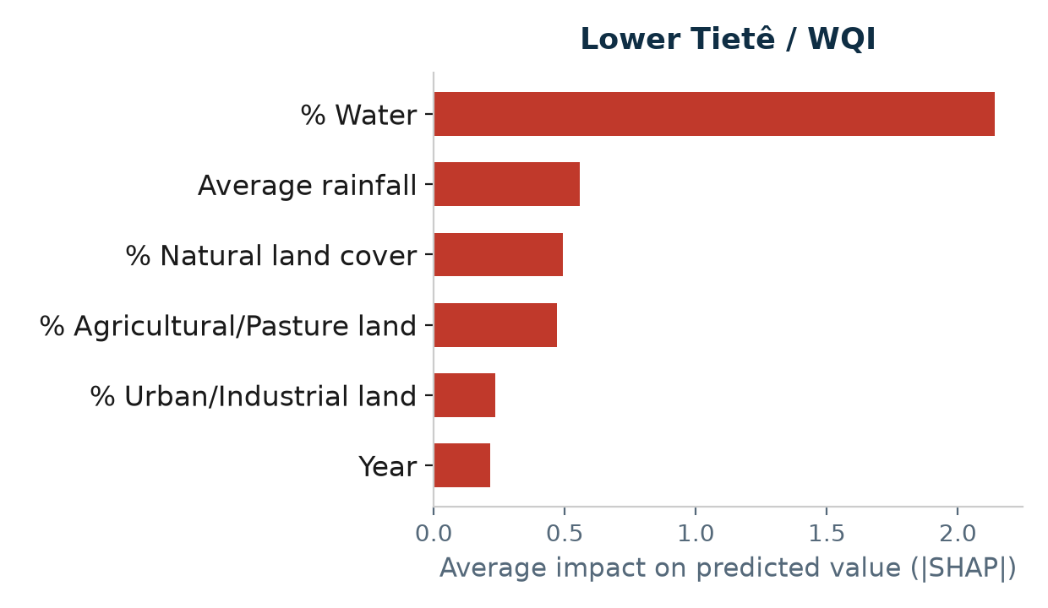
Figure A4. Lower Tietê / WQI.
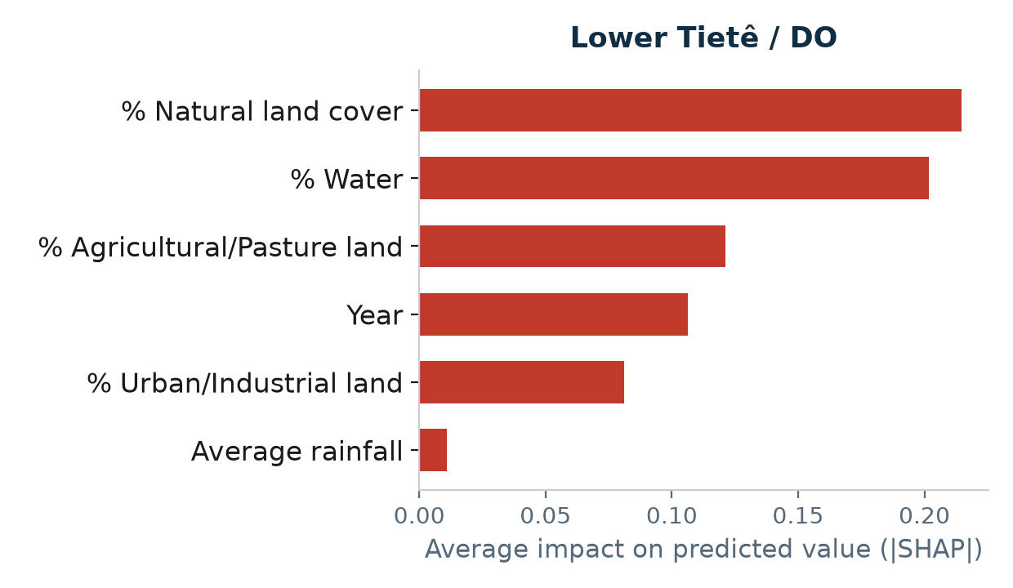
Figure A5. Lower Tietê / DO.

