WaterWeave-Tietê
Complete Technical Report
A Hybrid Modeling Platform (Biophysical + Machine Learning + Agent-Based Model) for Water Resource Management on the Tietê River
Post-doctoral research — WaterWeave-Water4All project
August 2026

Executive Summary
WaterWeave-Tietê is a hybrid modeling platform that combines a deterministic biophysical model, a statistical Machine Learning model, and an Agent-Based Model (ABM) to simulate and forecast water quality along three study reaches of the Tietê River in São Paulo, Brazil — the Upper, Middle and Lower Tietê. The platform is anchored throughout in real, verifiable data: 1978–2024 official water-quality monitoring (CETESB), real streamflow and rainfall records (ANA/SNIRH), real land-use classification (MapBiomas, via Google Earth Engine), real historical remote sensing (Landsat), and a real climate-reanalysis calibration (Copernicus Climate Data Store, ERA5/CMIP6). Every table in the pipeline carries an explicit provenance flag distinguishing observed from simulated data, and every simplification made in the models is documented in the project's own source code rather than hidden.
This report describes, in full and without any code excerpts, what was actually built and verified: the data architecture, the real connectors integrated and the concrete bugs fixed while validating them against live services, the hybrid modeling architecture, the Machine Learning methodology (including a full audit that corrected four real methodological issues in 2026-07), real validation results, feature-importance findings, the interactive dashboard, and the limitations the team consciously accepted.
1. Project Context and Objectives
The Tietê River originates near the coast in Salesópolis and runs for approximately 1,100 kilometers to its confluence with the Paraná River, crossing the São Paulo metropolitan region and an extensive agricultural and industrial zone. The project divides this course into three study reaches — Upper, Middle and Lower Tietê — and, for each one, builds a computational platform able to simulate how water-policy decisions (sanitation investment, regulatory enforcement, pesticide use, water-abstraction permits, climate scenarios) affect water quality over time.
The central design principle is that no simulated value is ever allowed to masquerade as an observation. Every table in the pipeline carries a provenance column (observed / simulated), propagated from the raw ingestion layer through to the final aggregated tables. Wherever a real measurement exists — CETESB, ANA/SNIRH, MapBiomas, Landsat, ERA5/CMIP6 — it takes priority; the simulated historical series (a proxy covering 1940–2025) only fills gaps where no real measurement is available. The Machine Learning models, for instance, are trained by default exclusively on years flagged as observed.
2. Data Architecture
The ingestion and transformation pipeline follows the Medallion architecture — Bronze, Silver and Gold layers — implemented on real Delta tables (ACID transaction log, physical partitioning by river reach), without requiring a Spark/Hadoop cluster. A single orchestrator executes the full chain — Bronze ingestion, live connector calls, Silver normalization, Gold aggregation — and runs automatically on every code change via continuous integration.
2.1 The Three Layers
- Bronze — a faithful mirror of each raw source, with explicit provenance (origin of the data and of the source file it came from).
- Silver — a single, clean schema, at the granularity of the individual station, gauge or river reach.
- Gold — the final aggregations, by river reach and year, consumed by the Machine Learning models, the Agent-Based Model, and the dashboard.
2.2 Real Data Sources Integrated
Source | What it provides | Real coverage
CETESB | Water quality (dissolved oxygen, BOD, heavy metals) — 32 stations on the Tietê axis | 1978–2024
ANA/SNIRH | Streamflow and rainfall (public API) | +1,762 streamflow rows / +6,355 rainfall rows (2000–2026)
MapBiomas (Collection 9) | Land use and land cover, via Google Earth Engine | 1985–2023
Landsat (Earth Engine) | NDVI, surface temperature, turbidity proxy | 1984–present
Copernicus CDS (ERA5/CMIP6) | Historical climate reanalysis and future SSP projections | ERA5 historical + CMIP6 SSP1-2.6/2-4.5/5-8.5
DAEE | Historical streamflow/rainfall by gauge (local archive files) | Complements ANA/SNIRH

Two sources remain partly simulated, by a documented decision rather than an overlooked gap: the water-quality series prior to 1978 (a proxy built from CETESB/DAEE/SOS Mata Atlântica trends) and the illustrative remote-sensing spreadsheet from before 2026 — now superseded, with priority, by the real Landsat series wherever the two overlap in time.
3. How the Data Is Aggregated for Machine Learning
The models never consume raw measurements directly. Each point measurement passes through a funnel of successive aggregations — each stage summarizing the previous one a little more — until it becomes a single row per (river reach, year), which is the unit the Machine Learning models actually learn from.
3.1 From Point Measurement to Station/Month
Each real source arrives as a point-in-time reading: CETESB measures dissolved oxygen and BOD at a specific point on the river, on a specific date; ANA measures streamflow and rainfall at a specific gauge, also on a specific date. All readings from the same gauge, in the same month, are collapsed into a single monthly average. Streamflow and rainfall are never merged at the individual-gauge level — they are physically distinct monitoring networks (a streamflow gauge measures the river; a rain gauge measures precipitation), and merging them prematurely would create a false correspondence.
3.2 From Individual Stations to River Reaches
All 32 real monitoring stations are classified into the Upper, Middle or Lower Tietê reach based on their real geographic position along the river's course. From that point on, every gauge within a reach is aggregated together: the reach's monthly streamflow is the AVERAGE of all gauges in that reach for that month (the same logic applies to rainfall). Real coverage differs sharply by reach — 10 stations in the Upper Tietê, 20 in the Middle, only 2 in the Lower — and this difference is preserved through the aggregation rather than hidden behind a single river-wide average.
3.3 From Monthly to Annual Granularity
Water quality (WQI, dissolved oxygen) only exists in the real source at ANNUAL granularity — there is no measurement "for March" distinct from one "for August" in the consolidated historical record. For that reason, streamflow and rainfall are also aggregated to the annual level, matching the true granularity of the water-quality target.
A corrected structural issue: An earlier version of the feature store repeated each year's single water-quality value across all 12 months to match the monthly granularity of streamflow and rainfall. Because the value was constant within the year, a one-month lag was, in practice, almost always equal to the value being predicted — the model was largely copying a known value, not genuinely forecasting. Moving to a dedicated annual feature table removed this structural leakage entirely.

3.4 The Final Feature Matrix
Group | Predictors | Source
Temporal | Year | Derived — a real, statistically significant secular trend (Mann-Kendall test)
Hydrological | Average streamflow · Average rainfall | ANA/SNIRH (streamflow removed for the Lower Tietê)
Land use | % natural · % agricultural/pasture · % urban-industrial · % water | Real MapBiomas classification
Autocorrelation (WQI) | 1, 2 and 3-year lags + 5-year moving average | Real CETESB series
Autocorrelation (DO) | 1, 2 and 3-year lags + 5-year moving average | Real CETESB series

Fourteen predictors in total, specific to each reach — never a single matrix mixing all three. A second, reduced predictor set (year, streamflow, rainfall and the four land-use percentages, without any lag of the target itself) is used exclusively for interpretability analysis (Section 8) and is never used to train the production forecasting model.
3.5 Controlled Imputation
Missing streamflow or rainfall values are forward-filled within the reach, but only for up to two consecutive years; land-use percentages are forward- and backward-filled for up to ten consecutive years, since land use changes far more slowly year to year than streamflow or rainfall. The target variables themselves — WQI and dissolved oxygen — are never imputed: a real gap in the target means the true value for that year is genuinely unknown, and filling it in would hide real uncertainty rather than an exogenous predictor's gap. Every imputed value is flagged with a companion boolean column, so no completed value is ever indistinguishable from a real measurement.
4. Hybrid Modeling Architecture
4.1 Biophysical Model
A simplified monthly water-balance model (a linear-bucket model, not field-calibrated) produces a runoff index, which is converted into simulated streamflow (cubic meters per second) through a factor calibrated against the real historical average of the reach. Water quality is modeled with the classical Streeter-Phelps equation, using literature coefficients rather than ones calibrated specifically for the Tietê.
4.2 Agent-Based Model (ABM)
Implemented with the Mesa framework: five agents per reach — River Basin Committee, Industry, Farmer, Water Utility, and Public Authority — adjust water-abstraction permits and pollutant loads every month, based on the ecological state observed the month before. The scenario runner executes the complete agent simulation — these are genuine simulated decisions, not illustrative multipliers — and feeds the "Scenario Comparison" dashboard page directly.
4.3 Machine Learning Model
A separate Random Forest regressor is trained for each reach and each target variable, predicting Water Quality Index and Dissolved Oxygen from the annual feature matrix described in Section 3. Forecasts for future years are produced recursively, using the model's own prior-year prediction as the lag input — this mechanism is described in full in Section 9.
5. What the Machine Learning Model Predicts
This section is deliberately explicit, since the scope of the model's output is easy to misread.
5.1 The Two Target Variables — What They Are, and What They Are Not
The Water Quality Index (WQI) used throughout the project is a simplified proxy computed from real dissolved-oxygen and BOD measurements (0.6 × normalized dissolved oxygen + 0.4 × normalized BOD). This proxy value — not the official nine-parameter CETESB/NSF-WQI index (which also weighs coliform count, pH, temperature, nitrogen, phosphorus, turbidity and total solids) — is what the model is trained to reproduce and predict. The second target, Dissolved Oxygen, is the real physical concentration in milligrams per liter, exactly as reported by CETESB, with no transformation applied.
The model has exactly two outputs, always the same two: it does not predict BOD, heavy metals, pesticides, land use, streamflow, or any other parameter.
5.2 Prediction Granularity: What Goes In, What Comes Out
Every single run of the model produces exactly one pair of numbers — never a per-station prediction, never a monthly prediction. The input is one specific river reach, one specific year, and the fourteen predictors for that reach/year (Section 3.4). The model consulted is the already-trained Random Forest belonging to that specific reach (three reaches, three distinct models — see Section 9). The output is one predicted WQI value and one predicted Dissolved Oxygen value, for that reach, for that year. This is a regression task — a continuous numeric output — never a classification into categories such as "good" or "poor".
5.3 Two Regimes of Use
In the evaluation/validation regime, the model forecasts a year that already has a real measured value (any year from 2015 onward, or any fold of the walk-forward validation), and every predictor fed into the model — streamflow, rainfall, land use, lags — is itself a real measured value for that year. The purpose is to compare the forecast against the known real value and measure the error, which is how the team knows whether the model actually works.
In the real future-forecasting regime, the model forecasts a year that has not happened yet and for which no real value exists at all. Future streamflow and rainfall are set to the climatological average of the reach's last ten years, and the lags of WQI and Dissolved Oxygen use the model's own prediction for the previous year — a recursive mechanism detailed in Section 9. This regime powers the "Future Scenarios" dashboard page, as a fast statistical alternative to the deterministic Agent-Based Model.
6. Model Training and Validation
6.1 Architecture and Hyperparameter Search
Three independent Random Forest models per target variable (Upper, Middle, Lower — six models in total). A single model using the river reach as a categorical feature was tested and produced a negative R² across every cross-reach transfer, confirming that a shared model was attempting to learn a relationship that genuinely changes level and slope between reaches; three independent models correct this.
Hyperparameter | Search grid
Number of trees | 100 · 200 · 300
Maximum depth of each tree | 3 · 4 · 6 · unlimited
Minimum samples per leaf | 1 · 2 · 4
Fraction of features evaluated per split | square root · 50% · 100%

6.2 Validation Methodology
- Temporal split — training uses years before 2015, testing uses years from 2015 onward — never shuffled at random, which would let the model "see the future" during training.
- Walk-forward validation (expanding window) — 11 folds per reach/target, testing the model year by year with an expanding training window — this reveals whether performance is stable over time, not just a single aggregated average.
- Persistence baseline — "predicted value = last year's value", computed on the exact same test set — every reported error is read against this baseline, never in isolation.
- Metrics broken down by source — test-set error is measured separately for observed and simulated years, exposing whether the test set itself is contaminated with simulated years.
6.3 Real Results
Reach | Target | Mean error (MAE) | Baseline error | % of folds beating baseline
Upper Tietê | WQI | 6.41 | 5.93 | 36.4%
Upper Tietê | DO (mg/L) | 0.29 | 0.24 | 36.4%
Middle Tietê | WQI | 7.09 | 10.27 | 81.8%
Middle Tietê | DO (mg/L) | 0.48 | 0.50 | 45.5%
Lower Tietê | WQI | 4.84 | 5.63 | 63.6%
Lower Tietê | DO (mg/L) | 0.37 | 0.56 | 63.6%

An honest reading of these numbers: the Middle Tietê shows the most consistent gain over the baseline, beating it in 82% of the walk-forward folds for WQI. The Upper Tietê is the weakest reach, beating the baseline in only about a third of the folds — a signal that its series is genuinely harder to predict than simply repeating last year's value. This reach-level breakdown only exists because an aggregated single metric would have concealed this weak reach behind two stronger ones.
7. Feature Importance: How the Model Behaves With Each Variable
7.1 Methodology
A Random Forest's native "feature importance" (how often a predictor was used to split the data) does not indicate the direction of an effect, nor how much a predictor weighed in any one specific prediction. This project instead uses SHAP (SHapley Additive exPlanations), which attributes, for each individual prediction, how much each predictor pushed the outcome above or below the average — enabling both an importance ranking and a read on the direction of the effect. Two complementary readings are produced: one including the target's own lags (the production feature set, more accurate for forecasting) and one excluding them (the reduced "drivers" feature set, more interpretable, used only for this analysis and never for the production model).
7.2 Real Finding: What Actually Moves the Water Quality Index
The two charts below were generated directly from the project's own trained models, for the Middle Tietê / WQI case.
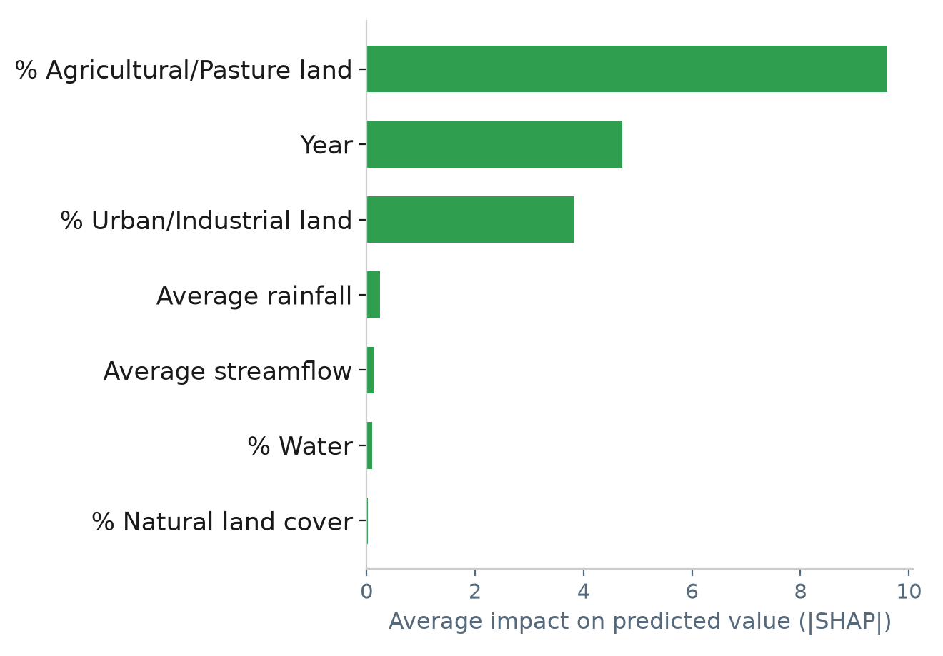
Figure 1. Feature importance without target lags ("drivers" set) — Middle Tietê, WQI.
The percentage of agricultural/pasture land dominates — more than double the impact of the calendar year, and far ahead of rainfall and streamflow. Its contribution is consistently negative for WQI, meaning a higher share of agricultural land is associated with a lower predicted WQI, consistent with agricultural runoff effects documented in the literature. The percentage of urban/industrial land is the third-strongest factor, also negative. Rainfall and streamflow have almost negligible impact for this reach.
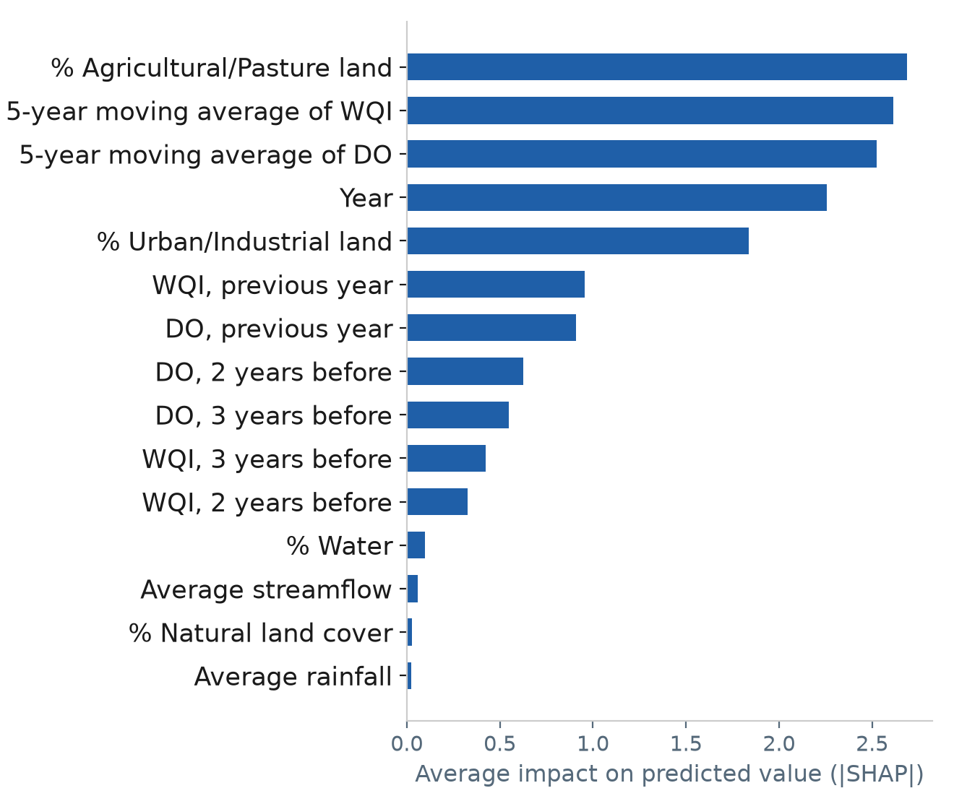
Figure 2. Feature importance including target lags (production set) — Middle Tietê, WQI.
Even after including the target's own lags, the percentage of agricultural/pasture land remains the top-ranked predictor — it is not overwhelmed by autocorrelation in this reach. The 5-year moving averages of WQI and DO appear immediately behind it, ahead of the individual 1/2/3-year lags. The real pattern is that land use competes on equal footing with the series' own temporal memory — the target's own lags do not automatically dominate every reach and every target; the finding is genuinely reach- and target-specific.
8. How Predictions Are Made, Per River Reach
8.1 Independence Between Reaches
The three models are entirely independent. The Upper Tietê model never sees Middle or Lower Tietê data, either during training or during inference. Predictors can differ between reaches — average streamflow is present for the Upper and Middle Tietê but removed for the Lower Tietê, whose streamflow series carries a documented structural inconsistency. The lags used to forecast the Middle Tietê come exclusively from the Middle Tietê's own history.
8.2 Recursive Forecasting
For future years, no real WQI or DO value exists to use as a lag, so each step uses the model's own prediction from the previous step. Forecasting year N+1 draws its lags from real, already-known history. Forecasting year N+2 draws its 1-year lag from the model's own prediction for year N+1. Forecasting year N+3 draws on the predictions for both N+1 and N+2. A direct consequence is that forecast error can propagate and accumulate across successive years — longer forecast horizons warrant more caution than short ones.
8.3 Climatology for Future Streamflow and Rainfall
Streamflow and rainfall for future years are set to the ten-year historical average of the reach, not an actual meteorological forecast. There is no explicit limit on how many years ahead can be requested, but the Random Forest does not extrapolate well beyond the range of years seen during training — for long horizons it tends to saturate near the value of the last trained year rather than linearly projecting the underlying trend. For long-term policy scenarios, the Agent-Based Model — which simulates explicit causal mechanisms — is the more appropriate tool; this statistical model is best suited to short-horizon forecasting.
9. Real Data Connectors — What Was Actually Solved
Beyond the modeling work, a substantial part of the project consisted of validating each real data connector against its live service and fixing the concrete bugs that surfaced — not assumptions made from documentation alone.
- CETESB — 699 statewide points, roughly 2.4 million real measurements from 1978 to 2024, ingested and pivoted from a long (attribute-value) format into a wide table, with analytical censoring (values below the detection limit) handled explicitly.
- ANA/SNIRH — public streamflow/rainfall API, real backfill executed for 2000–2026 (+1,762 streamflow rows, +6,355 rainfall rows). A real bug was found and fixed: the API matches municipality names by substring, so "ITAPURA" was also matching "ITAPURANGA" (Goiás state) — the reach-classification logic now requires both latitude and longitude to fall within the Tietê basin's real bounding box before accepting any station.
- MapBiomas — real land-use classification (Collection 9, 1985–2023) obtained via Google Earth Engine, aggregated over a 5-kilometer buffer around each reach's real monitoring stations — a proxy for the monitoring network's immediate surroundings, not the true upstream drainage basin, which would require a digital elevation model and flow-accumulation analysis outside the project's scope.
- Landsat — historical NDVI, surface temperature and turbidity-proxy indices, 1984 to present, obtained via Earth Engine. These spectral indices have not yet been calibrated against in-situ Tietê measurements, so they currently feed the interactive map dashboard but are not used as a Machine Learning predictor.
- Copernicus CDS (ERA5/CMIP6) — the extreme climate-change scenario in the Agent-Based Model previously used a fixed proxy of a 25% reduction in streamflow. This was recalculated against real Copernicus data: historical ERA5 reanalysis (1995–2014 baseline) compared against the CMIP6 SSP5-8.5 projection (2040–2060, mpi_esm1_2_lr model). The real result is a climate factor of 0.982 — a far less severe effect than the original fixed assumption. Three real formatting discrepancies between the assumed and the actual API response were found and fixed: temperature and precipitation arrive in separate files within the same archive with offset timestamps; the CMIP6 experiment identifier requires underscores in a specific format; and requesting temperature and precipitation together in a single CMIP6 request causes the service to silently drop the precipitation variable.
10. Machine Learning Audit (2026-07) — Four Corrected Findings
A dedicated audit of the Machine Learning pipeline identified and corrected four genuine methodological issues, each documented directly in the project's source code.
- 1. Temporal leakage — the monthly lag was almost always equal to the target itself, because the annual value was repeated across all twelve months. Corrected by moving to a dedicated annual training table (Section 3.3).
- 2. Poor spatial generalization — a single model using the river reach as a categorical feature produced a negative R² across every cross-reach transfer. Corrected with three independent models, one per reach.
- 3. Structural noise in Lower Tietê streamflow — the Lower Tietê streamflow series shows a double-mass-curve break around 1980 and a Q5/Q95 flow-duration ratio of 3.47×, against 115–212× in the other two reaches — evidence of gauges with mismatched measurement scale being mixed over time. Corrected by removing streamflow as a predictor for that reach only.
- 4. SHAP dominated by autocorrelation — even without the monthly leakage, the one-year lag dominated the SHAP analysis simply because it is genuinely the strongest feature in a temporally autocorrelated series — useful for forecasting, but uninformative for a causal-adjacent reading. Corrected by introducing the reduced "drivers" feature set, used exclusively for interpretability (Section 7), never for the production model.
11. Interactive Dashboard and Deliverables
11.1 Web Dashboard
- Home / KPIs — real-time indicators per reach, map of the 32 real monitoring stations.
- Interactive Map — interactive map with water-quality and remote-sensing layers.
- Historical Series — streamflow, rainfall and water-quality time series by reach.
- Future Scenarios — policy sliders (sanitation, enforcement, pesticide use, water permits, time horizon, climate), KPIs, a 2D trajectory chart, and a 3D animation of the Agent-Based Model.
- Scenario Comparison — the complete Agent-Based Model run side by side across named scenarios, including proposals saved by community stakeholders.
11.2 Formal Reports and Presentations
- EDA Report (.docx) — 28-section integrated exploratory data analysis report.
- Data Engineering Audit Report (.docx) — critical data-provenance finding and the three new real sources integrated afterward.
- Algorithms Report (.docx) — 21 didactic chapters covering the methods used (walk-forward validation, Earth Engine, Copernicus CDS, and more).
- Presentations (.pptx) — multiple technical presentations covering the modeling process and data pipeline.
- Basin Infographic (.png/.jpg) — a complete basin infographic built from the real river course, tributaries and reservoirs (OpenStreetMap), overlaid on the real São Paulo state boundary.
An automated test suite (executed on every code change via continuous integration) covers ingestion parity — every declared raw source must have a real Bronze-layer module reading it — and every finding from the Machine Learning audit: leakage-free granularity, real/simulated separation in training, absence of temporal leakage in the walk-forward validation, and correct diagnostic SHAP behavior.
12. Documented Limitations
Every simplification below is documented directly in the project's own source code — none is a hidden gap.
- Water Quality Index — a simplified proxy (dissolved oxygen and BOD), not the official nine-parameter CETESB/NSF-WQI index.
- Land-use geometry is approximate — measured within a 5-kilometer buffer around monitoring stations, not the true upstream drainage basin.
- No hydrological chaining between reaches — each reach is modeled independently in the Agent-Based Model; streamflow and pollutant load are not propagated from upstream to downstream reaches.
- Uncalibrated coefficients — the water-balance model and the Streeter-Phelps coefficients use literature values, not ones calibrated specifically for the Tietê.
- Extrapolation limits — the Random Forest does not extrapolate beyond the range of years seen in training — long forecast horizons tend to saturate rather than follow the underlying trend.
- CETESB incremental updates — CETESB does not currently expose a documented programmatic route equivalent to the ANA/SNIRH API; the 1978–2024 historical record is fully resolved, but incremental updates beyond 2024 remain a deliberate, documented placeholder rather than an implemented connector.
13. Next Steps
- Hydrological chaining between reaches — propagate streamflow and pollutant load from the Upper to the Middle to the Lower Tietê in the Agent-Based Model — the most natural extension of the current independent-reach design.
- Incremental ANA backfill — the pipeline now uses the date of the last successful run for incremental updates; the initial backfill used a manual starting date to complete quickly.
- CETESB connector — should CETESB publish a documented REST API, or should a browser-automation route against its public portal be prioritized, a dedicated connector would replace the current documented placeholder.
- Remote-sensing calibration — the Landsat spectral indices (NDVI, turbidity proxy) have not yet been validated against in-situ Tietê measurements — a prerequisite before using them as a Machine Learning predictor.
14. References
Institutional data sources and technical/academic references underpinning the methods, standards and data used throughout the project.
Institutional and Public Data Sources
CETESB — Companhia Ambiental do Estado de São Paulo. Water quality monitoring network and public data portal. Available at: https://cetesb.sp.gov.br (accessed 2026).
ANA — Agência Nacional de Águas e Saneamento Básico. Sistema Nacional de Informações sobre Recursos Hídricos (SNIRH), streamflow and rainfall telemetry service. Available at: https://www.snirh.gov.br (accessed 2026).
DAEE — Departamento de Águas e Energia Elétrica do Estado de São Paulo. Historical streamflow and rainfall gauge records.
MapBiomas Project — Collection 9 of Brazilian Land Use and Land Cover Maps, using the Google Earth Engine platform. Available at: https://mapbiomas.org (accessed 2026).
U.S. Geological Survey / NASA — Landsat Program, Collection 2 surface reflectance products. Available at: https://landsat.gsfc.nasa.gov (accessed 2026).
Copernicus Climate Change Service (C3S) — Climate Data Store, ERA5 reanalysis and CMIP6 projection datasets. Available at: https://cds.climate.copernicus.eu (accessed 2026).
CONAMA — Conselho Nacional do Meio Ambiente (Brazil). Resolução CONAMA n° 357, de 17 de março de 2005 — classification of water bodies and effluent discharge standards, including the BOD reference threshold used in this project.
Technical and Academic References
Armbrust, M., Das, T., Sun, L., Yavuz, B., Zhu, S., Murthy, M., Torres, J., van Hovell, H., Ionescu, A., Łuszczak, A., Świtakowski, M., Szafrański, M., Li, X., Ueshin, T., Mokhtar, M., Boncz, P., Ghodsi, A., Paranjpye, S., Senster, P., Xin, R., & Zaharia, M. (2020). Delta Lake: High-Performance ACID Table Storage over Cloud Object Stores. Proceedings of the VLDB Endowment, 13(12), 3411–3424.
Breiman, L. (2001). Random Forests. Machine Learning, 45(1), 5–32.
Brown, R. M., McClelland, N. I., Deininger, R. A., & Tozer, R. G. (1970). A Water Quality Index — Do We Dare? Water & Sewage Works, 117(10), 339–343.
Eyring, V., Bony, S., Meehl, G. A., Senior, C. A., Stevens, B., Stouffer, R. J., & Taylor, K. E. (2016). Overview of the Coupled Model Intercomparison Project Phase 6 (CMIP6) Experimental Design and Organization. Geoscientific Model Development, 9(5), 1937–1958.
Gorelick, N., Hancher, M., Dixon, M., Ilyushchenko, S., Thau, D., & Moore, R. (2017). Google Earth Engine: Planetary-Scale Geospatial Analysis for Everyone. Remote Sensing of Environment, 202, 18–27.
Hersbach, H., Bell, B., Berrisford, P., Hirahara, S., Horányi, A., Muñoz-Sabater, J., et al. (2020). The ERA5 Global Reanalysis. Quarterly Journal of the Royal Meteorological Society, 146(730), 1999–2049.
Kazil, J., Masad, D., & Crooks, A. (2020). Utilizing Python for Agent-Based Modeling: The Mesa Framework. In Proceedings of the International Conference on Social Computing, Behavioral-Cultural Modeling and Prediction and Behavior Representation in Modeling and Simulation (SBP-BRiMS).
Kendall, M. G. (1975). Rank Correlation Methods. Griffin, London.
Lundberg, S. M., & Lee, S.-I. (2017). A Unified Approach to Interpreting Model Predictions. In Advances in Neural Information Processing Systems (NeurIPS), Vol. 30.
Mann, H. B. (1945). Nonparametric Tests Against Trend. Econometrica, 13(3), 245–259.
Pedregosa, F., Varoquaux, G., Gramfort, A., Michel, V., Thirion, B., Grisel, O., et al. (2011). Scikit-learn: Machine Learning in Python. Journal of Machine Learning Research, 12, 2825–2830.
Streeter, H. W., & Phelps, E. B. (1925). A Study of the Pollution and Natural Purification of the Ohio River. U.S. Public Health Service, Public Health Bulletin No. 146.

