**Github Integration**

**DNE GITHUB Documentation**

**Github documentation**

**____________________________________________________________________________________**

**Version 1.01**

## PROCEDURE

Submit a SEC1 request to add LAN ID to group GHE_AFTT.

Below is tfs github link

<https://github.tfs.toyota.com/>

To utilize inbuilt git terminal software, there are some public open source tools. For this documentation,

We would be using git bash. The process is same for other open source tools.

Download and install [Git bash](https://git-scm.com/downloads)

After installation, you should have the below;

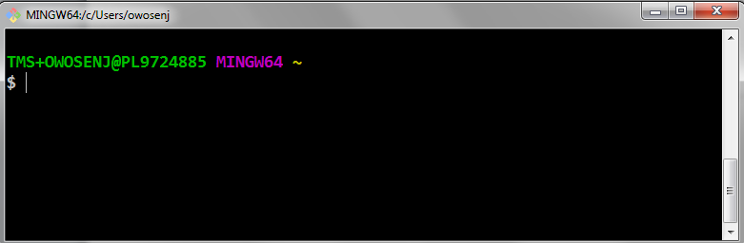

Git bash is terminal running as mintty (Windows) and it is reading your PC

Generate SSH keys on your local PC using Git bash. The SSH keys is needed to integrate with Github

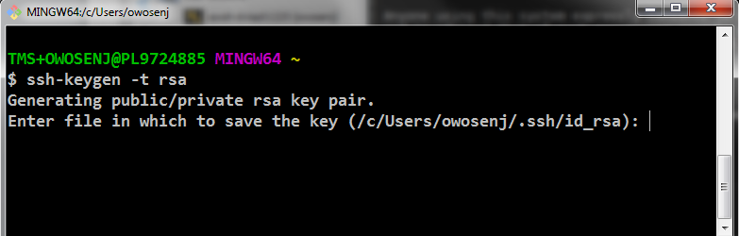

Login to [Github](https://github.tfs.toyota.com/) with your lan ID

Go to settings and add SSH key generated on git bash.

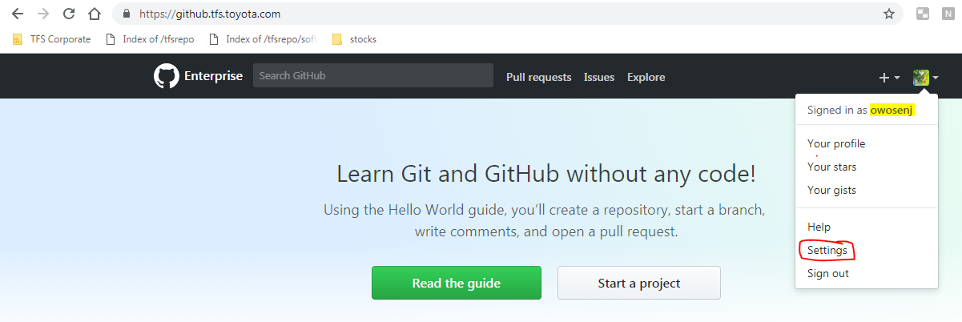

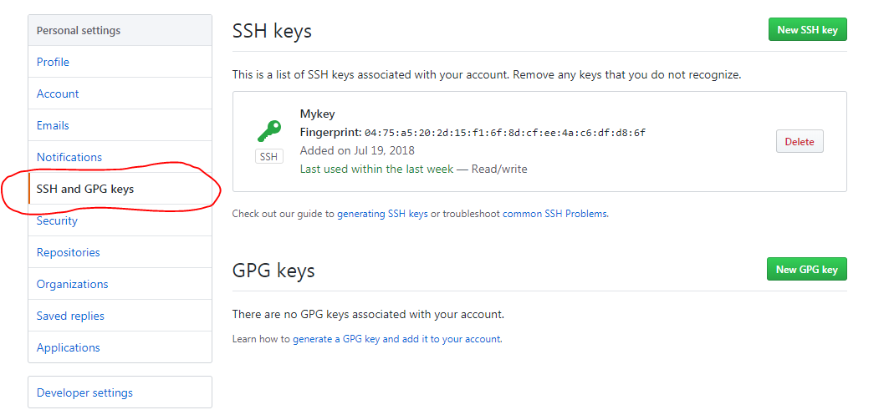

## DNE GITHUB REPOSITORY

To utilize DNE repository for AWS build, please send an email to [Lakshmikanth.Pandre1@toyota.com](mailto:Lakshmikanth.Pandre1@toyota.com) to be giving permission to read from the private repository.

Search for srv-aws-git-repo-prd/dne.aws.ec2 on [Github](https://github.tfs.toyota.com/)

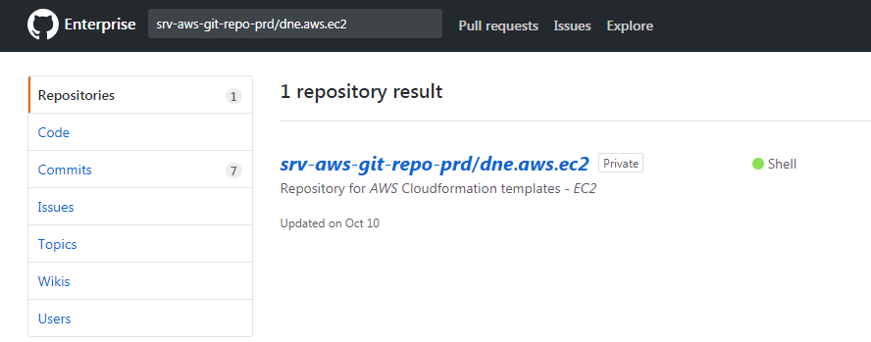

Once giving permission to read the repository, you should see the below;

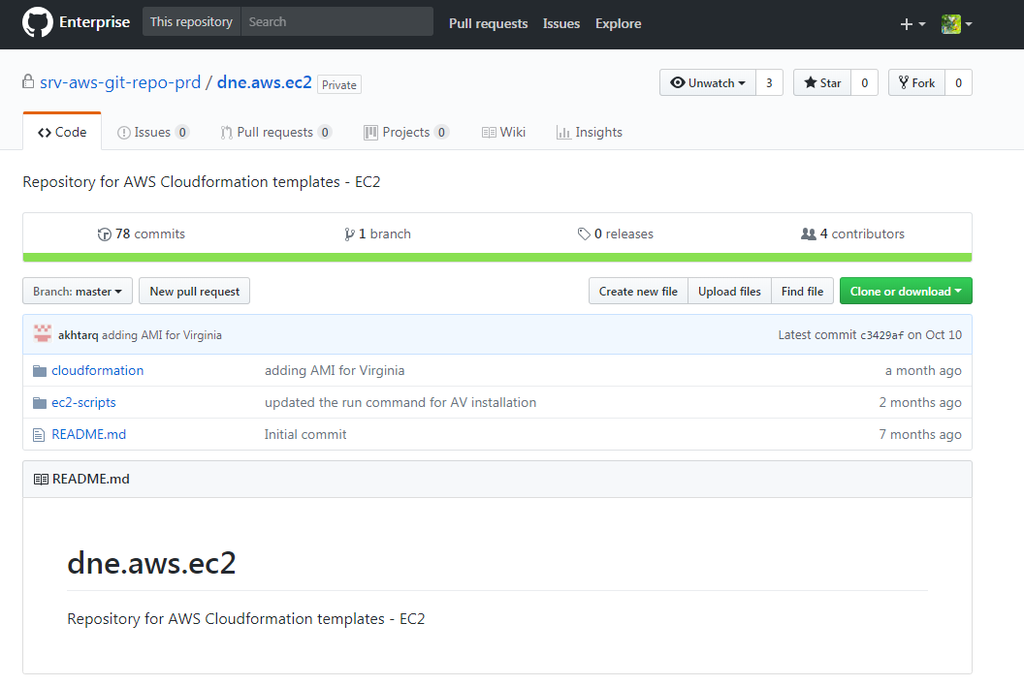

Integrate Github with your local PC by cloning the repository.

Please note, use “Clone with SSH”.

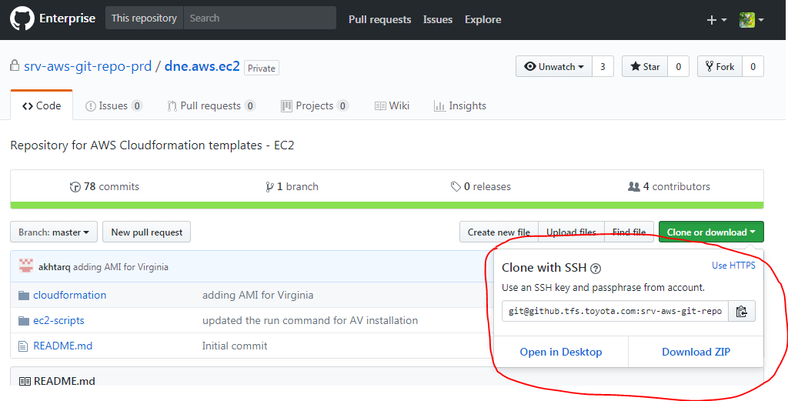

Please follow the below steps;

Make a directory for the project in git bash as in DNE_project

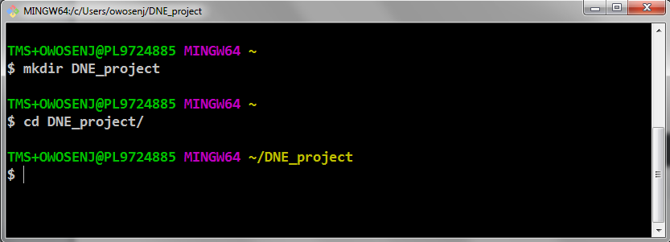

Run the command below;

git clone git@github.tfs.toyota.com:srv-aws-git-repo-prd/dne.aws.ec2.git

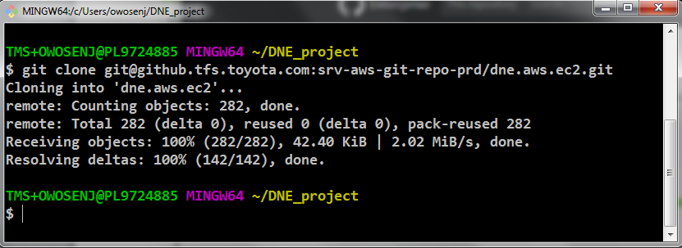

After cloning, you would be able to view the content of the repository on your local PC and it is continuously connected to Github with SSH;

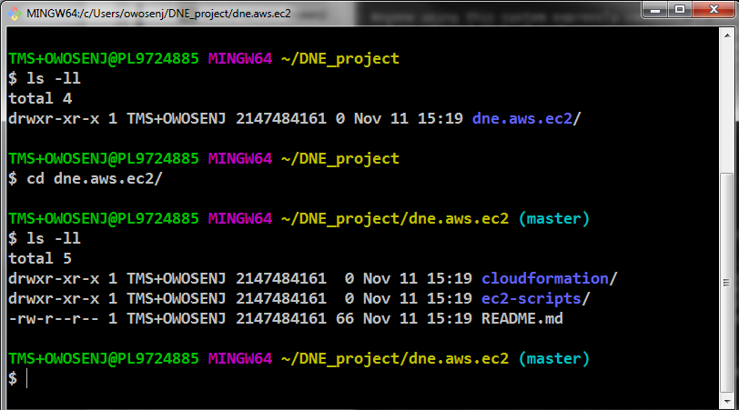

To confirm you are connected, run command “**git remote –v**”, you should get the response as below;

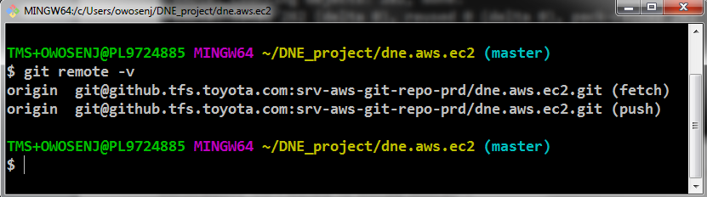

Unless giving permission to write into the repository, you would only have permission to pull.

Run the command “**git fetch**” then “**git pull**” to ensure you are connected to Github and have updated code from the repository.

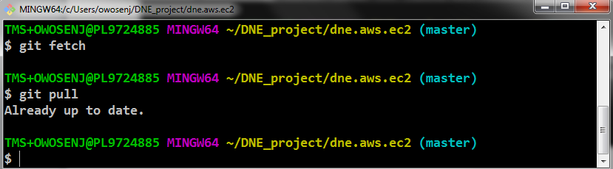

To view the repository on the local PC;

Run pwd on git bash

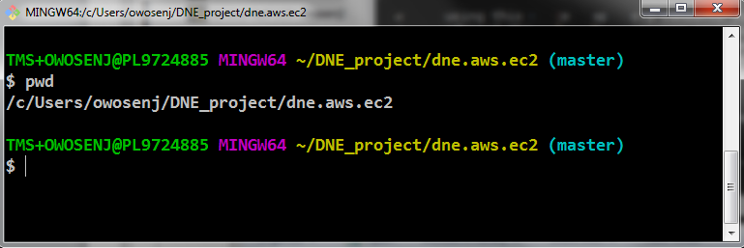

Navigate to the folder on PC

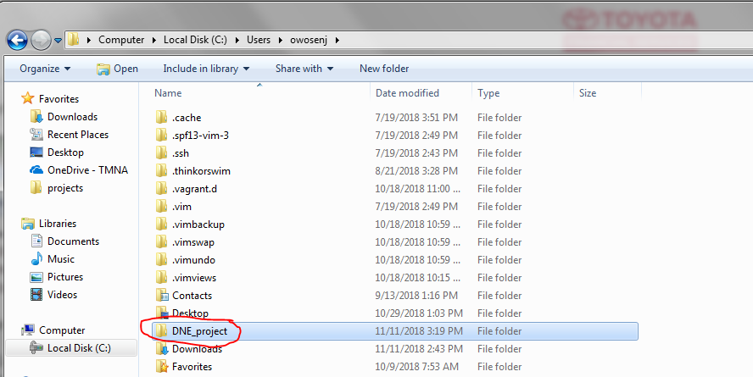

For easy navigation, drag and drop the folder DNE_project as in this case to Favorites on the side;

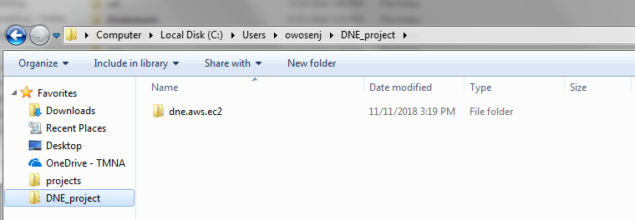

## TEMPLATE AUTHOR & OWNER

The team named below is the author & owner of this document. All modifications made to the document will be recorded by the document owner in the “Record of Past Modifications” section above.

|  |  |
| --- | --- |
| Template Owner | **TFS DNE Unix** |
| The Latest Author: | Joshua Owoseni |
| Job Title: | Unix System Engineer |
| Email: | Joshua.owoseni@toyota.com |