 **UNIVERSIDAD PRIVADA FRANZ TAMAYO**

**INGENIERÍA DE SISTEMAS**

**LABORATORIO 1**

**Componente:**

**Univ. Cristian Josue Poma Zuleta**

**Materia:**

**Programación De Sistemas Embebidos**

**Docente:**

**Ing. William Roddy Barra Paredes**

**BOLIVIA**

**2022**

**Consigna:**

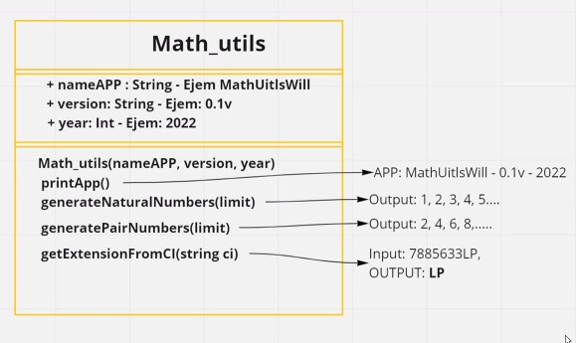

**Solución:**

**Main:**

from Math_utils import Math_utils  
  
instancia = Math_utils("APP: MathUtilsWill", "- 0.1", "- 2022")  
instancia.print_app()  
  
print(instancia.generate_serie(1, 10, 1))  
print(instancia.generate_serie(2, 10, 2))  
  
instancia.extention_from_ci("7885633LP")

**Math_utils:**

class Math_utils:  
 nameAPP = ""  
 version = ""  
 year = ""  
  
 def __init__(self, name, s, j):  
 self.nameAPP = name  
 self.version = s  
 self.year = j  
  
 def getfullname(self):  
 return self.nameAPP  
  
 def setlastversion(self):  
 return self.version  
  
 def setlastyear(self):  
 return self.year  
  
 def setnameAPP(self, text):  
 self.nameAPP = text  
  
 def setversion(self, n):  
 self.version = n  
  
 def setyear(self, n):  
 self.year = n  
  
 def print_app(self):  
 print(self.nameAPP, "", self.version, "", self.year)  
  
 def generate_serie(self, ini, hasta, incre):  
 result = ""  
 for i in range(ini, hasta + 1, incre):  
 if i == (hasta):  
 result = result + str(i) + "."  
 else:  
 result = result + str(i) + ","  
 return result  
  
 def extention_from_ci(self, ci):  
 print(ci[-2:])