Q2

## 1: Price summary

### Output 1: Summarised price statistics for Paris and Copenhagen

## Min. 1st Qu. Median Mean 3rd Qu. Max.   
## 10.0 60.0 84.0 110.8 121.0 11323.0

## Min. 1st Qu. Median Mean 3rd Qu. Max.   
## 10.0 77.0 105.0 118.4 144.0 5620.0

### Figure 1: Boxplots and histograms for price data, Paris and Copenhagen

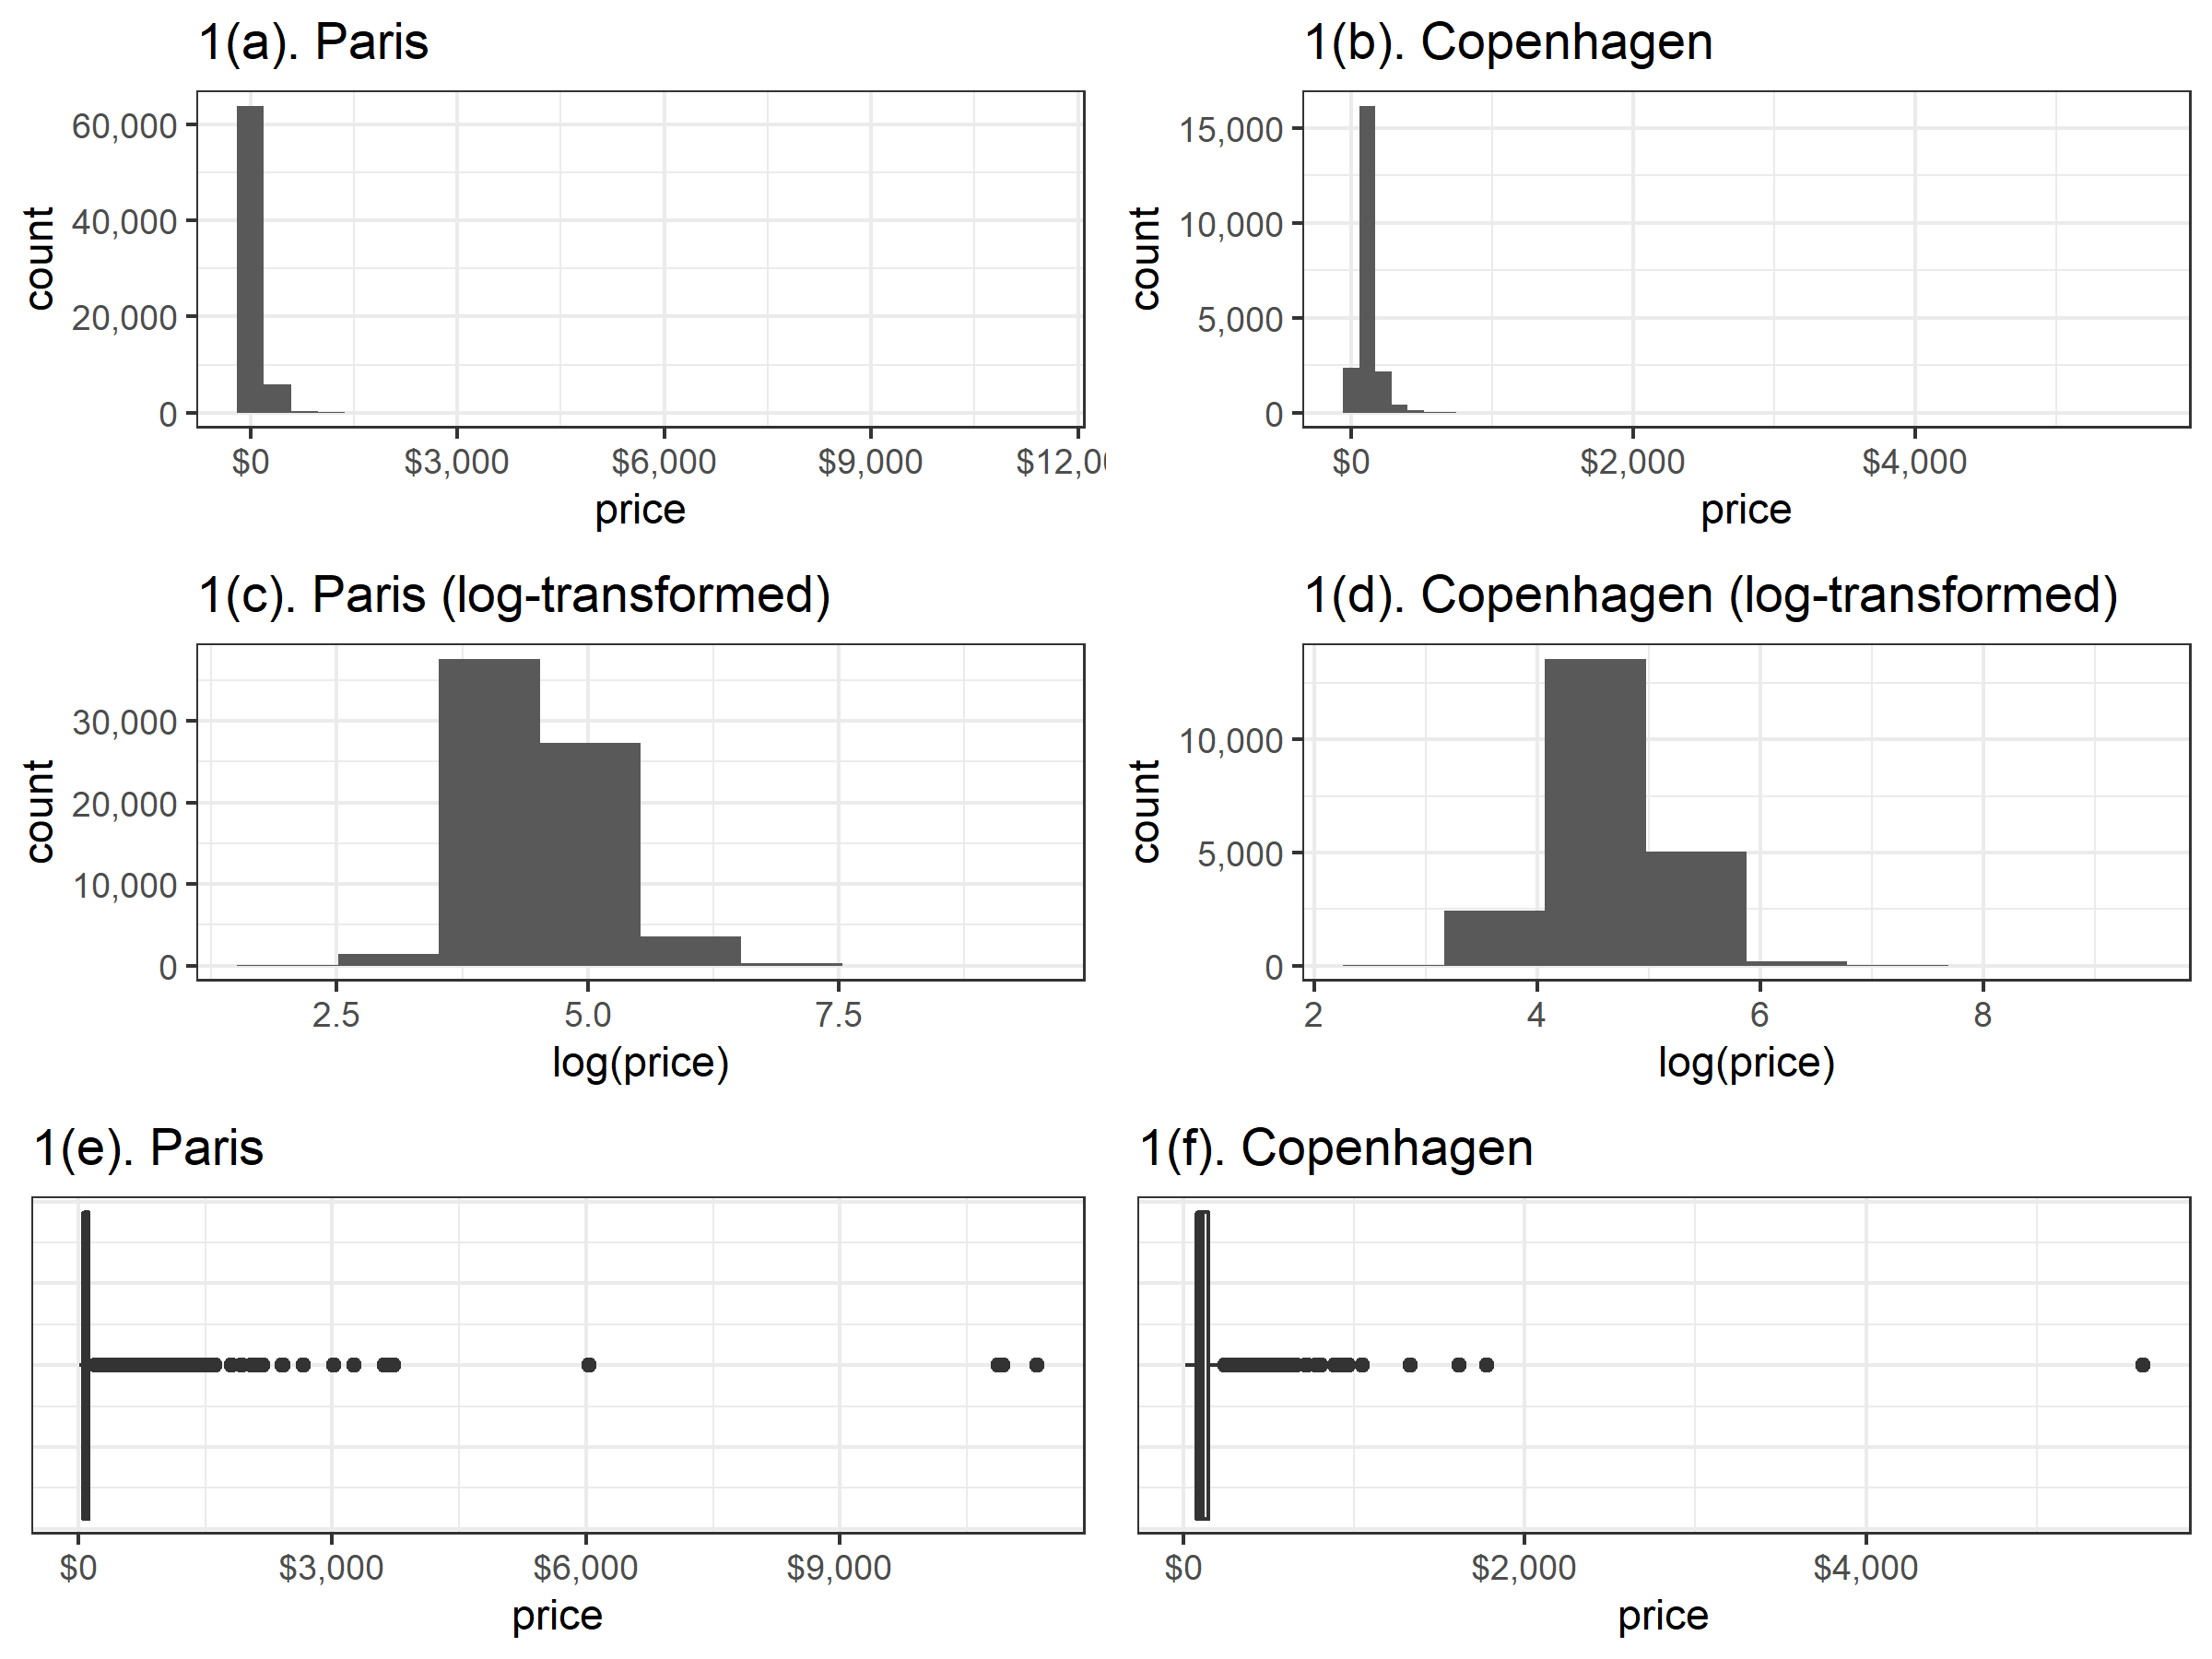 `

### Output 2: Two-sample t-test.

##   
## Two Sample t-test  
##   
## data: ttest$price by ttest$city  
## t = 8.1195, df = 91457, p-value = 4.74e-16  
## alternative hypothesis: true difference in means is not equal to 0  
## 95 percent confidence interval:  
## 5.766361 9.436151  
## sample estimates:  
## mean in group Copenhagen mean in group Paris   
## 118.3664 110.7652

##   
## Two Sample t-test  
##   
## data: ttest$price2 by ttest$city  
## t = 32.913, df = 91457, p-value < 2.2e-16  
## alternative hypothesis: true difference in means is not equal to 0  
## 95 percent confidence interval:  
## 0.1355903 0.1527617  
## sample estimates:  
## mean in group Copenhagen mean in group Paris   
## 4.646323 4.502147

##   
## Wilcoxon rank sum test with continuity correction  
##   
## data: ttest$price by ttest$city  
## W = 896935657, p-value < 2.2e-16  
## alternative hypothesis: true location shift is not equal to 0

### Table 1: Raw counts for private room type

## [,1] [,2]  
## [1,] 3564 17737  
## [2,] 7880 62278

### Output 1: Two proportion test

##   
## 2-sample test for equality of proportions with continuity correction  
##   
## data: c(3564, 7880) out of c(nrow(Q3copenhagen), nrow(Q3paris))  
## X-squared = 450.99, df = 1, p-value < 2.2e-16  
## alternative hypothesis: two.sided  
## 95 percent confidence interval:  
## 0.04943724 0.06055911  
## sample estimates:  
## prop 1 prop 2   
## 0.1673161 0.1123179