Q1

## 1(a): Number of reviews each property receives in each city

### Output 1: Summarised statistics for reviews, Paris and Copenhagen

## Min. 1st Qu. Median Mean 3rd Qu. Max.   
## 0.00 1.00 4.00 10.26 12.00 400.00

## Min. 1st Qu. Median Mean 3rd Qu. Max.   
## 0.00 0.00 4.00 14.61 14.00 529.00

### Table 1: Number of reviews per property, Paris and Copenhagen

| Number of reviews per property | Paris total | Paris % | Copenhagen total | Copenhagen % |
| --- | --- | --- | --- | --- |
| 0 | 19,103 | 27.2% | 4,421 | 20.8% |
| 1 to 10 | 29,461 | 42% | 11,008 | 51.7% |
| 11 to 50 | 16,365 | 23.3% | 5,163 | 24.2% |
| 51 to 100 | 3,409 | 4.9% | 534 | 2.5% |
| 101 to 200 | 1,497 | 2.1% | 152 | 0.7% |
| 201 to 300 | 276 | 0.4% | 18 | 0.1% |
| 301 to 400 | 36 | 0.1% | 5 | 0% |
| over 400 | 11 | 0% | 0 | 0 |
| **TOTAL** | **70,158** | **100%** | **21,301** | **100%** |

### Figure 1: Boxplots and histograms for reviews, Paris and Copenhagen

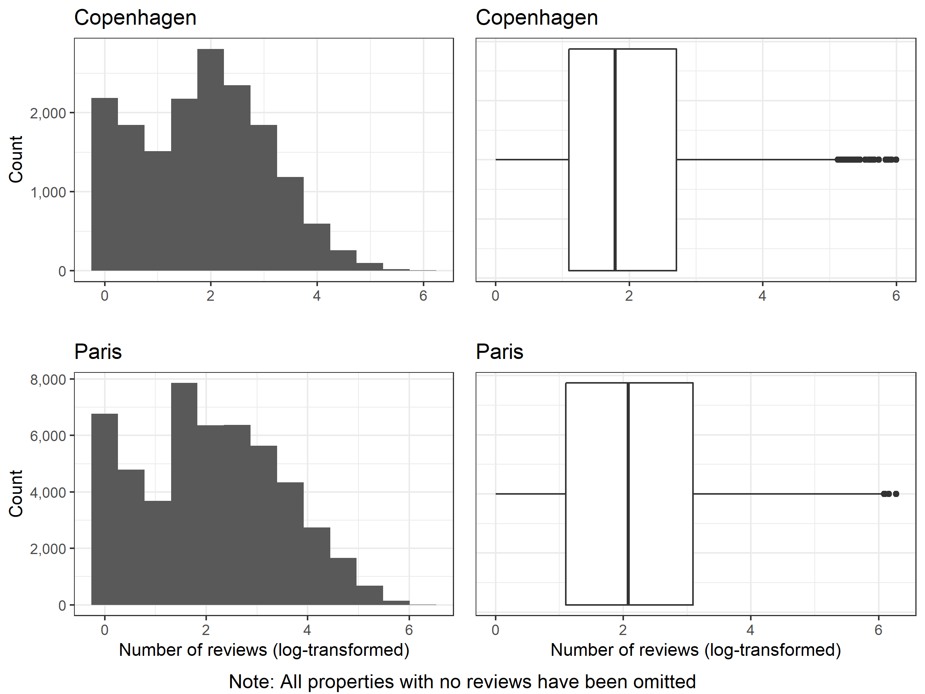

## 1(b): Room type in each property by city

### Figure 2: Roomtype by city, Paris and Copenhagen

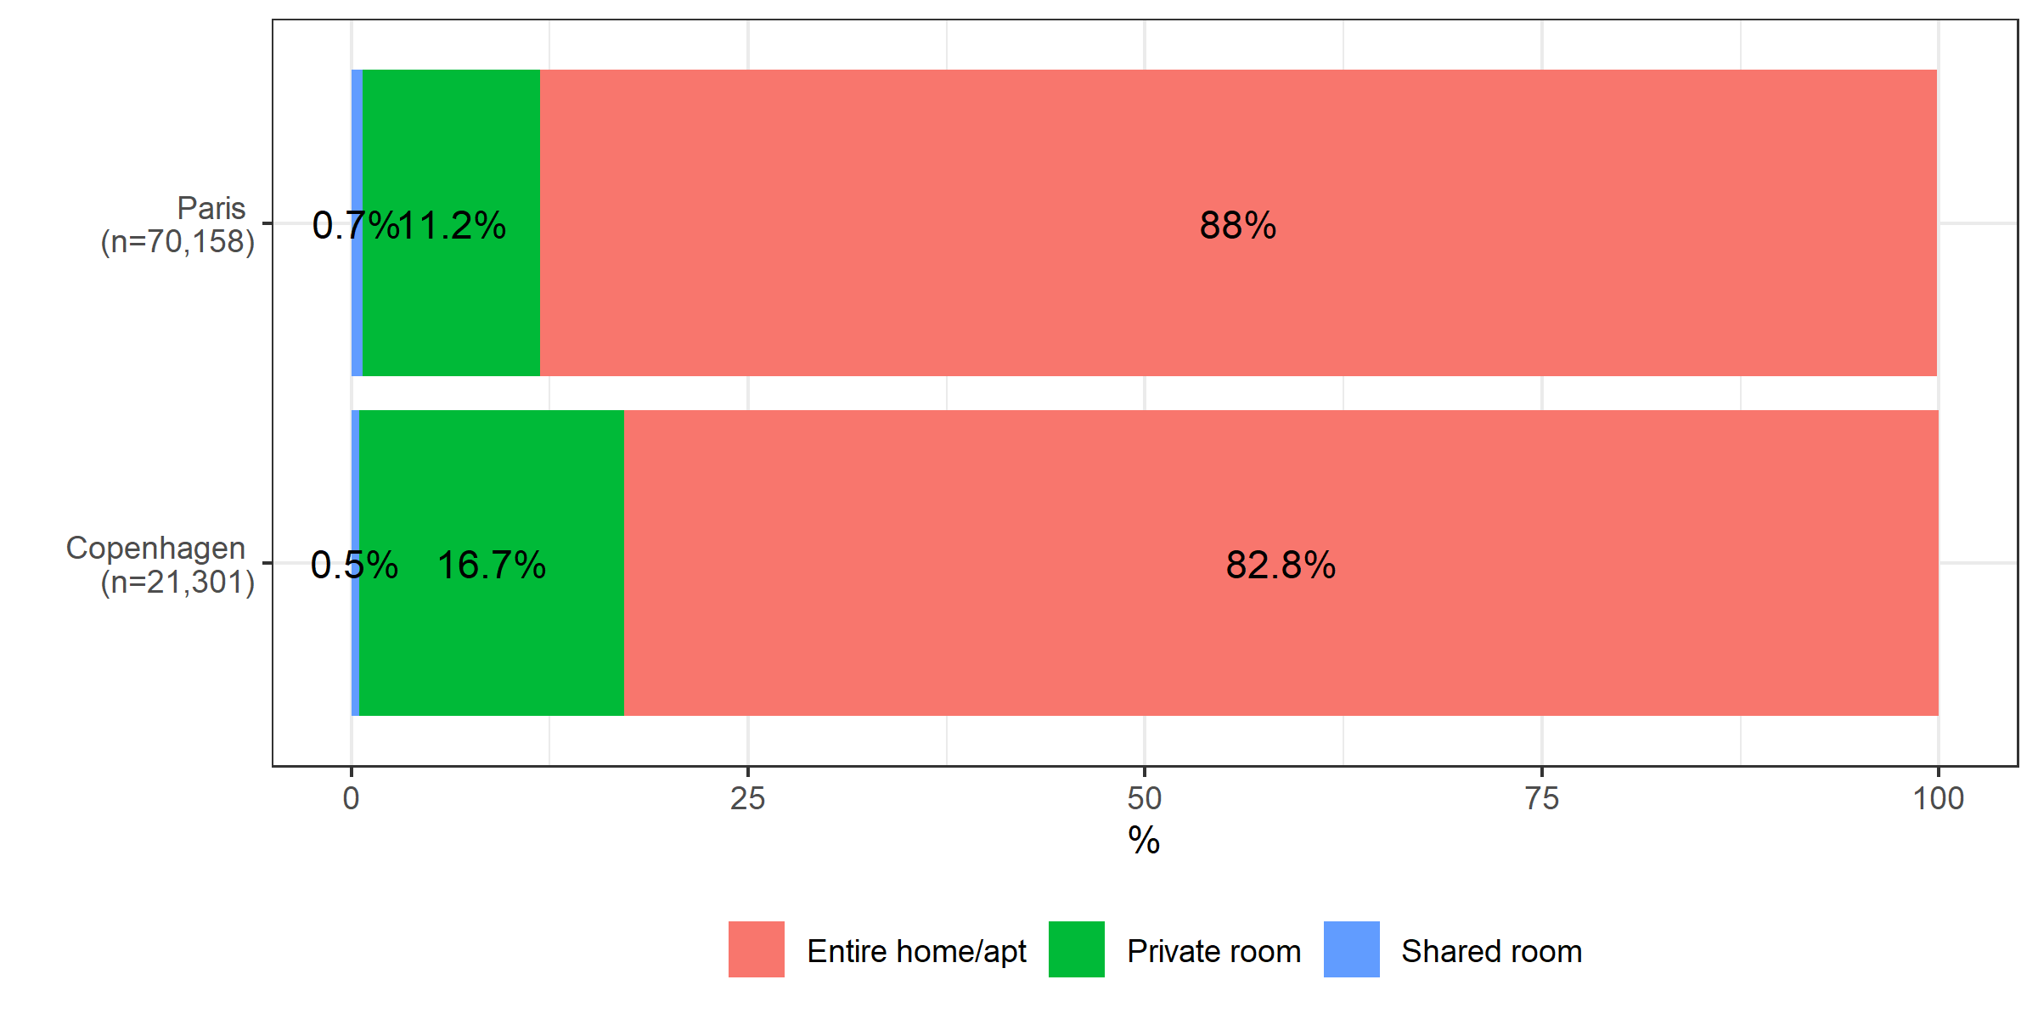

## 1(c): Satisfaction by property

### Figure 3: Satisfaction by city, Paris and Copenhagen

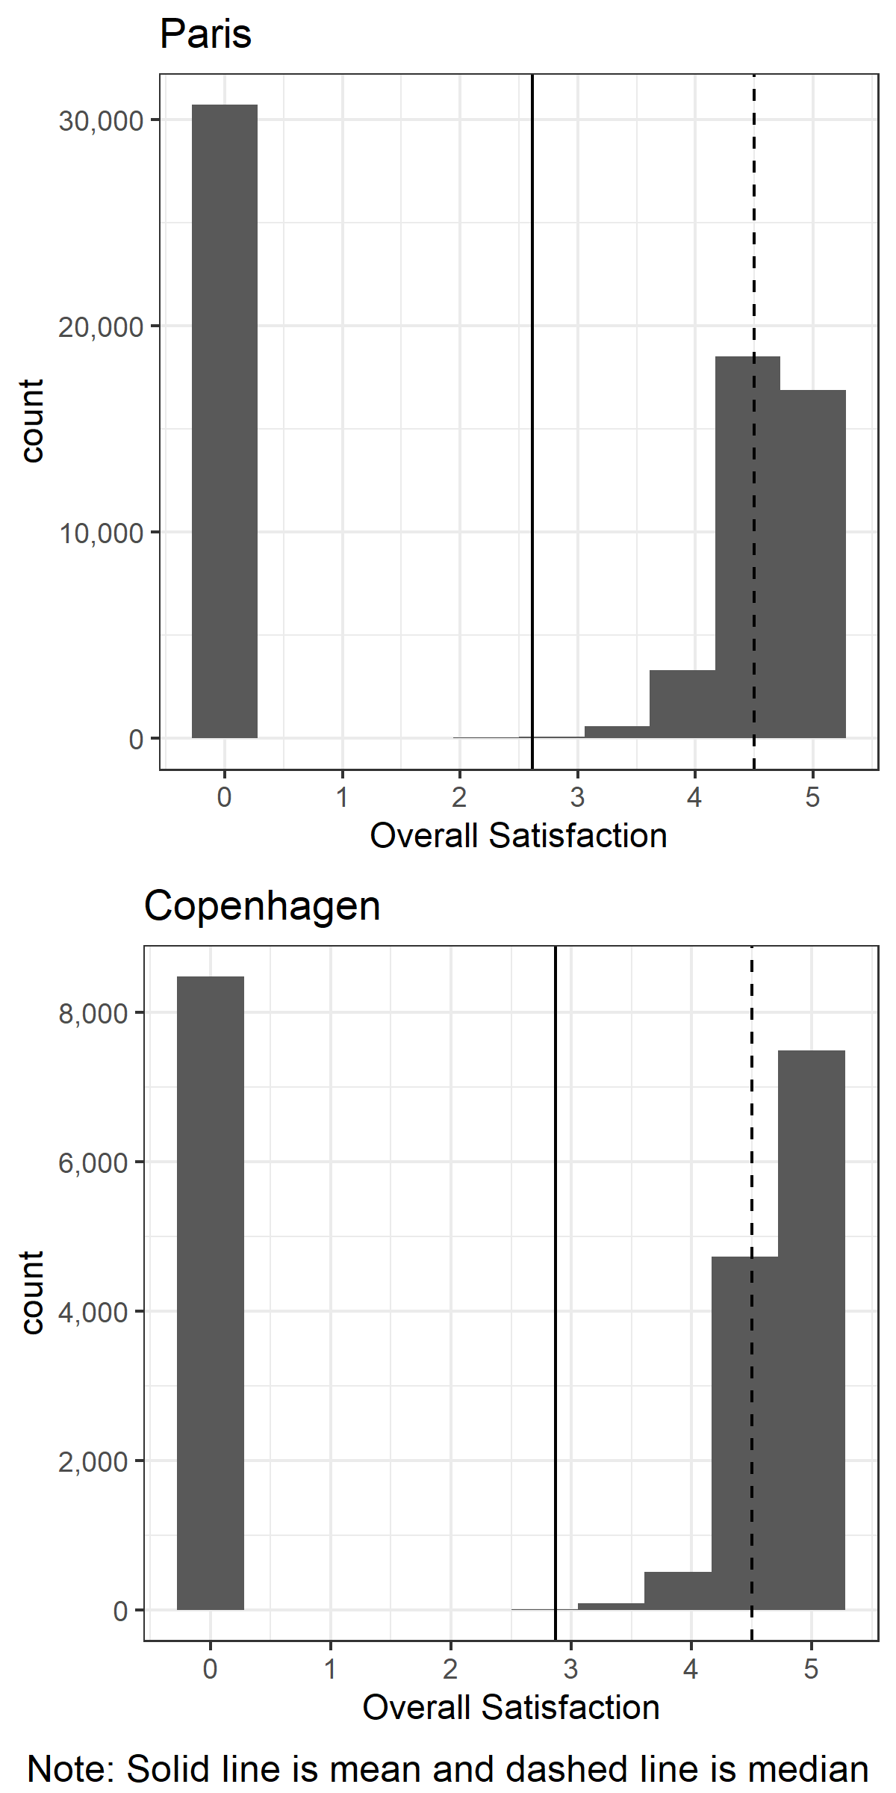

## Output 1a: Satisfaction rating by number of reviews

## # A tibble: 846 x 5  
## # Groups: reviews [332]  
## reviews overall_satisfaction total totals prop  
## <int> <dbl> <int> <dbl> <dbl>  
## 1 0 0 19103 70158 27.2   
## 2 1 0 6766 70158 9.64   
## 3 2 0 4790 70158 6.83   
## 4 3 0 25 70158 0.0356   
## 5 4 0 7 70158 0.00998  
## 6 5 0 3 70158 0.00428  
## 7 6 0 2 70158 0.00285  
## 8 7 0 2 70158 0.00285  
## 9 10 0 1 70158 0.00143  
## 10 3 1 5 70158 0.00713  
## # ... with 836 more rows

## # A tibble: 396 x 5  
## # Groups: reviews [186]  
## reviews overall_satisfaction total totals prop  
## <int> <dbl> <int> <dbl> <dbl>  
## 1 0 0 4421 21301 20.8   
## 2 1 0 2187 21301 10.3   
## 3 2 0 1845 21301 8.66   
## 4 3 0 11 21301 0.0516   
## 5 4 0 5 21301 0.0235   
## 6 5 0 4 21301 0.0188   
## 7 6 0 1 21301 0.00469  
## 8 8 0 1 21301 0.00469  
## 9 5 1.5 1 21301 0.00469  
## 10 4 2 2 21301 0.00939  
## # ... with 386 more rows