Skills and Qualifications in Scotland’s Alcohol and Drug Workforce

## 1. Introduction

This briefing paper provides descriptive statistics on the types of qualifications germane to the alcohol and drugs workforce in Scotland. The figures included here are the result of a secondary data collection exercise of both publicly-available and specially-requested data from partner organisations across a variety of sectors. These data provide a time series overview of the potential skills supply for this workforce, comprising people earning relevant qualifications (i.e. pegged to the [Scottish Credit and Qualifications Framework](https://scqf.org.uk/)) in colleges and universities, as well as working professionals undertaking professional development, upskilling, or micro-credential opportunities.

There are limitations to what this data can tell us, especially around qualifications earned in further/higher education settings. However, these data will be further bolstered and contextualised by a rapid evidence review as well as a survey of the extant workforce in services currently on the DAISy that Scottish Government ran between 22 November and 10 December 2021.

## 2. Further and Higher Education

The Scottish Funding Council for Further and Higher Education ([SFC](https://www.sfc.ac.uk/)) is the non-departmental public body in Scotland responsible for collecting and monitoring data in colleges and universities. This is thus a robust source from which key insights about the skills pipeline into the alcohol/drugs workforce might be derived.

### 2.1 Colleges

Colleges offer a range of courses and study options across many levels of study. They deliver over 117,000 full-time equivalents’ worth of activity every academic year, nearly 30% of which relates to health and care services[1], and are thus primary driver of skills development and acquisition in Scotland.

To this end, a bespoke data request was submitted to SFC for more information on delivery in health care, social care, or medical subjects. This collection only captured students undertaking ‘substantive’ activity – courses at or above SCQF level 5 (senior phase of high school and up) and having a duration greater than 160 hours. The resulting datasets provide a rich picture of meaningful activity taking place in the college sector that is relevant to this research.

Figure 1 shows the number of students meeting the aforementioned criteria that successfully completed a course by subject area between AY2013-14 and AY2019-20 (the most recent data available). Although this analysis is relatively high-level, it shows that activity levels in relevant subject areas varied substantially over this period. For example, the number of students successfully completing psychology courses fell by nearly 40% (1,386 in AY2013-14 to 854 in AY2019-20), while successful completions in health care management/health studies more than doubled from 1,511 to 3,502. By contrast, the number of people gaining nursing qualifications in AY2013-14 – 956 - is nearly identical to the 950 successful completions in AY2019-20. This was likewise the case with medical technology/pharmacology (75 and 65 successful completions in AY2013-14 and AY2019-20, respectively).

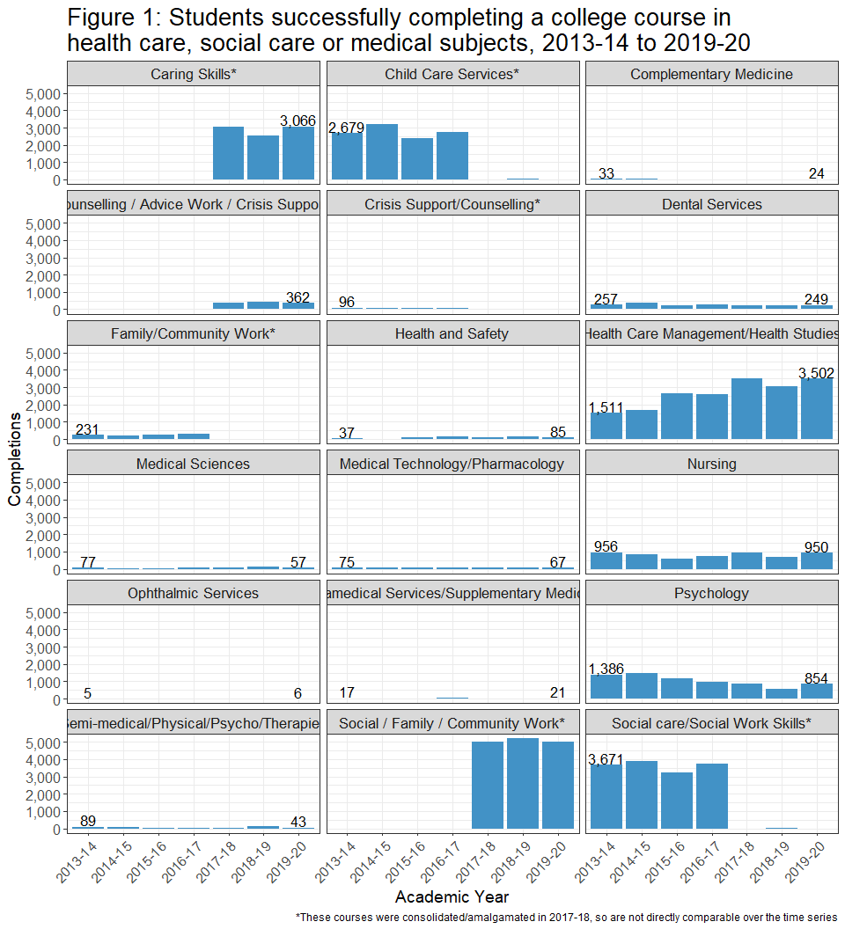

Other subject areas are less straightforward. The reason for this is because SFC modified their superclasses in AY2017-18[2], with the resulting groupings complicating attempts to draw conclusions across the entire time series. Nevertheless there are still interesting findings here. Since AY2017-18 alone, 1,170 people have successfully completed courses in counselling/advice work/crisis support, while over 15,000 have done so in social/family/community work.

Granted, a major limitation of this analysis is that it is coarse, containing only information about qualifications earned at the subject level. SFC confirmed that there is not a single college course currently offered which includes ‘drugs’, ‘alcohol’, ‘addiction’ or ‘substance’ in the course title. Moreover there does not exist any database of course content (i.e. module names, syllabi, etc), with this information only available piecemeal on each college’s website. However, this data *does* suggest that hundreds, if not thousands, of students are gaining the qualifications necessary to enter the alcohol and drugs workforce every academic year. These range from nursing, psychology and pharmacology, to courses preparing them for non-clinical yet still essential roles in e.g. advocacy work, social work, counselling and health/social care management. If leveraged properly, the college sector could be a key skills incubator for this workforce.

### 2.2 Universities

The Higher Education Statistics Authority (HESA) is responsible for collecting, processing and publishing data about higher education institutions in the UK. However, this section will not focus on on training/registration/recruitment of the medical professions in Scotland, which is covered in Section 3 below. Instead, this section will provide an overview of students completing university-level qualifications in more specified areas.

Beginning in AY2019-20, HESA implemented its Higher Education Classification of Subjects (HECoS) regime for categorising university-level subject areas, which replaced the previous Joint Academic Coding System (JACS). This change introduced a standalone ‘drug and alcohol studies’ subject, which was an amalgamation of three JACS subjects: pharmacology, toxicology & pharmacy, counselling, and health & welfare. Although HESA outlines several caveats to the HECoS to JACS mapping[3], this new category provides a relatively convenient means of evaluating time series data relevant to this research.

Once again working with SFC, who publishes HESA data for Scottish universities[4], a bespoke request was submitted for data on students qualifying any of the three ‘drug and alcohol studies’ subjects between 2013-14 and 2018-19[5]. It was decided that this cut would only include Scots-domiciled students - i.e. those who would most likely stay in Scotland to work post-study - and be measured in full-person equivalents (FPEs) to account for students doing joint degrees.

While there have been overall increases in students qualifying in both counselling (+50%) and health & welfare (+29.4%) between 2013-14 and 2018-19, there has been a substantial downturn in pharmacology, toxicology & pharmacy graduates (-71%). These figures are further contextualised by study level, as shown in Figure 2.

Predictably, there were fewer students gaining research postgraduate qualifications compared to other study levels, with each subject producing <5 graduate FPEs in every academic year since 2016-17. By contrast, there was substantially more variation for undergraduates. Especially since AY2015-16 there have been notable increases in health and welfare as well as counselling graduates (312 and 74 respectively in AY2018-19), offset by decreases in pharmacology, toxicology and pharmacy (27). At the taught postgraduate level it is counselling which comprises the greatest share of graduate FPEs (132 in 2018-19), whereas health and welfare and pharmacology, toxicology and pharmacy subjects have been relatively stable - albeit with a slight downward trend in the former - since 2013-14. In any case, the introduction of a bespoke ‘drugs and alcohol studies’ subject area from 2019-20 will further improve data quality in graduates from these areas.

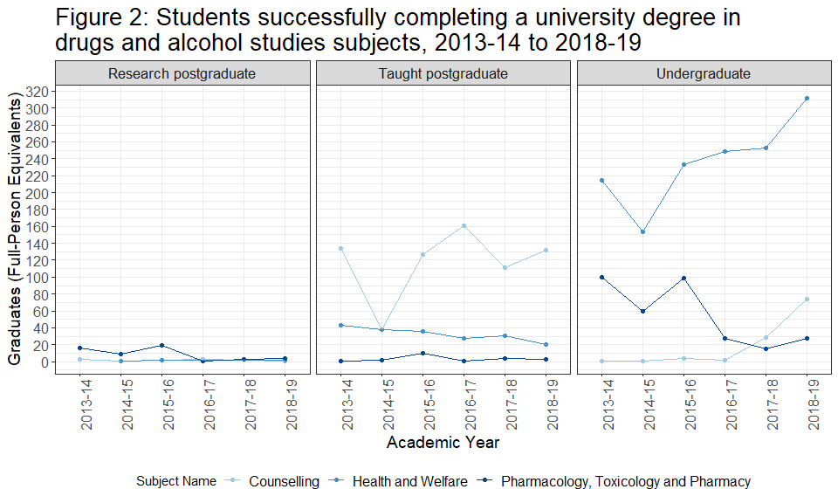

In addition to this work with SFC, we worked closely with the [Drugs Research network for Scotland](https://drns.ac.uk/) to identify offerings at individual institutions. Table 1 shows that, in contrast to the college level, universities offer qualifications at various study levels which are directly relevant to this analysis (and which will have been captured in Figure 2). There are also research consortia at various institutions which are actively progressing work in this space. Finally, this table does not include individual academics that are working in drugs/addiction/substance abuse but are unaffiliated with a formal research group.

| Table 1: Courses and research groups in relevant areas | | |
| --- | --- | --- |
| **Institution** | **Title** | **Type** |
| Glasgow Caledonian University | Substance Use | Research Group |
| University of Dundee | Leverhulme Research Centre for Forensic Science | Research Group |
| Robert Gordon University | Addiction and Substance Use in a Range of Contexts | Short Course |
| University of Glasgow | Substance Use in a Contemporary World | Microcredential |
| MRC/CSO Social and Public Health Sciences Unit | Research Group |
| University of Stirling | Substance Use | Taught Postgraduate |
| Salvation Army Centre for Addiction Services and Research | Research Group |
| University of the West of Scotland | Contemporary Drug & Alcohol Studies | Taught Postgraduate |
| Addiction Psychology | Taught Postgraduate |

Overall, this data shows the breadth of activities taking place at both the college and university levels, and provides a solid evidence base for future work. One potential avenue would be to evaluate curriculum offerings (via e.g. web scraping), with the intention of working with key stakeholders to align these offerings with the needs of the workforce. This underscores the need to have more formalised pathways into alcohol and drug service settings. Further and higher education institutions could be a key player in driving this change.

## 3. Working Professionals and CPD

### 3.1 An overview of the health and social care workforce

Recruitment and registration data for clinicians and allied health professionals is already publicly-available from other bodies, such as the General Medical Council[6] and Nursing & Midwifery Council[7], as well as NHS Scotland[8]. This section will therefore showcase high level employment figures in select specialties, with the aim of deriving some idea of the potential pool of medical professionals relevant to the alcohol and drugs workforce.

#### 3.1.1 Medical workforce

<https://turasdata.nes.nhs.scot/data-and-reports/official-workforce-statistics/all-official-statistics-publications/07-december-2021-workforce/dashboards/nhsscotland-workforce/?pageid=5982>

At the census date of 30 September 2021, the medical workforce constituted 14,242.5 WTEs across all medical specialties. For the purposes of this research we focussed on those members of the workforce specialising in general practice Figure X shows the number of people in X, Y and Z specialties

Figure Y shows the grades of these people?

#### 3.1.2 Non-medical workforce

fdjkslfjdlksjfds

### 3.2 NHS Education for Scotland

In 2010, NHS Education Scotland (NES) established a Psychological Interventions Team (PIT) to increase workforce capacity and deliver evidence-based psychological therapies and interventions. Over the last decade, PIT has worked closely with Scottish Government to develop a suite of education and training programmes aimed at staff working within the NHS, social services and third sector organisations. Substance abuse is a priority work stream in NES’s training programme, and through their TURAS portal have recorded robust data on the typology of health/social care professionals undertaking CPD courses in this area.

| Table 2: Training courses available through NES, 2019-20 to 2020-21 | | |
| --- | --- | --- |
| **Course Title** | **AY2019-20** | **AY2020-21** |
| Implementing Core Skills for Preventing Relapse and Managing Recovery Management in Substance Misuse Services | 42 | - |
| Training the Trainers: Introduction to Core Behavioural and CBT Skills for Relapse Prevention and Recovery Management | 5 | 4 |
| Coaching the Coaches Seminar (invitation only) | 12 | - |
| Developing and Enhancing Motivational Coaching Skills | 17 | 22 |
| Scottish Winter School in Motivational Interviewing | 44 | 27 |
| Implementing Workforce Development Planning in Scottish Alcohol and Other Drug Services | 32 | 36 |
| Introduction to Cognitive Behavioural Therapy for Anxiety in Substance Misuse Settings | 10 | - |
| Core Behavioural and CBT Skills for Relapse Prevention and Recovery Management | - | 32 |
| Safety and Stabilisation in Substance Misuse and Forensic Settings | - | 28 |
| **TOTAL** | **162** | **149** |

Table 2 shows that over 300 health and social care professionals have completed courses in substance abuse offered by NES over the last two years. These have ranged from cognitive behavioural therapy to motivational interviewing to multidisciplinary modules, and have been run across every NHS Health Board in Scotland. Moreover, these figures do not include enrollments on training courses run in other (yet related) workstreams such as anxiety, depression and psychosis. Granted, there was a slight downturn in the number of courses offered and therefore attendance in 2020-21. Course organisers have attributed this to Covid and the wholesale migration of training to online delivery. Nevertheless, these figures show that there is high demand for these courses, such that NES has submitted proposals to SG for recruiting more staff to deliver these trainings.

### 3.3 Scottish Drugs Forum (SDF)

Lorum ipsum etc

### 3.4 Royal College of General Practitioners Scotland

The Royal College of General Practitioners Scotland (RCGP Scotland) offers a [Certificate in the Management of Problem Drug Use](https://www.rcgp.org.uk/rcgp-near-you/rcgp-nations/rcgp-scotland/certificate-in-the-management-of-problem-drug-use.aspx) that has been approved by an expert advisory panel of senior clinicians. Funded in part by Scottish Government, this course is designed to assist primary care professionals help and care for people affected by drug use, and is open to GPs, pharmacists, allied healthcare professionals, third sector workers, and anyone else working in primary care in Scotland.

Since its relaunch in 2020, this two-part course has proven popular. Data provided by RCGP Scotland shows that a total of 84 people earned this certificate during the first cohort (February-October 2021) - 67 for part 1 and an additional 17 for part 2 of the course. These figures break down as:

* **GP or trainee GP**: 56
* **Pharmacy**: 14
* **Prison healthcare**: 14

Although GPs and GP trainees comprise the majority in both part 1 and part 2, there is also notable participation within the pharmacy and prison sectors as well. Demand has increased for cohort 2, with 80 people registered for part 1 (currently running from November-December 2021). Part 2 will take place in spring 2022.

RCGP Scotland has confirmed that they are able to run this course due to a three-year tranche of SG funding which is currently in place until 2023. Given the announcement of the National Mission, it is worth discussing how this certificate can be supported beyond the end of the three year cycle.

## 4. Conclusion

MAT standards, National Mission,

1. <https://www.sfc.ac.uk/publications-statistics/statistical-publications/2021/SFCST012021.aspx>
2. See Further Education Statistics guidance for additional details: <https://www.sfc.ac.uk/publications-statistics/guidance/guidance-2017/SFCGD012017.aspx>
3. See additional documentation here: <https://www.hesa.ac.uk/support/documentation/hecos>
4. See Higher Education Students and Qualifiers publication: <https://www.sfc.ac.uk/publications-statistics/statistical-publications/2021/SFCST032021.aspx>
5. The data would not be comparable for 2019-20 due to the migration to HECoS
6. <https://data.gmc-uk.org/gmcdata/home/#/reports>
7. <https://www.nmc.org.uk/about-us/reports-and-accounts/registration-statistics/>
8. <https://www.scotmt.scot.nhs.uk/recruitment/recruitment-statistics.aspx>