|  |
| --- |
| **Eigenface Project** |
| **Josh Gleason and Rod Pickens** |
| **Programming Assignment 3** |
| **Computer Science 679 – Pattern Recognition, UNR, Dr. Bebis** |
| **Due: Monday April 13, 2015** |
| **Submitted: Monday April 13, 2015** |

Contents

1 Abstract 3

2 Technical Discussion 3

2.1 Eigenvectors and eigenvalues 3

2.2 Eigenfaces 3

3 Project 5

3.1 Training and software validation 5

3.2 Experimental Results for High Resolution Imagery 6

3.2.1 Training a.I: Hi resolution with 80% information 6

3.2.2 Testing a.II to a.IV: Hi resolution with 80% information 7

3.2.3 Testing a.II to a.IV: High resolution with 90 % information 8

3.2.4 Testing a.II to a.IV: High resolution with 95 % information 8

3.2.5 Part b: Feature and ROC performance charts 10

3.3 Experimental Results for Low Resolution Imagery 11

3.3.1 Training a.I: Lo resolution with 80% information 11

3.3.2 Low resolution a.II to a.IV with 80% information 12

3.3.3 Low resolution a.II to a.IV with 90% information 13

3.3.4 Lo resolution a.II to a.IV with 95% information 14

3.3.5 Part b: Feature and ROC performance charts 15

4 Conclusion 16

4.1 Part A: Face recognition 16

4.2 Part B: Intruder detection 17

5 Contributors 18

# Abstract

This paper describes our research regarding the third class project for the Computer Science pattern recognition class CS 679 taught by Dr. Bebis who is Department Chair of the Computer Science Department at the University of Nevada in Reno, Nevada.

The primary topics included in the main body of this report are a description of the project, linear algebra and eigenvectors, eigenface theory from eigenvectors, and approach to eigenface recognition.

# Technical Discussion

## Eigenvectors and eigenvalues

Eigenvectors are those vectors that are invariant in direction to the action of a matrix A on the vector as follows:

|  |  |  |
| --- | --- | --- |
|  | $$A\overline{v}=λ\overline{v}$$ | (1) |

In the above, $A$ is a square nxn matrix, $\overline{v}$ is an nx1 vector, and $λ$ is a scalar. As mentioned above, the action of the matrix $A$ upon the vector $\overline{v}$ is to scale, and to only scale, the vector $\overline{v}$ and not to change the direction of the vector $\overline{v}.$

## Eigenfaces

The eigenface approach taken and experimented in this paper is from the research of Turk and Pentland,[1] and their work was motivated by the earlier works of Sirovich and Kirby who represented pictures using principal component analysis.[2] Principal component analysis is a least squares approach for minimizing the error associated with a projection of the data onto a different basis.

Given a vector $\overline{x}$ in an N dimensional space, it can be represented by a set of N orthogonal basis vectors ${\overline{v}}_{i}$ as follows

|  |  |  |
| --- | --- | --- |
|  | $$\overline{x}=a_{1}{\overline{v}}_{1}+a_{2}{\overline{v}}_{2}+…+a_{N}{\overline{v}}_{N}=\left[{\overline{v}}_{1} {\overline{v}}_{2}… {\overline{v}}_{N}\right]∙\overline{a}$$ | (2) |

The goal is to find an N x K transformation matrix U such that

|  |  |  |
| --- | --- | --- |
|  | $$\overline{y}=U^{T}∙\overline{x}$$ | (3) |

Where $\overline{x}$ is an Nx1 rasterized image

|  |  |  |
| --- | --- | --- |
|  | $$\overline{x}={\left[\begin{matrix}I(1,1) \\ \begin{matrix}I(1,2) \\ \begin{matrix}⋯ \\ I(m,n)\end{matrix}\end{matrix}\end{matrix}\right]}_{(N,1)}={\left[\begin{matrix}I(1,1) \\ \begin{matrix}I(1,2) \\ \begin{matrix}⋯ \\ I(m,n)\end{matrix}\end{matrix}\end{matrix}\right]}_{(n*m,1)}=\left[{\overline{v}}_{1} {\overline{v}}_{2}… {\overline{v}}_{N}\right]\left[\begin{matrix}a_{1} \\ \begin{matrix}a_{2} \\ ⋯ \\ a_{N}\end{matrix}\end{matrix}\right]$$ | (4) |

And the basis vectors ${\overline{v}}_{i}$ the right side of the equation are the standard basis (natural or canonical) vectors of Euclidean space as follows:

|  |  |  |
| --- | --- | --- |
|  | $${\overline{v}}_{i}={\left[\begin{matrix}δ_{1,i} \\ \begin{matrix}δ_{2,i} \\ \begin{matrix}⋯ \\ δ_{N,i}\end{matrix}\end{matrix}\end{matrix}\right]}_{(N,1)} i=1,…,N$$ | (5) |

Where $δ_{i,j}$ is known as the Kronecker delta function

|  |  |  |
| --- | --- | --- |
|  | $$δ_{i,j}=\left\{\begin{matrix}0 if i≠j \\ 1 if i=j\end{matrix}\right.$$ | (6) |

Yielding a set of basis vectors as follows

|  |  |  |
| --- | --- | --- |
|  | $$e_{1}=\left[\begin{matrix}1 \\ 0 \\ \begin{matrix}⋮ \\ 0\end{matrix}\end{matrix}\right], e_{2}=\left[\begin{matrix}0 \\ 1 \\ \begin{matrix}⋮ \\ 0\end{matrix}\end{matrix}\right],⋯e_{N}=\left[\begin{matrix}0 \\ 0 \\ \begin{matrix}⋮ \\ 1\end{matrix}\end{matrix}\right]$$ | (7) |

Moreover, the vector $\overline{x}$ can be represented by a set of K orthogonal basis vectors ${\overline{u}}_{i}$*i*=1,…,K in a lower K (K<N) dimensional space, and each vector ${\overline{u}}_{i}$ is an Nx1 vector. The lower K, again where K<N, dimensional space is defined as

|  |  |  |
| --- | --- | --- |
|  | $$\hat{x}=b_{1}{\overline{u}}_{1}+b_{2}{\overline{u}}_{2}+…+b_{K}{\overline{u}}_{K}=\left[{\overline{u}}_{1} {\overline{u}}_{2}… {\overline{u}}_{N}\right]\overline{∙b}$$ | (8) |

Principal component analysis selects the basis and coefficients to minimize the error

|  |  |  |
| --- | --- | --- |
|  |  | (9) |

# Project

This project consists of several experiments to compare various versions of the eigenface recognition algorithm on different data sets.

## Training and software validation

To ensure the eigenface program works correctly, we were asked to project an image from the training data set onto the eigenspace, reconstruct it from the full set of eigenfaces, and then compute the error between the original image and the reconstructed image. Our selected input image and the reconstructed image is shown in Figure 1. The reconstruction error is $\left|\left|I_{orig}-{\hat{I}}_{rec}\right|\right|=0.82$. This value is extremely small as expected and validates that our software is working properly.

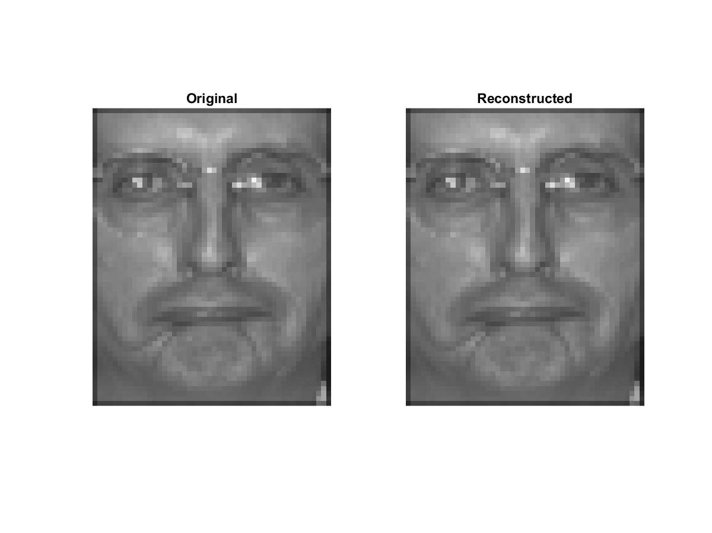

Figure 1: Original input image and reconstructed image from eigenfaces

## Experimental Results for High Resolution Imagery

In the first experiment, we are asked to use fa_H (frontal image, high resolution) for training and fb_H (alternate frontal image, high resolution) for testing. The results shown in this section will be discussed in more detail in Section 4.

### Training a.I: High resolution

We run the experiments a.I through a.IV with varying information content. With the training data, we compute the average face and then the eigenfaces of the 1204 images (with 867 subjects). We then display the average face along with the eigenfaces corresponding to the top ten largest eigenvalues.

The average face is shown in Figure 2.

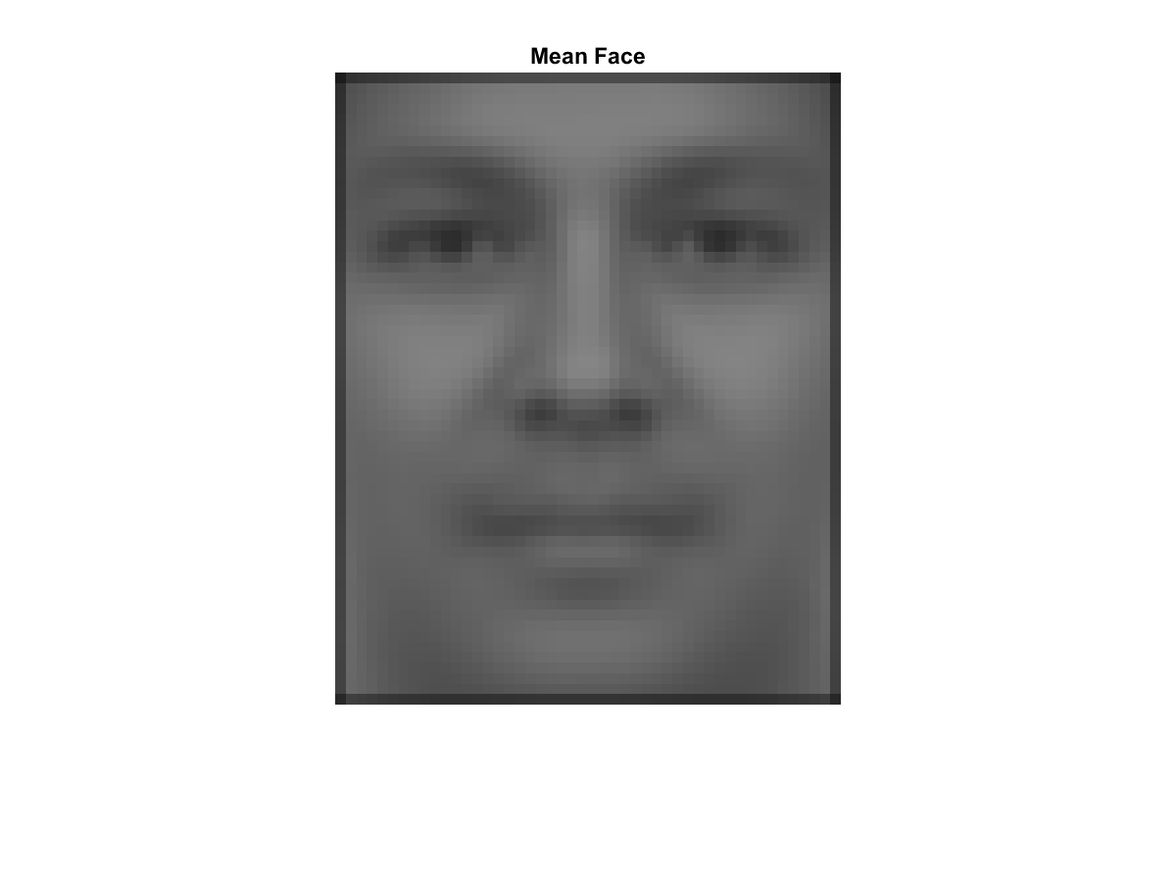

Figure 2: Average face, high resolution

The ten eigenfaces corresponding to the ten largest eigenvalues are shown in Figure 3.

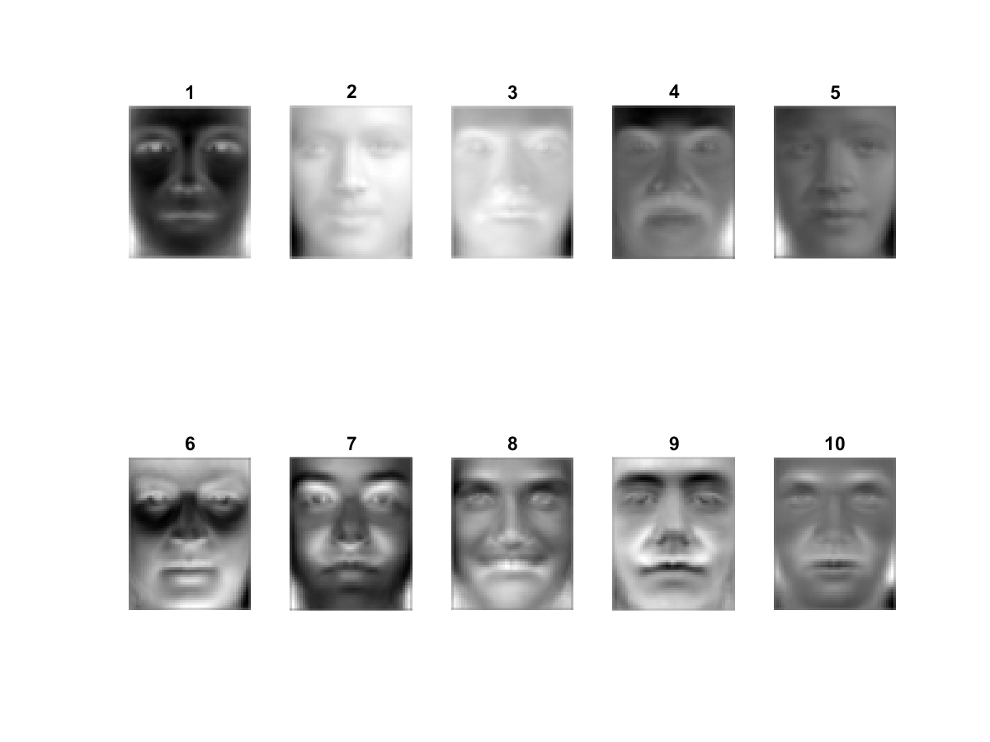

Figure 3: High resolution eigenfaces for the ten largest eigenvalues (in decreasing order)

The ten eigenfaces bases corresponding to the ten smallest eigenvalues are shown in Figure 4. Clearly, the noise spans the space but the face information does not.

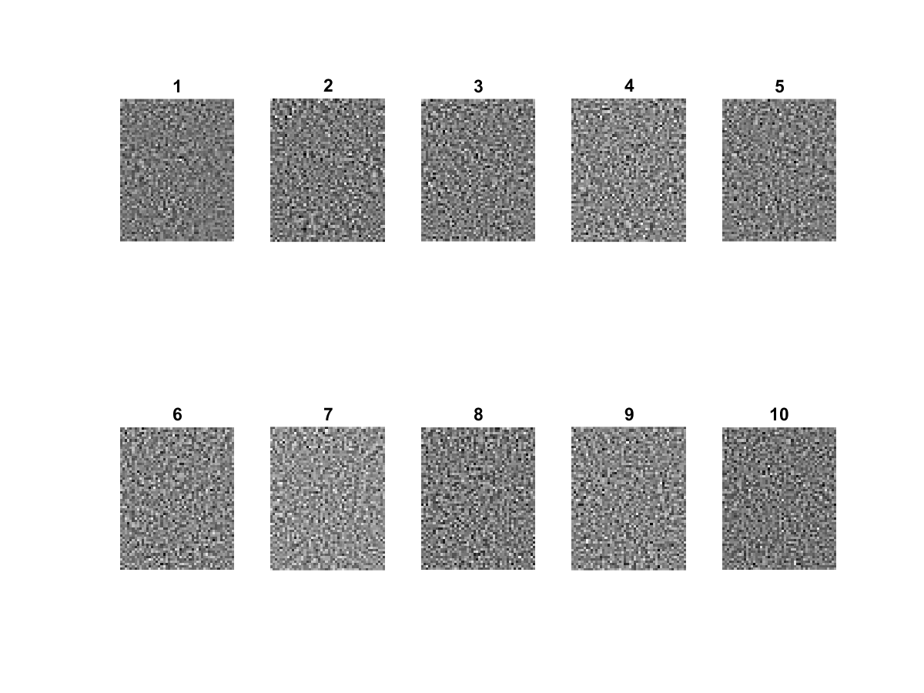

Figure 4: Eigenfaces (noise) for the ten smallest eigenvalues (in decreasing order)

### Testing a.II to a.IV: High resolution with 80% information

In this experiment, we chose the top eigenvectors (eigenfaces) that will preserve 80% of the information in the imagery based on the basis sets, and we project the training images onto the 80% basis set. We then compute the Mahalanobis distance between the eigencoefficient vectors for each pair of training and query images to determine the match distance. We then chose the top N images having the highest similarity score with the query image and if a matching image is among the N most familiar faces retrieved then it is a true positive or a match. We plot the Cumulative Match Characteristic Curve in Figure 5, the correctly matched images in Figure 6 along with training, and the incorrectly matched images in Figure 7 along with the training.



Figure 5: High resolution and CMC given 80% information

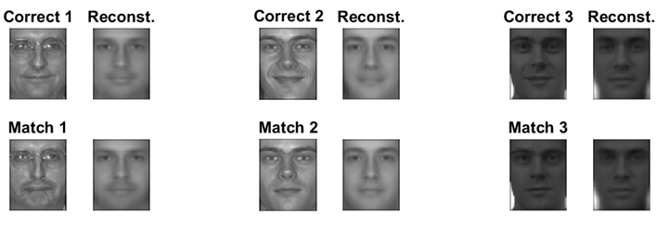

Figure 6: Correct detections, high resolution, and 80% information

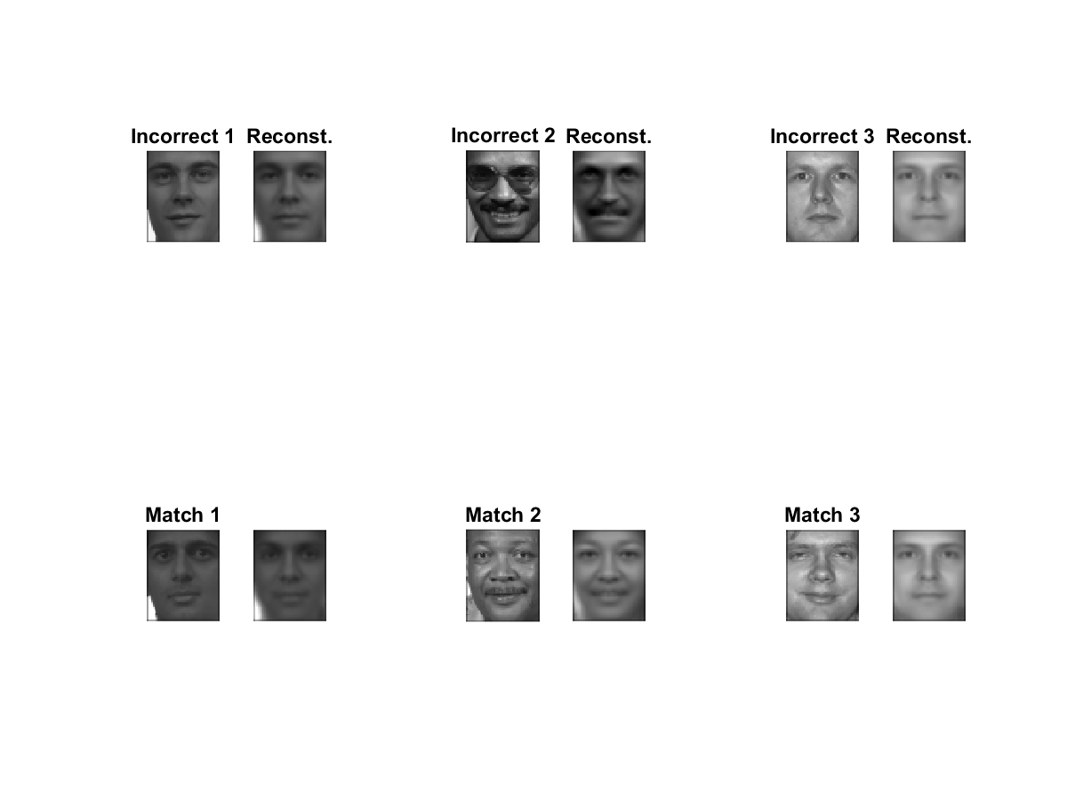

Figure 7: Incorrect detections, high resolution, and 80% information

### Testing a.II to a.IV: High resolution with 90 % information

In this experiment, we chose the top eigenvectors (eigenfaces) that will preserve 90% of the information in the imagery based on the basis sets, and we project the training images onto the 90% information basis set. We then compute the Mahalanobis distance between the eigencoefficient vectors for each pair of training and query images to determine the match distance. We then chose the top N images having the highest similarity score with the query image and if a matching image is among the N most familiar faces retrieved then it is a true positive or a match. We plot the Cumulative Match Characteristic Curve in Figure 8, the correctly matched images in Figure 9 along with training, and the incorrectly matched images in Figure 10 along with the training.



Figure 8: High resolution and CMC given 90% information

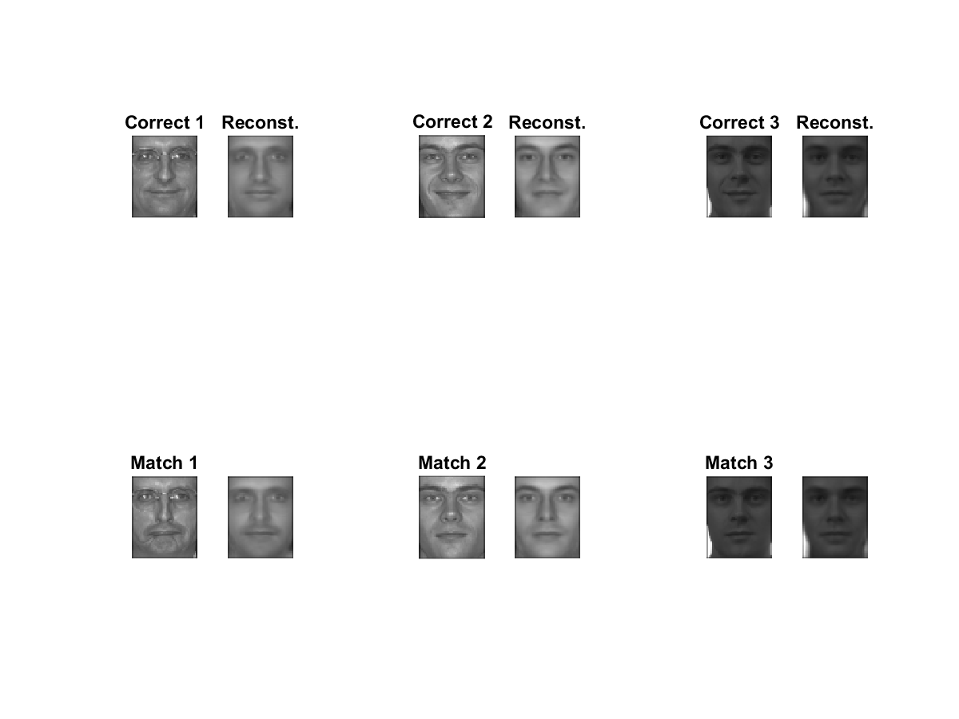



Figure 9: Correct detections, high resolution, and 90% information

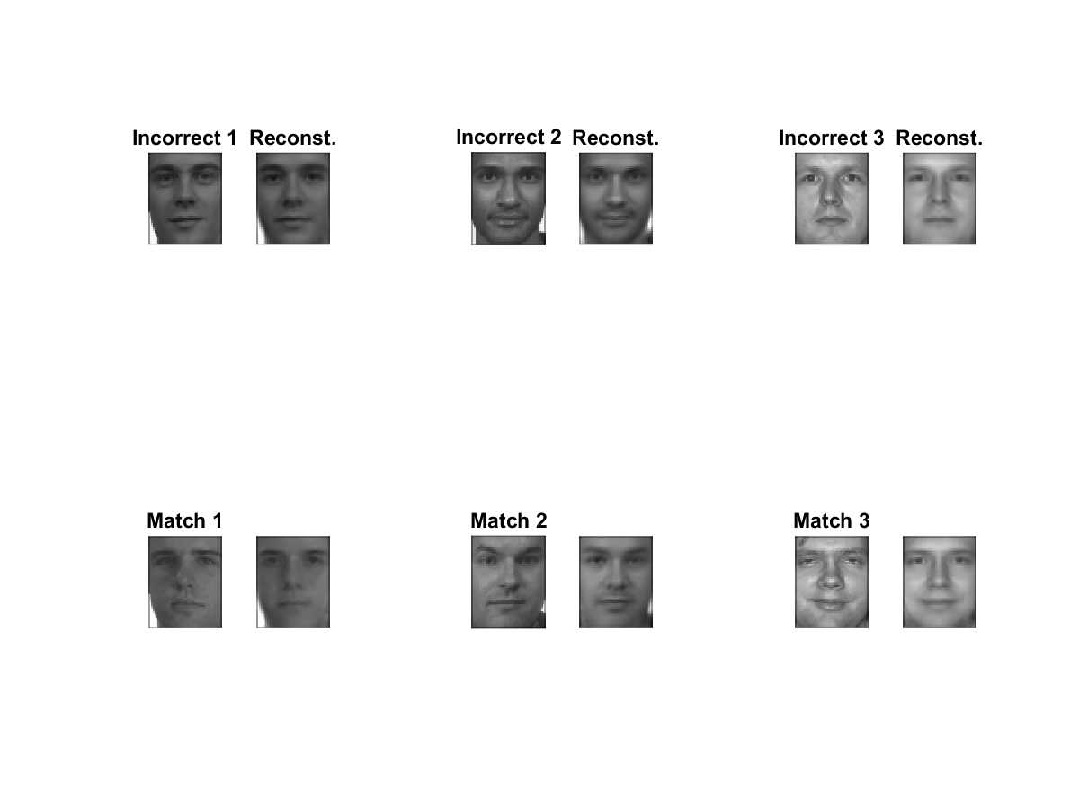

Figure 10: Incorrect detections and high resolution and 90% information

### Testing a.II to a.IV: High resolution with 95 % information

In this experiment, we chose the top eigenvectors (eigenfaces) that will preserve 95% of the information in the imagery based on the basis sets, and we project the training images onto the 95% basis set. We then compute the Mahalanobis distance between the eigencoefficient vectors for each pair of training and query images to determine the match distance. We then chose the top N images having the highest similarity score with the query image and if a matching image is among the N most familiar faces retrieved then it is a true positive or a match. We plot the Cumulative Match Characteristic Curve in Figure 11, the correctly matched images in Figure 12 along with training, and the incorrectly matched images in Figure 13 along with training.



Figure 11: High resolution and CMC for 95% information

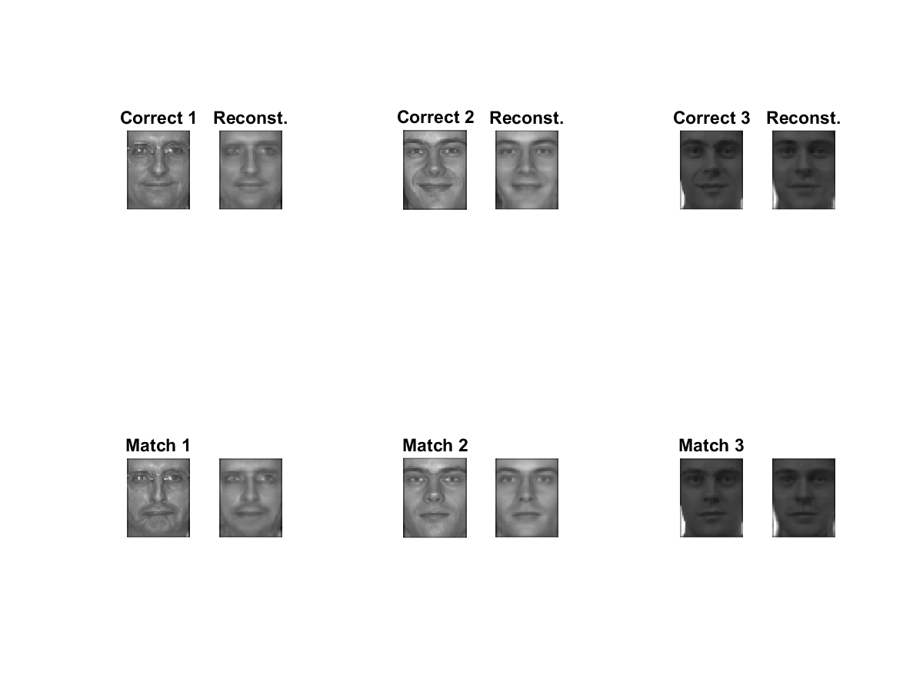



Figure 12: Correct detections, high resolution, and 95% information

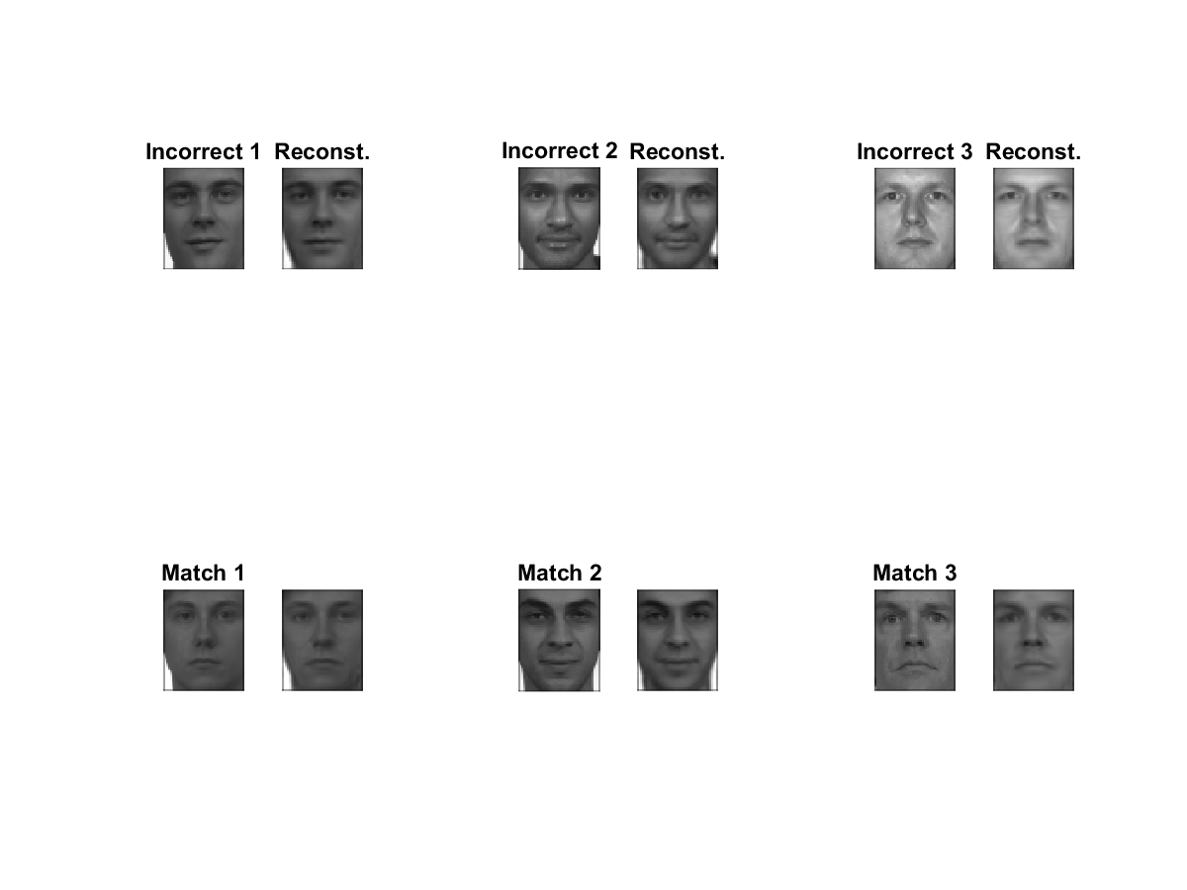



Figure 13: Incorrect detections, high resolution, and 95% information

### Part b: Feature and ROC performance charts

In the section we plot both the feature density and cumulative distributions, Figure 14 and Figure 15, and the receiver operator characteristic (ROC) plot, Figure 16, for the eigenface based detector in the high resolution studies.

|  |  |
| --- | --- |
| Figure 14: High resolution image feature density functions | Figure 15: High resolution feature cumulative distribution functions |
| Figure 16: High resolution image ROC for Intruder Detection | |

## Experimental Results for Low Resolution Imagery

In the second experiment, we are asked to use fa_L (frontal image, low resolution) for training and fb_L (alternate frontal image, low resolution) for testing. The results shown in this section will be discussed in more detail in Section 4.

### Training a.I: Low resolution

We run the experiments a.I through a.IV with varying information content. With the training data, we compute the average face and then the eigenfaces of the 1204 images (with 867 subjects). We then display the average face along with the eigenfaces corresponding to the top ten largest eigenvalues.

The average face is shown in Figure 17.

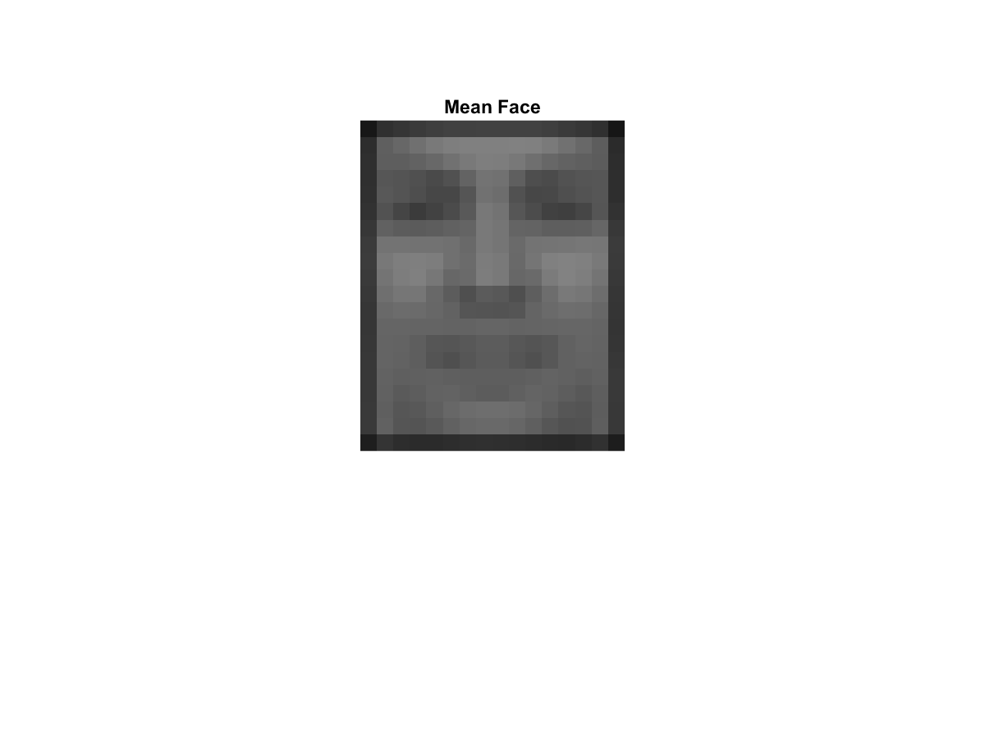

Figure 17: Mean face, low resolution

The ten eigenfaces corresponding to the ten largest eigenvalues are shown in Figure 18



Figure 18: Low resolution eigenfaces for the ten largest eigenvalues (decreasing order)

The ten eigenfaces bases corresponding to the ten smallest eigenvalues are shown in Figure 19. Clearly, the noise spans the space but the face information does not.



Figure 19: Low resolution eigenfaces for the ten smallest eigenvalues (decreasing order)

### Testing a.II to a.IV: Low resolution with 80% information

In this experiment, we chose the top eigenvectors (eigenfaces) that will preserve 80% of the information in the imagery based on the basis sets, and we project the training images onto the 80% basis set. We then compute the Mahalanobis distance between the eigencoefficient vectors for each pair of training and query images to determine the match distance. We then chose the top N images having the highest similarity score with the query image and if a matching image is among the N most familiar faces retrieved then it is a true positive or a match. We plot the Cumulative Match Characteristic Curve in Figure 20, the correctly matched images in Figure 21 along with training, and the incorrectly matched images in Figure 22 along with the training.



Figure 20: Low resolution and CMC for 80% Information

|  |
| --- |
| Figure 21: Correct detections, low resolution, and 85% information |
| Figure 22: Incorrect detections, low resolution, and 85% information |

### Testing a.II to a.IV: Low resolution with 90% information

In this experiment, we chose the top eigenvectors (eigenfaces) that will preserve 90% of the information in the imagery based on the basis sets, and we project the training images onto the 90% information basis set. We then compute the Mahalanobis distance between the eigencoefficient vectors for each pair of training and query images to determine the match distance. We then chose the top N images having the highest similarity score with the query image and if a matching image is among the N most familiar faces retrieved then it is a true positive or a match. We plot the Cumulative Match Characteristic Curve in Figure 23, the correctly matched images in Figure 24 along with training, and the incorrectly matched images in Figure 25 along with the training.



Figure 23: Low resolution and CMC for 90% Information

|  |
| --- |
| Figure 24: Correct detections, low resolution, and 90% information |
| Figure 25: Incorrect detections and low resolution and 90% information |

### Testing a.II to a.IV: Low resolution with 95% information

In this experiment, we chose the top eigenvectors (eigenfaces) that will preserve 95% of the information in the imagery based on the basis sets, and we project the training images onto the 95% basis set. We then compute the Mahalanobis distance between the eigencoefficient vectors for each pair of training and query images to determine the match distance. We then chose the top N images having the highest similarity score with the query image and if a matching image is among the N most familiar faces retrieved then it is a true positive or a match. We plot the Cumulative Match Characteristic Curve in Figure 26, the correctly matched images in Figure 27 along with training, and the incorrectly matched images in Figure 28 along with training.



Figure 26: Low resolution and CMC for 95% Information

|  |
| --- |
| Figure 27: Correct detections and low resolution and 95% information |
| Figure 28: Incorrect detections and low resolution and 95% information |

### Part b: Feature and ROC performance charts

In the section we plot both the feature density and cumulative distributions, Figure 29 and Figure 30, and the receiver operator characteristic (ROC) plot, Figure 31, for the eigenface based detector in the high resolution studies.

|  |  |
| --- | --- |
| Figure 29: Low resolution image feature density functions | Figure 30:Low resolution image feature cumulative density functions |
| Figure 31: Low resolution image ROC for Intruder Detection | |

# Conclusion

In this project we performed two different experiments, face recognition, and intruder detection. The face recognition experiments apply the theory of principal component analysis via the eigenface algorithm for face recognition with varying amounts of information and resolution. The second experiment performed intruder detection by comparing both intruders and non-intruders to non-intruders in the test data. A distance threshold was then used to generate a Receiver Operator Characteristic (ROC) curve.

## Part A: Face recognition

In the face recognition experiments we found interesting results which challenge our intuition about information content. We were surprised to find that the best results were obtained from low resolution data which contains much less information than the higher resolution images as seen in Figure 32. This result really demonstrates how retaining information not important for recognition can actually diminish a classifiers performance.

Throughout the duration of the course, we have mentioned “the curse of dimensionality” on more than one occasion. In fact, the whole purpose of dimensionality reduction is to avoid this phenomenon. While the primary method of dimensionality reduction discussed in this experiment is the eigenface approach, it is also true that reducing the resolution of an image is also a form of dimensionality reduction, and in this research, the spectral resolution reduction removes high frequency components in the image. Combining these observations with the results of our experiments, it is this author’s opinion that the high frequency components on a face are less important for recognition than our intuition may lead us to believe. The other insight gained from the reduced resolution experiments is that, while the eigenface chooses the dimensions with the highest information content, it doesn’t necessarily choose the optimal dimensions for recognition purposes. If it had, then reducing the resolution should never have been able to out-perform the high resolution dataset.

The result in Figure 32 also directly demonstrates the curse of dimensionality in that the high resolution 90% information retention experiment outperforms the 95% information experiment. The 95% information experiment contains all of the coefficients that the 90% one does, as well as a few more, yet the 90% information experiment outperforms the 95% information experiment.

Another observation from the experiment is that the reconstructed faces from Figure 6 and Figure 7 which use only 80% of the information completely removes facial expressions which seem like an ideal quality of facial recognition. This yields another possible justification for why lower information may perform better for facial recognition. Also, in Figure 7 the incorrect match pairs are very similar. Perhaps so similar that even a human would likely mistake these faces as matches.



Figure 32: CMC curve for all experiments

## Part B: Intruder detection

In the second experiment we tested how well an intruder detection system could perform using the eigenface approach. For this experiment we compared each sample in a list of training data to each of the training samples using the Mahalanobis distance. If the two samples were below some distance then the test sample would be accepted and if not then the test sample would be classified as an intruder. The threshold was varied in order to generate a ROC curve.

The combined results of the experiment are shown in Figure 33. From the ROC curve we see that both the high and low resolution experiments are able to detect intruders fairly accurately, however the difference between the high and low resolution experiments is marginal. Based on some intuition from part A we decided to test the intruder detection with more information retention in the low resolution dataset. We found that by increase the information retention to 90% for the low resolution data the performance matches the 80% retention high resolution experiment. We also tested multiple other information retention amounts and found the best results at 80% for high resolution and 90% for low resolution. This indicates that, just like in Part A, the high resolution data does not add to the classifiers ability to detect intruders.



Figure 33: ROC Curves for high and low resolution intruder detection experiment.

# Contributors

Josh Gleason wrote the code for training and Part A, and Rod Pickens wrote the code for Part B. Josh and Rod both discussed the outcome of the experiments and formulated the story to tell in the conclusion. Rod wrote the theory and the results section while Josh wrote the conclusion, gave the final review, and corrected the paper.

In all, both authors felt that this project was challenging and very educational.

1. M. Turk and A. Pentland, “Eigenfaces for Recognition,” Journal of Cognitive Neuroscience, vol. 3, no. 1 pp. 71-86, 1991.
2. L Sirovich and M Kirby, “Low-dimensional procedure for the characterization of human faces,” Journal of the Optical Society of America A, 4(3), 519-524.