Joshua Gleason

Lab 2
Diode Characteristics and Rectifier Circuits

Rectifiers are very important type electrical circuit. They are used in the process of converting AC to DC, without which many of the electronic devices used would simply not exist. Nearly every household electronic device runs at on DC, even though the power is delivered as AC. For the first part of this lab two different diodes are examine and tested to ensure they match the correct characteristics. Once this is complete a peak and half-wave rectifier are constructed, afterwards a capacitor is added to the high-wave rectifier to help maintain the voltage. Next a full-wave bridge rectifier is constructed which uses four diodes, again an RC filter is added to observe its effects. For the final section of the lab, a transformer is used to step down an input signal, which is then run through a half-wave rectifier. Overall the experiments were a success, as each one yielded results similar to what was expected.

Diode Characteristics

The 1N914 and 1N4002 diodes were analyzed using ELVIS to measure the forward bias curve for both. The circuits used are shown in Figures 1 and 6. The forward bias curve for the 1N914 seems to fall within the three different 1N914 diode graphs, but not to one in particular. Although the diode that was used was simply a 1N914, this would be a difficult conclusion to draw based on the ELVIS analysis.
The 1N4002 diode forward bias analysis doesn't seem to resemble the forward bias curve from the data sheet much at all. Looking at the values around 0.7V in the analysis the output is approximately 10.0mA, while in the data sheet at 0.7V the output current should be less than 0.1mA. It is also important to note that the graph for the data sheet is the typical forward bias for diods 1N4001 through 1N4007, so the exact values aren't shown here.
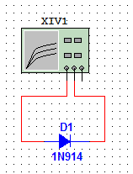Figure 1: 1N914
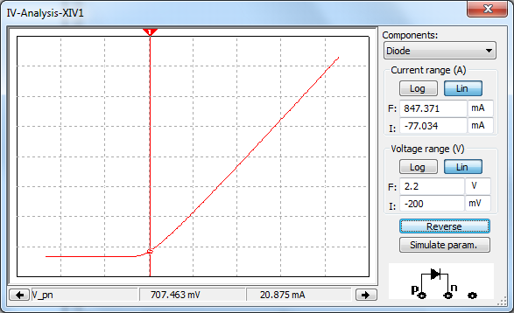Figure 2: Multisim 1N914 Diode Simulation
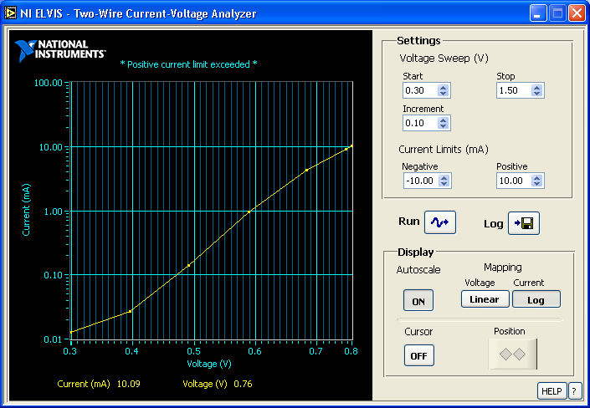Figure 3: ELVIS IV-Analysis for a 1N914 Diode

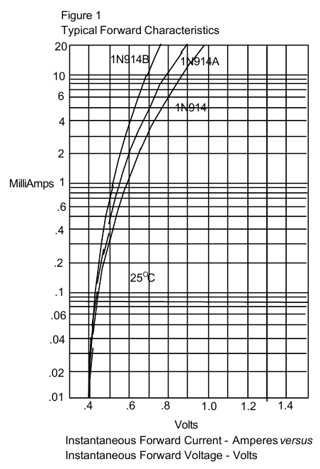Figure 4: 1N914 Datasheet Graph

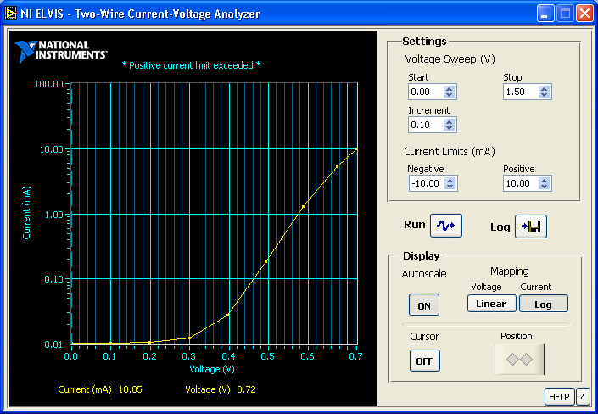Figure 5: ELVIS-IV Analysis 1N4003 Diode

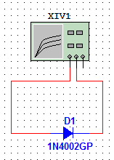Figure 6: 1N4002
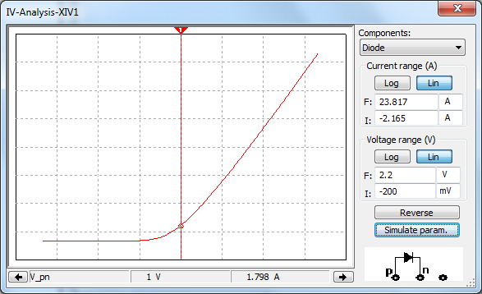Figure 7: Multisim 1N4002 Diode Simulation`
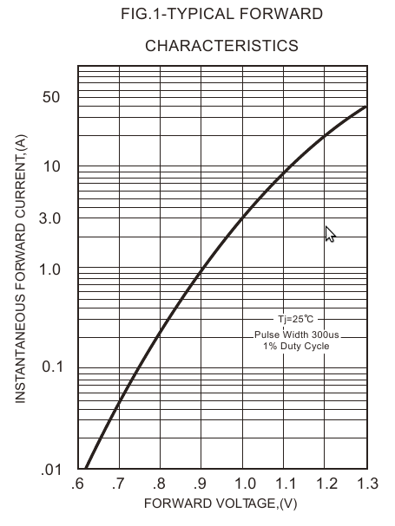Figure 8: 1N4001-1N4007 Datasheet
Rectifier Circuits

Peak Rectifier

The peak rectifier circuit charges the capacitor initially and then continues to charge it. This happens because a negative potential is never applied across the capacitor so it never discharges. When the 0.47uF capacitor is replace with a 1pF one, the resistance in the wires is enough of a load to cause the tiny capacitor to discharge however. This is expected because when dealing with a capacitor of this size the resistance in a wire is no longer negligible.

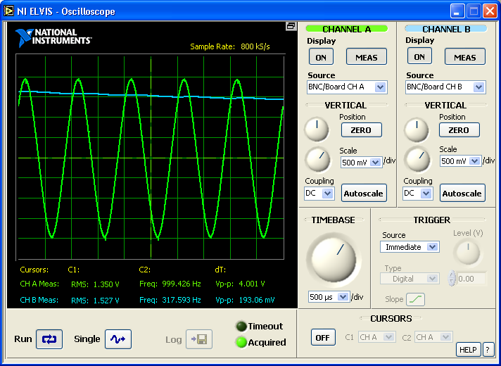Figure 9: ELVIS-IV Peak Rectifier
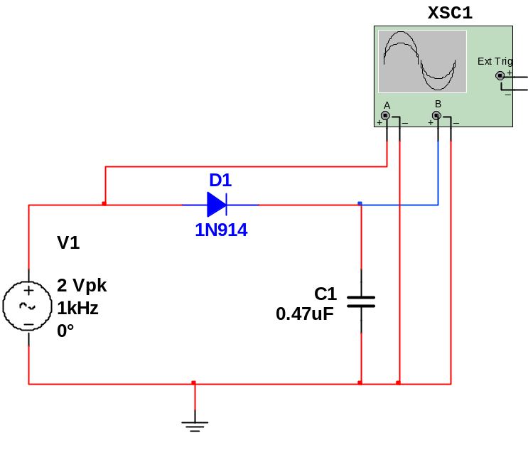Figure 10: Peak Recitfier Circuit
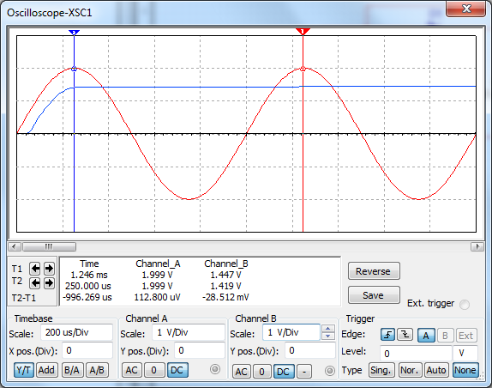Figure 11: Peak Rectifier Simulation
Half-Wave Rectifier

The half wave rectifier circuit uses the property of a diode to only allow only high voltage to pass through. If the diode is reversed in this circuit, rather than allowing only positive potentials to exist in across the diode, only negative potentials will be kept. See Figure 13.

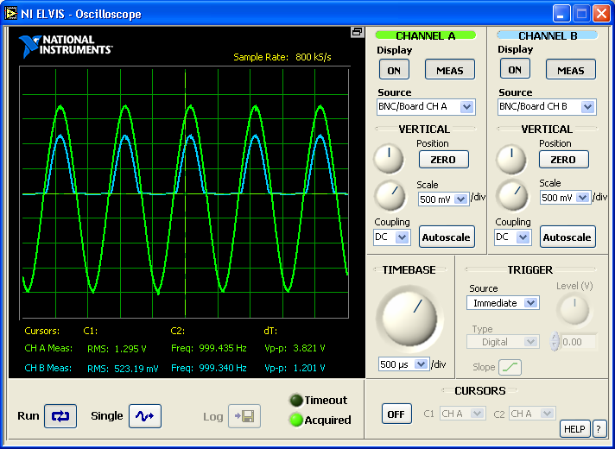Figure 12: ELVIS-IV Half-Wave Rectifier

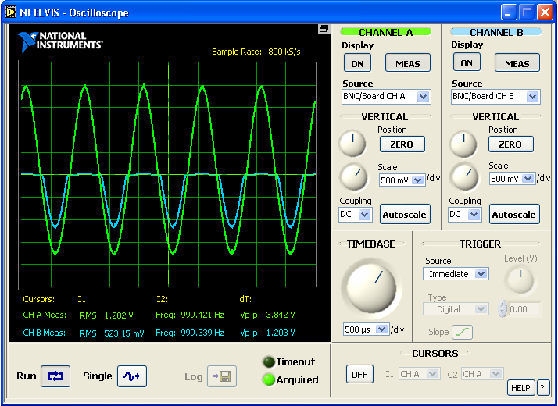Figure 13: ELVIS-IV Half-Wave Rectifier (Diode reversed)

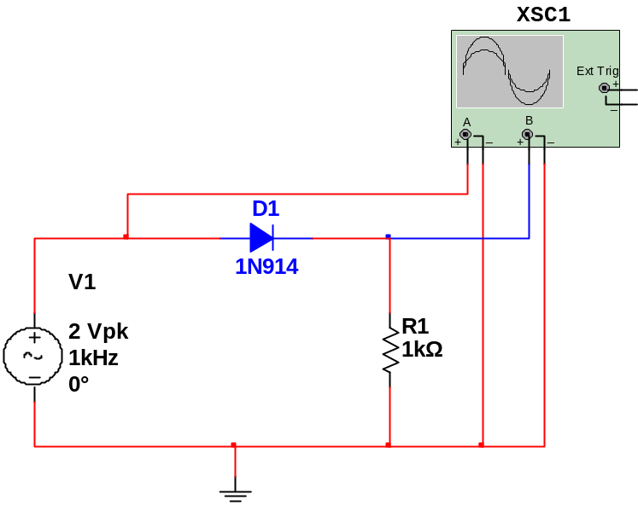Figure 14: Half-Wave Rectifier Circuit

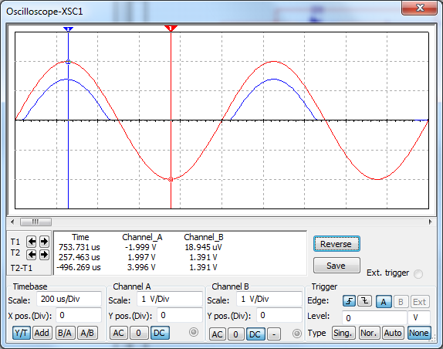Figure 15: Half-Wave Rectifier Simulation
Half-Wave Rectifier with RC Filter

The RC filter addition to the Half-Wave rectifier allows it to maintain a voltage that is near DC, even with a load on the system. The load does however cause a ripple to occur, as the capacitor discharges over the wire between the peaks of the input voltage.

The ripple voltage can be calculated as 333mV, however the actual ripple as observed in Figure 18 is 250mV. This is a difference of 83mV from the expected, however the wave is actually smaller than calculated, which is interesting. One would think that if anything the actual value would be higher due to the higher resistance in the wires.

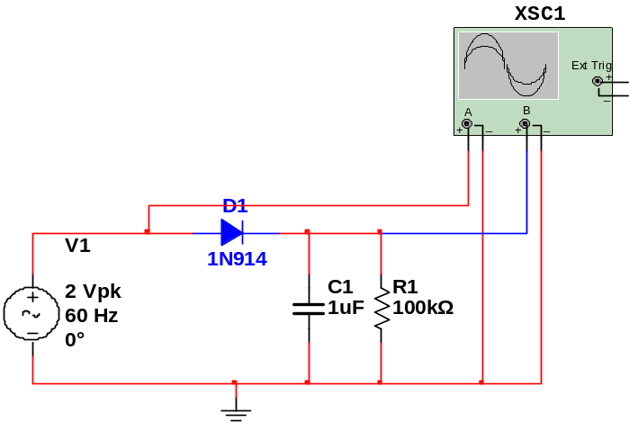Figure 16: Half-Wave Rectifier with RC Filter Circuit
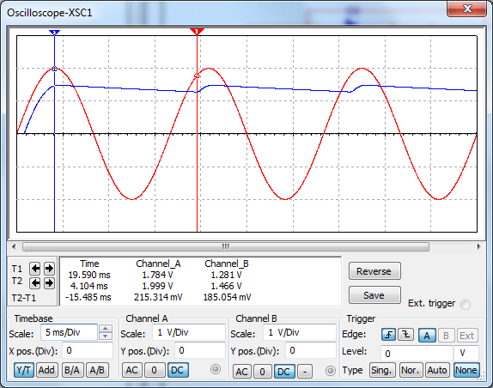Figure 17: Half-Wave Rectifier with RC Filter Simulation

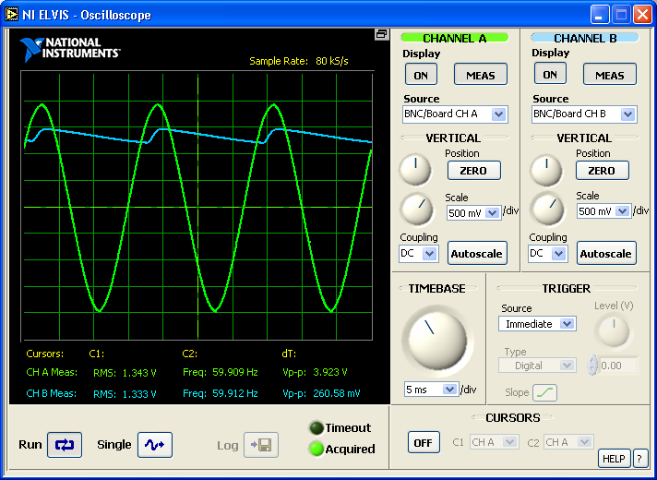Figure 18: ELVIS-IV Half-Wave Rectifier with RC Filter

Full-Wave Bridge Rectifier

The Full-Wave Bridge Rectifier allows the positive sections of the period to pass and also inverts the negative parts of the wave to make them positive. This allows the rectifier to make use of more of the voltage overall. This does come at a price however, because the current needs to cross two diodes, twice as much voltage is lost in this process. This is why when calculating the output voltage a factor of 2*V is subtracted from the input voltage, rather than simply V. In this case V for the 1N914 diode is 0.7, which means the output voltage should be 2 - 1.4 = 600mV Pk. The actual value is 743mV, which is in the vicinity of the expected value.

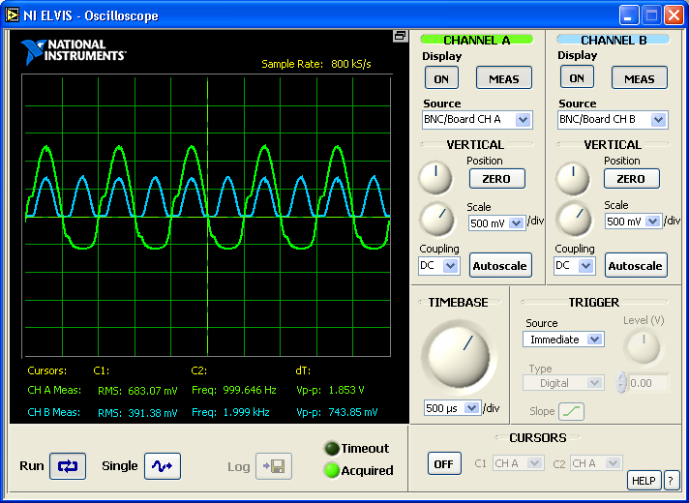Figure 19: ELVIS-IV Full-Wave Bridge Rectifier Analysis
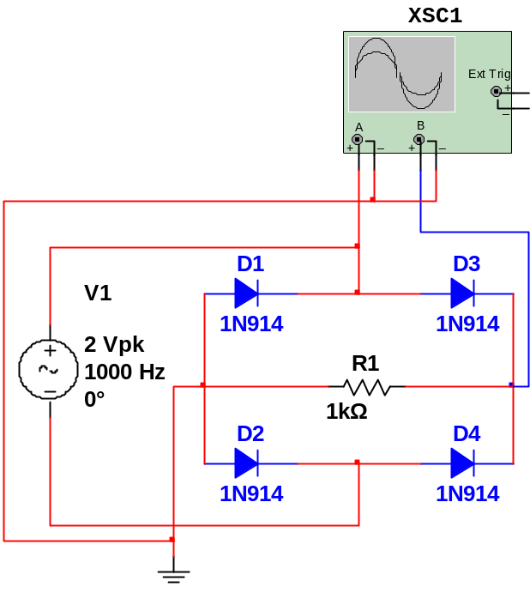Figure 20: Full-Wave Bridge Rectifier Circuit
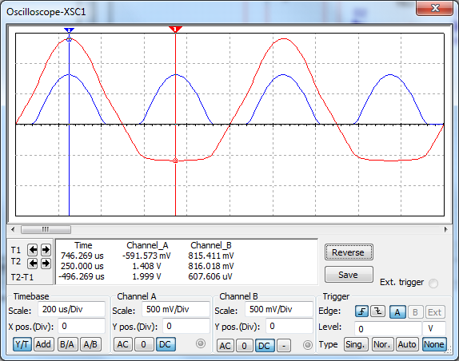Figure 21: Full-Wave Bridge Rectifier Simulation
Full-Wave Bridge Rectifier with RC Filter

The Full-Wave Bridge Rectifier has the advantage of reducing the ripple size by half. This is because rather than recharging the capacitor every period of the input, it is charged twice per period. The ripple voltage is calculated to be 0.4/(2*60*0.1)=33mV, while the actual voltage is about 80mV. The 80mV is actually expected because the peak voltage of the output is approximately 1.0V not 1.3V. Calculating the ripple using 1.0V, it comes out to be 83mV, which is much closer than before. The reason the value is so much smaller is because for one, the capacitor is recharged twice as often, giving it less time to discharge, and also the peak voltage of the output is lower, making the ripple voltage become lower because the ripple voltage is directly proportional to the output voltage peak.

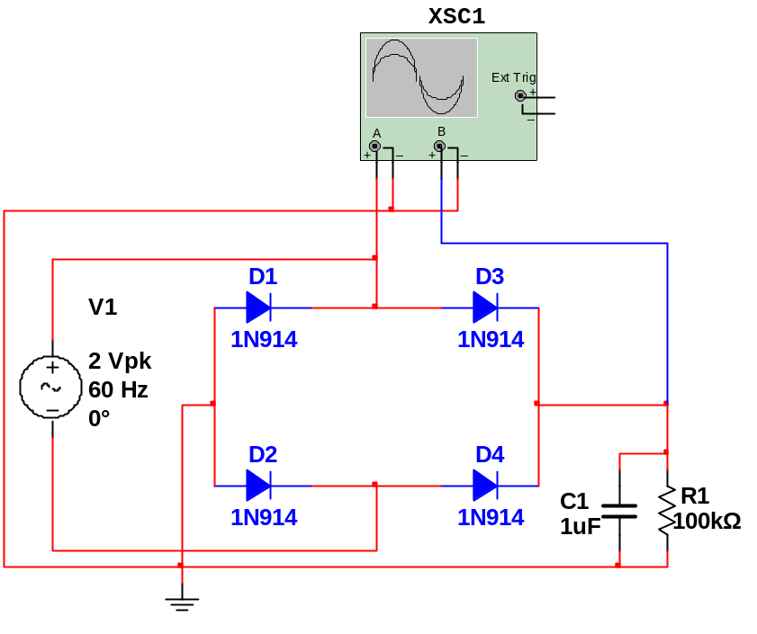Figure 22: Full-Wave Bridge Rectifier with RC Filter Circuit
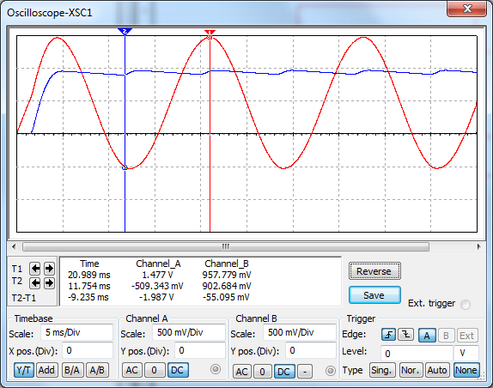Figure 23: Full-Wave Rectifier Simulation
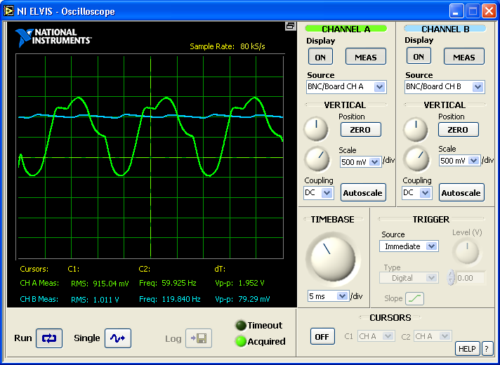Figure 24: Full-Wave Rectifier with RC bridge Analysis
Power Supply Circuit with Transformer

A transformer was used in this test to step down a voltage to 2V. The turns ratio of this transformer based on the results of Figure 25 is 8.3/1.22 = 6.8. This means that a voltage of 13.6V pk-pk is required to get the desired 2V pk-pk output. The output is what is expected based on the previous half-wave rectifier results, adding the capacitor smooths out the signal because the capacitor discharges slower than the voltage drops and then recharges before it ever finished discharging. This allows the voltage to always stay positive, and also stay much smoother.

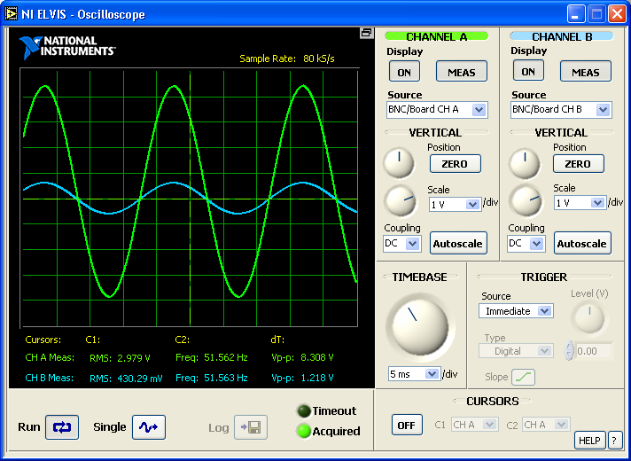Figure 25: Transformer Test for turn ratio

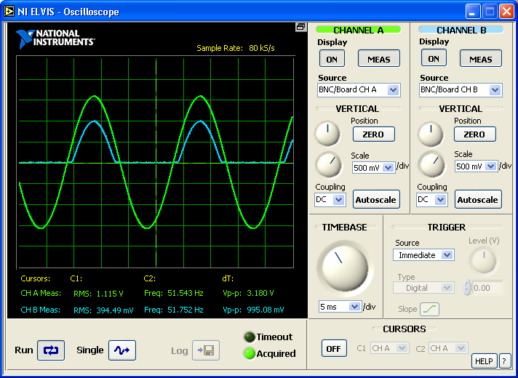Figure 26: Half-Wave Rectifier with transformer
Discussion

This lab explored in some detail the difference between rectifiers. By examining different rectifier circuits the different strengths and weaknesses of them can be seen. The half-wave rectifier for example was able to achieve a higher peak voltage, but suffered when it came to applying an RC filter, as the ripple was always quite large. On the other hand, the Full-Wave rectifier was able to maintain a moderately low ripple while having a lower peak voltage.
By running these experiments the idea that different tools are better for different jobs is reinforced. Many times when people begin getting used to doing something a particular way, they forget to look to other, possibly better methods. As an electrical engineer it is important to remember all the tools that are available in order to develop the most efficient and cost effective products.

