INFO-I 360 | Usability Report

Parrot Key Caribbean Grill

Introduction & Overview

Within this usability report, I focus on exploring in-depth website usability for various restaurants located in Sanibel Island / Fort Myers Beach, Florida; having visited these locations on multiple occasions and experienced many of the vast cuisine options that differentiate within this locality, I wanted to better elucidate a different medium of interaction and customer experience based on several factors I had already generally known about them, such as its primary target demographics, restaurants’ size and resources, and various business ventures for helping facilitate the overarching experiences at these restaurants beyond just the cuisine. Ultimately, I decided to examine six different sites before deciding upon **Parrot Key Caribbean Grill**, which is visually appealing to me yet somewhat lacks the comprehensive user experience that many of the other five restaurant sites employ based on the aforementioned factors.

Within the subsequent sections, I will attempt to categorize certain issues or areas of improvement regarding the Parrot Key Caribbean Grill site, conduct a series of observations as well as take notes ­­while individuals complete a set of specific tasks on the website, and coalesce any insights to be able to provide recommendations for usability improvements in terms of the overall user experience for the website.

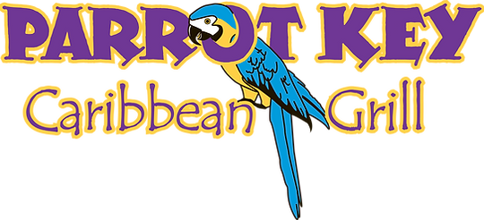

Research

General Research

Having analyzed the six websites collectively in terms of their purpose and functionalities, they tend to emanate the idea of a “complete experience” in terms of the supplementary aspects that the restaurants seek to provide for their customers like music or events, emphasis on the location itself, and more social media presence. Moreover, while most of the websites appear professional in appearance, they visually tend to want to create uniqueness within their own brand and emphasize elements like design, color, and website navigation to accentuate their own brand more (which perhaps is pervasive within the restaurant industry regarding website usability choices). Some websites like Doc Ford’s Rum Bar and Grille and Cielo also take into consideration the intuitiveness of their sites and will, for instance, provide multiple options to view different menus based on their categories, while other websites like The Sanibel Grill and The Mucky Duck seek to focus on offering other enjoyable features on their websites beyond the reservation and menu functionalities; regardless, this concept of brand uniqueness is ubiquitous across all the websites I retrospectively analyzed when considering usability. None of the websites’ designs felt too elaborate yet did not impose poor uses of colors, typographies, and images.

As for the general visual elements within each website, it is apparent that the restaurants want to further exacerbate brand uniqueness in this capacity since they tend to offer similar functionalities like menu selections, “About Us” pages, galleries, and event planners. Therefore, their visual representations generate varying design themes that help viewers to conceptualize what they believe the complete experience encapsulates without necessarily needing to resonate only with the menu options. This is most apparent on these websites’ home pages since they utilize the predisposition of unfamiliarity to help incentivize curiosity and excitement about what these restaurants can offer for potential tourists and other users in general, who obviously want to prioritize the best possible dining experiences as possible while staying on the island. As a result, the websites appear sophisticated and thoughtful with this consideration in mind yet try not overburden its viewers with too much information, whether consciously or subconsciously, so that unfamiliarity is addressed with the intention to bolster this curiosity. Lastly, each website, even with their variability in functionalities, still consider calls to action in a similar manner and may include a visual hierarchy on the home pages yet ensure that calls to action are consistent. This helps users understand that the flow from a page to another page fulfilling the call to action is contingent on their understanding of what they can accomplish on each website.

Based on the research observations made above, I would conclusively rank the six websites as such, where the top-to-bottom order indicates what I felt were the strongest to weakest websites based on these usability considerations:

1. Doc Ford’s Rum Bar and Grille - <https://www.docfords.com/sanibel-island/>
2. The Mucky Duck - <https://www.muckyduck.com/>
3. Parrot Key Caribbean Grill - <https://www.myparrotkey.com/>
4. Cielo - <https://cielo-sanibel.com/>
5. Cip’s Place Island Restaurant - <https://cipsplace.com/>
6. The Sanibel Grill - <https://thesanibelgrill.com/review-us/>

Website Choice Rationale

I chose Parrot Key Caribbean Grill’s restaurant since there were a few confusing visual elements that slightly dropped its user experience compared to the first two websites listed and additionally still employed some outdated/weaker user functionalities I felt could be improved upon. Furthermore, Parrot Key Caribbean Grill offered more navigation options in comparison to the other websites I researched, which somewhat affected its rating since more issues could subsidiarily be enumerated on top of the longer workflows for the user tasks I decided upon. Overall, the website is still represented in a professional manner and does better than three of the other restaurant websites researched in relation to its overarching usability issues, yet its issues are glaring and can be analyzed further to generate potential alternatives or recommendations for these issues.

Analysis & Evaluation

While Parrot Key Caribbean Grill’s website encompasses many foundational restaurant components like menus, upcoming events, and ways to contact the restaurant, the website invokes some more critical dialogue toward unrefined aspects that can detract from a user’s experience. For instance, much of the font styling is inconsistent and makes it difficult to distinguish more important pieces of information throughout the website, which is especially prominent on the somewhat inadequate homepage. Likewise, there are too many navigation menu items, which probably could be condensed to sub-navigation items to better encapsulate pages containing less information and falling under more broad categories; having no search function magnifies this issue since I found it quite tedious to parse through several tabs to be able to identify specific information without being about to navigate back to previous pages in an intuitive manner. Most critically, certain pages are more polished than others, which diminishes the continuity of the website and even makes some functionalities feel altogether deprecated, thereby minimizing the user experience for multiple user stories. While these are a few of the myriad of issues that could be highlighted, I decided to condense my user testing to three primary issues delineated below.

Issue 1 – Parsing through Restaurant Menus

Because menus are displayed as images on each sub-navigation link, it is impossible to be able to search for menu items on the page and is not very conducive given the possibility for multiple menus on a single page. Furthermore, menus stack on top of each other in a single column regardless of viewport size, which can make it frustrating when trying to scroll multiple times across the pages to be able to compare menu items. Users also need to renavigate back to the navigation bar to be able to select a different menu, which does not seem efficient for the website’s flow since it is harder to conceptualize a menu tab with the incongruent menu image(s) due to this renavigation task. Finally, after further investigation, some menus exist only after clicking on the menu landing page (Ex. Early Bird Menu) while others only exist on the navigation bar itself.

Issue 2 – Event Calendar Information and Filtering

While the calendar function is beneficial, it can be difficult to find a specific event and adds a lot of additional time for users when trying to manually filter through it. Many useful calendars tend to include a button to open a miniature calendar popup to quickly select dates, which is not present on this website and forces the user to have to navigate across individual months to be able to reach a certain event. Lastly, from a user experience perspective, a selected event does not contain any additional information apart from the time, which therefore populates a large rectangular box on the page even though the lack of information indicates that the size of these popups is too large. Since many of the events are also ambiguous, users cannot predict what an event will comprise of (Ex. Music, performances, etc.), which could affect their enjoyment after booking a reservation since they may want, for example, a quieter event or vice versa.

Issue 3 – Contact Page Usage and Security

On the contact page, the organization is a bit disorganized but more importantly includes two containers asking for the same information on the frontend (the first container also includes a subject text field); I was thoroughly confused if this was a coding mistake in addition to which container to fill out since both are similar regarding their input fields yet are much more different regarding their styling. Also, rather than having labels outside of the input fields, they are annotated in the input fields and disappear whenever a user inputs anything from the keyboard. While this seems helpful for reducing the amount of text space on the screen, I otherwise found it counterintuitive since the page does not contain much information as it exists now and makes it difficult to remember which field is supposed to contain which information after longer periods of time. To conclude, in terms of user experience (and website security), I was able to type various special characters and numbers outside of alphabetic characters for fields such as “First Name,” which is not effective on the frontend since I did not receive any feedback for incorrect inputs as well as the backend since I could either intentionally or unintentionally break this vulnerability using malicious code.

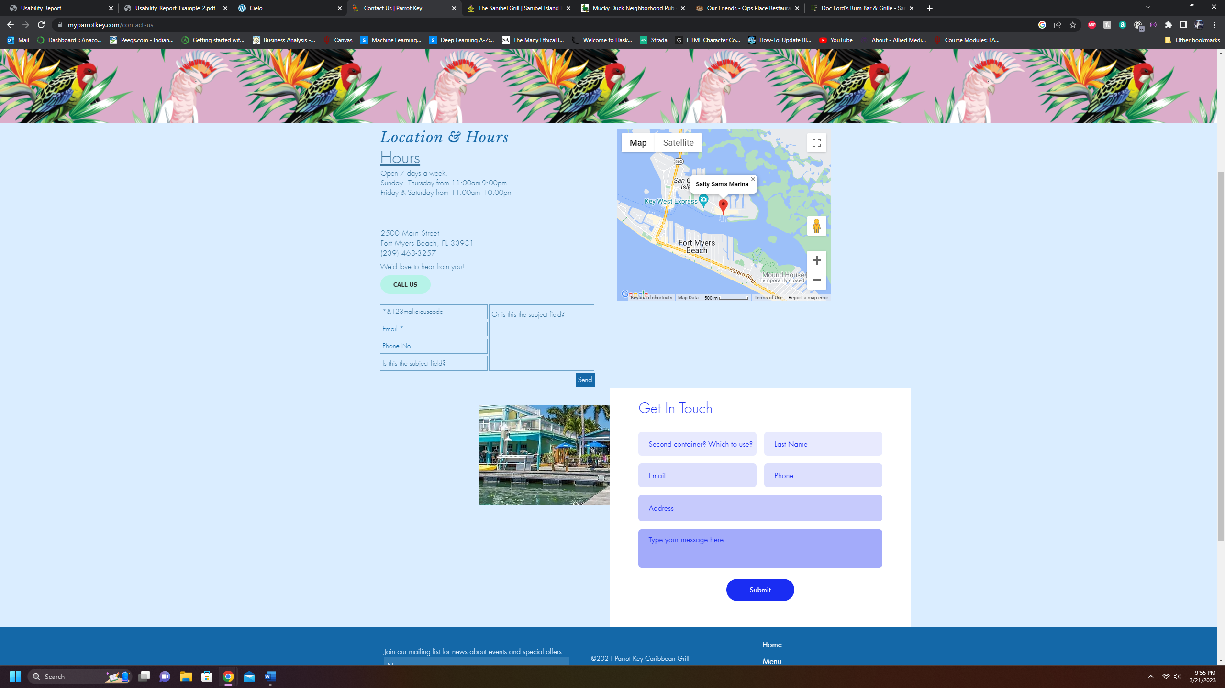

Background on Users

I ran the same usability test with three participants, all of whom are Indiana University-Bloomington senior students. Participants 1 and 2 identify as male while participant 3 identifies as female. Their majors differentiate and include informatics (participant 1), biochemistry (participant 2), and nursing (participant 3). While none of the participants had visited Parrot Key Caribbean Grill’s website previously, all three participants indicated that they are familiar with restaurant websites yet prefer to either use services like DoorDash if available or call in orders directly. However, all the participants felt proficient in website layouts and general navigation, thereby rating themselves between 7-9 on a scale of 1-10 when asked about these skills. Overall, each test took approximately 25-30 minutes.

*Note: Participant 3 has worked in the food industry for over seven years throughout part of high school and all of college thus far. While she has not directly worked on any aspects of the restaurants’ website designs, she has managed many transactions facilitated through the website and online ordering systems.

Findings

Issue 1 Findings – Parsing through Restaurant Menus

For this section, I gave participants the following tasks / scenarios in relation to the website’s menu navigation, where I wanted to see how they were able to interpret and address them given that menus tend to be the main component for restaurant websites. While the tasks / scenarios simply had the participants parsing between the menus to find different menu items, I felt that the subsequent findings exhibited greater usability issues with this functionality.

* *Scenario 1*: You and your group of friends traveling together for spring break have just arrived on the island after a long drive. Thus, you would like to grab a nice early dinner and some drinks so that you all can spend the rest of the evening relaxing or going to the beach. Does the website accommodate these considerations? Also, think of a general meal you’d order and talk about your process for accomplishing this. Was there something missing that you were expecting to see?
* *Scenario 2*: For lunch, you’re craving a hamburger and sweet potato fries since you heard from a friend how delicious they were at Parrot Key Caribbean Grill. However, you forgot to ask him the pricing, and you want to be somewhat frugal for the first few days on vacation. Find the pricing for each and walk through your actions for achieving this. How easy or difficult was it to accomplish this? (Select an option below)
* *Task 1*: Find the Early Bird Menu relating to Scenario 1. Try to describe your process and whether there were any indicators on the website that helped with this.

These findings demonstrate a lot of inconsistency with how the functionality exists as well as inconvenience due to the fact that the menus were included on the website as images that stacked on a single column. In Scenarios 1 and 2, every participant asserted that the tasks were more difficult to accomplish since the menus themselves were blurry, thereby also making the text difficult to read. Participant 1 in Scenario 1 was able to identify an additional cocktail menu for the drinks and became confused as to why the dinner menu had some of the same drinks yet was the only included the prices. Lastly, regarding Scenario 1, I tried to hint that there could be an Early Bird menu, but because some menus only displayed while hovering over the “Menu” tab while others were visible after navigating to the menu landing page (which is not very obvious), none of the participants were able to find this menu until reaching Task 1. In relation to Scenario 2, the two most notable concerns were the tedious scrolling between menus and slight difficulties when trying to find the menu items since many of the menu items had unconventional names. Task 1 illustrated the most challenges across all the participants since Participant 2 understandably could not find this menu while Participants 1 and 3 found the menu after some time even without any indicators on the website.

*Scenarios 1 & 3*

*Scenario 2*

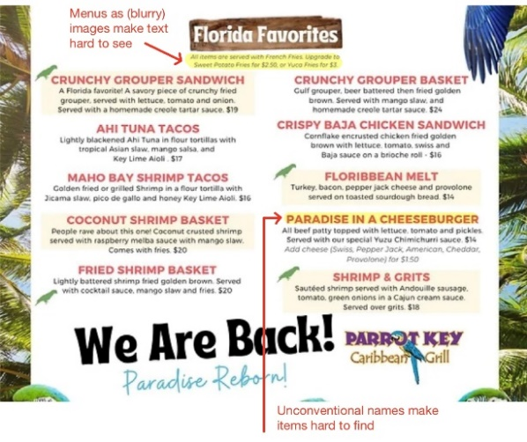

*Scenarios 1, 2, & 3*

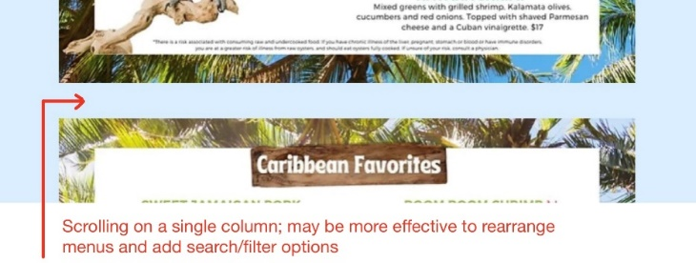

Given the findings, I would first recommend changing the menus to a more readable format on the website since navigating a menu at a restaurant tends to be easier due to recommendations from servers, continuity from page to page, etc.; menus could also have filtering and search functionalities since, as Participant 1 mentioned, these have become almost ubiquitously necessary for websites and could provide a nice alternative to in-person menus since users would then have the agency to narrow down their search more conveniently. Finally, rather than having the menus only as sub-navigation links, I would include links on each separate menu page or even minimize the multiple pages to one menu landing page with tabular views for each menu.

Issue 2 Findings – Event Calendar Information and Filtering

With the event calendar functionality, I gave participants the following scenario and task to try to understand their perspective on the user experience of the calendar as it exists.

* *Scenario 1*: You’ve decided to go to Florida for the holidays during all of December 2022 and was told by a website that this restaurant has some interesting performances/events every week. Find the events during this period and see which days have events. Explain how you reached this step. How easy or difficult was it to accomplish this? (Select an option below)
* *Task 1*: Navigate to the events calendar and select an event to see its information. Is this information helpful? Was there something missing that you were expecting to see?

Although the scenario and task are not as extensive as the ones pertaining to the menu navigation, the findings confirm a few usability issues that I encountered when analyzing the functionality. In Scenario 1, none of the participants found the task particularly difficult, but Participant 1 indicated that the traversal between months could be improved by allowing the calendar to expand to the year and then selecting a specific month more conveniently. Because users may have preconceived notions of certain functionalities due to their experiences in other websites, they can make comparisons across websites, which was observed by Participant 1’s perception on how the actions for the scenario could have been expedited. As for Task 1, all three participants made it evident that the events on the calendar could contain more information since an event itself can be ambiguous and needs more context regarding information like performer backgrounds, reservations, style/music of the event, etc. Beyond this, the foundation of the calendar seemed to work as intended since the three participants correctly assumed that events would exist on the calendar and enumerate which events occur in which days.

*Scenario 1 & Task 1:*

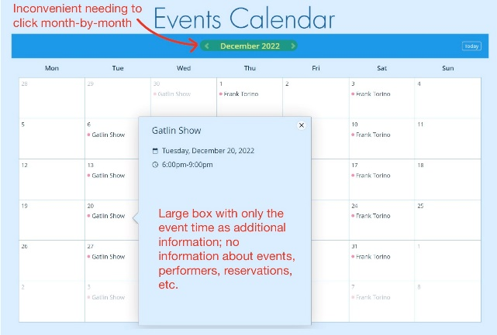

Two of my recommendations for this usability issue address the two criticisms made by the participants. First, the calendar should be able to expand to a yearly calendar view so that users can more plan upcoming days where they may want to attend or avoid a specific event. Second, the event boxes that populate after users select events should contain more information so that they can decide whether they want to eat at the restaurant while an event is occurring and whether, for example, they need to make a reservation. Lastly, while not addressing the criticisms made by the participants, I would consider an event filtering option so that users can narrow upcoming events to specific interests rather than needing to click on individual events to see this information.

Issue 3 Findings – Contact Page Usage and Security

For the contact page, I gave participants the following scenario and task. While I did not predict any difficulties finding the pages to accomplish them, I wanted to gauge their perspectives on some of the potential usability issues with this page.

* *Scenario 1*: For some reason, you have trouble finding where the restaurant is based on your search in Apple Maps. Try to find the address on the website and note your findings.
* *Task 1*: Contact the website directly through the restaurant (but don’t send the message). Describe any difficulties you come across with this task.

Like the second usability issue(s), the scenario and task for the third issue are not as extensive since they are contingent on the depth of the functionalities themselves. However, they expound upon the idea that small errors in user experience can create some needless confusion for relatively simple tasks. In Scenario 1, none of the participants had any difficulties ascertaining that address information could be found on the “Contact Us” page, yet Participant 1 immediately gravitated to the map view on the right and became confused as to why the name on the pinpoint tag was different from the restaurant name. These functionalities are beneficial in practice yet can become usability issues when a target demographic (Ex. Tourists) may not have the same level of information to understand what the information means. In Task 1, the three participants were reasonably confused after seeing the two contact forms on the same page, and they indicated that they would have to assume only using one would work.

*Scenario 1:*

*Task 1:*

Having reviewed these findings, I would first recommend removing one of the contact forms so that users have no more feeling of ambiguity for contacting the restaurant. Next, I would rearrange the contact form to make the functionality more noticeable on the page and potentially help guide the user on what the contact form can be used for (Ex. Change the placeholder on the subject line to a few examples that the users could reference when contacting the restaurant). Ultimately, having some form of guidance can improve the call to action and make users feel less perplexed on whether the contact form applies to them, even if they have an intuition for discerning this.

Conclusion

The purpose of this study was to select a set of real-world websites within the more specific category of restaurants on Sanibel Island / Fort Myers, Florida and identify usability issues that could be iterated upon to make the chosen site more functional or beneficial for users. In this case, I chose to focus on the Parrot Key Caribbean Grill’s restaurant website, which was sufficient with its design philosophy for propagating its brand awareness but could certainly be more intuitive with some of its subtle design choices. As illustrated in the prior section, the site’s menus need to be redesigned with HTML so that users can better parse through some of the more extensive menus using, for example, a search function with other parameters in mind like food/drink categories. In fact, I suggest that this specific design philosophy could be pervasively applied to the website as a whole to eliminate some of the unnecessary navigation elements. Secondly, the calendar function needs additional options like event filtering and information to increase the users’ comprehension as to how it conveys the restaurant’s complete experience as well as simply improving the continuity from the initial website experience to the in-person interaction at the restaurant. Thirdly, pages such as the contact page can be reorganized to maximize their information spacing and better guide users with tasks (Ex. Contact the restaurant by filling out the form) preceding larger calls to action. Overall, after implementing these changes and conducting further user testing, these series of changes could cohere the website based on the user experience it intends to provide and better exhibit the complete experience when eating at Parrot Key Caribbean Grill.

Addendum

Reflection Question

*How successful were you at creating tasks / scenarios for each usability issue? Explain.*

In general, I think that I was successful with creating tasks / scenarios for each usability issue since the participants understood what these tasks / scenarios were asking of in context to what a broad restaurant website would probably provide. With this being said, because I had conducted much more in-depth analysis to see where usability issues may cascade to further usability issues, I needed to ensure that I had generalized every task / scenario so that this report would encapsulate and better highlight a user’s experience having visited the website for the first time, which I think is exemplified well by their responses. For example, with the first usability issue, I subconsciously indicated that an Early Bird menu may exist but did not *explicitly* say so, which is why some participants chose to consider otherwise when navigating through the website. Then, I noted in the subsequent task to find this menu, which I think especially stimulated interesting answers since these tasks worked together to exacerbate this usability issue. Overall, the website in its entirety was not very complex in terms of the content and design, so I do feel that my tasks / scenarios were perhaps more limited than I would have liked but also feel that they were sufficient enough for the scope of this report. If I were to conduct further tests, I believe that think-aloud sessions may benefit so that participants can more freely play around with the website and identify areas where usability issues may cascade based on my own research.

*Did your tasks help to illustrate whether or not the issue was there? Do you wish you had written any of them differently?*

While some tasks / scenarios generated more feedback than others when attempting to illuminate usability issues, I think that they all definitely helped illustrate that at least some issue regardless of extent existed from a UX perspective. For instance, having the participants navigate the different menus propagated insights into most of the UX categories we discussed in lectures; having the participants simply navigate across the calendar to find a specific month, on the other hand, may not have exemplified the same extent yet demonstrated that users *will* use preconceived notions of strong UX philosophy to compare or create perceptions of the website, thereby illustrating if an issue exists. As mentioned before, my tasks / scenarios felt a bit limited due to the website being somewhat simplistic, but I would not have written any of them differently since I felt that they were sufficient enough for this type of report.

Usability Testing Questions and User Notes

Participant 1 Participant 2 Participant 3

*Intro Questions*

What is your college standing and current listed major(s)?

* Senior; informatics
* Senior; biochemistry
* Senior; nursing (BSN)

How comfortable are you with restaurant websites or general website usage? Do you have any personal experiences?

* Pretty comfortable - having used restaurant websites when unfamiliar with a new place or wanting to try something new
  + Mostly use food delivery apps like Grubhub, which means using that app rather than the specific website
  + Does help looking at menus for more unfamiliar / international restaurants to already know what to get
* Comfortable but don’t go to restaurants often or ones where I may want to look at the website beforehand
  + Still have a good idea of what a restaurant website includes like menus, ordering systems, booking, etc.
* Never had any issues before so mostly comfortable
  + Not many personal experiences

Have you visited this specific website before?

* No
* No
* No

What are your initial thoughts after first viewing the website?

* Website is vibrant & clean looking
  + Like the animation at the bottom with the ocean water
    - Matches what I expect when I think of a tropical restaurant
  + Some aspects are a little disorganized
  + Navbar is sort of difficult to see compared to other larger text & images on the homepage
* Website visualizes the name of the restaurant well
  + Like the variety of options beyond just things like a menu or contact info
  + Homepage is a bit simple
* Close to looking good on the homepage but doesn’t feel the most professional
  + Can’t pinpoint why
  + Too many links to click on; feel a bit overwhelmed at first for what I would think a restaurant website would offer

Who do you think is the main target demographic for this website?

* Younger, maybe more affluent people & couples who like to casually eat & drink
* Tourists since this the image makes the restaurant seem not the most expensive but equally fun to spend time at
* No specific target demographic, but maybe leaning toward tourists
  + The website feels inclusive due to the number of different things it offers in the links

Have you ever used a restaurant website when traveling?

* No, haven’t been on vacation in a while so wouldn’t consider doing this
* Yes, was really helpful when I went to Chicago for only a few days & could plan out what I wanted to eat during lunch/dinner
* Yes, went to a place we had never been to in Florida before w/ family & looked at different restaurant websites to plan what we all thought we’d want to eat that week
  + More for skimming of the menus & then calling to make reservations

*Issue 1 – Parsing through Restaurant Menus*

Scenario 1: You and your group of friends traveling together for spring break have just arrived on the island after a long drive. Thus, you would like to grab a nice early dinner and some drinks so that you all can spend the rest of the evening relaxing or going to the beach. Does the website accommodate these considerations? Also, think of a general meal you’d order and talk about your process for accomplishing this. Was there something missing that you were expecting to see?

* Somewhat, when I hover over the navbar, I can see that the website offers different menus like the cocktail menu
* I’d start by clicking on the dinner menu & looking for a main dish
  + A bit confused why the dinner menu also has cocktails
  + I’d click the cocktail specialty menu to compare to see if they’re the same, where it does seem like some are; see no prices with those cocktails
  + Feel like I’d have to wait until I got to the restaurant to ask about the differences
* Don’t see an early dinner menu since it was mentioned in the scenario. I assume the restaurant only has lunch & dinner menus
* I’d first look at the menu tab, & since I see the dinner menu, I’d select this first
  + First pick a cocktail option & one of the foods below them
  + A little tricky to try to read the menu
  + Need to scroll a lot, which I suppose is about the same as looking at a menu in-person in terms of tediousness
* Since both the drink & food options are on this menu, I’d say that the website does accommodate in this way
* No
* Yes, because the website offers multiple menus that cover these considerations
* Click on the dinner menu & choose a few cocktail options to ask about at the restaurant as well as an entrée I’d think I’d want
  + Menus look nice but can be hard to read, so I may just wait until I get to the restaurant to consider what I want to order
* No

Scenario 2: For lunch, you’re craving a hamburger and sweet potato fries since you heard from a friend how delicious they were at Parrot Key Caribbean Grill. However, you forgot to ask him the pricing, and you want to be somewhat frugal for the first few days on vacation. Find the pricing for each and walk through your actions for achieving this. How easy or difficult was it to accomplish this? (Select an option below)

1. Extremely difficult
2. Somewhat difficult
3. Neither difficult, nor easy
4. Somewhat easy
5. Extremely easy

* I’d select the menu option again only for the lunch menu this time. I can see that the sections are labeled but have to scroll to the next menu
  + The names are a bit unique so took some time to find the cheeseburger option
  + Pricing is a bit hard to read
  + Don’t see a side options section
  + After scrolling between pages again, I barely see that under the section, sweet potato fries are offered
* Option 3: Could be better formatted since a website is different compared to ordering at the restaurant
  + Maybe the ability to search since I expect that from most websites nowadays
* Click on the lunch menu first
  + Look through the different sections first. Don’t see a match so start looking at the menu items individually
  + Find the hamburger item & note the price
  + Maybe look for a sides section
  + Find the cost below the section with the hamburger. The image is blurry though so it was hard to see
* Option 4: Knowing how the menu was laid out wasn’t too difficult
  + Items need to be larger to see
* Click on the lunch menu
  + See appetizers on the first menu so scroll down
  + Notice that the “Florida Favorites” have more American-type food so should have the hamburger
  + See the item & its price
  + See that all items are served with fries; find the sweet potato fries price
* Option 3

Task 1: Find the Early Bird Menu relating to Scenario 1. Try to describe your process and whether there were any indicators on the website that helped with this.

* Clicked on the main menu navbar just to see if it does anything
  + Surprisingly found the menu here
* No indicators to even tell me this menu exists
* Starting on the homepage since I didn’t see that menu in the menu links
  + No luck with this so now going through every menu link
* Honestly can’t find the menu; no indicators even though the other menus do
* Not listed with the other menus so clicking on every link that may have it at the top
  + Skimming the pages to see if the website has it in some other place
  + After clicking on the menu link again, saw the menu there but on a different page
* No indicators. I knew it existed from the scenario but had to look around for it on the website when it should just have a link like the other menus

*Issue 2 – Event Calendar Information and Filtering*

Scenario 1: You’ve decided to go to Florida for the holidays during all of December 2022 and was told by a website that this restaurant has some interesting performances/events every week. Find the events during this period and see which days have events. Explain how you reached this step. How easy or difficult was it to accomplish this? (Select an option below)

1. Extremely difficult
2. Somewhat difficult
3. Neither difficult, nor easy
4. Somewhat easy
5. Extremely easy

* Know that I’m looking for performances or events so first look at the events tab
  + See the calendar & assume I can find the events here
  + Click on the arrows next to the month until I get to December 2022
  + View the calendar to identify which days have performances
* Option 4: Inconvenient but not that difficult. Some calendars I’ve used do navigation better where I can look at the yearly calendar & then choose the month
* Try to click on or hover over Events
  + Choose the calendar link
  + See the current month & click the arrows to get to December
  + Look at the calendar & see all the days that have events during that month
* Option 4
* When mousing over Events, choose the calendar option
  + Use the arrows to move the calendar to December
  + Note the day of the week, actual date in that month, & event occurring based on those conditions
* Option 5

Task 1: Navigate to the events calendar and select an event to see its information. Is this information helpful? Was there something missing that you were expecting to see?

* Somewhat helpful since I can see the time of the event
* Lacking besides this. Would I need to get a reservation? What’s the event about?
* Not that helpful besides the time
* The event description was barren, could use more options like notifications
  + Event dashboard may make more sense
* Includes time; I guess is helpful?
* Maybe info about the event. I’d assume an event is something like music but don’t really know what an event includes since the word is generic

*Issue 3 – Contact Page Usage and Security*

Scenario 1: For some reason, you have trouble finding where the restaurant is based on your search in Apple Maps. Try to find the address on the website and note your findings.

* Start by clicking on the “Contact Us” tab since this is where someone can usually find this info
  + Saw the map first, which I’d assume has the address
  + Confused why the map points to “Salty Sam’s Marina” though – Is the restaurant part of this place?
  + Can’t use the map to view the address
  + Look over & see the address on the left column
* Sometimes addresses are in the footer, so will check there first
  + Can’t see it here, will click on the “Contact Us” tab in the footer
  + Almost immediately see the address on the page
  + Do like the map option to help with this
* Choose the “Contact Us” link
  + See the title with the word “Location” and look below it
  + Find the address

Task 1: Contact the website directly through the restaurant (but don’t send the message). Describe any difficulties you come across with this task.

* After clicking on the “Contact Us” page, I see two forms(?). Don’t know which one to use since they’re similar but the first one has a subject field while the other one has an address
  + I guess just use the first one
* Saw two forms when finding the address in the last scenario. Easily the main difficulty is knowing which form to use
  + Only one of the forms should be used and better organized so that it’s not a tiny box
* There were two forms with the same info. Maybe they’re for different things, but they look almost exactly the same so just have to assume one form would work

*Exit Questions*

Is there anything that you perhaps liked about the website after completing this usability test?

* As mentioned, styling reminds me of a tropical restaurant, which the restaurant seemed to do well overall
  + Nothing felt invasive. I felt like I could pick & choose what I wanted to do without needing to depend on something else I didn’t need on the website
* Liked how the website tries to include things besides just food like the event sections
* The overall appeal seemed to be there. Some of the issues from the tests hold the website back, but the foundation is pretty great

Was there anything about the website that felt obscure or difficult to understand?

* The navbar items can be difficult to interpret & felt like they could have been used better
  + Wouldn’t want to have to navigate through every link to get more information when the homepage could be a better way for that
* The contact page was a bit hard to understand. It seems like it wasn’t completed & didn’t have a way to guide me on what is important to contact the restaurant about
* Maybe the events. They didn’t have any way to see what they were about, so at that point it may just be better to call the restaurant than use that part of the website

If you felt stuck during any point when completing a task, what would you change about the website to make the task more easy or straightforward?

* Wasn’t with any task, but the website needs more guidance for people. Maybe have links that pop up information since that way it’s not invasive but helps me avoid spending so much time trying to go through the task
* The website could use some better website options
  + Ex. Make the menus more navigable. If I’m visiting a restaurant’s website, it’s probably because I don’t know what the menu includes & need to quickly see what it has
* Have a better flow from page to page. There’s a lot of links so need some sort of visual to see my progress for a task

Assuming you went to Sanibel Island / Fort Myers Beach, Florida, would you want to use this website again then? Why or why not?

* No, the website is not that intuitive right now
  + It felt like a bit of chore to do some of the tasks, even doing something like contacting the restaurant made me confused in some way
* Maybe, the only reason being to avoid days with events
  + Beyond that, the only thing I’d look at is the menu, which is fine waiting until I get to the restaurant
* No, I think it would just be easier to do everything at the restaurant