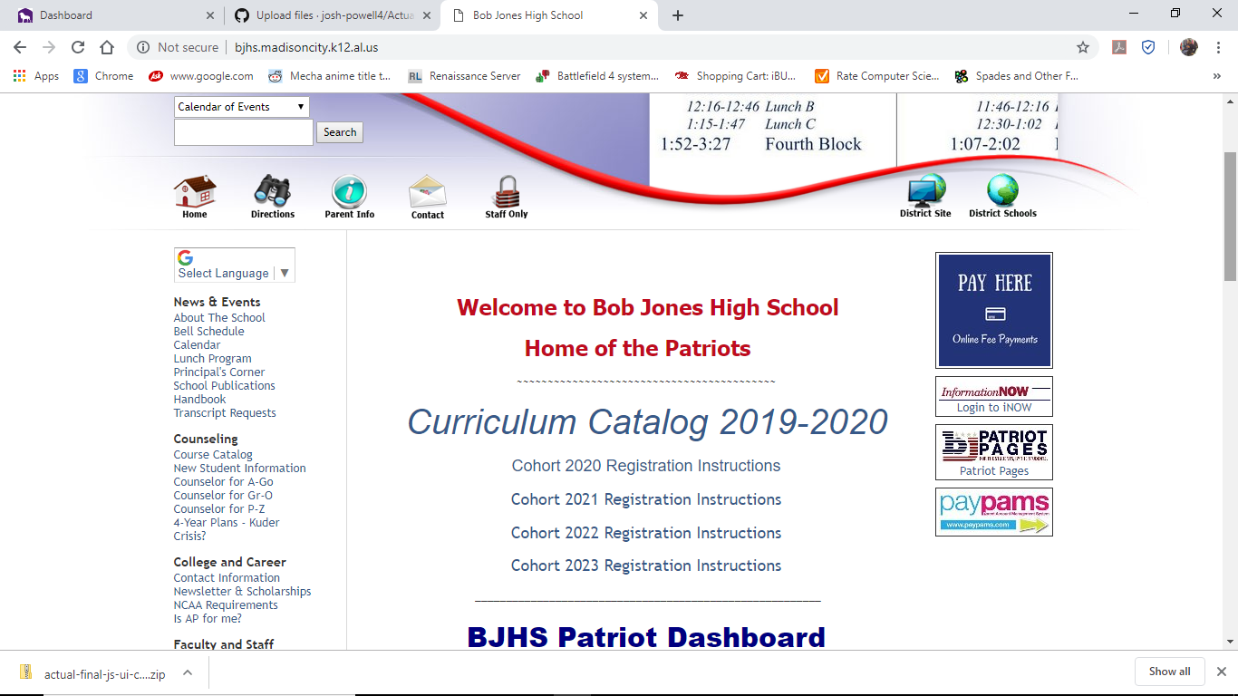

The original page design of Bob Jone’s home page.

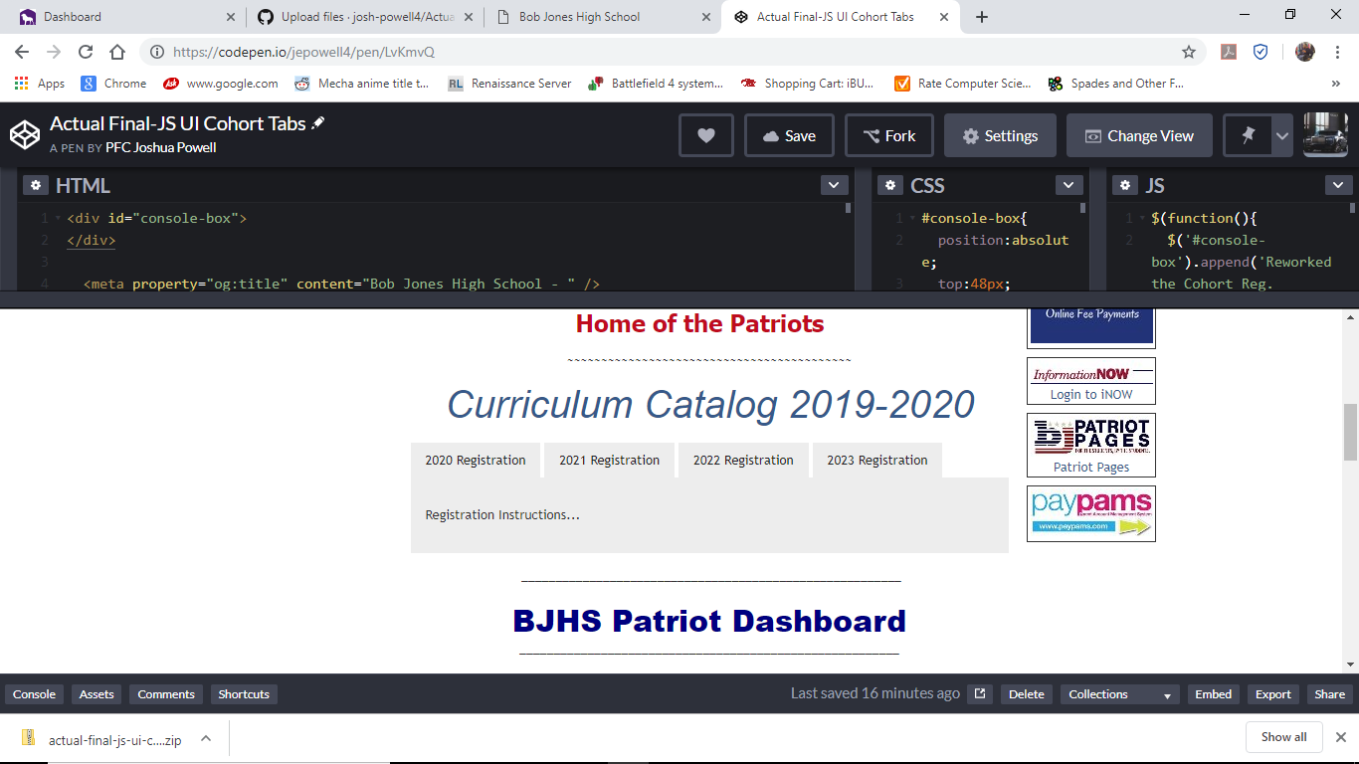

Here’s what I did by adding tabbing content using Jquery.