**FI 393**

**Chapter 9—Cost of Capital**

**Notes Outline**

1. **Concept of Cost of Capital.**
   * As investors, we often make decisions to purchase a stock or a bond based on how the investment's expected return compares to our required rate of return.
   * This same type of decision process is used by firms.
     + A firm's required rate of return is called its __***Weighted overage costof Capital (WACC)*** __ ___________________________________________________________
     + In order for a project to be accepted, the expected return on the project must ______________________________________________________
   * The cost of capital is a composite cost of a firm’s long-term capital and is calculated as the weighted average cost of the types of financing the firm uses:
     + ***Debt***
     + ***Perferred Stock***
     + ***Common Stock***
   * The WACC reflects the overall cost of long-term financing and is the required rate of return for projects that have the same level of risk as the firm.
2. **Why the Cost of Capital is Important.** 
   * The return earned on assets depends on __***Risk of assets***__.
   * The return to an investor is the same as _***The Cost to the Company***__.
   * Our cost of capital provides us with an indication of _***How the Market views the risks of our assets***

.

* + Knowing our cost of capital can also help us determine our _***Required return for capital budgeting projects***

1. **Required Return vs. Cost of Capital.** If the required return is 12%, usually this means the investment will have a positive NPV only if its return exceeds 12%.

Another interpretation of required return: the firm must earn the required return on the investment just to __***Compensate its investors for the use of the capital needed to finance the project***

* + Risk-free project: appropriate required return?
* Risky project (ceteris paribus) the required return is obviously __***Greater***
* We use required return, appropriate discount rate and __***Cost of Capital***_ interchangeably because they mean essentially the same thing.

Key fact: the cost of capital associated with an investment depends on the _***Risk***__ of the investment.

* Thus, the cost of capital depends **primarily** on the __***Use of the funds***_, not the source (although the source plays a secondary role).

Firm’s overall cost of capital will reflect the _***Required return to the firms assets as a whole***

If both debt and equity capital are used, this overall cost of capital will be a mixture of the returns needed to compensate its _***Creditors***_ and those needed to compensate its __***Stockholders***.

* In other words, a firm’s __***Cost of Capital***_ will reflect both its

______________________ capital and its _________________________ capital.

1. **Cost of Equity.** The cost of equity is the return required by equity investors given the risk of the cash flows of the firm:
   * Business risk: ***the possibility a company will have lower than anticipated profits or experience a loss rather than taking a profit.***
   * Financial risk: ***the possibility that shareholders or other financial stakeholders will lose money when they invest in a company that has debt if the company's cash flow proves inadequate to meet its financial obligations.***

The most difficult capital cost to estimate is the cost of equity. Why?

Two main models to estimate the cost of equity capital:

* The Dividend Growth Model (DGM)
* The Capital Asset Pricing Model (CAPM) or the Security Market Line (SML)

1. **The Dividend Growth Model Approach.** If we can assume that the firm’s dividends will grow at a constant rate, *g,* then the current price per share of stock is:

**P0 = D0(1+g)/re – g = Dt/re-g**

We can rearrange this equation to solve for the required return on equity:

1. **Example: Dividend Growth Model.**
   * Your company is expected to pay a dividend of $4.40 per share next year. (*D1*) Dividends have grown at a steady rate of 5.1% per year and the market expects that to continue. (*g*) The current stock price is $50. (*P0)*
   * What is the cost of equity?

Re = 4.40/50 + .51 =.139 = 13.9%

1. **The Dividend Growth Model Approach.** Based on the equation, in order to estimate *re*, we need P0, D0 and g.
   * For a publicly traded, dividend-paying company, the price and current dividend are easy to obtain.
   * But the expected growth rate is significantly harder to predict.
   * There are two ways to estimate the growth rate:
2. **The Dividend Growth Model Approach.**

Advantage:

***Simplicity. It’s both easy to understand and to use***

Disadvantages:

* Only applicable to companies that _***Pay Dividends***_.
* Even for companies that pay dividends, we must assume the _***Dividend growth rt is constant***__

_________________________________________________________________.

* The estimated cost of equity is **very sensitive** to the estimated _______________.
  + A 1 percentage point change in ___________ results in a 1 percentage point change in re.
* Finally, this approach does explicitly _______________________________.

1. **The SML (or CAPM) Approach.** Under the Capital Asset Pricing Model (CAPM), the required return on a firm’s equity is a function of three things:
2. The risk-free rate, rf.
3. The ___***market risk premium***___, (rM – rf).
4. The systematic risk of the firm relative to the market, which we call _***Beta***, β.

Using the CAPM, we can write the required return on the company’s equity, re as:

***re = rf + B(beta)e (rm – rf)***

where βe is the estimated beta.

* In order to implement this approach, we need a _***risk-free rt***_, an estimate

of the _________________________, and an estimate of the relevant _________.

1. **Example: CAPM (SML).** Company’s equity beta = 1.2
   * Current risk-free rate = 7%
   * Expected market risk premium = 6%
   * What is the cost of equity capital?

***re = 7% + 1.2(6%-7%) = 14.2%***

1. **Advantages and Disadvantages of SML.**

Advantages:

* Explicitly adjusts for _***Systematic Risk***_.
* Applicable to all companies, as long as __***BETA***_ is available.

Disadvantages:

* Must estimate the *expected* _***market risk premium***__, which does _***Vary***_ over time.
* Must estimate ___________, which also ___________ over time.
* Relies on the past to predict the future, which is not _______________________.

1. **Example: Cost of Equity.** 
   * Beta = 1.5
   * Market risk premium = 9%
   * Current risk-free rate = 6%.
   * Analysts’ estimates of growth = 6% per year
   * Last dividend = $2.
   * Currently stock price =$15.65

Using SML: re =  ***6 + 1.5 (9)=19.5%***

Using DGM: re = ***[2(1.06)/15.65] + .06 = 19.55%***

1. **Cost of Debt.** The cost of debt equals the __***Required Return***__ on a company’s debt.

* Unlike the cost of equity, a firm’s cost of debt can normally be observed either directly or indirectly:
  + Method 1: __***Compute the yield to maturity (YTM) on the firm’s existing debt.***_
  + Method 2: Use estimates of current rates based on the _***Bond Rating***_ expected on new debt.
* The cost of debt is **NOT** the coupon rate!

1. **Example: Cost of Debt.** Current bond issue: 15 years to maturity, coupon rate is 12% with coupons paid semiannually, and the current bond price is $1,253.72. What is the firm’s cost of debt?

**N-30 PV —1253.72 FV – 1000**

1. **Component Cost of Debt.** Use the ______ on the firm’s debt. Interest is tax-deductible, so the ___________ cost of debt is:

$$r_{d. AT}=r_{d, BT}(1-T_{C})$$

* If the corporate tax rate is 40%:

1. **Cost of Preferred Stock.** Determining the cost of preferred stock is fairly straightforward.
   * Preferred stock has a fixed dividend paid every period forever, so a share of preferred stock is essentially a _______________.
   * The cost of preferred stock is:
2. **Weighted Average Cost of Capital.** Use the individual costs of capital to compute a weighted “average” cost of capital for the firm
   * This “average” = the required return on the firm’s assets, based on the market’s perception of the _________________________.
   * The **___________** are determined by how much of each type of financing is used
3. **Determining the Weights for the WACC.** Weights = __***Percentage of the firm that wil; be financed by each component***_ that will be financed by each component.
   * Always use the target weights, if possible.
     + If not available, use market values.
4. **Capital Structure Weights.**

Notation:

* E = market value of __***Common Equity***_

= number of outstanding shares times ______________________.

* P = market value of ____________________________

= number of outstanding shares times ______________________.

* D = market value of ______________

= number of bonds times _____________________.

* V = market value of _____________ = E + P + D

Weights:

* E/V = percent financed with ________________________
* P/V = percent financed with ________________________
* D/V = percent financed with _____________

1. **WACC.** The Weighted Average Cost of Capital (WACC) is computed as:

$$WACC=\left(\frac{E}{V}\right)r_{e}+\left(\frac{P}{V}\right)r_{p}+\left(\frac{D}{V}\right)r_{d}(1-T_{C})$$

where:

Weights 🡪 (E/V) = % of _***Common Equity***___ in capital structure

(P/V) = % of __***Perferred Stock***_ in capital structure

(D/V) = % of __***Debt***__ in capital structure

Component Costs 🡪 re = firm’s cost of _***Equity***

rp = firm’s cost of ___**Preferred Stock**__

rd = firm’s cost of __***Debt***

TC = firm’s corporate tax rate

1. **Estimating Weights.** Given: Component Values:
   * Stock price = $50 E = 50 x 3m = 150m
   * 3m shares common stock D= 75m
   * $25m preferred stock P = 25m
   * $75m debt Vf = 150m + 25m + 75m = $250m
   * 40% Tax rate

Weights:

* E/V = 150m/250m = 60%
* P/V = 25m/250m = 10%
* D/V = 75m/250m = 30%

1. 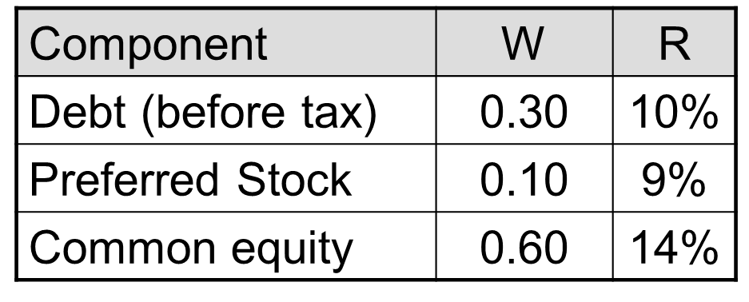**WACC.**

WACC = 0.6( 14%) +0.1(9%) + 0.3(10%)(1 - .40) = 11.1%

1. **WACC.** The WACC has a straightforward interpretation.
   * It is the overall return the firm must earn on its existing assets to maintain _***The Value of its stock***
   * It is also the required return on any _***Investments***_ by the firm that have essentially the same risks as existing operations.
2. **Factors that Influence a Company’s WACC.**
   * Market conditions, especially __***Interest Rts***______, __***Tax rts***____, and the __***Market risk Premium***____.
   * The firm’s __***Capital Structure***__ and dividend policy.
   * The firm’s _***Investment Policy***___
     + Firms with riskier projects generally have a _***Higher***__ WACC.