**FI 393**

**Chapter 7—Characterizing Risk and Return**

**Notes Outline**

1. Return is the ____________________________________________________________.
2. Two key lessons from capital market history:
   * There is a ___________ (return) for bearing a specific type of _________:
     + This type of risk cannot be avoided.
     + This unavoidable risk is called _______________ risk.
   * The greater the potential ____________, the greater the __________________ risk.
3. **Measuring returns.**

Dollar returns vs. Percentage returns:

* **Total Dollar Return:** _______________________________________________

**_________________________________________________________________**

* **Total Percent Return:** ______________________________________________ _________________________________________________________________

**Example:** In 2017, Apple’s stock price at the beginning of the year was $115.80. It paid a $2.46 per share dividend during 2017 and the stock price at the end of the year was $169.23. If you owned 1 share of Apple’s stock, what was your dollar return and percent return?

1. **Average returns.** We just computed the one-year return for Apple using 2017 data. However, are one-year returns typical for expectations in the long run?
   * We look to **average percentage returns** to examine ______________________

____________________________________.

* + - The average return can be used as a proxy for the expected future rate of return.

**Example:** The annual returns for Apple over the last few years are given below. What is Apple’s average return over this time period?



1. Note: **Average Return** vs. **Geometric Average Return**
   * An average return—like we just computed—does not reflect _________________ ______________ or the impact that ____________________________________ _________________________________________________________________
   * ________________________________ is a better measure if an investor wants to know the compound rate of growth on an investment.
     + **Example**: Suppose you invest $100 today in a stock that earns a 50% return over the next year. At the end of the year, the stock is worth $150. The next year, the stock suffers a 50% loss. So, now your stock is worth $75.
     + The average return is: (50%+-50%)/2 = 0%. Do you believe your average return was 0% per year? _______________________________________
     + The _______________ return is better suited to reflect past performance evaluation. (The geometric avg. return on this investment is -13.4%.)
2. **U.S. Financial Markets, The Historical Returns Record: 1925-2011**

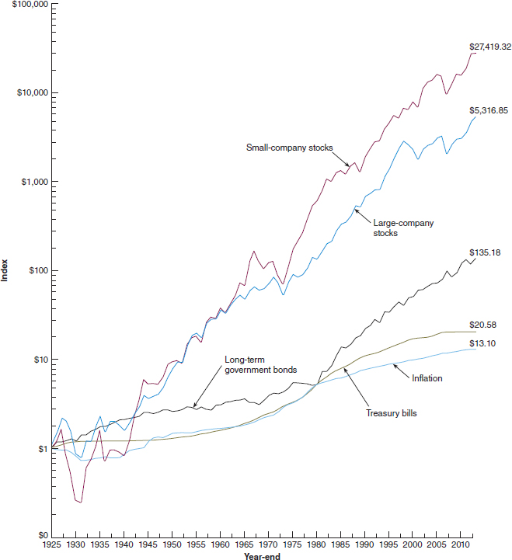

**FIGURE 1**

A $1 investment in different types of portfolios: 1925–2014 (year-end 1925 = $1)

1. **Year-to-Year Total Returns**

Large-Company Stock Returns

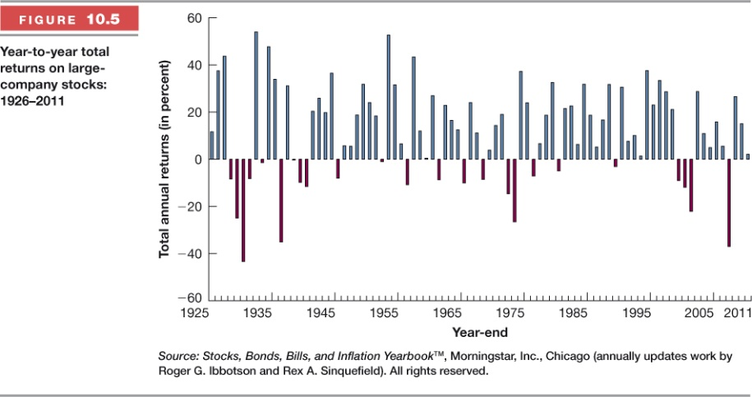

Small-Company Stock Returns

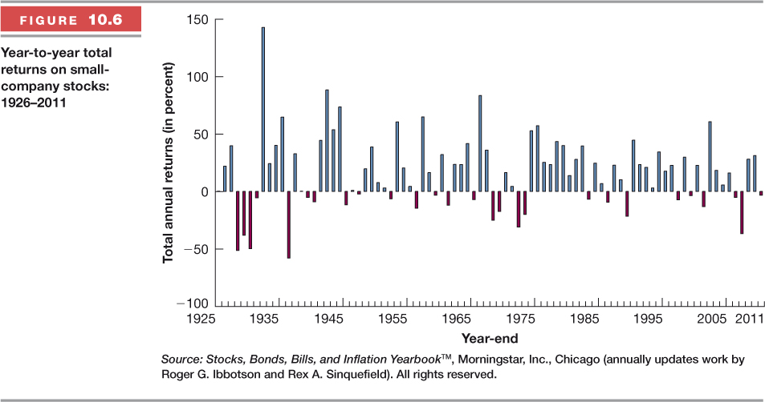

Long-term Government Bond & U.S. Treasury Bill Returns

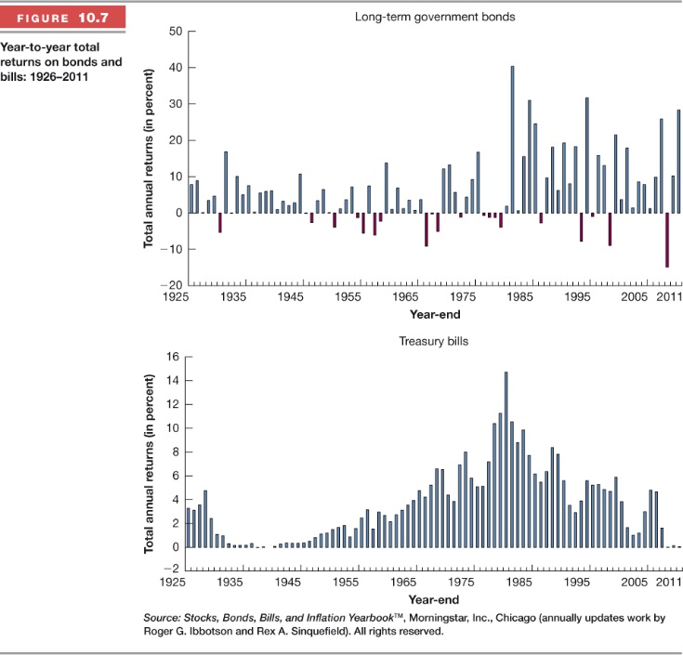

1. **Average Returns: The First Lesson**

**1926-2014**

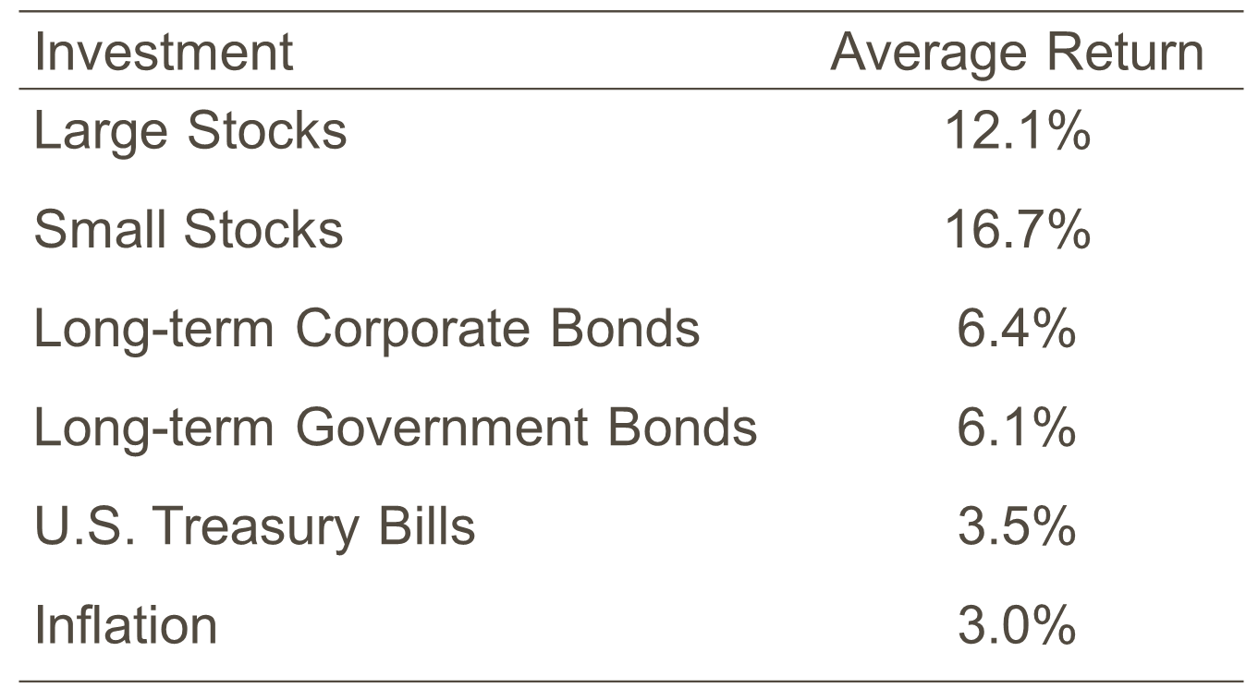

1. **Risk Premiums.**

**Risk-free rate**:

* + ___________________ are considered risk-free

The **risk premium** is:

* + ____________ for bearing risk

1. **Historical Risk Premiums.**

Large Stocks: 12.1 – 3.5 = 8.6%

Small Stocks: 16.7 – 3.5 = 13.2%

L/T Corporate Bonds: 6.4 – 3.5 = 2.9%

L/T Government Bonds: 6.1 – 3.5 = 2.6%

U.S. Treasury Bills: 3.5 – 3.5 = 0*

*By definition!

1. **The First Lesson.**

From the previous table, we see that the average risk premium earned by a typical large-firm common stock is ________.

* + This is a significant ___________.
  + The fact that it exists historically is an important observation, and the basis for our first lesson:
  + **First Lesson**: _____________________________________________________.
    - Said another way: _____________________________!

1. **Measuring Risk.** 
   * When you purchase a **________________________**, you know exactly what your dollar and percentage return are going to be.
   * On the other hand, when you purchase a **__________**, you do not know what your return is going to be.
     + This ______________ is precisely what makes stock investing **_______**.
   * It’s useful to evaluate this _________________ quantitatively so that we can compare **_______** among different ____________________________________.

**Risk** is the ______________________________________________________________

**_______________________________________________________________________.**

Risk is measured by _______________________________________________________

________________________________________

* + By calculating the ***___________ ________________*** of historical returns, we can assess the volatility or **risk** of an investment.
  + The **____________** the *standard deviation*, the **___________** the volatility of historical returns and therefore, the **_____________** the risk.

**Example:** Compute the standard deviation of Apple’s returns.



*By comparison, the standard deviation of the S&P 500—a common “market” approximate—was about 12.90% over this time period.

1. **Historical Average Returns and Standard Deviations.**

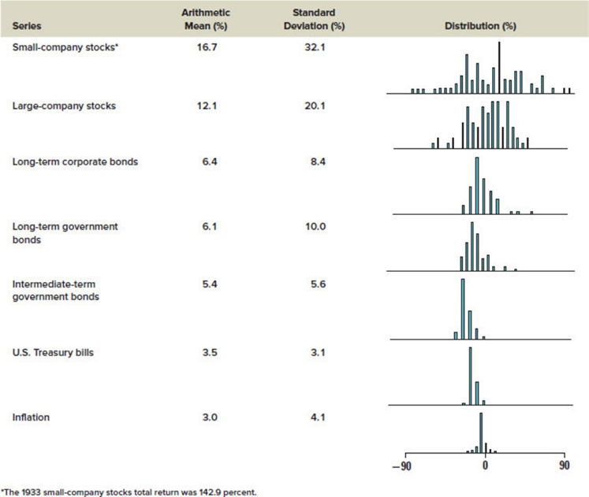

Asset classes (not an individual stock) with greater volatility pay higher average returns.

1. **Second Lesson.**

* Our observations concerning the year-to-year variability in returns are the basis for our second lesson from capital market history.
* On average, bearing risk is handsomely rewarded, but, in a given year, ___________ ____________________________________________________________________
* Thus, our **Second Lesson:** ______________________________________________

___________________________________________________________________.

1. **Risk vs. Return.**

*Risk-return tradeoff:*

* Most investors _____________________________________________________
* Investors are ____________________________.
* In order to invest in higher risk investments, investors will __________________ _________________________________________________________________
  + This is the __________________________.
  + The **coefficient of variation** (CoV) is a common relative measure of this risk-vs-return relationship.
  + The CoV is interpreted as the *___________________________________*.
* As an investor, you would want a very high _________ with a very low _______. So, a *smaller* CoV indicates a *_________________________________________*

Given the information below and assuming risk-averse behavior, answer the following questions.

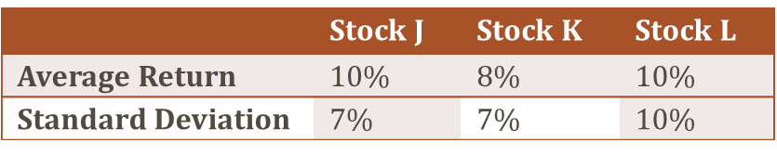

* + If deciding between Stock J and K, explain which stock is preferred.
  + If deciding between Stock J and L, explain which stock is preferred.
  + If deciding between Stock K and L, explain which stock is preferred.
  + Rank the three stocks by their risk-return relationship.

1. **Diversification: Forming Portfolios to Reduce Risk.**

________________, stocks may be very _________.

* + Recall, Apple’s *σ* of returns from 2013-2017 was about 22.70%, compared to 12.90% on the S&P 500.

Combining stocks into **______________** can reduce many sources of stock ________.

* + A ***portfolio*** is just a _________________________________________________.
  + The way portfolios reduce risk is through ***diversification***.
  + ***Diversification*** is ___________________________________________________ ___________________________ for the purpose of reducing risk.
    - If a portfolio is well-diversified, it will have ________________________ ____________________________________________________________
    - If one can combine assets whose returns are not strongly correlated, then when Asset A loses money, Asset B may make money and offset the loses on Asset A.

Again, combining stocks into portfolios can reduce many sources of stock risk. What risks are we talking about?

* For a stock investment, there are two major components to its total risk:
* ***Firm-specific risk*** includes the ________________________________________

***________________________________________***. It is also called ***unique risk*** or ***unsystematic risk***.

* + - Firm specific risk IS diversifiable—meaning it can be ________________ ____________________________________________________________
  + ***Market risk***: this includes ____________________________________________

***__________________________________________________***. It is also known as ***systematic risk****.*

* + - Market risk is NOT ________________.

As you increase the number of stocks in a portfolio, the firm-specific risk is __________ but market risk will ________________________.

1. **Correlation: How Diversification Works.**

So, *how* exactly does diversification reduce risk?

* + Through the ***correlation*** of asset returns.
  + ***Correlation*** is a ____________________________________________________

***_____________________________________________***.

* + Correlation coefficients can be any number between _____ and _____.
  + Perfect positive correlation (*ρ* = +1) means that ___________________________ _________________________________________________________________
    - Combining assets that are perfectly positively correlated offers_________

___________________________.

* + Perfect negative correlation (*ρ* = -1) means that the two investments ___________ __________________________________________________________________
    - Combining assets whose returns are negatively correlated reduces the overall risk of the portfolio substantially. (If one could find *perfectly negatively correlated* assets, you could ___________________________.)

1. **Correlation among various stocks.**

Which two stocks would you combine in order to maximize your diversification benefit (i.e., reduce the most risk)?

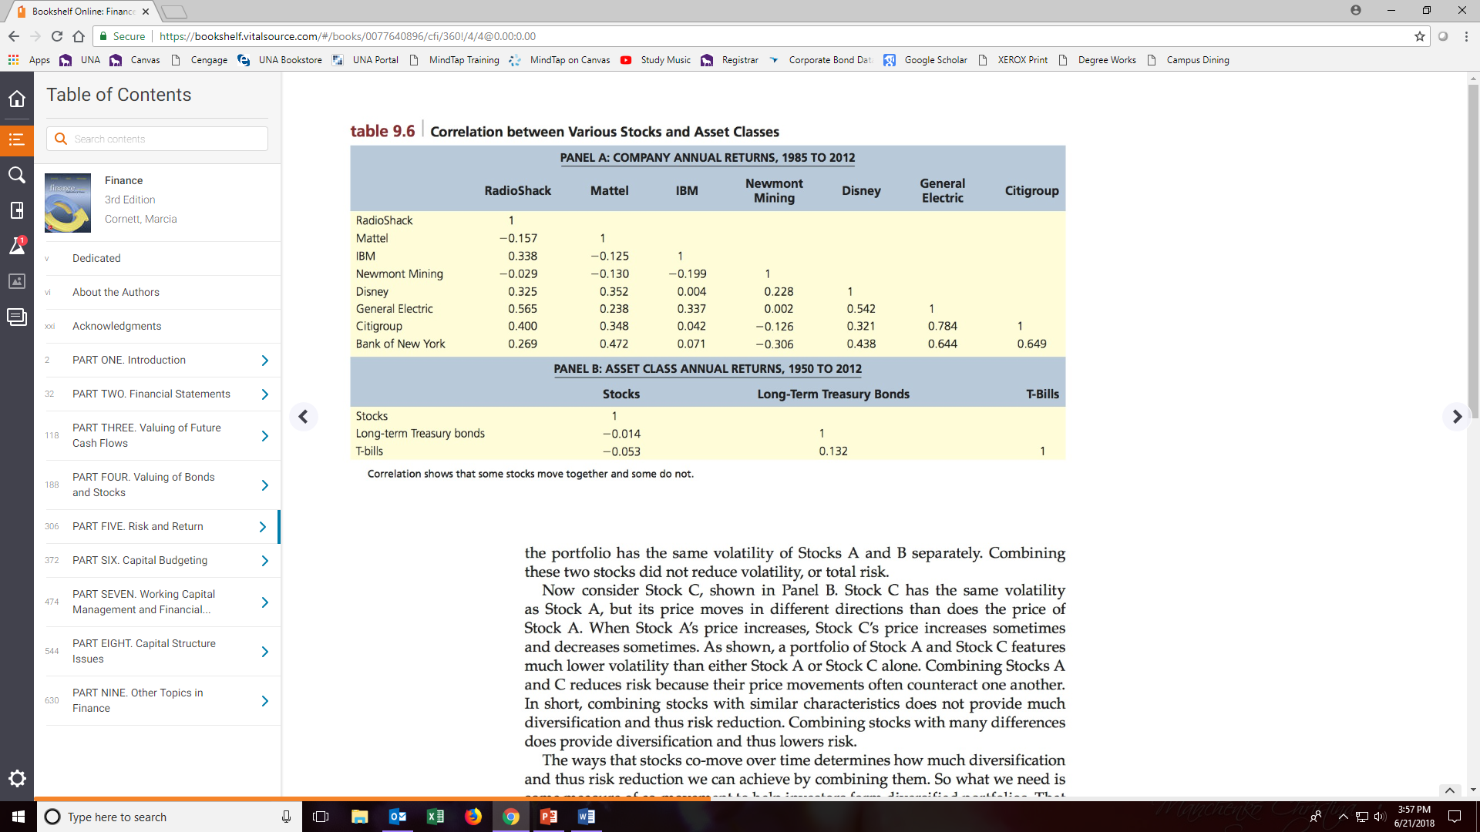

1. **Portfolio Return.**

* A portfolio’s return is a weighted average of the returns of the portfolio’s component assets:
  + Where weights (*w1 w2,* etc.) are the proportion of the overall portfolio invested in each asset.

**Example**: What is the return on the following portfolio?

