Summary for Scholarly Journal Article:

The Wonder Years

Allyson Mann

Joshua Powell

Allison Bookout

Ethan Goodwin

Matthew Thiam

University of North Alabama

November 03, 2018

Table of Contents

Results of the Research 3

Price 3

Availability. 3

Reviews 3

References 5

The Wonder Years

The Wonder Years is a trending magazine company that offers students college and world trends in many categories. For our company we decided to change internet providers. This report compares different internet providers that we considered for our growing business. With our publishing of campus related events and news, it has picked up the steady flow of loyal reader and now we need to accommodate our internet usage in order to get growing our business and to keep up with increasing work projects.

As a team we each picked an internet provider that we felt had a lot to offer us as a business. The companies we chose were Comcast/Xfintiy, AT&T, Verizon, CenturyLink, and Direct. We looked at each company’s price, customer reviews, and the availability in the area. To find the needed information we looked at each company’s website for the price and availability, but we had to use third-party websites to provide accurate customer reviews.

# Results of the Research

At the end of our research we concluded that Comcast/Xfinity offered a great service at a reasonable price when considering the large package, we would be investing in. We recommend that our company invest in switching internet providers during the summer months when campus activity is low due to student enrollment numbers being less than the fall and spring semesters.

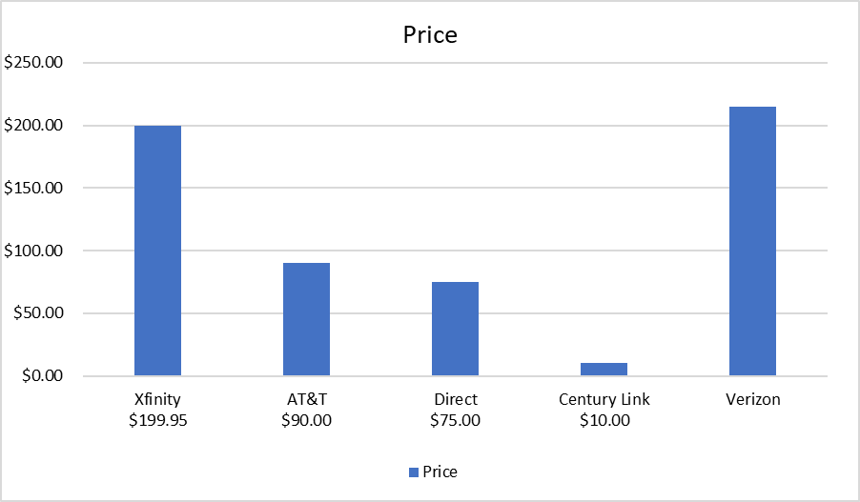

## Price

Price is what you pay, value is what you get. (Buffett, Warren). Finding providers with great internet and service for the right price is tough. Our company uses the internet heavily so having high-speed internet is a must. Verizon is hands down the best service provider, however they drive a very hard bargain for the best internet service a person can buy. It nearly costs a whopping $300 dollars just for the Verizon-Fios plan; and, that’s just for internet alone. The exact price would come out to be $214.99 not including tax. Although being the best service today, it is more than what we’re willing to pay. (**Next)**

Availability

Verizon might have been the ideal choice, however, the service we wanted wasn’t available in our area. Even though it’s not available, we can have it installed. **(Next**)

### Reviews

AT&T and Verizon are the most used services by consumers. Every review on Verizon-Fios talks about how expensive the plan is. However, price is the only con their plans has to offer. Verizon-Fios is hands down the fastest plan out today. Costumers rejoice over the blazing speeds and lack of technical issues. One customer talk about how well their internet runs in stormy weather in their review. Consumers agree that Verizon-Fios is a bang for one’s buck. **(Next)**

|  |  |  |  |
| --- | --- | --- | --- |
| 2Company | Price | Availability | Customer Reviews |
| Xfinity | $199.95 | Yes | 3/5 Stars |
| AT&T | $90.00 | Yes | 3/5 Stars |
| Direct | $75.00 | Yes |  |
| Century Link | $10.00 | Yes | 4/5 |
| Verizon | $214.99 | No (Can be Installed) | 4/5 |

# References

Verizon. (n.d.). Verizon Business. Retireved from https://www.verizon.com/foryourhome/ordering/checkavailabilitylq.aspx?doid=BYOB_Triple_Custom1G_2YR_OFR2

Pickett-Adamson, J. (2018, January 31). *Verizon Business Internet Review: 2018.* Retrieved from https://www.business.org/services/internet/verizon-business-internet-review/

White, J. S. (2017). The best article ever. *UNA Journal, 12*(3), 5-65. doi:148985.6ij/1561

Country Economy.