**Basic Elements of the Economy**

There are many elements that make up a country’s economy. The elements that makes up a country’s economy are consumption, investments, government spending, and net exports and imports.

|  |  |  |
| --- | --- | --- |
| **BASIC ELEMENTS OF THE ECONOMY** | | |
| ***Elements*** | ***Germany*** | ***USA*** |
| Population (2017) | 81.9 mil | 325.7 mil |
| GDP (2017) | $3.68 trillion USD | $19.39 trillion USD |
| GDP Growth Rate (2017) | 2.5% | 2.3% |
| Unemployment | 3.4% | 3.7% |
| Employment | 5.9% | 60.70% |
| Inflation | 1.7% | 1.9% |
| Trade Deficit | $65 billion USD (35%) | $55.5 billion USD |
| Trade Surplus | $23.4 billion USD (20.5 EUR) | * 50.1 billion USD |
| Country’s Debt | 2.5 trillion USD / 2 trill EUR | 21.9 trillion USD / 2.10 trillion EUR |
| Income (avg income per household) | $33,652 USD | $59,039 USD |

Based off of these numbers we can compare a nation that’s considered a super-power to a nation that’s looked at as an underdog. We sometimes view countries in Europe as unorganized, but Germany is far from it. Germany has the fourth strongest economy in the world not to far behind the United States (US). Based on the data, because of US population and size, their economy is doing better than Germany’s overall. Germany is the leading exporter is chemicals, vehicles, machinery, and household goods (Nation Master, 2019). Germany also has a very high employment rate and a low unemployment rate. Research shows that 2.7 million of Germans, age 30 or over, are unemployed or actively seeking work. We can infer that Germany’s economy have trouble sustaining long-term growth; however; Germany’s labor market is experiencing a boom. This can be due to the fact the government has been running a budget surplus since 2016 (Nation Master, 2019). Germany is credited for having a highly skilled labor force. Germany’s manufacturing market makes up one-quarter of their economy, as the manufacturing sector only makes up twelve-percent of the US economy. Germany’s labor force is very skilled because their employees undergo rigorous training and companies get punished for getting rid of workers. Also, companies pay a very low-income tax which benefits investors and companies, and, this allows companies to hire more people. Research also show that the population of young adults in Germany has the lowest rate of unemployment, job happiness and security in the workplace, and enjoy high quality of living compared to the US. The cost of living in Germany is 11% cheaper than living in the US. Even though the US economy is in good standing right now, Germany’s economy is prospering and growing very fast. Hopefully, the Us can one day learn from Germany and make our economy even stronger to remain the world only superpower.

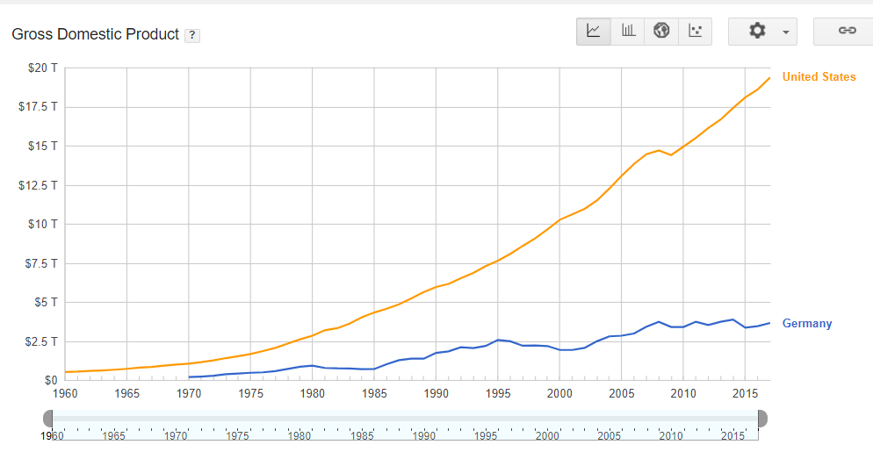

This graph illustrates the comparison of Germany’s GDP to US GDP. Since 1960, US GDP has been on a rapid incline with only a faulter between 2005 to 2010 during the Great Recession. Germany’s GDP didn’t start to rise until 1970. Germany’s GDP slowly staggers upward; however, we may see a huge incline in future years due to their booming economy as of now.

Contribution Matrix:

|  |  |
| --- | --- |
| Economic Situation | Jordan Scruggs |
| Basic Elements of the Economy | Joshua E. Powell |
| GDP | Debbie Gomez |
| Trade | Joseph E. Powell IV |
| Imports & Exports | Shay Price |
| Currency | Ashley Rikard |
| FDI | Shay Price |
| Economic Outlook | Debbie Gomez |

# References

Country Economy. (2018). Retrieved from https://countryeconomy.com/countries/compare/germany/usa

Central Intelligence Agency. (2018). Retrieved from https://www.cia.gov/library/publications/the-world-factbook/geos/gm.html

Nation Master. (2019). Retrieved from https://www.nationmaster.com/country-info/compare/Germany/United-States/Economy

National Debt Clocks. (2019). Retrieved from https://www.nationaldebtclocks.org/

Roger, Yu. (2017, June). Here's why Germany's trade surplus with the U.S. is so big . USA Today. Retrieved from https://www.usatoday.com/story/money/2017/06/01/heres-why-germanys-trade-surplus-us-so-big/102349370/

Trading Economics. (2019). Retrieved from https://tradingeconomics.com/germany/unemployment-rate

OECD. (2019). Retrieved from http://www.oecdbetterlifeindex.org/countries/germany/