Task 2: Ticketing Data Model

What I built
I built three layers, each with one job. ./run.sh builds all of them from scratch and then runs the checks.
The raw layer holds the four ticketing files exactly as delivered, with every column as text, so a bad value can never block the load. It is dropped and reloaded on every run.
The staging layer has one view per file. The views cast types, trim text, turn blanks into NULL, and add three helper columns: the event start in UTC, a normalized email, and the section type (LOGE, CLUB or BAL). They never add or remove rows. Event times have no time zone, so I treated them as Boston time.
The modeled layer is a small star schema built from staging. Analysts, Tableau and Tasks 3, 4 and 6 read from it.

Model
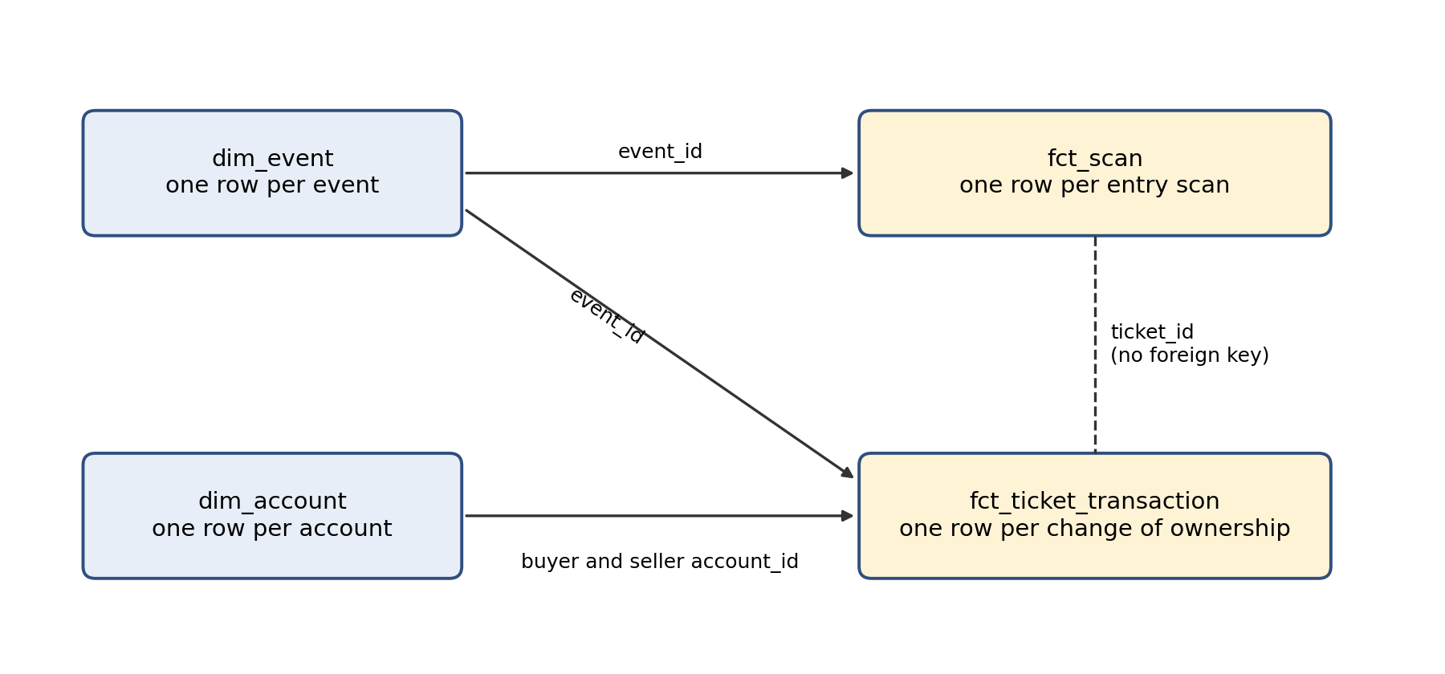
Table | Grain | Key | Flags
dim_event | One row per event | event_id | is_bruins_game, has_scan_data
dim_account | One row per ticketing account | account_id | is_club_member
fct_ticket_transaction | One row per change of ownership of a ticket | transaction_id | transaction_sequence, is_latest_transaction, is_double_sold_seat
fct_scan | One row per entry scan | scan_id | is_first_valid_scan, is_refunded_ticket

A PRIMARY sale has no seller and a REFUND has no buyer, so each transaction has zero or one of each. The two fact tables share ticket_id but have no foreign key between them, because a ticket has several transaction rows. The checks confirm every scan matches a ticket sold for the same event.

Why I chose this
The facts record what happened, a ticket changing hands or a ticket being scanned, and the dimensions describe the game and the account. That is a standard shape for reporting. It keeps each table at one grain, and the later tasks become simple joins and GROUP BYs.
The flags carry what I learned in profiling, so later tasks don't have to rediscover it. For example, the current owner of a ticket that wasn't refunded is the buyer on the row where is_latest_transaction is true, and is_first_valid_scan makes a re-entry count once.
Staging is views because a view reads raw every time, so it can never fall out of sync. There is no load-control or quarantine here, unlike Task 1. These four files are one-time full extracts that profiled clean on keys and formats. In production they would follow the Task 1 pattern.
The alternative I rejected was one wide table with every transaction plus its event and account columns. It is easy for a single dashboard, but it repeats event and account details on every row and has no place for scans, which are a different grain. That makes counting tickets or fans easy to get wrong.

Redshift distribution and sort keys
At this size distribution makes little difference, and Redshift's AUTO setting would likely choose on its own. These choices are for production volumes.
Table | Distribution | Sort key | Why
dim_event | ALL | event_id | 75 rows. A copy on every node means joins to it never move data.
dim_account | ALL | account_id | 2,792 rows is small. If it grew to millions, I would switch to KEY on account_id.
fct_ticket_transaction | KEY ticket_id | event_id, transaction_datetime_utc | Task 3 groups by ticket and scans join on ticket. Most reporting filters by game, then time.
fct_scan | KEY ticket_id | event_id, scan_datetime_utc | Same key as transactions, so the ticket join stays on each node. Attendance queries filter by game.

