Task 7: Running This in Production on AWS
In production, AWS runs the same steps as my run.sh every day, starting from the vendor's API instead of CSV files.
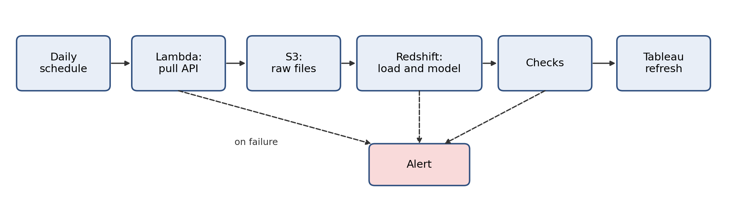

Pulling from the vendor API
A small Python job in Lambda does the pull. The API key lives in Secrets Manager and is read at run time, never stored in code. The job requests pages until none are left and records the page and row counts. If the vendor returns "too many requests," the job retries, waiting longer each time. Pages go to a temporary folder and move to the final folder only when the whole pull succeeds, so a partial pull is never loaded. If retries run out, the run stops and alerts.
To load only what changed, the job uses a stored watermark for the last successful load and requests listings updated since that point, with one extra hour of overlap to catch late changes. The overlap is safe because my load skips versions it already has. A weekly full pull catches anything missed.

Where data lands
Every raw API response is saved to S3 unchanged, in folders by date. Redshift holds the same logical three layers I built locally: raw, staging and analytics. Because S3 keeps the originals, Redshift can always be rebuilt from them.

Scheduling and orchestration
An EventBridge schedule starts a Step Functions workflow early each morning, so dashboards are fresh by business hours. It runs the same order as run.sh: pull, load, rebuild the model and summaries, run checks, refresh Tableau. Each step retries on failure. If a step still fails, everything after it stops and SNS sends an alert. If the team already uses Airflow, the same steps become one DAG.

Loading into Redshift
COPY bulk-loads the S3 files into a staging table. Then the Task 1 SQL runs in one transaction: remove duplicates, quarantine bad rows, insert only new versions, and recalculate valid_to. The Task 2 through Task 5 SQL and the Python fan matching then rebuild the model, fan IDs and summaries in dependency order, using the distribution and sort keys from Task 2. A few Postgres-only pieces need small rewrites, like DISTINCT ON becoming ROW_NUMBER(). Redshift does not enforce primary keys, which is why the checks matter.

Data quality checks and what happens on failure
I check at three levels. If a file has the wrong columns or the pull is empty, nothing loads, the run is logged in load-control and the team is alerted. Bad rows go to quarantine with a reason, and good rows still load. My 36 checks on the final tables run before anything is published. If one fails, the pipeline stops before Tableau refreshes or the Pre-Arrival Guide is sent, so yesterday's good data stays live, and the alert names the failing check.
If no successful run has finished by the cutoff time, an alert fires for the missing data.

Onboarding a new vendor
A new source follows the same pattern and is mostly configuration, not new code. Store its key in Secrets Manager and add a config entry with the endpoint, how pages work, which field shows a change, and the schedule. Profile the first pull to document its grain and key. Create its raw, load-control and quarantine tables and a staging view, and register its checks. Agree with the vendor on the schema and on notice before changes.

