Project Lifecycle

Initial I upheld the integrity of my schedule and progress began on development. The first stages up to the structure, HTML and CSS basics went well and the product begin to take shape and the overall appearance has changed very little since then. My focus then moved to more of the server side and interaction with PHP files via AJAX.

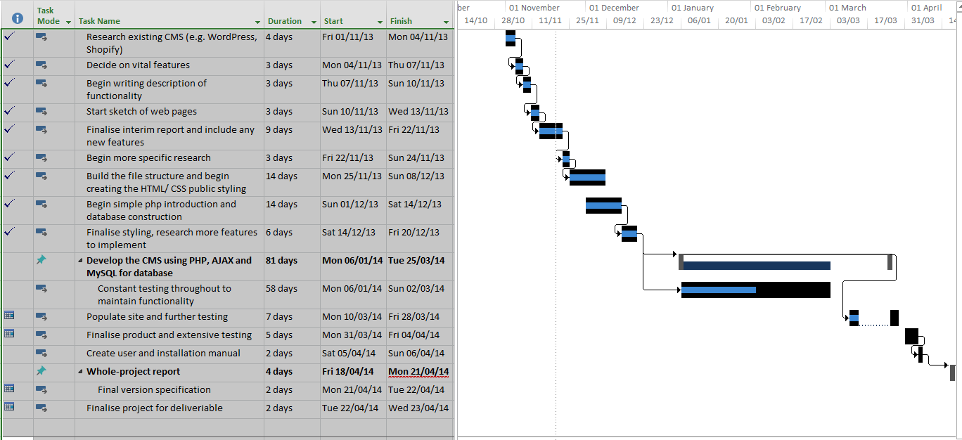

After starting on track and keeping to the schedule I began to spend less time working on the project as I delegated some extra time towards other coursework’s. This resulted in delays for started new areas of the product and some features I did not fully manage to implement in time such as, a fully working checkout system and client account system with order feedback. Then, after consulting with a fellow peer, I decided to try and implemented an object oriented approach to my product. It resulted in me wasting a few weeks of development time trying to implement something I did not fully understand. I then scrapped this idea and began continuing as usual with the implementation. Many features to my product were not clearly identified at the start of the project and became more apparent later on whilst other features started to take place. This resulted in a skew on my work and new features were introduced less and less and current features went through extensive testing to make sure they would work in all environments and were easy to understand.

As the deadline drew closer I stopped adding new features to the product altogether and thoroughly tested the content management system using sample data. I began to implement a checkout system to follow the basket but I could not complete it within the time. Therefore I have commented out these new features, leaving it open for development at a later date. Finally I spend my time creating these documents and begin commenting and annotating my code, justifying my intentions.