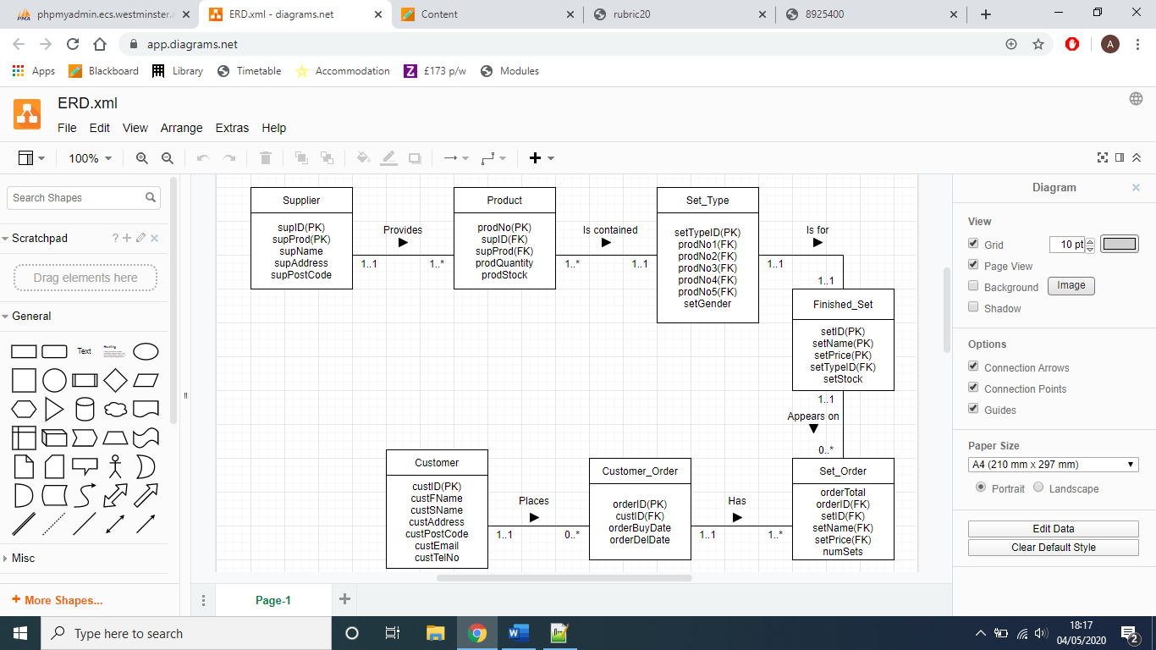
ERM:
Entity | Primary Key (PK) | Foreign Key (FK) | Rationale for PK
Supplier | supID, supProd |  | The supID and supProd will be referenced in the Product table to give the Product a Supplier parent.
Product | prodNo | supID, supProd | The prodNo is used to uniquely identify each product and is referenced in the Set_Type table.
Set_Type | setTypeID | prodNo1, prodNo2, prodNo3, prodNo4, prodNo5, | The setTypeID allows for all of the information about the make up of the set to be referenced by a single piece of data the setTypeID.
Finished_Set | setID, setName, setPrice | setTypeID | In this table I give the Finished set the most important aspects the setName and setPrice I am able to reference this in other tables with the use of an ID. However I will also need the setPrice to do calculations in the Set_Order table. setName is also a PK as an ID and a name makes the data more readable instead of just a number.
Set_Order | … | orderID, setID, setName, setPrice | …
Customer_Order | orderID | custID | The orderID is used to find information on the custID, orderBuyDate, and orderDelDate essentially the custID is used to link tables.
Customer | custID |  | The custID is used for referring to the different customers through the use of a unique number.

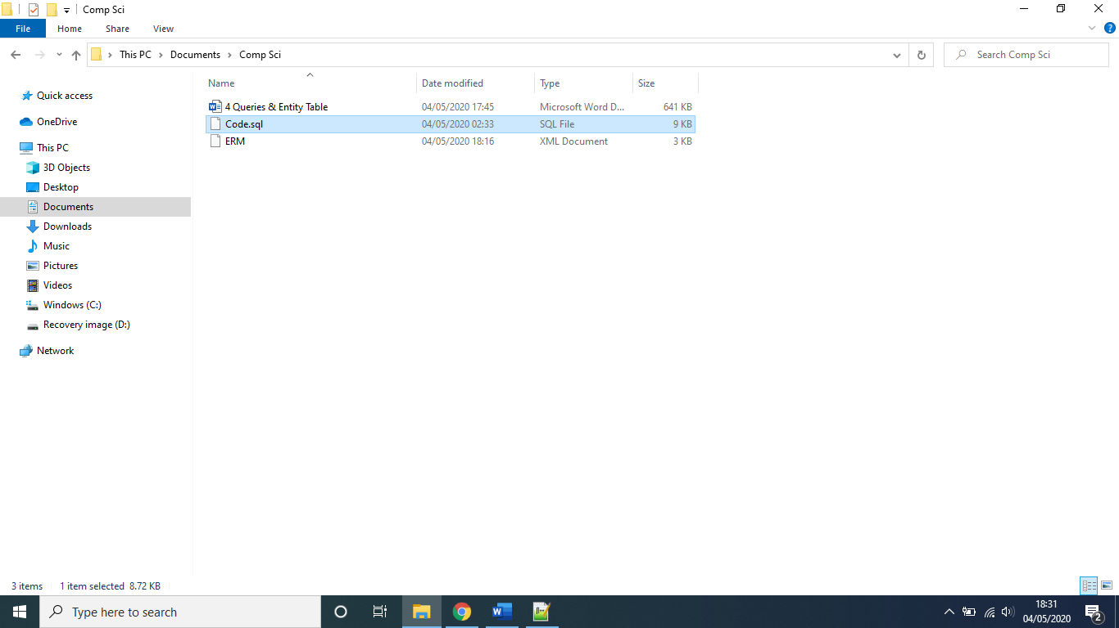
The sql script I created in Notepad ++. I’ve include the file as Code.sql, The file has been made so you can copy and paste straight into the SQL tab on phpMyAdmin.
I originally created the ERM on https://app.diagrams.net/ and have included this file also, as well as the screenshot in this document.

Query No | Purpose | Tables involved | SQL | Correct Execution
1 | Show all of the deliveries that will be between the first 5 days of the month | 1 table -Customer_Order | SELECT *  FROM Customer_Order  WHERE orderDelDate BETWEEN '2019-06-02' AND '2019-06-04' | 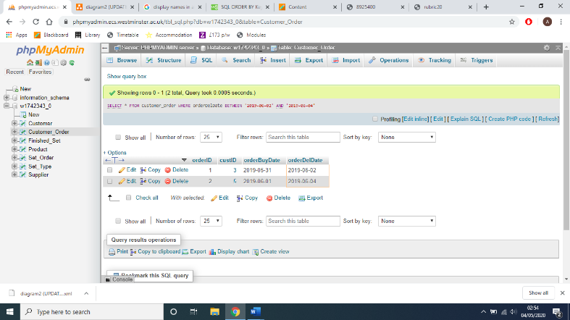  Yes
2 | Order all of the suppliers by name and postcode. | 1 table - Supplier | SELECT * FROM Supplier  ORDER BY supName, supAddress; | Yes  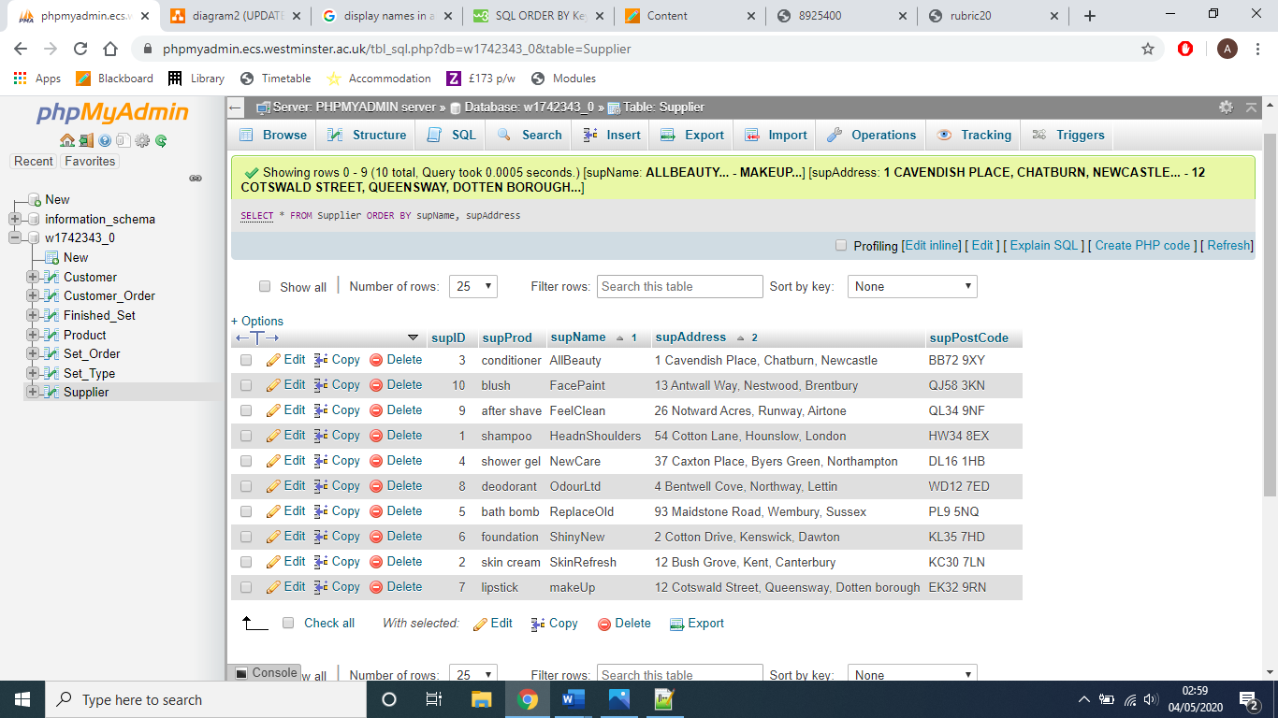
3 | This shows how many orders have been made in total. | 1 table – Set_Order | SELECT COUNT(orderID)  FROM Set_Order; | Yes  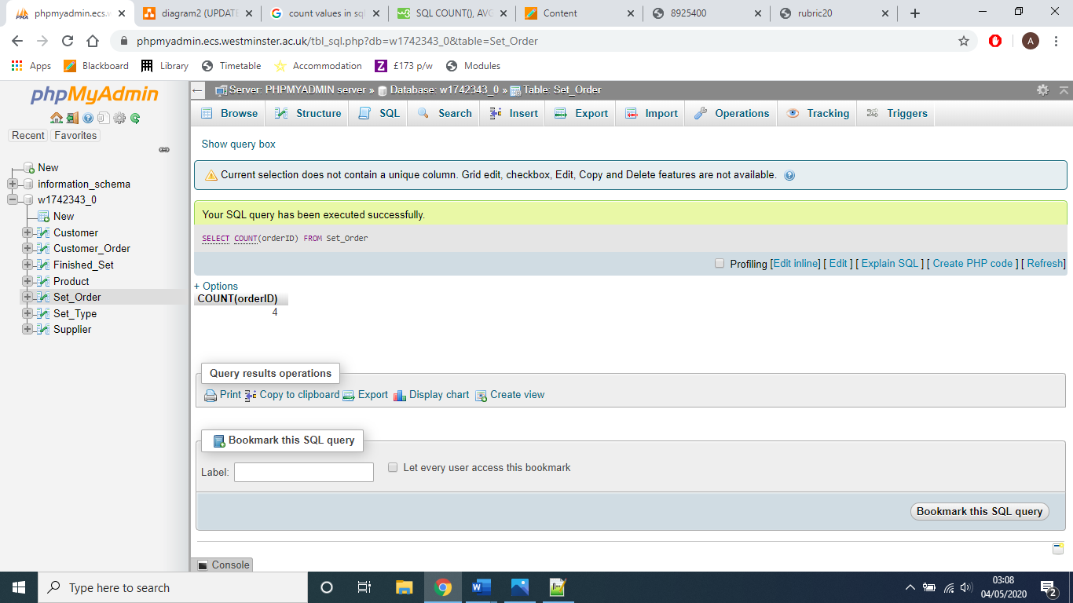
4 | Find the average level of stock for all sets. | 1 table – Finished_Set | SELECT AVG(setStock)  FROM Finished_Set; | Yes