CHAPTER FOUR

RESULTS AND DISCUSSION

4.1 Introduction
This chapter presents the results obtained from the development, training, and evaluation of an AI-powered tiger nut sorting system deployed on the ESP32-CAM microcontroller. An earlier phase of this project used a three-class formulation (good tiger nut, bad tiger nut, stone), reaching 86.5% validation accuracy but limited by visual overlap between the bad-tiger-nut and stone classes at the model's 96×96 input resolution. Following the project supervisors' direction to judge only good tiger nut and stone, the bad-tiger-nut class was removed and the model retrained as a binary classifier. This chapter reports the dataset and training configuration used for that change, the resulting classification accuracy of both the full-precision (float32) and the quantised (INT8) model actually deployed to the microcontroller, a reproducibility check obtained by retraining a second time, a comparison against the project's earlier Random Forest baseline, and a discussion of the findings in relation to the project objectives.

4.2 Dataset Composition and Preparation
After removing the bad-tiger-nut class, the dataset used for training and evaluating the model comprised 257 images across two classes: Good Tiger Nut (136 images) and Stone (121 images). These images were drawn from the project's existing image pool (an initial controlled-lighting batch plus a supplementary batch collected to improve class balance); 70 bad-tiger-nut images originally collected for the three-class model were excluded rather than discarded, and remain available on disk should the class be reinstated in future work (Section 4.9.4). A standard 80/20 split was applied, resulting in 204 images for training and 53 images for testing, as summarised in Table 4.1 and illustrated in Figure 4.1.
Class | Training Images | Testing Images | Total
Good Tiger Nut | 108 | 28 | 136
Stone | 96 | 25 | 121
TOTAL | 204 | 53 | 257
Table 4.1 — Dataset Split Summary
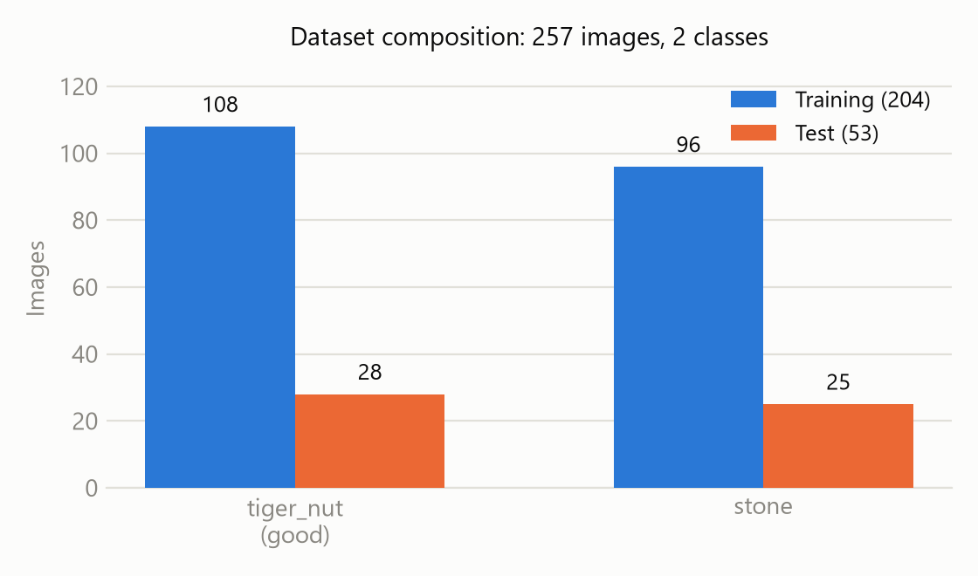
Figure 4.1 — Dataset distribution across classes and training/testing split

4.3 Model Training Configuration
The MobileNetV1 96×96 RGB model (0.25 width multiplier, with a 16-unit dense head and 0.1 dropout trained on top of the frozen pretrained base) was trained using the Edge Impulse platform with transfer learning. Training was conducted over 30 epochs with a learning rate of 0.0005 and image augmentation (flips, brightness, zoom) enabled to improve generalisation. Two deployment variants were exported from the same training run: a full-precision float32 model, and an INT8 post-training-quantised model — the latter being the variant actually required for deployment on the ESP32-CAM's 520 KB of SRAM. The training configuration is detailed in Table 4.2 and was kept identical to the earlier three-class run so that the effect of the binary reframing, reported in Section 4.4, is not confounded with a hyperparameter change.
Parameter | Value
Model Architecture | MobileNetV1 96×96 0.25 (Transfer Learning)
Dense Head | 16 units, dropout 0.1
Input Dimensions | 96 × 96 pixels, RGB (3 channels)
Number of Epochs | 30
Learning Rate | 0.0005
Batch Size | 32
Data Augmentation | Enabled (flip, brightness, zoom)
Validation Set Size | 20% (41 of 204 training images)
Exported Variants | float32 and INT8 (post-training quantisation), TensorFlow Lite
Table 4.2 — Training Hyperparameters

4.4 Classification Performance on Test Set
Upon completion of training, both exported variants were evaluated on the held-out test set of 53 images (28 good tiger nuts, 25 stones) never used during training or validation, as well as on Edge Impulse's internal 20% validation split (41 images). Table 4.3 reports overall accuracy and loss for both variants on both splits; Figure 4.2 presents the same comparison graphically.
Variant | Validation accuracy | Validation loss | Test accuracy
float32 | 95.1% | 0.136 | 84.9%
INT8 (deployed) | 73.2% | 0.392 | 69.8%
Table 4.3 — Overall Accuracy and Loss by Exported Model Variant
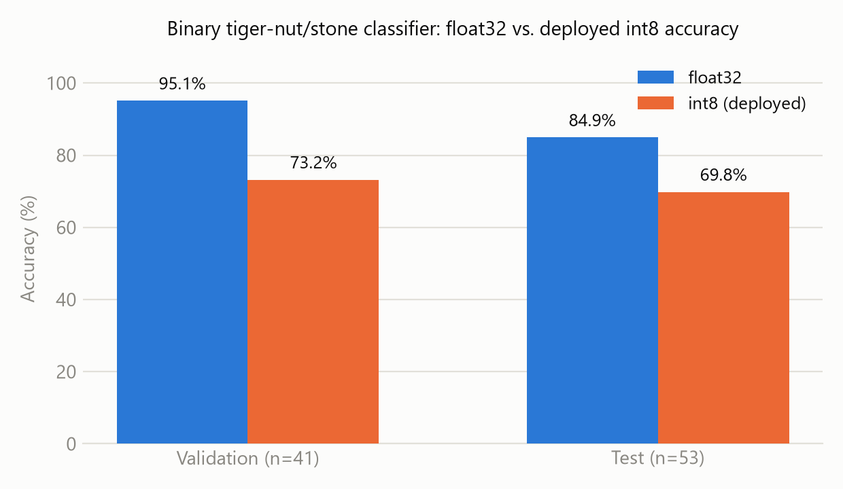
Figure 4.2 — Validation- and test-set accuracy for the float32 and INT8 model variants
The INT8 model required for on-device deployment is substantially less accurate than its float32 counterpart on both splits. Table 4.4 breaks the validation-set metrics down by class: stone recall is 100% for both variants, while tiger-nut recall collapses from 90.5% (float32) to 47.6% (INT8).
Variant | Class | Precision | Recall | F1 | Support
float32 | Stone | 0.909 | 1.000 | 0.952 | 20
float32 | Tiger Nut | 1.000 | 0.905 | 0.950 | 21
INT8 | Stone | 0.645 | 1.000 | 0.784 | 20
INT8 | Tiger Nut | 1.000 | 0.476 | 0.645 | 21
Table 4.4 — Per-Class Classification Metrics (Validation Split, n = 41)
The same asymmetry appears on the independent 53-image test set (Figure 4.3). In both variants, no stone was ever classified as a tiger nut — the model never introduces the food-safety-relevant error of letting a stone through as a nut. All errors run the other way: the float32 model misclassified 4 of 28 good tiger nuts as stone and flagged 4 more as uncertain (20 of 28 correct, 71.4% recall); the INT8 model misclassified 16 of 28 good tiger nuts as stone outright, correctly classifying only 12 (42.9% recall), with zero uncertain calls.
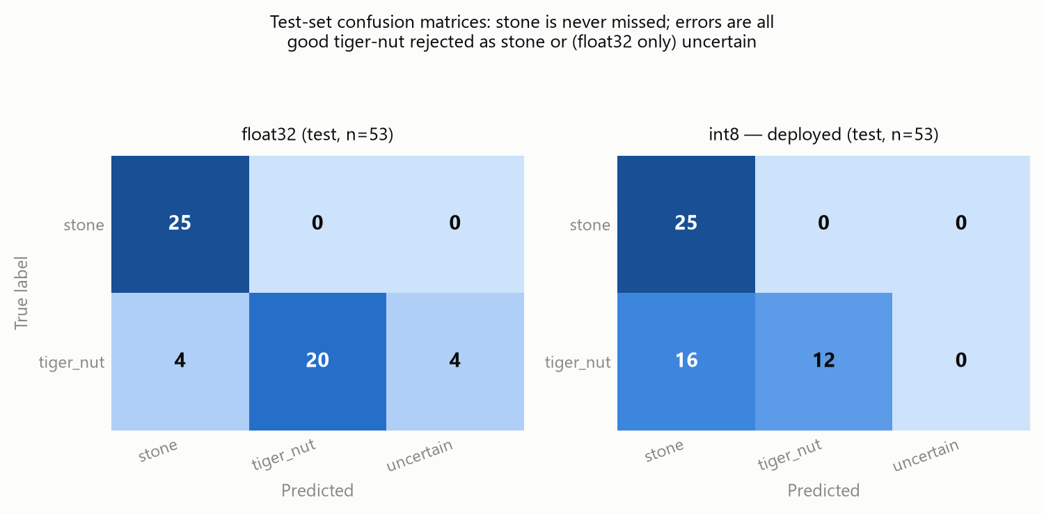
Figure 4.3 — Test-set confusion matrices for the float32 (left) and INT8 (right) models

4.5 Reproducibility Across Independent Training Runs
Edge Impulse redraws its 80/20 validation split internally on every training run rather than pinning one, and a dataset of 204 training images leaves considerable room for a single run's result to be unrepresentative. To check how much the Section 4.4 numbers depend on one favourable or unfavourable run, training was repeated a second time with identical hyperparameters (Table 4.2), and validation metrics were captured immediately afterward, before any other action could touch the project's state. Table 4.5 compares the two runs.
Run | Variant | Validation accuracy | Confusion matrix (stone→stone, stone→nut, nut→stone, nut→nut)
1 (Section 4.4) | float32 | 95.1% | 20, 0, 2, 19
1 (Section 4.4) | INT8 | 73.2% | 20, 0, 11, 10
2 (repeat) | float32 | 73.2% | 9, 11, 0, 21
2 (repeat) | INT8 | 73.2% | 20, 0, 11, 10
Table 4.5 — Validation Accuracy and Confusion Matrix Across Two Independent Training Runs
The INT8 variant reproduced closely: 73.2% validation accuracy in both runs, with an identical confusion matrix down to every cell. The float32 variant did not: it reached 95.1% in the first run but only 73.2% in the second, and its error pattern inverted — the first run's weakness was tiger-nut recall (good nuts misread as stone), while the second run's weakness was stone recall (stones misread as tiger nuts) instead.
This is informative rather than merely noisy. If the INT8 accuracy ceiling were simply inherited from whichever float32 model happened to train, it would be expected to vary at least as much as float32 did; instead it stayed fixed while float32 swung by 22 percentage points and flipped which class it struggled with. This is read as evidence that the approximately 73% figure is a systematic property of quantising this architecture (a 16-unit dense head over a frozen 0.25-width-multiplier MobileNetV1 base) at this dataset size, rather than an artefact of one unlucky training run — and, conversely, that a single float32 run's accuracy should not be treated as a reliable headline figure on its own. A second attempt to reproduce the Section 4.4 test-set numbers was not usable: it returned identical results for both the float32 and INT8 variants, which is not plausible for two differently-quantised models and is attributed to a limitation in the evaluation tooling used rather than to the models themselves; this is reported as a methodological limitation in Section 4.9.4 rather than as a result.

4.6 System Processing Pipeline
An item placed on the conveyor belt is captured by the OV2640 camera integrated into the AI Thinker ESP32-CAM module. The raw image frame is resized to 96×96 pixels and passed through the MobileNetV1 inference engine running on-device. The classification result is evaluated against a confidence threshold of 65%: if confidence is below this threshold, the item is allowed to flow straight through for manual inspection rather than being sorted automatically. Otherwise, a green LED flashes for a good tiger nut (which flows freely, no actuation needed), or a red LED flashes and a relay pulses — after a 300 ms delay accounting for belt travel time, held active for 400 ms — to divert a stone. The left-deflector relay and orange “bad nut” LED used in the three-class version of the firmware were removed when the model was reframed as binary.

4.7 Model Footprint and On-Device Profiling
The generated TensorFlow Lite model source was 3.90 MB for the INT8 build and 10.28 MB for the float32 build — roughly a 2.6× difference. This is the size of the generated C array compiled into the Arduino library, not a measured flashed-binary or runtime RAM figure. It was, however, stable across retraining: rebuilding both variants after the second training run (Section 4.5) produced source files within 0.15% of their original size, so model footprint is treated as reliable even though the underlying trained weights differ between runs.
An attempt was made to obtain true on-device latency and RAM/ROM figures from Edge Impulse's device-profiling API, targeting its closest match for the AI Thinker ESP32-CAM: the Espressif ESP-EYE reference device (ESP32, 240 MHz). Two separate profiling calls against the exported models returned substantially different latency estimates for both variants (float32: 1.1 ms, then 4.3 ms; INT8: 5.6 ms, then 1.5 ms), and the accompanying RAM, ROM, and tensor-arena-size fields were unpopulated in every attempt. Since the model-size figures above were reproducible across the same two calls, the exported models are not believed to have changed meaningfully between profiling attempts; the profiler's latency output is instead treated as unreliable for this project, and no point estimate is reported from it. Edge Impulse's separate DSP (feature-extraction) profiler reported 7 ms latency and 4096 bytes of RAM for the image pre-processing stage alone — unaffected by this issue, since it does not depend on model variant — but that figure is upstream of the classifier itself and not a full inference-time measurement. Measuring inference time directly on physical ESP32-CAM hardware, by timing run_classifier() in the deployed sketch, is identified as necessary future work (Section 4.9.4) rather than estimated here from an unreliable source.

4.8 Comparative Analysis: Random Forest vs. MobileNetV1
The initial prototype of the tiger nut sorting system was implemented using a Random Forest classifier (200 decision trees) trained on handcrafted features (HSV colour histograms, Local Binary Patterns, and statistical texture descriptors). On the original three-class problem, that model reached 74% test accuracy on a Raspberry Pi. Table 4.6 compares that three-class baseline against the current two-class MobileNetV1 model; because the two differ in both class count and hardware, this is contextual rather than a controlled comparison.
Attribute | Random Forest (Raspberry Pi, 3-class) | MobileNetV1 (ESP32-CAM, 2-class)
Feature Extraction | Manual (HSV, LBP, texture stats) | Automatic (learned by CNN)
Test Accuracy | 74% | 84.9% float32 / 69.8% INT8 (Run 1; see §4.5)
Hardware Platform | Raspberry Pi 4 | ESP32-CAM (520 KB SRAM)
Model Size | ~2 MB (original 3-class .pkl, not re-measured) | 3.90 MB INT8 / 10.28 MB float32 (generated source)
Table 4.6 — Model Comparison Summary (contextual, not a controlled comparison — differing class counts, datasets, and hardware)
As a closer, same-task comparison, the local Random Forest pipeline (app.py's HSV/LBP feature extractor) was also retrained on the reduced two-class problem, using a separate, smaller local image set (158 images: 106 good tiger nut, 52 stone — not the same 257-image pool used for the Edge Impulse model above). This retrained Random Forest reached 90.6% validation accuracy, with the resulting model file measuring 259 KB on disk, and averaged 42.2 ms per image (feature extraction plus prediction) on a development PC — not the target Raspberry Pi hardware, so this timing figure is a sanity check on the feature pipeline's cost rather than a deployment benchmark. On this smaller local dataset, a two-class Random Forest therefore sits between the MobileNetV1 model's float32 and INT8 results rather than clearly below either, which is a different picture from the three-class comparison above and is reported here as context rather than as a resolved conclusion; a controlled comparison would require training both models on the identical 257-image pool.

4.9 Discussion

4.9.1 Model Performance
Removing the bad-tiger-nut class achieved its intended effect: it eliminated a three-way confusion rooted in a class that shared stone's colour signature at 96×96 resolution, and the float32 model's Run 1 test accuracy (84.9%, on a larger 53-image test set) comfortably exceeds the original three-class model's validation accuracy (86.5%, though not a directly comparable split). Binary reframing is therefore a reasonable response when a middle class in a visual sorting problem is not separable from a neighbouring class at the working image resolution — though it changes what the system can do: a sorter with no bad-nut class cannot flag quality degradation, only contamination, so the decision to drop that class should be revisited once more bad-nut images at higher resolution are available.

4.9.2 The INT8 Gap and Its Reproducibility
The more consequential finding of this chapter is the INT8 gap and, from Section 4.5, its reproducibility. Published post-training-quantisation studies for TinyML generally report a 0.3–3 percentage-point accuracy cost; the 22-point validation gap observed in Run 1 is an order of magnitude larger, and Section 4.5's second run shows this gap is not just run-to-run noise in one direction — it persists because INT8 is the stable, reproducible quantity, while float32 is the one that moves between runs. The size of the gap is attributed to the small training set (roughly 100–110 images per class before splitting): with few examples per class, the decision boundary has little margin before quantisation noise in the activations crosses it. Practically, the INT8 model as currently trained is not fit for deployment: across both runs it correctly identified every stone (100% stone recall) but rejected roughly half of good tiger nuts as stone, which is uneconomical even though it is never unsafe in the sense that matters most for food safety — no stone was ever classified as a tiger nut in any run or variant observed in this study.

4.9.3 Confidence Thresholding
The 65% confidence threshold carried over unchanged from the three-class firmware continues to serve its purpose under the binary model: items the model is not confident about are allowed to pass straight through for manual inspection rather than being silently mis-sorted. Given the INT8 model's accuracy profile, this threshold is of limited help against its dominant error mode — confidently misclassifying a good nut as stone — since that error is not, in general, a low-confidence prediction. The threshold remains useful primarily for genuinely ambiguous images rather than for correcting the systematic quantisation bias identified in Section 4.5.

4.9.4 Limitations
Several limitations should be acknowledged. First, the dataset (257 images, roughly 110–135 per class) is modest for a deep-learning image classification task, and Section 4.5 shows this directly: a single training run's float32 accuracy varied by 22 percentage points between two otherwise identical runs, so any single reported accuracy figure — including figures published earlier in this project — should be treated with caution until confirmed across repeated runs or a pinned validation split (Edge Impulse supports this via an explicit-validation-set option, not used in this study). Second, two of the platform-based measurements attempted for this chapter were found to be unreliable rather than simply unavailable: the device-latency profiler returned inconsistent estimates across repeat calls for the same exported model (Section 4.7), and a second test-set evaluation returned identical, implausible results for two differently-quantised model variants (Section 4.5); both are reported as methodological limitations of the tooling used rather than suppressed or silently corrected. Third, the visual overlap between the discontinued bad-tiger-nut class and stone — the main source of three-class misclassification identified in the earlier phase of this project — was side-stepped by removing that class rather than resolved; a system that must also grade nut quality, not just reject contaminants, will need to revisit it. Fourth, the fixed camera position and controlled lighting conditions used during data collection may not fully represent the lighting and background variability of a commercial agricultural environment.

4.10 Summary
This chapter presented the results of reframing a three-class tiger-nut sorting problem as binary (good tiger nut vs. stone) and training a MobileNetV1 convolutional neural network for the revised task on an ESP32-CAM microcontroller via Edge Impulse. The float32 model benefited clearly from the binary reframing in its first training run (95.1% validation / 84.9% test accuracy), but a second, identically-configured run reached only 73.2% validation accuracy with an inverted error pattern, so that result should not be treated as a reliable baseline on its own. The INT8 model actually required for deployment was less flattering but far more consistent: 73.2% validation accuracy and an identical confusion matrix in both runs, over-rejecting good tiger nuts as stone even though it never once let a stone pass as a nut in any run or variant tested. Attempts to benchmark on-device latency and to re-verify test-set accuracy through the platform's own tools were found to be unreliable and are reported as limitations rather than results. The following chapter presents the conclusions of the study and recommendations for future work, including pinning an explicit validation split, training across multiple seeds before reporting a headline number, and measuring inference time directly on physical hardware.

