Real-Time Tiger Nut–Stone Sorting on ESP32-CAM: A Binary MobileNetV1 Classifier and the Accuracy Cost of INT8 Quantization
Joshua Ojoagefu Okpanachi¹, [Supervisor/Co-Author Name]^{2*}
1 Department of Mechanical/Mechatronics Engineering, Federal University of Technology, Minna, Nigeria
2 [Department], Federal University of Technology, Minna, Nigeria
* Corresponding author: [email@futminna.edu.ng]
Abstract Postharvest processing of tiger nut (Cyperus esculentus) requires separating edible nuts from stones and other field debris picked up during harvesting and sun-drying. This paper presents an embedded computer-vision sorter built around an AI Thinker ESP32-CAM, an OV2640 camera, and a MobileNetV1 image classifier trained by transfer learning on the Edge Impulse platform. An earlier three-class formulation (good tiger nut / damaged tiger nut / stone) reached 86.5% validation accuracy but was limited by visual overlap between the damaged-nut and stone classes. Reframing the task as a binary good-nut/stone problem and retraining on 257 images (204 train / 53 test; 136 tiger nut, 121 stone) raised the full-precision (float32) model's accuracy to 95.1% validation and 84.9% on the held-out test set, while the INT8-quantized model required for deployment on the ESP32-CAM's constrained SRAM reached only 73.2% validation and 69.8% test accuracy — rejecting 16 of 28 good nuts as stone while never once passing a stone through as a nut in either precision. Repeating training a second time under identical settings reproduced the INT8 result almost exactly (73.2% validation, an identical confusion matrix) while the float32 result did not reproduce (95.1% vs. 73.2% across the two runs, with an inverted error pattern), indicating the quantization bottleneck, not training-run variance, is the dominant limit on this dataset. We report this gap, its confusion-matrix structure, the resulting model-size trade-off (3.9 MB int8 vs. 10.3 MB float32 generated model source), and the limits we hit trying to obtain on-device latency from the platform's profiler, and argue that TinyML sorting systems should report accuracy for the deployed quantized model, checked across more than one training run, rather than a single training-time float32 figure.
Keywords TinyML · Edge Impulse · ESP32-CAM · MobileNetV1 · tiger nut · INT8 quantization · agricultural sorting

1 Introduction
Tiger nut (Cyperus esculentus), known locally as aya in northern Nigeria, is processed into snacks, flour, and the beverage kunun aya after harvesting, washing, and sun-drying [3]. Washing removes most sand, but small stones of similar size and mass to a dried tiger nut routinely survive into the dried batch and must be separated before packaging or milling [2]. On a small or medium processing line this separation is still typically done by hand, which is slow and inconsistent, motivating low-cost automated optical sorting [1].
Embedded vision on microcontroller-class hardware (TinyML) has become a practical option for this kind of small-scale sorting task, since boards such as the ESP32-CAM combine a camera, Wi-Fi, and enough compute for a quantized convolutional network at a cost of only a few dollars [5,6]. An earlier iteration of the system described here used a Random Forest classifier trained on handcrafted HSV colour-histogram and Local Binary Pattern features, reaching 74% accuracy on a Raspberry Pi [4]; replacing it with a MobileNetV1 transfer-learning model trained via Edge Impulse raised accuracy to 86.5% on a three-class good/damaged/stone problem while running on cheaper, lower-power hardware. However, the damaged-tiger-nut class shared enough grey-brown surface tone with stone at the model's 96×96 input resolution that it was the dominant source of error.
This paper reports what happened when that non-separable third class was removed and the problem was reframed as binary classification (good tiger nut vs. stone), and — more importantly — what happened when the resulting model was quantized to INT8 for on-device deployment and retrained a second time to check reproducibility, two steps most TinyML write-ups do not separately report. The contributions of this paper are: (1) a case study in reframing a three-class agricultural sorting problem as binary once one class proves visually inseparable from another; (2) a quantified comparison of float32 and INT8 accuracy and confusion-matrix structure for this task on ESP32-CAM-class hardware, including a markedly asymmetric degradation pattern; (3) evidence from two independent training runs that this INT8 result is reproducible while the float32 result is not, on a dataset this size; and (4) a complete, working embedded sorting pipeline — camera capture, inference, confidence thresholding, and relay/LED actuation — reported here with the deployed model's real accuracy rather than a single training-time figure.
The remainder of the paper is organised as follows. Section 2 reviews embedded machine-vision food sorting and TinyML quantization literature. Section 3 describes the hardware, dataset, and training configuration. Section 4 reports validation- and test-set results for both model variants, including a second independent training run used to check how reproducible those results are. Section 5 concludes and outlines future work.

2 Related Work
Machine vision has been applied across food processing broadly, from sorting and grading to foreign-material detection, with colour- and texture-based optical sorters now standard for separating grains from field stones by surface reflectance [1,2]. Stones are a common contaminant in cereal and legume processing specifically, and are comparatively easy to detect optically because of their density and colour contrast with the target crop [2].
Within embedded TinyML, the ESP32-CAM paired with Edge Impulse has been used for several agricultural classification tasks: Kulkarni et al. report ESP32-CAM tomato grading and classification through Edge Impulse's cloud-trained ResNet pipeline for sustainable farming [6], while Ben Aicha presents a general optimisation study for running quantized CNNs on the ESP32-CAM's 520 KB SRAM, addressing TensorFlow Lite buffer-overflow and memory-alignment issues at the firmware level [5]. Both report the trained model's accuracy without separately isolating the accuracy of the quantized model actually flashed to the board. A YOLOv8-based alternative exists for crop sorting specifically: Rojas Yana and Salcedo combine a YOLOv8 detector and a YOLOv8 classifier with pneumatic ejection to sort green lentils into six grades at 87.2% separation accuracy [7]. That approach requires bounding-box-annotated training data to locate grains on a belt; the dataset used in the present work has only whole-image class labels, so a head-to-head comparison against a detection-based pipeline is left for future work rather than attempted here.
On the quantization side, Zhuo et al. benchmark post-training quantization (PTQ) methods for TinyML use cases and report accuracy losses typically in the 0.3–3 percentage-point range relative to float32 on their benchmark datasets [8]. Abushahla et al.'s survey of microcontroller-targeted quantization likewise treats sub-1-point PTQ degradation as the expected case, while noting that small or imbalanced training sets are a known sensitivity factor that can push the loss higher [9]. The gap we report in Section 4 (22–25 percentage points) is far larger than either source's typical range, which we attribute to the small per-class image count available here (roughly 120–135 images per class) relative to the benchmark datasets those studies use.
The gap this paper addresses is narrow but, we think, common in practice: published ESP32-CAM/Edge Impulse agricultural deployments report the float32 training metric, not a separately measured accuracy for the INT8 model that is actually exported and flashed to the device. The results in Section 4 show that, at least for a small, two-class dataset, this distinction is not cosmetic.

3 Methodology / System Design

3.1 Hardware and sorting pipeline
The sorter uses an AI Thinker ESP32-CAM module with an OV2640 camera. An item on the conveyor is captured, resized to the model's 96×96 RGB input, and classified on-device. If the top class confidence is below a threshold of 0.65 the item is treated as uncertain and allowed to flow straight through for manual inspection; otherwise a green LED flashes and the item proceeds for a tiger nut, or a red LED flashes and a relay pulses (after a 300 ms belt-travel delay, held for 400 ms) to divert the item for a stone. The firmware and sort logic were updated for this study to match the binary model: the previous left-deflector relay and orange LED used to divert damaged nuts were removed along with the corresponding class.

3.2 Dataset
Images were collected in two batches under controlled lab lighting: an initial batch and a supplementary batch collected to improve class balance. After the damaged-tiger-nut class was removed, the remaining labelled set comprised 257 images — 136 good tiger nut and 121 stone — split 80/20 at upload time into 204 training images (108 tiger nut, 96 stone) and 53 held-out test images (28 tiger nut, 25 stone) never used during training or validation.
Table 1 summarises the dataset composition used for this study.
Class | Training images | Test images | Total
tiger_nut (good) | 108 | 28 | 136
stone | 96 | 25 | 121
Total | 204 | 53 | 257
Table 1. Dataset composition after removing the damaged-tiger-nut class.

3.3 Model and training configuration
The Edge Impulse impulse consists of an image input block (96×96, RGB), an image DSP block, and a transfer-learning block built on MobileNetV1 96×96 (0.25 width multiplier) with the pretrained convolutional base frozen and a 16-unit dense head (dropout 0.1) trained on top. Table 2 lists the training configuration, identical to the configuration used for the earlier three-class model so that the binary-reframing effect in Section 4 is not confounded with a hyperparameter change.
Parameter | Value
Input resolution | 96 × 96 RGB
Base model | MobileNetV1 0.25, transfer learning
Dense head | 16 units, dropout 0.1
Epochs | 30
Learning rate | 0.0005
Batch size | 32
Validation split | 20% (41 of 204 training images)
Augmentation | Flips, brightness, zoom
Exported variants | float32 and INT8 (post-training quantization), TensorFlow Lite
Table 2. Training hyperparameters (unchanged from the three-class run).

3.4 Evaluation protocol
Two accuracy figures are reported for each model variant. Validation accuracy is Edge Impulse's internal 20% split (41 of the 204 training images), measured separately after export for the float32 and INT8 variants to capture any quantization error. Test accuracy is computed by running the deployed model over all 53 test images, which were not used in training or validation; this is the figure most representative of real deployment.

4 Experiments and Results

4.1 Overall accuracy: float32 vs. INT8
Table 3 and Fig. 1 report overall accuracy for both exported variants on both splits. Reframing the problem as binary raised the float32 model's accuracy well above the earlier three-class figure (86.5% validation on the three-class problem vs. 95.1% validation / 84.9% test here). The INT8 model required for on-device deployment, however, is substantially less accurate than its float32 counterpart on both splits.
Variant | Validation accuracy | Validation loss | Test accuracy
float32 | 95.1% | 0.136 | 84.9%
int8 (deployed) | 73.2% | 0.392 | 69.8%
Table 3. Overall accuracy and loss by exported model variant.
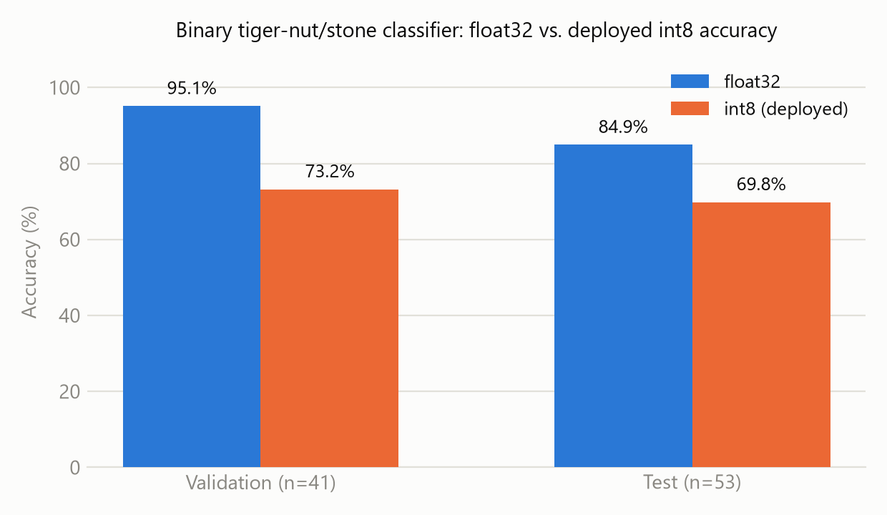
Fig. 1. Validation- and test-set accuracy for the float32 and INT8 model variants. The gap between variants is larger than the gap between splits.

4.2 Per-class behaviour and confusion structure
Table 4 breaks the validation-set metrics down by class. The asymmetry is the central result: stone recall is 100% for both variants, while tiger_nut recall collapses from 90.5% (float32) to 47.6% (INT8).
Variant | Class | Precision | Recall | F1 | Support
float32 | stone | 0.909 | 1.000 | 0.952 | 20
float32 | tiger_nut | 1.000 | 0.905 | 0.950 | 21
int8 | stone | 0.645 | 1.000 | 0.784 | 20
int8 | tiger_nut | 1.000 | 0.476 | 0.645 | 21
Table 4. Per-class precision, recall, and F1-score on the validation split (n = 41).
The same asymmetry appears on the independent 53-image test set (Fig. 2). In both variants, no stone was ever classified as a tiger nut — the model never introduces a food-safety-relevant false negative of that kind. All errors run the other way: the float32 model misclassified 4 of 28 good tiger nuts as stone and flagged 4 more as uncertain (correctly classifying 20 of 28, 71.4% tiger_nut recall on this split); the INT8 model misclassified 16 of 28 good tiger nuts as stone outright, correctly classifying only 12 (42.9% tiger_nut recall), with zero uncertain calls.
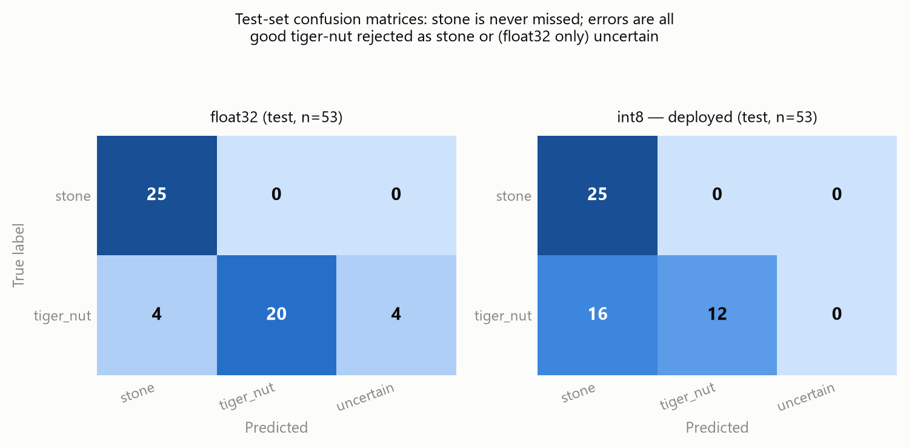
Fig. 2. Test-set confusion matrices for the float32 (left) and INT8 (right) models. Stone is classified perfectly in both; all error mass is good tiger nut misrouted as stone (and, for float32 only, as uncertain).

4.3 Model footprint and the limits of platform-based latency profiling
The generated TensorFlow Lite model source was 3.90 MB for the INT8 build and 10.28 MB for the float32 build — roughly a 2.6× difference. This is the size of the generated C array used to compile the model into the Arduino library, not a measured flashed-binary or runtime RAM figure. It was, however, stable: rebuilding both variants after the second training run (Section 4.4) produced source files within 0.15% of their original size (int8: 3.90 MB both times; float32: 10.28 MB and 10.27 MB), so we treat model footprint as reliable even though the underlying weights differ between runs.
We also attempted to obtain on-device latency and RAM/ROM figures from Edge Impulse's device-profiling API, targeting its closest match for the AI Thinker ESP32-CAM: the Espressif ESP-EYE reference device (ESP32, 240 MHz). Two separate profiling calls against the exported models returned substantially different latency estimates for both variants (float32: 1.1 ms, then 4.3 ms; int8: 5.6 ms, then 1.5 ms), and the accompanying RAM, ROM, and tensor-arena-size fields were unpopulated in every attempt. Since the model-size figures above were reproducible to within 0.15% across the same two calls, we do not believe the exported models changed meaningfully between profiling attempts; we instead treat the profiler's latency output as unreliable for this project and do not report a point estimate from it. The Edge Impulse DSP profiler separately reported 7 ms latency and 4096 bytes of RAM for the image feature-extraction stage alone (unaffected by this issue, since it does not depend on model variant), but that is upstream of the classifier and not a full inference-time figure. Measuring inference time directly on physical ESP32-CAM hardware — wrapping run_classifier() in the provided sketch with micros() — is listed as future work (Section 5) rather than estimated here from an unreliable source.

4.4 Reproducibility across independent training runs
Edge Impulse redraws its 80/20 validation split internally on every training run rather than pinning one (explicitValidationEnabled was not enabled for this project), and a dataset of 204 training images leaves substantial room for a single run's result to be unrepresentative. To check how much the Section 4.1 numbers depend on one lucky or unlucky run, we repeated training a second time with identical hyperparameters (Table 2) and captured validation metrics immediately afterward, before any other API call could touch the project's state.
Run | Variant | Validation accuracy | Confusion matrix (stone→stone, stone→nut, nut→stone, nut→nut)
1 (Section 4.1) | float32 | 95.1% | 20, 0, 2, 19
1 (Section 4.1) | int8 | 73.2% | 20, 0, 11, 10
2 (repeat) | float32 | 73.2% | 9, 11, 0, 21
2 (repeat) | int8 | 73.2% | 20, 0, 11, 10
Table 5. Validation accuracy and confusion matrix across two independent training runs with identical hyperparameters.
The INT8 variant reproduced closely: 73.2% validation accuracy in both runs, with an identical confusion matrix down to every cell. The float32 variant did not: it reached 95.1% in the first run but only 73.2% in the second, and its error pattern inverted — the first run's weakness was tiger_nut recall (good nuts misread as stone), while the second run's weakness was stone recall (stones misread as tiger nuts) instead.
This asymmetry is informative rather than just noisy. If INT8's accuracy ceiling were simply inherited from whichever float32 model happened to train, we would expect it to vary at least as much as float32 did; instead it stayed fixed while float32 swung by 22 points and flipped which class it struggled with. We read this as evidence that the ~73% figure is a systematic property of quantizing this architecture (a 16-unit dense head over a frozen 0.25-width-multiplier MobileNetV1 base) at this dataset size, rather than an artifact of one unlucky training run — and, conversely, that a single float32 run's accuracy should not be treated as a reliable baseline on its own. We did not attempt to reproduce the Section 4.2 test-set numbers a second time: a second test-set evaluation returned identical results for both the float32 and INT8 variants (45.3% accuracy, matching confusion matrices), which is not plausible for two differently-quantized models and which we attribute to a platform caching issue in the evaluation endpoint we used rather than to the models themselves; we report this as a limitation of our methodology rather than as a result.

4.5 Discussion
Removing the damaged-tiger-nut class achieved its intended effect: it eliminated a three-way confusion rooted in a class that shared stone's colour signature, and the float32 model's test accuracy (84.9%, on a larger 53-image test set) comfortably exceeds the original three-class model's validation accuracy (86.5%, though not a directly comparable split). Binary reframing is therefore a reasonable response when a middle class in a visual sorting problem is not separable from a neighbouring class at the working image resolution — though it changes what the system can do: a sorter with no damaged-nut class cannot flag quality degradation, only contamination, so the decision to drop that class should be revisited once more damaged-nut images at higher resolution are available.
The more consequential finding is the INT8 gap. Literature on PTQ for TinyML generally reports a 0.3–3 percentage-point accuracy cost [8,9]; the 22-point validation gap observed in our first run is an order of magnitude larger, and Section 4.4's second run shows this gap is not just run-to-run noise in one direction — it persists because INT8 is the stable, reproducible quantity, while float32 is the one that moves. We attribute the size of the gap to the small training set (roughly 150 images per class before splitting), which both studies flag as a sensitivity factor for PTQ: with few examples per class, the decision boundary has little margin before quantization noise in the activations crosses it. In our first run the degradation was asymmetric — it fell almost entirely on the tiger_nut class — but Section 4.4 shows that asymmetry's direction is itself not stable across runs for float32, even though INT8 lands on the same operating point both times. Practically, the INT8 model as currently trained is not fit for deployment: across both runs it correctly identified every stone (test-set recall 100% in Run 1) but rejected roughly half of good tiger nuts as stone, which is uneconomical even though it is never unsafe in the sense that matters most for food safety — no stone was ever classified as a tiger nut in any run or variant we observed.

5 Conclusion and Future Work
This paper reframed a three-class tiger-nut sorting problem as binary after finding that its damaged-nut class was not visually separable from stone at 96×96 resolution, and then measured — rather than assumed — the accuracy of the INT8 model actually required for ESP32-CAM deployment. The float32 model benefited clearly from the binary reframing in its first training run (95.1% validation / 84.9% test accuracy), but a second, identically-configured run reached only 73.2% validation accuracy with a different error pattern, so that result should not be treated as a reliable baseline on its own. The deployed INT8 model was less flattering but far more consistent: 73.2% validation accuracy and an identical confusion matrix in both runs, over-rejecting good tiger nuts as stone even though it never once let a stone pass as a nut in any run or variant tested. We also attempted to benchmark on-device latency through Edge Impulse's device profiler and found its output unreliable (Section 4.3), so no latency figure is reported.
Future work includes: (1) pinning an explicit validation split and training across multiple random seeds before reporting a headline accuracy number, since Section 4.4 shows a single float32 run is not reliable evidence on a dataset this size; (2) collecting more tiger-nut images specifically, since the quantization error concentrated on that class in Run 1; (3) comparing post-training quantization against quantization-aware training, which the literature suggests should close most of this gap; (4) measuring true on-device inference latency, RAM, and power directly on physical ESP32-CAM hardware, since both the Edge Impulse DSP profiler and its device-profiling API proved insufficient or unreliable for the full classifier (Section 4.3); (5) once bounding-box-annotated data is available, comparing this whole-frame classification approach against a YOLO-based detection pipeline such as that of Rojas Yana and Salcedo [7]; and (6) field-testing the sorter under real conveyor conditions and variable lighting, which the controlled lab-lighting dataset used here does not capture.

References
1. Zhu, L., Spachos, P., Pensini, E., Plataniotis, K.N.: Deep learning and machine vision for food processing: a survey. Current Research in Food Science 4, 233–249 (2021).
2. Payne, K., O'Bryan, C.A., Marcy, J.A., Crandall, P.G.: Detection and prevention of foreign material in food: a review. Heliyon 9(9) (2023).
3. Yu, Y., Lu, X., Zhang, T., Zhao, C., Guan, S., Pu, Y., Gao, F.: Tiger nut (Cyperus esculentus L.): nutrition, processing, function and applications. Foods 11(4), 601 (2022).
4. Okpanachi, J.O.: AI-Powered Tiger Nut Sorting System for Packaging — Chapter Four: Results and Discussion. Undergraduate project report, Department of Mechanical/Mechatronics Engineering, Federal University of Technology, Minna (2026). Unpublished.
5. Ben Aicha, F.: Optimized embedded AI: efficient implementation of CNNs on ESP32-CAM for real-time image classification. Computing 107, 206 (2025).
6. Kulkarni, S.M., Umadi, S., Amogh, R.M., Airani, S.S., Raikar, M.M.: Grading and classification of tomatoes using ESP32-CAM and Impulse Cloud based IoT platform for sustainability. Procedia Computer Science 260, 938–946 (2025).
7. Rojas Yana, D., Salcedo, E.: Low-cost machine vision system for sorting green lentils (Lens culinaris) based on pneumatic ejection and deep learning. In: Proceedings of the 30th International Conference on Automation and Computing (ICAC 2025). arXiv:2507.20531 (2025).
8. Zhuo, S., Chen, H., Ramakrishnan, R.K., Chen, T., Feng, C., Lin, Y., Zhang, P., Shen, L.: An empirical study of low precision quantization for TinyML. In: tinyML Research Symposium 2022. arXiv:2203.05492 (2022).
9. Abushahla, H.A., Varam, D., Panopio, A.J.N., AlHajri, M.I.: Neural network quantization for microcontrollers: a comprehensive survey of methods, platforms, and applications. arXiv:2508.15008 (2025).

