PPS Project

Simple Banking System

1] To Enter the Account Number and Account holder Name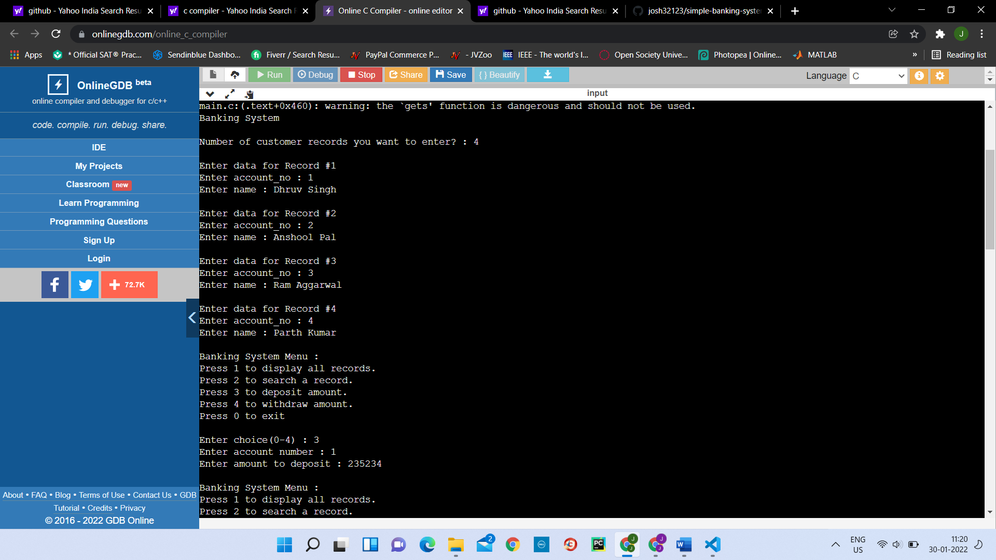

2] To Search for an Individual Account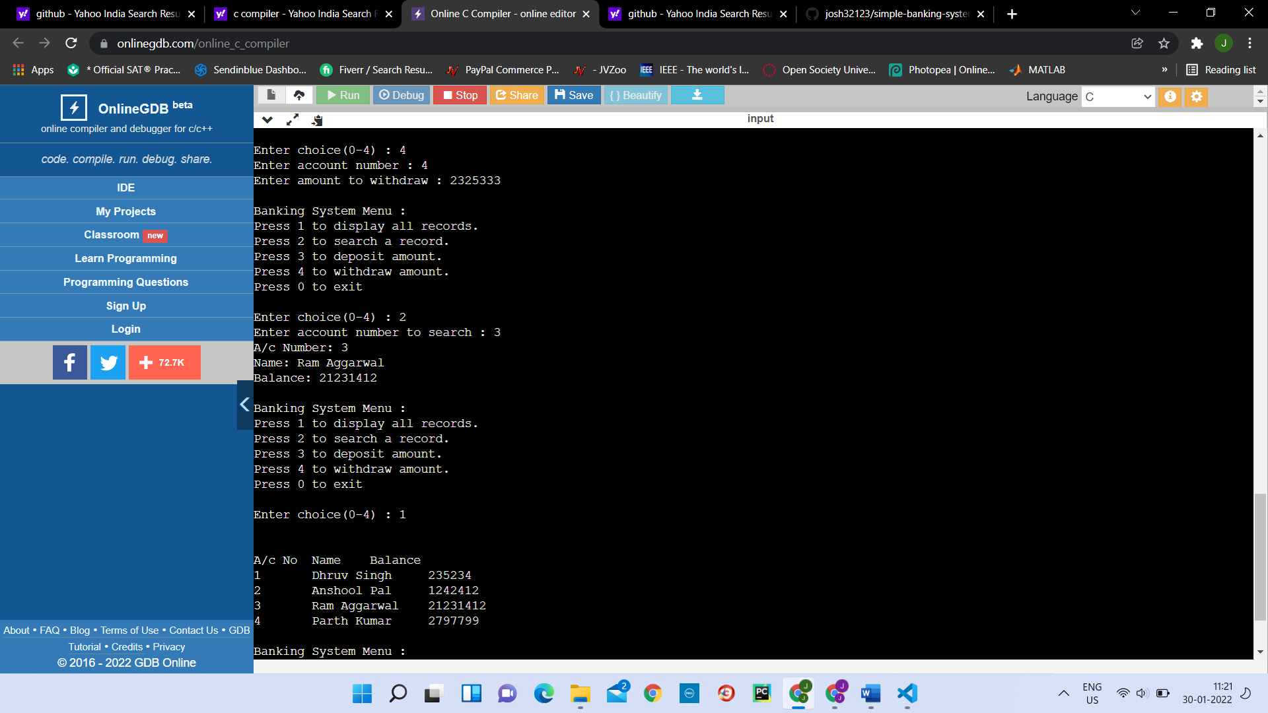3] To enter the Amount into the Account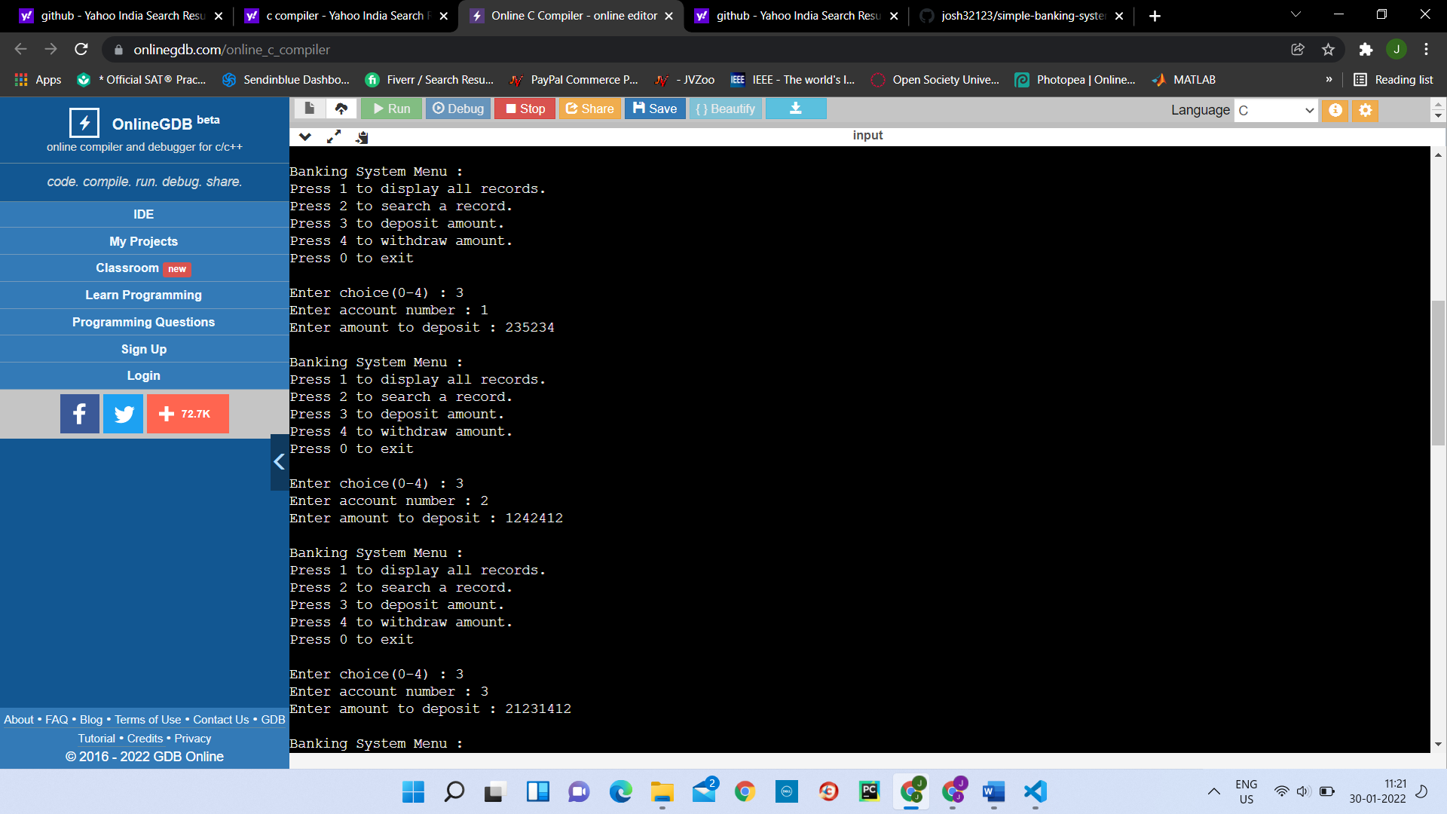

4] Withdrawing Amount from an Account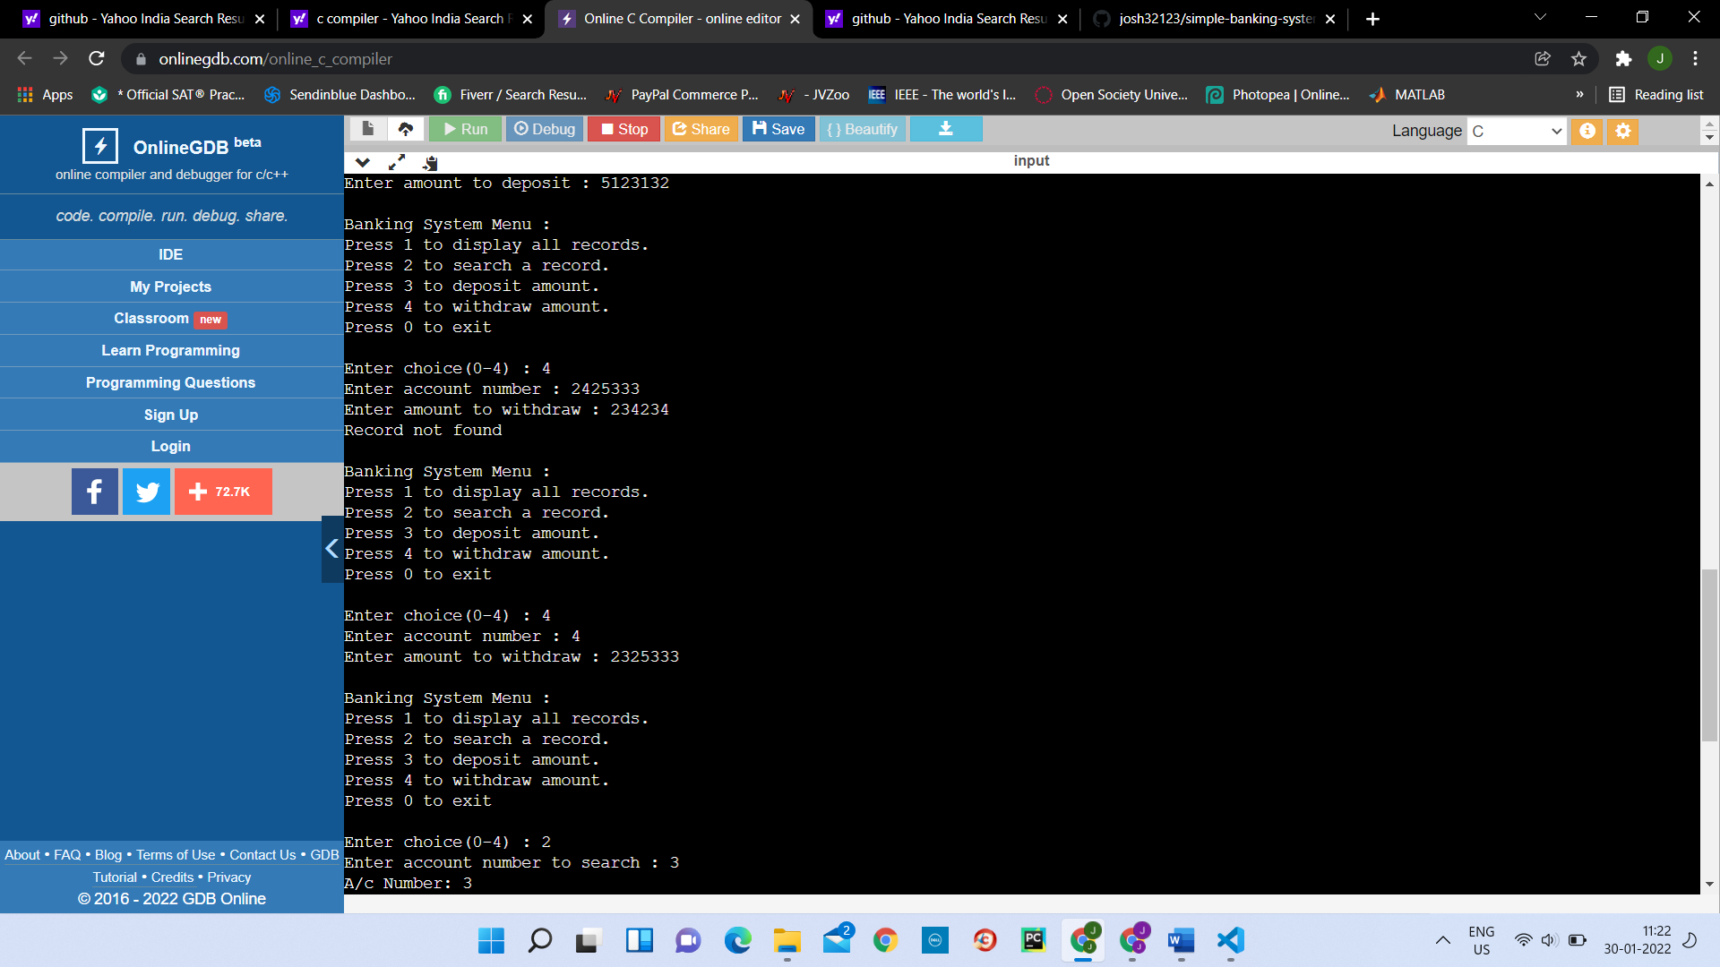

5] To Display all records

