FL-01 — AI Workflow Audit & Tool Setup
General AI Fluency Track · Week 1 ·

1. Workflow Audit
Recurring tasks from a typical week (study, work, side projects), classified by how AI should be involved.
Task | Classification | Rationale (1 line)
Cleaning & wrangling raw datasets for portfolio projects | Delegate to AI, with review | AI writes the pandas boilerplate fast, but I always check the transformed data against the raw source.
Choosing which ML model/approach fits a given problem | Collaborate with AI | I want a thinking partner to weigh trade-offs, but the final call reflects my own reasoning, not AI's default pick.
Writing first-draft training/evaluation notebook code | Delegate to AI, with review | Speeds up boilerplate (train/test split, metrics), but I trace through the logic before trusting results.
Debugging a model that won't converge or gives odd metrics | Collaborate with AI | Best as back-and-forth — I know the data and context, AI is good at spotting overlooked patterns.
Deciding which portfolio project to prioritize this month | Just me | This is about my career direction and time investment; AI has no real stake or context on that trade-off.
Writing SQL queries to pull data for analysis | Fully automate | Mechanical once the schema is known; a quick row-count sanity check is enough to catch errors.
Replying to recruiter emails / interview scheduling | Just me | Tone and relationship stakes are too high to hand off; I own the exact wording.
Drafting FL-series internship assignment write-ups | Delegate to AI, with review | AI drafts fast from my notes, but I check accuracy and make sure the content is genuinely mine.
Tailoring resume bullets / cover letters to a specific job posting | Collaborate with AI | AI is a good sounding board for phrasing, but I decide what's actually true and worth emphasizing.
Studying ML/stats theory for interviews (active recall, practice problems) | Just me | Learning happens through my own struggle with the material — outsourcing this defeats the purpose.
Formatting citations / reference lists for reports | Fully automate | Low-stakes and rule-based; easy to spot-check in a final pass.
Writing a first-draft README or project documentation | Delegate to AI, with review | Solves the blank-page problem fast; I still rewrite sections to match how the project actually works.
Building data visualizations / dashboards for a project | Collaborate with AI | I iterate with AI on chart choice and code, but what story the data tells is my call.
Writing unit tests for stable, well-understood functions | Fully automate | Repetitive enough that AI output is reliable with only a light final skim.

2. Toolkit Setup
- Claude account created at claude.ai
- ChatGPT account created at chat.openai.com
- Anthropic Academy account created; enrolled in “AI Fluency: Framework & Foundations”
- Module 1 completed — [note your key takeaway here]

3. Claude Project Configuration
Project name: AI audit workflow
Custom instructions used:
“I'm a Data Science bootcamp graduate from HyperionDev and doing a part-time AI fluency internship at FlyRank. Tone: direct and concise, no filler, push back if my reasoning is off, skip the caveats unless they matter. Current goals: completing the AI Fluency: Framework & Foundations course, building a workflow audit habit, and landing a data science role.”
Screenshot of the configured project:
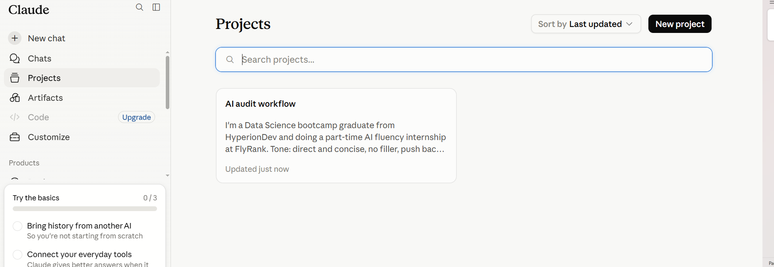

4. Three Target Tasks for FL-02 – FL-04

1. First-draft notebook/model code generation for portfolio projects
Done well = generated code runs without error on first try in ≥80% of requests, correctly reflects the dataset/problem I described (no invented columns or assumptions), and I can explain and justify every line before it goes in the final notebook.

2. FL-series internship assignment write-ups
Done well = draft needs less than 10 minutes of editing, every task/example in it is genuinely mine (not generic filler), and it passes the assignment's own evaluation criteria on the first review.

3. Tailoring resume bullets / cover letters to job postings
Done well = every claim in the draft is something I can back up in an interview (no exaggeration AI added on its own), and the tailoring visibly reflects the specific posting, not a generic template swap.

