Hosting Self-Rep at a new URL

The an easy and free way to spin up a second instance of the Self-Rep app is by creating a new Heroku app for it. Detailed below are the steps to do so.

Step 1: Sign up for an account

1. Go to: signup.heroku.com
2. Fill in the information fields, register an email, and sign up for a Heroku account

Step 2: Set up the app

1. Once logged into your new account, go to: https://dashboard.heroku.com/new-app
2. Select a name for your app and click "Create App".
3. On the next page, under "Deployment Method", click "GitHub". Then click, "Connect to GitHub". A popup, will appear asking for authorization. Click "Authorize Heroku"
4. 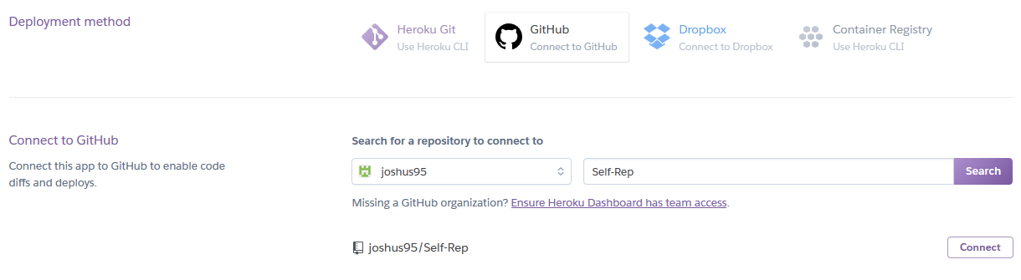
5. In the "Connect to Github" section, type in the "Self-Rep" to search for the self replicating repository and click "connect"

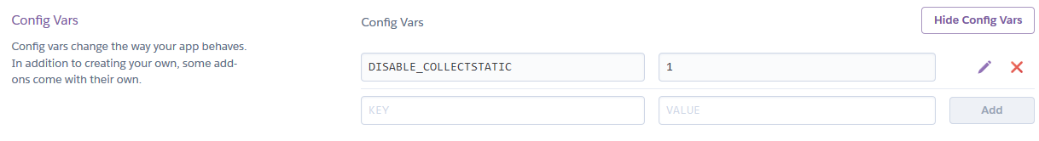

Add python buildpack

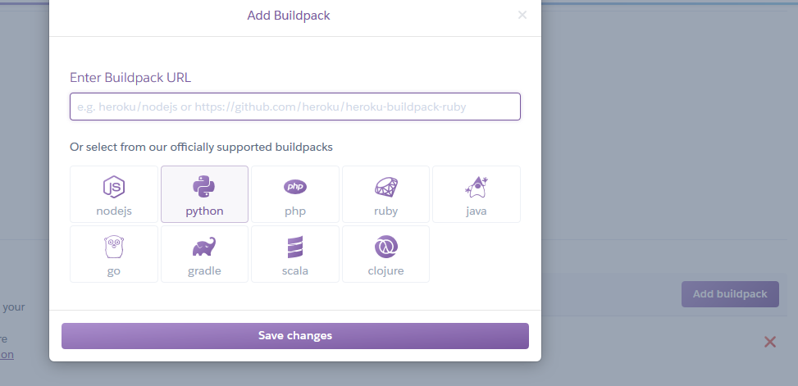

Add to allowed hosts

